Vishnu Sahasranamam

(Meanings: based upon the commentary of Shankaracharya)

Meanings: Courtesy: http://www.mypurohith.com
Sanskrit script courtesy: Shri. N. Krishnamachari: http://home.attbi.com/~chinnamma/

Vishnu Sahasranama means the “Thousand Names of Vishnu.” This narrative is based upon the commentary of Shankaracharya. Acharya sankara reached the feet of his Guru, Sri Govindapaachaarya, and on the bank of Narmada, the Nambootiri-boy from kaaladi got initiated into the secrets of the Mahaavaakyas. At the end of his short but intense study, sankara, the inspired missionary, wanting to fulfill his glorious work, craved from the blessings of his teacher. Govindapa Acharya tested sankara by ordering him to write an exhaustive commentary (Bhaashya) upon the Vishnu Sahasranaama. He accomplished his great task and the very first work of the Upanishadic commentator, sankara, the greatst Hindu missionary of the 7 ^{th} century, thus came to see the light of the day.

Govindaacharya, satisfied with the proficiency of the student blessed him and set him on the road of service and action. Earning the grace of the teacher and the blessings of the Lord Vishnu, Sri sankara inaugurated an incomparable revival movement of the decadent culture of the 7th century Hinduism. We shall here follow closely Sankara’s commentary and also draw our material from the Puranic literature that has an endless store of appeal to the hearts of all devotees.

The Vishnu Sahasranaama was composed by Sri Veda Vyaasa, the author of the Puraanas, and we meet this great chant in his classical work, the Mahaabaarata, Prince Yudhisthira, the eldest of the pandavas, at the end of the war approached Bheeshma Pitaamaha, when the mighty grandsire of the Kuru family was lying on the bed of arrows, unconquered and in conquerable, awaiting the scared hour of his departure to the feet of the lord. Yudhishthira, the righteous, asked six questions, Bheeshma, the constant devotee of Krishna, the gigantic Man of Action, calmly answered them all. This is how we find the “Thousand Names of Lord Vishnu” introduced in the immortal classic of the Hindus, the Mahaabaarata.

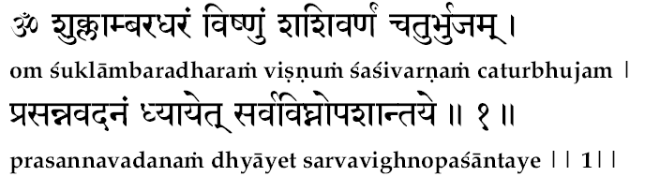

For the eradication of all obstructions, I meditate ("dhyayeth") on Vishnu, who is wearing ("dharam") a white ("shukla") cloth ("ambara"), who is of the color ("varnam") of the moon ("sashi"), who has four ("chatur") arms ("bhujam"), and who has a placid expression ("prasanna") on His face ("vadanam").

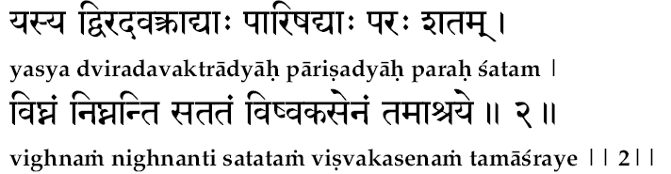

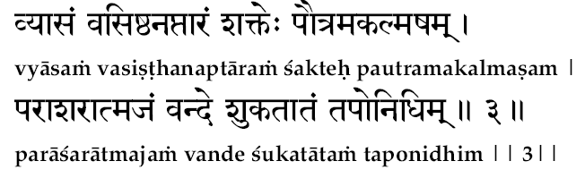

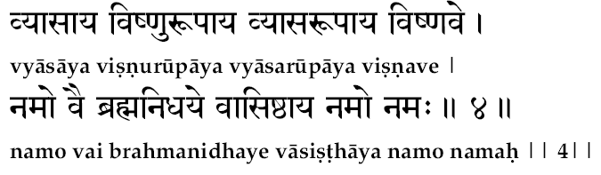

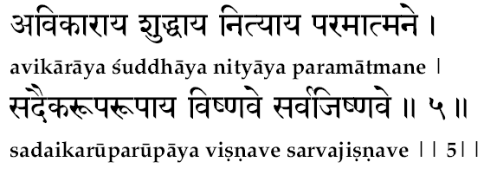

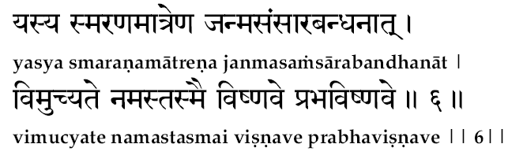

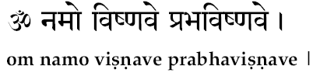

Shree Vaisham pãyana uvacha:
Shruthvã dharmãna séshéna pãvananicha sarvashaha
Yudhishtara shanthanavam punarévãbya bashatha

Vaisampayana, the narrator to Dhritrastra says: Yudhishthira, as a righteous man ("dharamana") of spiritual inclination, with the mortal integrity ("paavanaani") of a careful mortal, asks ("bhaashatha") Bhishma ("shaantanavam") quite an interesting set of questions which are typical queries which the heart of seekers will always ask.

Yudhishtira uvacha
Kimékam daivatham loke kim vápyekam parãyanam
Sthuvantha kam kamarchanda prapnuyur mãnavã shubam

Who ("kim") is the greatest ("ekam") Lord ("daivatam") in the world ("loke")?
Who is the one ("ekam") refuge ("paraayanam") for all?
By glorifying ("sthuvantah") whom ("kam") can man ("manavah") reach the Auspiciousness ("shubam") (peace and prosperity)?
By worshipping ("archantah") whom can a man reach auspiciousness (peace and prosperity)?
Ko dharma sarva dharmãnam bhavatha paramo mathaha
Kim japan muchyathé janthur janma samsãra bandhanãth

What ("ko") is, in thy opinion, the Greatest Dharma?
By ("kim") doing japa of what can “creatures” (jantu) go beyond ("mutchyate") the bonds ("bandhanaath") of samsara?
Shree Bheeshmã Uvacha
Jagath prabhum deva devam antham purushothamam
Sthuvan nãma sahasréna purusha saththo thithaha
The supreme ("uttamam") Purusha, who is ever up and working for the welfare of all, the Lord ("prabhum") of the world ("jagat") the endless ("anantam") – Sri Maha Vishnu.
Thameva chãr chayanth nithyam bhakthya purusha mavyayam
Dhayãyan sthuvan namasyamsha yajamãnas thamevacha 10
By meditating upon ("sthuvan naama"), by ("cha") worshipping ("archayan") and by prostrating at the same Purusha, man can reach true Auspiciousness.
Anãdhinidhanam vishnum sarva lokamahesvaram
Lokãdhyaksham sthuvan nithyam sarva dhukkã thigo bhavéth
The greatest Dharma is the one Vishnu, who has neither a beginning (Aadi) nor an end (Nidhanam), the supreme Lord ("maheshwaram") of the world. All creatures can go beyond the bonds of samsar, “and he goes beyond all sorrows” who daily ("nityam") chants ("stuvan") the sahasranaamas and within glorifies “the knower of the world” (Lokaadhyaksha).
Brahmanyam sarva dharmangyam lokãnãm keerthivardhanam
Lokanãtham mahath bhootham sarva bhootha bhavothbhavam
Esha mé sarvadharmãnãm dharmodhi kathamo mathaha
Yath bhakthyã pundari kãksham sthavai rar-chén nara ssatha
Paramam yo mahath teja paramam yo mahath thapaha
Paramam yo mahath brahma paramam ya parãyanam
He who is the great ("mahat") effulgence ("tejah"); He who is the Great controller ("tapah"); He who is the Supreme All-Pervading Truth; ("brahma") he who is the Highest (Param) Goal (Ayanam)-the Lord Vishnu.
Pavithrãm pavithram yo mangalãnãncha mangalam
Daivatham dévathãnãncha bhoothãnãm yovyaya pithã 15
He who is ("yo") the very sanctity ("pavitram") that sanctifies all sacred things ("pavitraanaam"); he who is most auspicious ("mangalam"); he who is the god ("devataa") of gods ("daivatam"); he who is the eternal ("avyayah") father ("pitaa") of all creatures ("bhootaanaam") is the one god – VISHNU.
Yatha sarvãni bhoothãni bhavanthyãdhi yugãgamé
Yasmimscha pralayam yãnthi punaréva yugakshayé
Thasya loka pradhãnasya jagan-nãdhasya bhoopathé
Vishnor nama sahasrm mé srunu pãpa bhayãpaham
Yãni nãmãni gounãni vikyãthãni mahãthmanaha
Rushibhi parigeerthãni thãni vakshãyãmi bhoothayé
Rushirnãmnãm sahasrasya védhavyãso mahãmunihi
Chchando-nushtup thadha dhévo bhaghavãn dhévagee-suthaha
Amruthãm soothbhavo bheejam shakthir dhévaki nandhanaha
Thrisãmã hrudhayam thasya shãnthyarthé viniyujyathe 20
Vishnum jishnum mahãvishnum prabhavishum mahéswaram
Anaika roopa dhaithyãntham namãmi purushoth-thamam

----------------------------------------------------------Meanings of the Dialogue------------------------------------------------
Yudhistirau Uvaachaa:
(Question 1.) Kim ekam daivatam loke?
Who ("kim") is the greatest ("ekam") Lord ("daivatam") in the world ("loke")?

(Answer 1.)
Pavitraanaam pavitram yo Mangalaanaam cha mangalam
Daivatam devataanam cha Bhootaanam yo avyayah pitaa.

He who is ("yo") the very sanctity ("pavitram") that sanctifies all sacred things ("pavitraanaam"); he who is most auspicious ("mangalam"); he who is the god ("devataa") of gods ("daivatam"); he who is the eternal ("avyayah") father ("pitaa") of all creatures ("bhootaanaam") is the one god – VISHNU.

--------------------------------------------------------------------------------------------------------------------------------------------

(Question 2. ) Kim vaapyekam paraayanam?
Who is the one ("ekam") refuge ("paraayanam") for all?
(Answer 2.)
Paramam yo mahat-tejah Paramam yo mahat-tapah
Paramam yo mahat-brahma Paramam yah paraayanam.

He who is the great ("mahat") effulgence ("tejah"); He who is the Great controller ("tapah"); He who is the Supreme All-Pervading Truth; ("brahma") he who is the Highest (Param) Goal (Ayanam)-the Lord Vishnu.

--------------------------------------------------------------------------------------------------------------------------------------------

(Question 3.) Stuvantam kam praapnuyuh (Maanavah subham)?
By glorifying ("sthuvantah") whom ("kam") can man ("manavah") reach the Auspiciousness ("shubam") (peace and prosperity)?

Answer 3.
Jagat-prabhum deva-devam Anantam purushottamam
Stuvan naama-sahasrena Purushah satatotthitah.

The supreme ("uttamam") Purusha, who is ever up and dong for the welfare of all, the Lord ("prabhum") of the world ("jagat") the endless ("anantam") – Sri Maha Vishnu.
--------------------------------------------------------------------------------------------------------------------------------------------

Question 4. (Kam archantah) praapnuyuh Maanavaah subham?
By worshipping ("archantah") whom can a man reach auspiciousness (peace and prosperity)?

Answer 4. Tameva cha archayan nityam Bhaktyaa purusham avyayam
Stuvan naama-sahasrena Purushah satatthitah.
By meditating upon ("sthuvan naama"), by ("cha") worshipping ("archayan") and by prostrating at the same Purusha, man can reach true Auspiciousness.

--------------------------------------------------------------------------------------------------------------------------------------------

Question 5. Ko dharmah sarva-dharmaanaam Bhavatah paramo matah?

What ("ko") is, in thy opinion, the Greatest Dharma?

Question 6. Kim japan muchyate jantuh Janma-samsaara-bandhaaat?
By ("kim") doing japa of what can “creatures” (jantu) go beyond ("mutchyate") the bonds ("bandhanaath") of samsara?

Answers 5&6.
Anaadi-nidhanam vishnum Sarvaloka-maheshvaram
Lokaadhyaksham stuvan nityam Sarva-duhkha-atigo bhavet.

Both questions are answered here: - the greatest Dharma is the one Vishnu, who has neither a beginning (Aadi) nor an end (Nidhanam), the supreme Lord ("maheshwaram") of the world. All creatures can go beyond the bonds of samsar, “and he goes beyond all sorrows” who daily ("nityam") chants ("stuvan") the sahasranaamas and within glorifies “the knower of the world” (Lokaadhyaksha).

The supreme is described as that from which the whole world of names and forms had risen in the beginning of the creation, that in which the world continues to exit, that into which alone the world can merge back during the ‘Dissolution’ (Pralaya); this supreme is VISHNU.

After thus answering all questions, “His thousand Name”, said Bheeshma, “I shall now advise you. Please listen to them with all attention”. This is how the Sacred Hymn, called as “The thousand names of Lord Vishnu”, is introduced in the Mahaabhaarata.

------------------------------------------------------END: Meanings of the Dialogue------------------------------------------------

Extra Comments: The Supreme cannot be defined and since He is the very substratum of all qualities, He cannot be denominated by any name, or indicated by any term, or defined in any language, or ever expressed, even vaguely, in any literary form. He is beyond both the “Known” and the “Unknown”. He is the very illumining Principle of Consciousness that illuminates all experiences.

And yet He has many manifestations and, therefore, He can have infinite names in terms of His manifestations. Definitions should directly describe the thing defined, and here we have a thousand indirect definitions with which the Real, the Infinite is being indicated in terms of the unreal and the finite. These “Thousand names of the Lord” have been coined and given out by the Rishis. They were collected and strung together into a joyous Hymn to Vishnu, a garland of devotion and reverence, by the poet-seer Vyaasa.

Since each of them is thus an indicative definition of the unknown in terms of the known, each term here is believed to rocket-us up into the realms of the divine experience, only when we have lifted our minds towards it through contemplation. Thus the Vishnu Sahasranaama is employed not only by the devotees, in the sweet attitude of ‘sporting with the Lord’, but these are also employed by the contemplative students of philosophy, as gliders to roam in the realms of inspired Higher Consciousness.
--------------------------------------------------------------------------------------------------------------------------------------------
More commentary: In the Kali-Santarana Upanishad, which is one of the minor Upanishads, we find the great devotee Naarada approaching Brahmaaji to enquire what is the way out for man to evolve in these hard days of extrovertedness, which is quite natural and unavoidable in the Iron-age (Kaliyuga).”Repetition of the names of Naaraayana is sufficient enough”, was the reply given.

It is to be carefully noted here that in the sixth question the enquiry was how can ‘creatures’ realise the Highest. Jantu means ‘that which is born’ (Janana-dharman). So all living creatures are fit for this easy path. ‘Creatures’ could even include the animal kingdom as it is described in the Puraanas in their own poetic language. In the Trikutaachala lake, the elephant that was caught by the crocodile is described as having been saved by the Lord (Gajendra Moksha). The story of Jadabharata is yet another example.
Sankara in his commentary describes here Japa as comprehensive of all the three types. (A) That which can be heard by others; (B) That which is heard by ourselves; (C) That which is mental.
Vishnu Sahasranaama can be employed in performing Japa of all these three kinds.

In the following “Thousand Names”, we meet with, though rarely, some repetitions. Exactly 90 names have been repeated in this Great Hymn; and of them, 74 are repeated twice, 14 are repeated thrice, and again 2 of them are found to have been repeated four times. Sometimes, the terms are repeated as such Vishnu- Vishnu, Siva-Siva etc. and sometimes different words with the same meaning are also employed (Sreepati- Maadhava; Pushkaraaksha- Kamalaaksha). These need not be considered as a defect, since this Hymn is a chant of His Glory .In a chant of glory (stuti) repetitions are acceptable-it is but a style of the emotional heart to repeat its declarations of love.

There are exactly 1,031 single “Names” of the Lord in the 1000-Name-Chant (Sahasranaama). The extra 31 Names are to be considered each as an adjective qualifying (Viseshana) the immediately following noun. When one makes Archanaa to the Lord the correct dative case is to be used. There are 20 double-names in the first 500 Names and 11 double-names in the second half of the chant. There is one indeclinable (Avyaya) word used, and it (896th) should be used in the dative for Archanaa as Sanaat Namah; so too the 929th Name in the chant, being a plural noun, should be used in Archanaa as Sadbhyo Namah.

It will also be found, as we study the significances of these Divine names, that Vyaasa has employed sometimes masculine gender, on other occasions feminine gender and some other times even neuter gender. Wherever it is masculine, it denotes Vishnu, the Lord of Lakshmi. and when it is feminine it is indicative of His Might. Glory or power (devataa) that is manifest everywhere, and when the term is in neuter gender, it means Pure Brahman, the infinite Reality.

This Archanaa is generally performed by devotees daily; if this is not convenient they perform this worship at least on their own birth-days, on eclipse days and on the day on which the Sun moves from one zodiac to another (the Samkraanti-day). This performance has been prescribed by the Sastra for warding off troubles arising from the position of planets, anger of the rulers, incurable diseases and ruthless enemies. The highest effect is for purifying the mind and thus gaining more and more inner-poise for the Saadhaka in meditation.

--------------------------------------------------------------------------------------------------------------------------------------------

INSTALLATION OF THE LORD

All ritualisms start in Hinduism with a beautiful function-the installation of the Lord in the devotee’s own physical form. This is technically called as Anga-Nyaasa and Kara-Nyaasa. The “Installation in the Limbs”, and the “Installation in the Palm”. This is a method by which the seeker with wilful thoughts and deliberate physical signs sanctifies himself to be a Divine Temple and installs various sacred deities in himself.

This helps the student to realise that though he is worshipping the Lord as a Goal (or an Ideal) other than himself (bheda or anya), in fact, he is to seek his identity with no traces of differentiation (Abheda or Ananya), between himself and the Lord. The final realization is a perfect identity indicated in the Mahaavaakya. “I am Brahman”. (Aham Brahmaasmi).

Neither in the Northern texts nor in the original Mahaabhaarata do we find this ‘subjective installation ceremony’ (Anga-Nyaasa) prescribed. However, pundits of ritualism in the South employ the Anga-Nyaasa; and it being such a beautiful act, so very helpful to the seekers, we give here below the most popular one practised widely in the South.

This “Installation Ceremony” declares to the devotees that the enchanting form of Vishnu is to be ultimately realised as One Infinite Reality without names or forms-in which the recognition of even the distinction of the meditator-meditated- meditation is to cease. Beside this deep significance, even though it be only for the time being, the student is also given a sense of purity and sanctity in himself. Just as a devotee feels highly inspired in the divine atmosphere of a sacred temple, so too, after the Anga-Nyaasa, however shattered we might have been, before we entered the Pooja-room, we can artificially work ourselves up into a divine mood of peace and purity.

The body itself is rendered as the temple of the Lord, wherein the various limbs become the altars upon which, with a heart of love and faith, the devotee invokes and installs various deities. In this process, in order to bring the full blast of the sacred suggestions to him, the repetition of each of these mantras is emphasised by a corresponding physical sign. The idea is only, as we have already explained, to establish the correct mood for devoted contemplation.

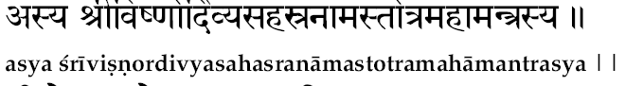
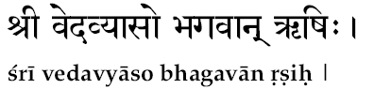

A. asya Vishnu-sahasranaama-stotrasya veda-vyaasa Rishih

For this sacred chant, the “Thousand Names of Lord Vishnu”, Sri Veda Vyaasa is the divine Rishi.
Great mantras of deep spiritual significance and sublime Vedic dignity are not mere poetic compositions by mortal fallible intellects. When a. mastermind through meditation transcends the lower levels of his personality and soars into the higher mental altitudes, through his contemplation, there he ‘receives’ certain ‘revelations’ that are faithfully repeated by them to the world. Such ‘heard’ statements (Srutam) alone have the power to stand against the onslaught of the intellect, the ravages of time, the forces of criticism etc.

Such statements when contemplated upon by lesser seekers, they too, in the spiritual cadence of these mantras, get unconsciously uplifted into realms unknown, and there they come to live a world of experiences unfrequented by the ordinary multitudes. The ‘author of the mantra’ is thus termed in our Vedas as the ‘Seer’ (Mantra- Drashtaa). Such Rishis themselves admit that they did not manufacture, compose or create the mantra, but they had a revelation or vision (Darsanam) of the mantra.

The Mantra- Drashtaa, the Rishi, is the guru of the seeker, who is seeking his path with the help of that particular mantra. The Rishi of a mantra is installed at the roof of the head and the seeker, in his seat of Vishnu-Sahasranaama-chanting,

Symbolism: ... chants this mantra in his mind, and, with his right-hand thumb, middle-finger and ring-finger touches the top of his head.

B. Anushtup Chandah

The metre ("chandah") in which the revealed mantra comes to the teacher is also mentioned because it orders the discipline that should be followed while chanting the mantra. Anushtup is the name of the particular metre in which this thousand-name- chant on Vishnu is sung. The chant is to come out through the mouth, and therefore, the ‘altar of the metre’ can be only the mouth.

Symbolism: The fingers that were touching the roof of the head now come down to touch the lips, when the mantra ‘B’ is repeated in the mind by the seeker.
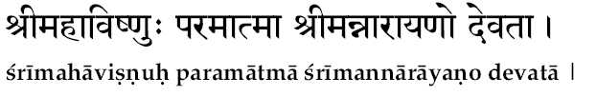
C. Sri Vishvaroopo Mahaavishnur-Devataa

Lord Vishnu of the form of the entire universe of variegated names and forms (Vishva-roopah) is the deity of the mantra. Vishnu is the theme of the chant. The Lord of Vaikuntha is the altar at which the devotee is preparing to offer himself in humble dedication and utter surrender.

Symbolism: Since Lord Vishnu is, to the devotee, the Lord of his heart, the very centre of his personality, while chanting mentally the mantra 'C' the student, installs the Lord in his heart, bringing the fingers from the lips down to touch his bosom.

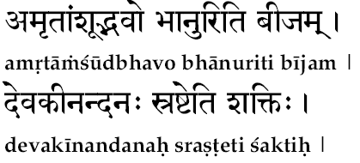
D. Devakee-nandanah srashteti Saktih

Every deity is a manifestation of the mighty Omnipotency of the Supreme. The creator and sustainer (Srashtaa) of Dharma, the son of Devaki (Devakeenandana), is the manifested power ("shaktih") of the Almighty.

Symbolism: This creative power of righteous-ness and peace is installed at the navel (naabhi) point, and, therefore, the fingers come down from the heart region to the navel.
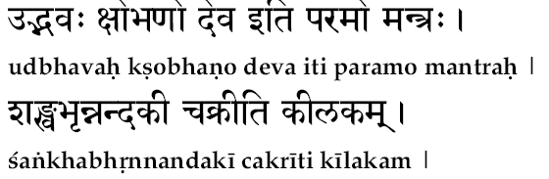
E. Sankha-bhrit nandakee chakree iti Keelakam

The mighty Creative Power invoked and established on the navel region cannot be as such conceived by the mind. Therefore, to ‘nail’ it down (Keelakam) and establish it in our comprehension, this mantra conceives ("udbavah") the Power as the Lord, who bears the Conch ("shanka"), the Sword, named Nandaka, and the Discus ("chakra"). This is only to show how the total cosmic Power, expressed in terms of our present understanding as creation, sustenance, and destruction, is but a manifestation of the Lord. The conch (Sankha) represents the ‘call’ of the Reality, the Lord’s own declarations stated in the scriptures. Nandaka, the sword that punishes to bring joy (Nandana) into the community and the destruction, without which evolution is impossible, is represented by the concept of the Discus (Chakra).

Here it is also to be noted that the blowing or the conch represents speech; wielding the sword represents action and the discus that takes off from Him at His will, represents his thoughts. Thus this great Power installed at the navel expresses itself in the world through speech, action and thought.

Symbolism: To conceive fully this form is to hold firmly the Lord’s own feet, and, therefore, when this mantra is mentally chanted, the fingers move away from the navel, and with both hands the seeker touches his own feet.

Here it is to be carefully noted how:
the Guru is kept at the roof of the head,
the Veda (metre) in the mouth,
the Lord in the heart,
the Power in the navel and, thereby, the seeker himself becomes so sacred that he prostrates unto himself by holding his own feet.
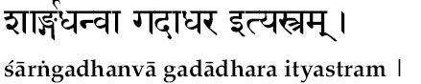
F. Saarnga-dhanvaa-gadaa-dhara iti Astram

Whenever there is a large wealth in a box it becomes a treasure and it is locked and safely protected; when this divine installation has taken place, and therefore, the body has become the Temple of the Almighty, and therefore, it has become a scared treasure house to be protected. But the seeker himself has no power to protect, and so, he invokes the very weapon (Astra) of Vishnu, the protector of the world, to stand by for the defence of the sanctified bosom. Saarga is the name of the Bow (Dhanus) of Vishnu and the Mace (Gadaa) is another of his weapons. These two form the artillery of defence; which are manned by the Lord himself.

Symbolism: At this moment when this mantra is mentally chanted, it is significant that the student lifts the palm away from the feet, and with the stretched out index and middle fingers of the right palm snaps them on the open left palm.
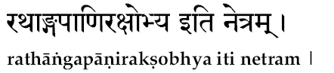
G. Rathaangapaanir-akshobhya iti Netram

Lord Vishnu as Lord Krishna played the part of the charioteer and gained the name “Rein-handed” (Ratha-anga-paani). A charioteer has to guide every step of every horse in order that the chariot be safe, and the travel be pleasant. Of the sense organs, the eyes ("netram") are the most powerful and once they are well guided, all others also follow their heels. When Lord Vishnu, the charioteer, Himself is installed in the eyes ("netram"), the individual is safe ("rakshobya") in his spiritual pilgrimage.

Symbolism: Therefore, invoking the Divine Driver, with reins in his hand (Rathaangapaani), He is installed in the pair of eyes, and at the moment of mentally chanting this, both the eyes are touched by the tip of the fingers.
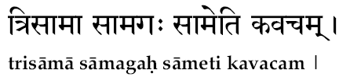
H. Trisaamaa saamagah saameti Kavacham

He (Tri-Saamaa) who is glorified by all the three ("tri") types, of Saama songs (Deva-Vrata-Prokta), He who is the very theme that is glorified by the Saama songs (Saamagah), He whose glory itself is the manifested Sama Veda (Saama), He is none other than the Supreme This great Lord is installed a, an armour ("kavacham") to wear for self-protection.

Symbolism: While chanting this in the mind the seeker first touches with the tip of his finger, of each arm, the same shoulders, and afterwards crosses the arm, in front of him making fingers of each palm touch the other shoulder-as if he is actually wrapping himself and wearing the divine armour.
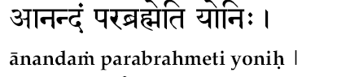
I. Anandam brahmeti Yonih

The Supreme ("para") Brahman, the Infinite Bliss ("anandam") is ("eti") the very womb (Yonih) from which the universe has emerged out. The procreated world of endless variety has only one Eternal Father, and this source is immaculate Bliss. When this is chanted the seeker installs the Bliss Infinite at the very place of procreation in himself. It is a spot in this great divine temple of the body, wherein is the one source, from which the world has emerged out, manifesting itself as the power of procreation (Taittireeya).

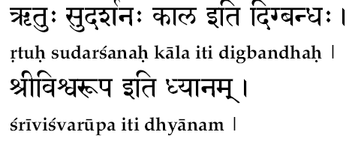
J. Visvaroopa iti Dhyaanam

The entire band of experience gained through the instruments of the body, mind and intellect in terms of perceptions, emotions and thoughts together is indicated by the term Visva. He, who has manifested to be the total world of experiences (Visva), must therefore be Visvaroopah. The cosmic form of the Lord (Visvaroopa) is the total universe. Thus to meditate (Dhyaanam) upon Him as the whole universe, is a method of installing Him in our intellect.

Symbolism: At this moment the student locks his fingers and sits in meditation.

K. Ritam sundarasnah kaala iti Dikbandhah

Truth (Ritam), the lord, and his weapon, the discus, called Sudarsana, and his annihilating power, Time (Kaala)-these three are the mighty forces that guard this scared temple of life in the seeker at the outer frontier of his world of influence (Dik-Bandhah). To be truthful and ever to seek the great Reality (Ritam), to discriminate and see the play of the Lord in all situations (Su-Darsanam), and to control the very instrument of the time (Kaala), which is intellect in the seeker, is to guard the frontiers of one’s spiritual world, against the hoards of inimical forces.

Symbolism: At this moment the student snaps his middle finger with the help of his thumb and runs his palm around his head.

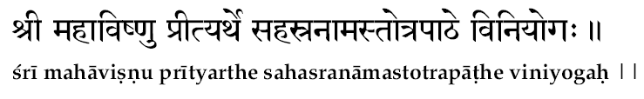
L. Sree-mahaa-vishnu-preetyarthe jape Viniyogah

Having thus installed through sankalpa the Lord in himself and having come under the protecting wings of the mighty lord, here is the declaration how he is going to employ himself in it. He is going to engage himself (Viniyoga) in japa (jape) of the “Thousand Names of Lord” ("sahasra-naama"). Now the question is: with what motive should be undertake this chanting? The answer is in the very statement that it is only for the grace (Preetyarthe) of Sree Maha Vishnu.

Symbolism: After chanting this declaration in the mind, the saadhaka, takes a spoon of water (Teertham) in his right palm and pours it on the floor in front of him.

A true seeker is not desire-ridden for material satisfaction, and, therefore, he can have only one intention-the grace of lord, which will manifest in him as contemplative power.

These twelve ‘slogans’ are chanted for invoking and installing these refreshing and spiritually benign ideas on the limbs of the devotee himself. At this juncture this makes him inspired sufficiently for higher meditation upon the truth as indicated and directed by the thousand terms in Sahasranaama.

This beautiful subjective ritual is known as ‘Installation on the limbs’ (Anga-nyaasa). Not only that the student temporarily discovers a new surge of inspiration, but even beginners feel highly relieved, at least temporarily, from the load of his senses of ‘sins’. When this is properly performed with a right attitude and devotion, the student gains identification (saaroopya) with the Lord of his heart, at the outer levels of his personality.

------------------------------------------------------------------------------------------------------------------------------------------

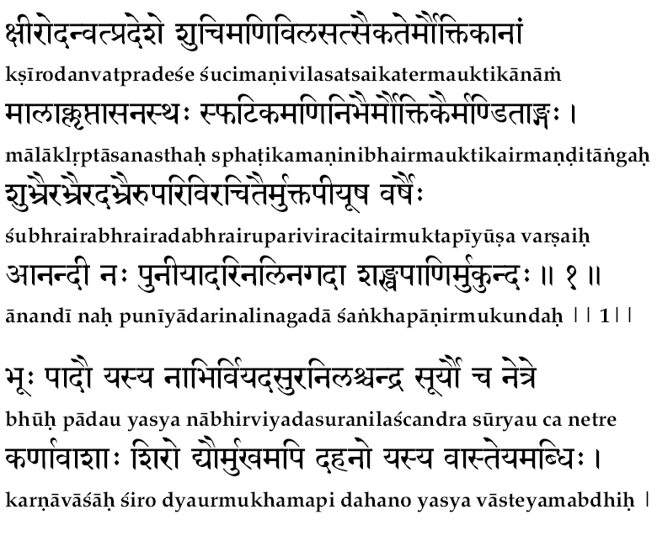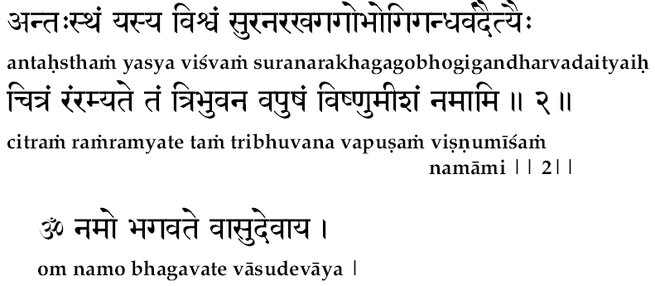

THE MEDITATION STANZA

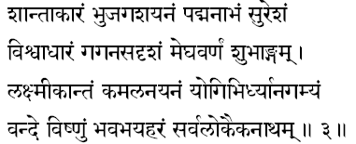

saantaakaaram bhujaga-sayanam
padmanaabham suresam

“We meditate ("vande") upon the master ("naatham") of the universe ("sarva-lokaika"), lord Vishnu, who is ever peaceful ("shaanta-aakaaram"), who lies on the great serpent-bed ("bhujaga-shayanam"), from whose navel ("nabhi") springs the lotus ("padma") of the creative power, who is the controller ("eesham") of the gods ("sura").

visvaadhaaram gagana-sadrisam
megha-varnam subha-angam

... whose form ("aakaaram") is the entire universe ("vishwa"), and who is the foundation ("aadhaaram") for the universe. who is all pervading ("sadrusham") as the sky("gagana"), of the hue ("varnam") of the cloud ("megha"), of fascinating beauty ("shuba-angam"),

Laksmikantam Kamalanayanam
Yogibhir-dhyaana-gamyam

... the lord ("kaantam") of Laksmi, the lotus ("kamala") eyed ("nayanam"), he who dwells in the hearts ("bhir") of the yogis and who can be approached ("gamyam") and perceived through meditation ("dhyaana"),

vande vishnum bhava-bhaya-haram
sarva-lokaika-naatham.

We pray to ("vande") to Lord Vishnu, he who is the destroyer ("haram") of the fear ("bhaya") of samsara ("bhava") and the Lord of all ("sarva") the worlds ("loka").

This is the meditation upon the form of the lord, visualising Him thus in His, all-Comprehensive nature, and meditating upon Him, the seeker starts the vishnu-sahasranaama chanting.

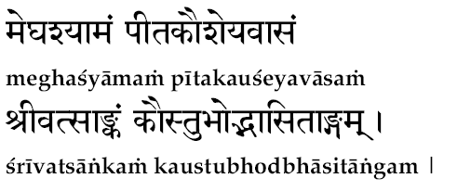
(Approximate meanings:
Whose body is of the dark ("shyamam") like the clouds ("megha").
He lives ("vaasam") in the pure ocean of milk ("peeta-kousheya").
He has Lakshmi ("sri") in his chest ("vatsangam"). )

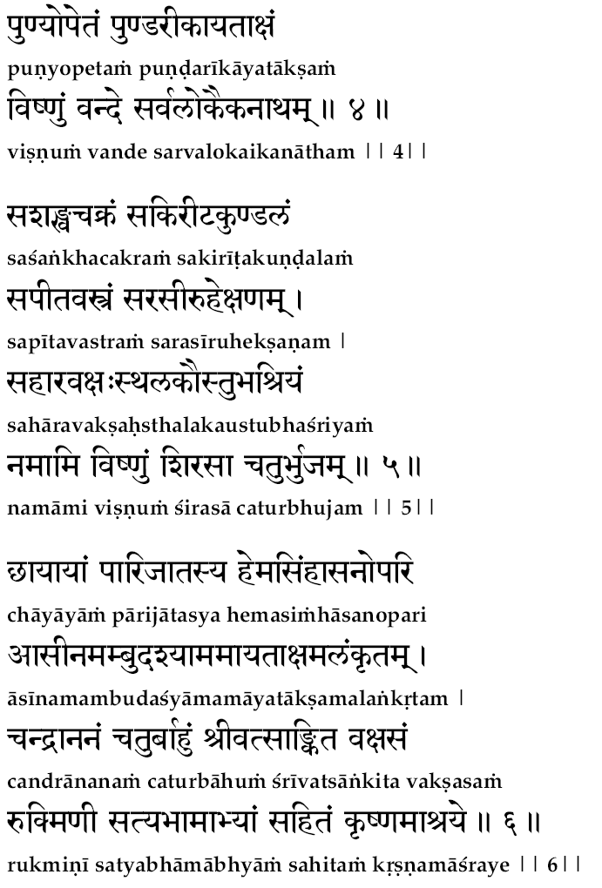

["shanka" = conch, "chakram" = discus; "kireeta" = crown; "kundalam" = ear-rings,
"peeta" = yellow, "vastram" = clothes; "saraseeruha-ekshanam" = lotus-like eyes;
"sahaara" = wide; "vakshasthala" = chest; "kaustubha" = gem stone;
"namaami" = i pray; "sirasaa" = bow down with my head; "chatur-bhujam" = to the four-handed one;
"chandra-aananam" = moon-faced; "baahum" = hands ]

------------------------------------------------------------------------------------------------------------------------------------------------
Stanza 1
Om visvam vishnur- vashatkaaro bhoota-bhavya-bhavat-prabhuh
bhoota-krit bhoota-bhith bhaavo bhootaatmaa bhoota-bhaavanah

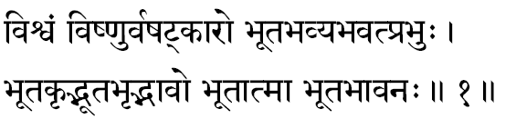
(1) Visvam - He whose manifestation is the whole universe of forms: the Viraat-Purusha. The cause is always present in the effects and as such That Form from which the whole universe has emerged out can only be its own manifestation. The whole cosmos of gross forms is His own expression, and therefore, He is called as Viraatpurusha. ‘Sa eva Sarva- Bhootaatmaa Visvaroopo Yato-Avyayah’. The Sanskrit term Visvam comes from the root Vis, to enter: Thus it means He who has created and entered into the entire universe, as the All-Pervading Reality. It can also mean, That into which the entire universe has entered to remain therein established. In the Upanishads also we have assertions of similar ideas. It is only when intellectually, we view the Lord that we come to recognise Him as the ‘cause’ for the universe. When viewed through contemplation, since the effect is nothing other than the cause, there can be no world other than Him. In fact, there is nothing other than the Supreme. In the Mandukya Upanishad we read ‘Omkaara Evedam Sarvam’. In Geeta ‘OM ltyekaaksharam Brahma’.

(2) Vishnuh -The term Vishnu is dissolved as Veveshti Vyaapnoti iti Vishnuh-That which pervades everywhere is Vishnu. That which has the nature of pervasiveness is Vishnu. He is the one who pervades all and nothing ever pervades Him. ‘Eesaavaasyam Idam Sarvam’-All this is indwelt, pervaded by the Lord. This very same idea is described in the typical style of the Puranas, in the incarnation of the Lord as Vaamana, the short-boy (Vamana), who, with His three feet, measured the entire universe. Because of this act, the Lord got the name Vishnu, says Mahaabhaarata. Vishnu Purana (3-1) says: The root Vis means ‘to enter’. The entire world of things and beings is pervaded by Him and the Upanishad emphatically insists in its mantra ‘whatever that is there is the world of change’. Hence it means that He is not limited by space (Desa), time (Kaala) or substance (Vastu).

(3) Vashatkaarah - ln the ritualistic portion of the Vedas we find many mantras ending with ‘vashat’ and they are used in pouring devoted and dedicated oblations. Thus the term Vashatkaara means: He who is invoked, and for propitiating whom, the oblations are poured in Vedic ritualism, using mantras ending with vashat.
Also Vashatkaara can mean yajna in its association and thus the term in its suggestion can signify ‘He who is of the form of the Yajna’. In the Upanishads also we find this meaning endorsed when the Upanishad mantra says: “Yajno vai Vishnuh” - Yajna itself is Vishnu.

(4) Bhoota-bhavya-bhavat-prabhuh - He who is the Lord (Prabhu) of the Past (Bhooita), the Future (Bhavya) and the Present (Bhavat). Time is the concept of the intellect; it expresses itself in the interval between experiences. Experiences are registered as thoughts and thoughts are ever changing. This very change is known and experienced by us. The knower of the change must be something other than the change. Thus, He who is the Illuminator of all changes, meaning the Consciousness (Aatman) is the Lord Vishnu. He is the One who is not conditioned by time.

(5) Bhoota-krit -The Creator (Krit) of all creatures (Bhoota). This word can be dissolved in two ways:
(a) One who creates the creatures (Bhootaani Karoti iti Bhoota- Krit) or
(b) One who annihilates all creatures (Bhootaani Krindati iti Bhoota-krit).
In both these cases, Brahman, the Supreme is the One Reality that seems to function as the Creator, Sustainer or Destroyer, when He functions through different gunas in the Total-Mind. Functioning through a preponderance in Rajoguna, He becomes the ‘Creator’; through Sattvaguna the ‘Sustainer’, and through Tamoguna, He Himself expresses as the ‘Destroyer’.

Extra comments: Subjectively, the Atman functioning through my own mind and intellect is I, the individuality. My personality entirely depends upon the quality and texture of my own thoughts. I myself become according to the moods of my mind the creator, sustainer and annihilator of my world of experiences. He who manifests and functions, in these three aspects, is the Supreme Vishnu.

(6) Bhoota-bhrit -One who nurtures ("brith") and nourishes all beings (living creatures: "bhoota") in all their attitudes is this Great Reality and, therefore, He is called as the Bhoota Bhrit. In Geeta there is an elaborate description of this idea in the l5th Chapter where the Lord points out how, He, as the light in the sun, fertility in the earth, growth in the plants, nourishment in food, heat in fire, -becomes Himself the ‘eater’, and, therefore, how He Himself presides over all the functions of the body and mind, and apparently nurtures and nourishes the creatures, who are in fact nothing other than Himself.

(7) Bhaavah -One who ‘becomes’ (Bhavati iti Bhaavah) Himself into the movable and the Immovable beings and things in the world. He is the Pure Existence in all the sentient organisms and the insentient objects in the universe. Hence He is indicated by the term Bhaavah.

(8) Bhootaatmaa -He is the Aatman (soul) of all the beings ("bhoota"): The very ‘Be’ in the living beings. Just as the same universal space manifests in all rooms as the room-space, so the Infinite Life manifesting through any given vehicle is called the Aatman of the vehicle. It is well known that space everywhere is one and the same; so too, the One Reality sports as though different Aatmans. This One Universal Soul is called in Vedanta the Supreme Brahman (Para-Brahman) .In Bhaagavata, the Lord is addressed as “You are the One Self in all living creatures ever illumining all their experiences.’’ In Kathopanishad: “The One enchanting Truth that revels in every form manifesting in plurality”.
(9) Bhoota-bhaavanah -One who creates and multiplies the creatures; meaning the One, who is the cause for the birth and who is responsible for the growth of all living creatures.

Stanza 2
pootaatmaa paramaatmaa cha muktaanaam paramaa gatih
avyayah purushah saakshee kshetrajno akshara eva cha.

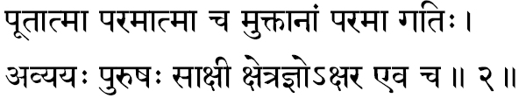
10) Poota-atmaa -One with an extremely Pure (Pootam) Essence; One who is not affected the least by the impurities of Maayaa. The Self is beyond all vaasanaas and, therefore, He cannot be affected by anyone of the manifestations of Maayaa such as thoughts of the intellect, emotions of the mind or the perceptions of the body. Immaculate is ever the Self, and so He is termed as the Pure Self (Poota-Aatmaa).

(11) Parama-atmaa -The Supreme, meaning that which transcends all limitations and imperfections of matter: in short, the Transcendental Reality. The Spirit is other than matter, and that in its presence, the vestures of matter, borrowing their dynamism from Him, play their parts rhythmically at all times. This has been the assertion found chorusly repeated in all the Upanishads and in the entire Vedantic literature. Sankara in Aatma Bodha points out that the Self is other than the three bodies and that He functions in the microcosm as a king in the nation. It was also said therein that matter borrows its energy from the Spirit and continues its activity “as the world from the Sun”.
Kathopanishad and the Geeta guide us from the outer levels of our personality, stage by stage, into the inner-most sanctum, and there, the teachers declare, is He the Infinite, transcending all, reigning in His own glory. “In short, that which remains other than the cause and effect-Maayaa and matter-is He, the Parama Aatman. In Vishnu Purana this Supreme is glorified as Maha Vishnu (Paramaatmaa)”-Vishnu Purana 6.4.10...

(12) Muktaanaam paramaa gatih -He who is the final Goal ("parama gathi"), that is reached by all the liberated souls ("mukta"). The limitations and bondages lived through by man are in fact the destiny of the matter vestures. Through delusion of non-understanding, we identify with them and come to suffer the consequent sense of imperfections. To liberate ourselves from the thraldom of matter is to realize the Self. Hence the Truth is defined as the Supreme Goal of the emancipated.
This ‘Goal’ to be attained is called as ‘Gati’ in Sanskrit, “The Supreme Goal” (Paramaa Gatih) would necessarily be then that Goal, having reached which, there is no return:
“There where having gone, men never return, That sacred place is My seat”-Geeta Ch. 15. St. 6. In Geeta. (Ch. 8. St. 6)
even more explicitly the same idea has been asserted by Sri Krishna when He says:
“O Son of Kunti, having reached Me, there shall be no more any re-birth”.
Again, He defines the final Goal as “That having reached no return again” – Geeta Ch. 15, st.4.

(13) Avyaah –“Vyaya” means destruction; destruction cannot be without change; therefore, that which is “without destruction” (Avyayah) is the changeless. The Indestructible, and therefore, changeless, can never have any modifications (Parinaama). For, modification is but the death of a previous condition and the birth of a new condition. The Eternal and the Immutable (Avyayah) is the Supreme Sat-chit- aananda, and every other thing and being come under the hammer or change. The medium in which all these changes are sustained is Brahman, the Immutable. The Upanishads glorify Him as “Ajaro Amaro Avyayah”-without old age, death or change.

(14) Purushah -One who dwells in the Fort-city (Puri sete iti Purushah). Herein metaphorically the Rishis conceive our body as a fortress with nine gate-ways-“Nava Dvaarc Pure Dehee”-(Geeta Ch. 5, St. 13) -and declare the One who rules within it, like a king, is the Self.
This term can also be dissolved in two more different ways giving more and more suggestions to the nature of the Self. Thus, Purusha can mean “That which was before all creatures” -Puraa Aaseet iti Purushah or it can be
“One who completes and fulfils the Existence everywhere”, meaning, without whom Existence is impossible (Poorayati iti Purushah).
This Aatman remains in the bodies of living creatures as their individuality (Jeeva) and in all the activities, physical, mental and intellectual, Aatman is not in fact involved but He is therein only an observer of all that is happening. This will become clear in the following discussion.

(15) Saakshee -Witness. In every day life he is a witness who without any mental reservation or personal interest observes and watches what is happening in a given field of experience. “Saakshaad Drashtari Saakshee syaad-Amarakosa. “The ‘Knower’ in every bosom is the same Supreme Self”, says Lord Krishna (Geeta Ch. 13, St. 3). Though thus Consciousness illumines everything, It is only a Witness, as It knows no change. Just as the sun illumines every thing in the world and yet the Sun is not affected by the condition of the things it is illumining, so too Vishnu, the Supreme, illumines all, without Itself undergoing any change.

According to Paanini Sutras the word Saakshee is derived from “Sa +akshi”, meaning “direct perceiver”.

(16) Kshetrajnah -One who knows the body and all the experiences from within the body, is the Knower-of-the- field, Kshetrajnah. As Brahmapurana would put it: Bodies are ‘fields’ and the Atman illumines them all without an effort, and therefore, is called Knower-of-the-field, Kshetrajnah”.

(17) Aksharah -lndestructible: things which are finite are necessarily conditioned by time and space; the Infinite is unconditioned, and so It is Aksharah. Since It is Indestructible, It cannot come under the methods of universal destruction arising from nature or through the wilful actions of man. “It cannot be cleaved by instruments of destruction, nor can fire burn It, nor water drench It, nor air dry It”-(Geeta Ch. 2, St. 23). It is also indicated that the Supreme Brahman is the Akshara-“Aksharam Brahma Paramam” -(Geeta Ch. 8, St. 3).
Please note that in the stanza there is the extra word ‘only’ (Eva) used, indicating that Kshetrajnah is the Aksharah; there is no difference between them both: the “Knower-of-the-field” and the “field”.

Stanza 3
yogoh yoga-vidaam netaa pradhaana-purushesvarah
naarasimha- vapuh sreemaan kesavah purushottamah.
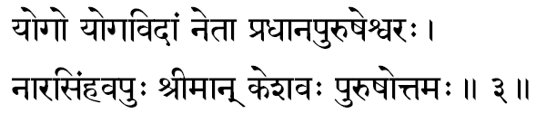
(18) Yogah -The one who is to be known or realized through yoga. By withdrawing the sense organs from their objects of preoccupation, when the mind of the seeker becomes quietened, he is lifted to a higher plane-of-consciousness, wherein he attains “yoga”, meaning wherein he realizes the Reality. At such moments of equanimity and mental quiet “yoga” is gained: Samatvam yoga uchyate- (Geeta Ch. 2, St. 48).
Since He is experienced through Yoga He is known as Yogah.

(19) Yoga-vidaam netaa –One who guides ("neta") all the activities of all men ‘who knows yoga’ (Yogaviti) .To all men of realization, He who is the Ideal, is the Supreme Lord. Just as our activities are today ordered by our selfishness and individuality, the Ideal that commands and orders all activities in the bosom of a Man of Realization is his God-Consciousness. This realm of experience is Mahaa Vishnu. In the Geeta also we find the same idea expressed, in the language of emotion, when the Lord says: “Those who contemplate upon Me with total dedication, their daily welfare and spiritual progress I shall bear”.

(20) Pradhaana-purusha-eesvarah -Lord of both Pradhaana and Parusha.
The term Pradhaana means ‘maayaa’-the total cause for the entire universe of forms.
The term Purusha indicates the individuality in each one of us-the Jeeva.
Lord Eesvara means the Master (Eeshte iti Eesvarah).
The Lord of Maayaa and Jeeva means the one who makes both these possible to exist and function. The One Infinite Reality which Itself manifests as Maayaa, Jeeva and Eesvara is the Essence in Vishnu.

(21) Naarasimha-vapuh -One whose form ("vapuh") is half human ("nara") and half lion ("simha").This is the famous fourth incarnation of Lord Vishnu which He took in order to destroy the atheistic tyrant Hiranyakasipu and bless his devotee, Prahlaada.

(22) Sreemaan -One who is always with ("maan") Sree. Mother Sree is Mother Lakshmi. In the Puranic terminology Lakshmi stands for all powers, all faculties. The total manifested power potential in the Omnipotent is Lakshmi. These powers are ever in Him and therefore, He is the Sreemaan.

(23) Keshavah -He who has beautiful and graceful (Va) locks of hair (Kesa) is familiar as in Lord Krishna’s form. Or, it can also mean, one who destroyed ("vah") the demon Kesin who was sent to destroy the child-Krishna by his uncle Kamsa This interpretation is endorsed by the Vishnu Purana, 5.16.23.

(24) Purushottamah -The constitution of the individuality, Jeeva, when analysed, we find that it is made up of both the perishable-matter and the Imperishable-Spirit. The Spirit expressing through matter is the individuality, Jeeva. Reflected moon is the moon of the heavens dancing on the surface of water. Just as the moon is something different from its reflections and the water surfaces, so too the Self is, in its transcendental nature, something different from both matter, the perishable, and Spirit, the Imperishable, ever playing in matter. This Transcendental Truth is indicated by the term the Supreme Purusha (Purusha-uttama).

Stanza 4
sarvas-sharvas-sivah sthaanur bhootaadir nidhir-avyayah
sambhavo bhaavano bhartaa prabhavah prabhur-eesvarah.
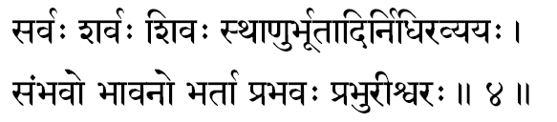
(25) Sarvah -He who is the all. He being the One cause from which have sprung forth all things and beings. He himself is the all. In Mahabharata Udyoga Parva (70-12) we read: “As He is the origin and end of all, whether existent or otherwise, and as He, at all times, cognises all, He is called “Sarva”. All waves rise from the same ocean and, therefore, the ocean is the very essence in all waves.

(26) Sharvah - The Auspicious One: meaning, the One who gives auspiciousness to those who hear of Him, to those who have a vision of Him, and to those who meditate upon Him.

(27) Sivah -The One who is Eternally Pure. In Him can never be any contamination of the imperfection of Rajas and Tamas. ‘Non-apprehension of Reality’ is Tamas and ‘misapprehensions of Reality’ constitute the Rajas. In the Reality Itself there can be neither of them ‘He is Brahman; He is Siva’, so the Upanishad declares of the Absolute Oneness, which is Vishnu.

(28) Sthaanuh: -Generally this term Sthaanuh is used for the permanent pillars that mark the frontiers of a country. They are permanent, immovable, fixed. The Truth, that remains thus firm and motionless, without movement, permanently established in Its own Realm of Purity, is called by the term Sthaanuh-the Pillar. “Eternal, All-Pervading, the Pillar, Motionless (is) this Ancient One,” so says Geeta Ch. 2, 24.

(29) Bhootaadih - The very cause ("aadi") for the five great elements: Space, Air, Fire, Water and Earth.

(30) Avyayah Nidhih -The Imperishable treasure. The term Nidhi means ‘that in which precious things are stored away or preserved secretly’: (Nidheeyate Asmin iti Nidhih). Therefore, He who is the substratum-container-for the entire universe is the Nidhi. During the dissolution (sleep) the One into Whom all things go to lie merged therein temporarily, till the next projection or creation (waking), as this Immutable Treasure Chest-the Vishnu. Here ‘unchangeable’ (Avyaya) is qualifying ‘Nidhi’.

(31) Sambhavah -One who takes up by his own free will various incarnations for the glory of the world is Sambhavah. In fact, He alone is the source of all that is created. In Harivamsa we read the assertion: “I am the Narayana, the Source from which all creatures and things spring forth”. To uphold Dharma I shall manifest again and again, declares the Lord in His Geeta:

(32) Bhaavanah -To do Bhaavana is to give: One who gives everything to His devotees is Bhaavanah. The Lord is One who gives both joy and sorrow to each one according to his deserts. In the case of humanity it is He again who destroys the evil and blesses the good.

(33) Bhartaa -The One who ‘Governs’ the entire living world. Governing includes protecting the world from all harms and serving it positively with progress and joy. One who does these to all creatures at all times is Vishnu-the great Bhartaa.

(34) Prabhavah - The One who is the very womb of all the Five Great Elements. It is That from which even the very concepts of time and space have sprung from.

(35) Prabhuh -The Almighty Lord. He who is the All-Powerful. He who has the supreme freedom to do (Kartum), not to do (Akartum), or to do quite differently from what He had already done (Anyathaa Kartum) is considered as the Prabhuh.

(36) Eesvarah -One who has the ability to do anything without the help of other beings or things is called Eesvara.

Stanza 5
svayambhooh sambhur aadityah pushkaraaksho mahaasvanah
anaadi-nidhano dhaataa vidhaataa dhaaturuttamah.
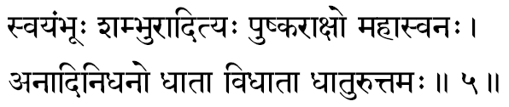
(37) Svayambhooh -The one who manifests Himself from Himself is considered as self-made. Everything born or produced must have a cause. The Supreme is the cause from which all effects arise, and Itself has no cause. This un- caused Cause-of-all, this Ultimate Cause, with reference to which every thing else is considered as ‘effects’ is in itself the Absolute Cause. This idea is indicated by the term Self-made (Svayambhooh).

(38) Shambhuh -He who brings Auspiciousness- both inner goodness and outer prosperity to His devotees. Sambhuh is one of the famous names of Lord Siva. By using this term in invoking Vishnu, by its suggestion, it declares that Vishnu and Siva are not two Divine Entities, but they are both manifestations of the One Essential Reality.

(39) Aadityah-The Truth (Purusha) that glows with a golden splendour in the solar system is called Aadityah. There are twelve Aadityas and of them One is called Vishnu.
Krishna Himself declares, ‘I am Vishnu among the Aadityas’ -Aadityaanaam Aham Vishnuh- (Geeta Ch. 10, St. 21).
The word Aaditya can mean ‘Son of Aditi’-signifying the one who was born as the son of Aditi in His Vaamana incarnation.
The term Aadityah can also mean in Sanskrit ‘One who is like the sun’. The Sun is the one who illumines all, and every living creature draws its nurture and nourishment directly or indirectly always from the sun alone. In the same way Brahman is the one Sun in the universe of living creatures illumining all experiences of all creatures.

(40) Pushkaraakshah -One who has eyes ("akshah") like the lotus ("pushkara"). Joy and Peace in the bosom of an individual are expressed in the world outside at no other point so vividly as in the eyes. The One, whose inner peace and joy, beaming out through His eyes, bring into the devoted hearts all the aesthetic beauty and romantic thrills of seeing a lotus dancing in the breeze, In short, the term indicates the Lord who with His beautiful looks, magically lifts all the sorrows in the devotee’s heart and fills it with Peace, Joy and Perfection.

(41) Mahaasvanah- One who possesses thundering ("mahaa") voice of compulsion: "Svana" means ‘sound’. One whose ‘call’ is thundered in all hearts, familiarly known as the ‘compelling whisper’ of the Higher.
Or, Svanam can also mean ‘breath’; and so, the term can mean, ‘He whose great breath is the very Vedas’. “Thus, O Maitreyee, this has been breathed forth from this great Being what we have as Rigveda. Yajurveda” -Brihadaaranyaka Upanishad (4.4.10). In the Spiritual literature of India we often read Vedas described as His breath; He breathed out the Vedas (Nih-svasitam).

(42) Anaadi-nidhanah –One who has neither ("an") birth (Aadi) nor death (Nidhanum). Thus One who is changeless is Anaadi-Nidhanam; for, any change should include the death of an old condition and the birth of newer condition. To the Immortal and the Immutable, change is impossible.

(43) Dhaataa- One who is the Substratum for the world of names and forms. And who supports all fields of experiences in all. He who is the screen for the cinema of empirical experiences’ (Visvam).

(44) Vidhaataa -The One who is the Dispenser of all ‘fruits-of-actions’. In the Karma-kaanda portion of the Vedas, Eesvara is described as the Dispenser of fruit (Karma- phala-daataa Eesvarah). He is the Lord who is behind this universe of scientific truths and rhythm. He is the One who has not only ordered the laws of the nature, but he is the one afraid of whom, the phenomena dare not disobey his laws anywhere at any time. The light of the sun, the heart is the fire, the sweetness in the sugar, the pains in the sin and the joy s in goodness, are all their ‘nature’ and none dare ever disobey these laws. The one who is thus the unquestionable law behind the entire universe of laws is Vidhaata.

(45) Dhaatur-uttamah –the fundamentals ("dhaatu") that form the reinforcement on any existent thing are called Dhaatu. In science of life, as explored by the Rishis, all corporal forms have risen form and exist as composed of some definite ‘elemental factor’ called the Dhaatus. Of the end less varieties of Dhaatus available in existence, the subtlest Dhaatu, without which no existence, is ever possible, is the chit Dhaatu, and this is the Dhaatu-ruttamah.
Though very rarely, we do find some commentators splitting this word into two as Dhaatu and uttama. But in the majority of the cases we find it taken to form one term and explained as ‘the subtlest of the Dhaatus’.

Stanza 6
aprameyo hrisheekesah padmanaabho-a- maraprabhuh
visvakarmaa manustvashtaa sthavishthah sthaviro dhruvah.
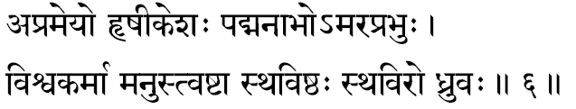
(46) Aprameyah – He, who cannot be defined and explained in terms of any logical term of reference with other things should necessarily be inexpressible. A thing that can be directly perceived (Pratyaksha) can be desired, certain other things, which we may not directly perceive, but can be infer (anumaama) them from data available. And there are yet things which can be brought home to the listener by describing them in terms of similar other objects (Upamaa). Since the infinite has no ‘Properties’. It cannot be perceived, nor can It be “understood through inference.” Nor even explained in terms of similar or dissimilar things.” Hence the supreme Reality, Vishnu, is called as Aprameyah. We can experience him only by ending all sense of separativeness and becoming one with Him.

(47) Hrisheekesah –In the Puranic literature the meaning of the term is ‘close-cropped’ or ‘One who has coiled up his locks of hair’ (Hrissheeka+Eesa).

The term ‘Hrisheeka’ is an absolute one now, and it means the “sense organs”. The Aatman, the self as Consciousness is the one who gives light to all sense organs and, therefore, it is the lord of all sense organs. This lord is Vishnu.

The obsolete word Hrisheeka also means the ‘rays’ or that which gives the joy’. Thus the term Hrisheekas can mean “the Lord of the rays”: the sun and moon. This way interpreted, commentators point out that the term Hrisheekesah means He who has Himself becomes the Sun and the Moon.

In His manifestation as the Sun and the Moon, the Lord Himself whips the world to wakeful activities and sends the world to sleep and rest. Thus Hrisheekesa in its deeper significance, is, to all contemplative hearts, the Lord, who becomes Himself the world, exhausts Himself in His activities, and ultimately packs His toys and goes to rest at the time of dissolution.

(48) Padmanaabhah – One from whose navel ("nabhi") springs the Lotus ("padma"), which is the seat of the four-faced Creator, Brahmaaji.
Lotus in Hinduism represents Truth or any of Its manifested powers. The creative faculties in man flow from the navel area (center: naabhi), and manifests as the ‘four-faced’ inner equipment (Antahkarana) constituted of the mind, intellect, Chit and ego.
In the Yoga-sastras, we find a lot of details regarding this concept. According to them every “idea” springs from Him (Paraa), and then at the navel area, each of them comes to be ‘perceived’ (Pasyantee).
Thereafter they play in the bosom as thoughts (Madhayamaa), and at last they are expressed (Vaikharee) in the outer fields-of –activity.
In this discussion-upon the evolutionary stages through which every “idea” becomes an “action” – we gather a clearer insight into the meaning of the symbolism of “the Creator seated on the lotus”, which springs forth from the navel of the Lord, the Supreme Vishnu.

(49) Amaraprabhuh -The Lord ("prabhu") of the Immortals ("a-mara"), the Devas. The Denizens of the Heavens, including all the office bearers therein (Dikpaalakas etc.) along with Indra, are called ‘Devas’, and they enjoy in their heavenly state a relative immortality.
The devas live and continue functioning till the great dissolution-the Sleep of the Creator. Compared with the short span of the existence of man on this globe, the aeons through which the Devas live can be considered as end- less or immortal.
One who serves them with His might, giving protection and security to all creatures, is called, therefore, Amaraprabhuh.

(50) Visvakarmaa -The very creator-of the world-of-objects, of all equipments-of-experiences, and of all experiences in all bosom-is called the Visva-Karmaa. Herein the Infinite Lord is but a Witness of all that is happening and though the experienced world is sustained in Him, He is not involved in the imperfections or mortality, that are happening all around at all times in the Visvam. “They are in Me, I am not in them”-Geeta.

(51) Manuh -The term means One who has the ability to reflect upon the Higher (Mananaseelah Manuh). Manu also means mantra and so, as applied to the Lord, it can mean as the One who has manifested Himself in the form of the Vedic mantras.

(52) Tvashtaa -One who makes gross things of huge dimensions into minutest particles. At the time of the world’s dissolution, the entire gross-world folds back into its subtler elements until at last pure objectless space alone comes to remain.

(53) Sthavishthah -lt is the superlative degree of gross (sthoola) and thus ‘the Supremely gross’ is the subtlest Reality. The contradiction that it contains is itself its vigour and beauty. The Infinite as the subtlest is All-Pervading in Its own nature. It is this Maha- Vishnu who has Himself become the entire universe of gross things and beings. Just as all waves are the ocean, the total world of gross things is itself the form of Vishnu.
In His cosmic form, Narayana had manifested to Arjuna in he Geeta. There the words of Arjuna’s chant will clearly bring home to us that the entire gross world is ever His own Divine form.

(54) Sthaviro Dhruvah -The Ancient (Sthavirah) and the Motionless or firm (Dhruvah). He is called the ‘Ancient’ because the very first ‘unit of time’ itself had risen from Him. He was the progenitor of the very concept of Time in us. Therefore, ‘Time’ cannot condition Him. Thus He becomes the most Ancient. He is the ‘Firm Truth’; nothing that happens in the phenomenal world can affect Him at any time.

Stanza 7
agraahyah saasvatah krishno lohitaakshah pratardanah
prabhootah trikakub-dhaama pavitram mangalam param.
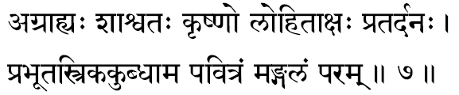
(55) Agraahyah -That which cannot ("a") be perceived ("graahyah") through the play of the sense organs; in short, that which is not an ‘object’ of perception, but which is the very ‘subject’-who is the Perceiver in all that is perceived.
The ‘subject’ can never become the ‘object’, and hence Truth is something that the sense organs cannot apprehend, as they do any other sense-objects. He is the one ‘subject’ ever-perceiving all objects, through all sense-organs of all living creatures, everywhere, at all times.
The Lord is the ‘subject’, not only in the sense organs, but He is the “feeler” in the mind and the “thinker” in the intellect.
And thus the sense organs cannot perceive It, nor the mind feel It, nor the intellect apprehend It; says the Upanishad, “That from which words retire unapproached along with the mind” is the Supreme. Hence He is Agraahya-Imperceptible and Incomprehensible.
Kenopanishad is very clear and emphatic: “That which the eyes cannot perceive, but because of which eyes are perceiving, understand That to be Brahman (Maha Vishnu) and not that which you here worship.”

(56) Saasvatah -That which remains at all times the same is the Permanent, That which is permanent, should remain Changeless in all the three periods of time. In short, He is unconditioned by time. The Supreme Consciousness Itself is the very Illumminator of Time, and the Illuminator can never be affected by what It illumines. This changeless reality is Vishnu.

(57) Krishnah -The word Krishna means in Sanskrit ‘the dark’. The Truth that is intellectually appreciated, but spiritually not apprehended, is considered as ‘veiled behind some darkness’.

The root Krish means Existence (Sattaa) and na means Bliss (Aananda). So says Vyasa in Mahabharata, Udyoga Parva 70, 5. Therefore Krishna (Krish+na) means Existence- Bliss (Sattaa-Aananda). Thus, the very name divine, ‘Krishna’, represents the Supreme Paramaatman.

Or, because of His dark-blue complexion He is called as Krishna. Mahabharata Santi Parva 343 says, “As My colour is dark-blue, I am called Krishna, O Arjuna.”

In Mahabharata, we find Krishna explaining Himself to Arjuna ‘when the earth becomes shelled in by its hard crux I shall turn myself into an iron plough-share and shall plough the earth.

Apart from the above meaning Krishna also means the Enchanter of all His devotees (Aakarshana). Truth is One which irresistibly attracts everybody towards Itself. Commentators have interpreted this significance in a more attractive context. They conclude that Krishna means One who sweeps away the sins in the heart of those who meditate upon Him.
Truth has got a magnetism to attract to Itself all the ego and ego-centric passions of the individual. In this sense viewed, we need not consider Krishna as a deity of the farmyard in the agricultural estates. The Lord ploughs the hard stupidities in us and prepares the heart-field, weeding out all the poisonous growths of sin, and cultivates therein-pure Bliss which is of the nature of Reality.

(58) Lohitaakshah -Red-eyed. Very often we find descriptions in the Puranas, where the Lord is explained as having eyes like the red-lotus (Hibiscus). Generally the ruddy eyes represent anger and the incarnations are taken for the purpose of destroying the evil and so His anger is towards the evil-minded materialists who live ignoring the higher values of life.

(59) Pra-tarda-nah - The root Tarda means “destruction” and with the prefix Pro the root (Pra-tarda) means “supreme destruction”. One who does this total destruction (Pratardanah) is the Lord in the form of Rudra at the time of the great dissolution (Pralaya).

(60) Prabhootah -The term means ‘born full’ or ‘ever-full’. He is ever-full and perfect in His Essential Nature, as the Transcendental Reality, or even when He manifests in the form of His various incarnations. Especially in His chief and glorious incarnation as Lord Krishna, He proved Himself to be ever full with His Omnipotency and Omnisciency.

(61) Tri-kakub-dhaama -One who is the very foundation or support (Dhaama) of the three ("tri") quarters (Kakubh). We find this is generally commented upon and described as “all quarters, in the three realms above, below and middle.” Viewing this from the platform of Vedanta, He must be considered by us as the three Planes-of -Consciousness-the waking (Jaagrat), the dream (Svapna) and the deep-sleep (Sushupti) conditions. The fourth Plane-of-Consciousness (Tureeya) is the Substratum for all the other three planes.

(62) Pavitram –One who gives purity to the heart. To the seekers who are meditating upon Him, He gives inner purity, and hence He is known as Pavitram.

Or, the term Pavi means; the weapon vajra (thunderbolt). One who saves ("tram") his devotees from the thunderbolt of lndra is Pavitram. This can also be interpreted as the "giridhara" episode where the lord saves his devotees from Indra's wrath.

The thunderbolt is described as an instrument made out of the bone of sage Dadheechi. Indra is the Lord of the lndriyas. In Vedanta Indra signifies the mind. Mind’s cross purposes, confusions, intellectual compromises and the consequent self- cancellation of our mental powers (Sankalpa-Vikalpa) can be the great thunderbolt of the mind with which Indra (mind) can destroy in no time all the acquired tapas of the saadhaka. Deep devotion, ardent meditation and firm faith in the Lord Vishnu save the saadhaka from all such mental storms and, therefore, the Lord acquires the significant name Pavitram

(63) Param Mangalam -Mangalam is that which not only removes the dark pains of evil, but brings the bright joys of merit. Param Mangalam is Supreme Mangalam, and It can be none other than He, by whose mere remembrance all inauspiciousness gets lifted up and all Auspiciousness comes to flood our hearts The Upanishad declares. “May That Brahman-who removes all inauspiciousness in man and gives man all auspiciousness, by a mere remembrance of Him -give us all auspiciousness.

Stanza 8
eesaanah praanadah praano jyeshthah sreshthah prajaapatih
hiranya-garbho bhoo-garbho maodharo madhu-soodanah.
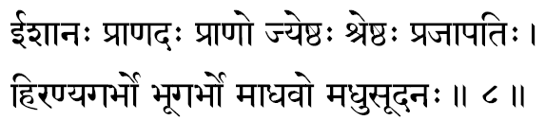
(64) Eesaanah –“The Controller of all the five Great Elements”. When this term is used, Eesvara becomes the Administrator of His own Law in the phenomenal world of plurality. The executive function of His Infinite Will, when manifested through Him, the Lord. Eesvara, is said to function as Eesaanah. Or, the term can also mean One who is the Supreme Eesvara-the Paramesvara.

(65) Praanadah -One who gives (Dadaati) the Praanas to all. The term Praanas used in philosophy indicated “all manifestations of Life in a living body”. The Source of Life from which all dynamic activities in the living organisms of the world flow out, meaning, That from which all activities emerge out is Praanadah.
Taittireeya Upanishad (2- 7) exclaims: “Who could then live. who could breath” if He be not every- where.”

(66) Praanah -That which sustains is Praana and that which has got Praana functioning in it is called a Praanee. Since the Lord is termed as this very same Praana, it means by its suggestion that He is One who ever lives. The Immortal and the Eternal is Praanah.

The term can also mean that which gives Life-impulse even to the air; the capacity to sustain life in the atmosphere flows from Him alone.

In the Kenopanishad we read the Supreme ‘Defined’ as the “Praana of Praanas” (Praanasya Praanah).

(67) Jyeshthah -Older than all. The Infinite is That which was even before the very concept of space (Aakaasa) came into existence. The term is the superlative degree of the Aged. In short, the import of this term is the same as the more familiar term used in our sastras, the Ancient (Sanaatanah).
(68) Sreshthah -The most Glorious One: Here again it is the superlative degree of glorious, Sreyah.
(69) Prajaapatih -The Lord (Pati) of all living creatures (Prajaah) .The term Prajas means ‘Children’. Therefore Prajaapati means the Great Father, to whom all beings in the living kingdom are His own children, In this sense, the term connotes One, who, as the Creator, creates all creatures.
(70) Hiranyagarbhah -One who dwells in the womb (garbha) of the world (Hiranya). The Upanishad declares: “All these are in-dwelt by the Lord.” The “Golden Universe” is an idiom in Sanskrit where ‘gold’ means “objects of fulfilment and joy”. One who dwells in them all is Hiranyagarbhah. The term can also mean as He who, having become first the Creator, has come to he considered as the womb of all objects.
(71) Bhoogarbhah -One who is the very womb of the world (Bhooh) The One from whom the world has emerged out. In the Cosmic Form of the Lord, this world occupies an insignificant though sacred portion, just as the foetus in the womb, constantly and lovingly nurtured and nourished by the very Essence in the mother. Or, Bhooh = the earth: the divine consort of Hari: Garbha = Protector.
(72) Maadhavah -The Lord of Maayaa, Spouse of Mahaalakshmee. Or, the term can signify the One who is ultimately experienced through a diligent practice of “Madhu technique”: the very famous Madhu Vidyaa of the Chandogya Upanishad. The term Maadhavah can also mean One who is the Silent (Mauni); who is ever the Non-interfering Observer, the Silent Witness of the physical, mental and intellectual activities in the realm of change. To put it in one word, He is the One whom the seeker experiences when he has stilled his mind which has been purified by Yoga practices.
(73) Madhusoodanah -One who destroyed the great demon Madhu. The story of Vishnu destroying these two demons, Madhu and Kaitabha, is a story of secret suggestions in Mahabharata. Madhu also means in Veda (Madhu=honey) as the fruits of actions (Karma-phala). Actions leave impressions and these sensuous Vaasanaas are destroyed by meditations on the Reality and so the Supreme gathers to Itself the name Madhusoodanah: “the Destroyer of Vaasanaas.”

Stanza 9
eesvaro vikramee dhanvee medhaavee vikramah kramah
anuttamo duraadharshah kritajnah kritir-aatmavaan.
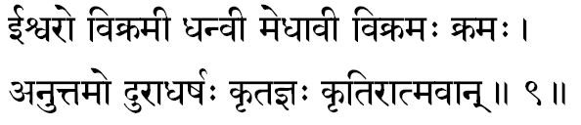
(74) Eesvarah -One who is Omnipotent, and so has all powers in Him to the full. The manifested powers of Life express themselves in every intelligent man as the power of action in the body (Kriyaa Sakti), the power of desire in the mind (Icchaa Sakti) and the power of knowledge in the intellect (Jnaana Sakti). All these three powers are manifestations of Him, and since He is the One everywhere, He is the total mighty power-the Great Vishnu.
(75) Vikramee -One full of prowess (Vikrama), courage, daring. Or, it can be One who has “Special foot steps”. This term commemorates how the Lord, as Vamana, measured with His tiny three steps all the three worlds.
(76) Dhanvee -Lord Vishnu’s Divine Bow is called ‘Saarnga’ and it is described as the mightiest among the weapons. One who is having this Mighty Bow at all times is Dhanvee. It can also remind us of His incarnation as Sree Ramachandraji, when, in order to protect the world from the mighty Raakshasas of Lanka, He had to dedicate a substantial part of His life almost constantly wielding his bow: hence Sri Rama came to be known as Dhanushpaani; in His attitude of protection He is known as Kodandaraama. Thus, the term Dhanvee, the Wielder of the bow, is quite appropriate for Vishnu. “I am Sri Rama among the Wielders of the bow” –Geeta Ch.l0, St. 31.
(77) Medhaavee -Supremely intelligent; One who is capable of understanding everything. One who has the capacity to comprehend intellectually all that is happening around is called Medhaavee. Since Consciousness is the One Light in all living creatures, which illumines all intellects, and since Vishnu is this Infinite Consciousness, He is the One Knower, knowing all things, at all times, at once. Hence Sarasvati, the Goddess of Learning and Knowledge is described as the very tongue of Vishnu.
(78) Vikramah -While describing the term Vikramee (75) we had already explained the meaning contents of Vikrama, and thus Vikrama is an appellation that had come to Vishnu as a result of His Supernatural Act of measuring the universe with three steps.
Also, Vi means the “king-of-birds”, the white-necked eagle; Krama means steps and, therefore, ‘movement or travel’. In this sense Vikrama can mean: “One who rides on the white- eagle (mind) is Vishnu”-who is described as having Garuda for His vehicle (Vaahanam).
(79) Kramah -He who is All-Pervading is Kramah. Because of His All-Pervasiveness, the Infinite is called as Vishnu. That which goes beyond the frontiers of the known is the Supreme, and, therefore, in the description of Him, who has manifested as the Cosmos, we have in Purushasookta an indication that He not only pervades all that is known but “extends even beyond by ten digits” (Atyatishthat Dasaangulam).
(80) Anuttamah -One who is ‘incomparably Great’ in glory-Anuttamah. In the Sanskrit construction of the word, it means something more than what we have said; it means: ‘He is one, beyond whom there exists none who is greater than He (unexcelled). The Upanishad itself describes Him: In Geeta (XI-43) we read: “For Thy equal exists not, whence another superior to Thee?” In Sri Narayana Upanishad (12) we again read, “There is nothing above or below, equal to Him”.
(81) Duraadharshah -One who cannot be attacked, stormed or beleaguered successfully. In short, He is All-Powerful. In the Puranas, we find Daityas and Asuras and others, mighty and powerful ones, become themselves helpless victims of His Power and come under His sway. To one who has realized the Infinite, the lower nature of the mind (Daityas) and the enchantments of the senses (Raakshasas) , are all helpless to overwhelm Him. “Rasopyasya Param Drishtvaa Nivartate” -Geeta Ch. 2, St. 59.
(82) Kritajnah -He who knows all that is done by all: the One Knower who knows all physical activities, all emotional feelings, and all intellectual thoughts and motives. He illumines them all, in all, at all times. Hence He is called Kritajna. Vishnu is the One who knows clearly the exact depth of sincerity, the true ardency of devotion, the real amount of purity in the bosom of all his devotees, and, accordingly, brings joy and bliss to their hearts.
(83) Kritih -The One, who is the very dynamism behind all activities. He is the Inevitability behind the result of actions. He is called Kritih because it is He who visits to bless the good and to punish the evil; in short; He is the One who rewards all our actions.
(84) Aatmavaan -One who is the Self in all beings. In the Chandogya Upanishad (7.24.1) when the disciple asks, “Where does the Lord, the Infinite, stand established?” the Sruti answers, “In Its own glory established ever is the Self”-(Sve Mahimni Pratishthitah).

Stanza 10
suresah saranam sarma visva-retaah prajaa-bhavah
ahah samvatsaro vyaalah pratyayah sarvadarsanah.
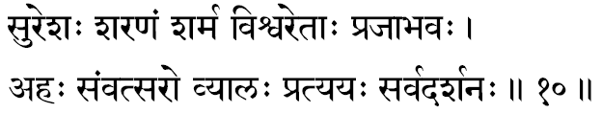
(85) Suresah -The denizens of the Heavens are called in the Puranas as Suras. Eesa means the Lord; Suresa, therefore, indicates the God of gods, the Lord of the Suras. The gods are called as Suras because they are capable of blessing their devotees with a fulfilment of their desires. Therefore, Suresah means One who is the best among those who fulfil all the demands of their devotees (Suras). In short, He is the One who gives the Supreme State of Beatitude and the consequent total liberation from all desires of the ego.
(86) Saranam -The Refuge for all who are suffering from the thraldom of imperfection in life. According to the Sanskrit Lexicon (Amarakosa), the term Saranam means ‘Protector’ and also ‘home’. Since the Lord is the Ultimate Goal, Saranam, He is also the “Destination”, the ‘Harbour’. The One Who realizes Him comes to live in Him.
He is the home to which the prodigal son (jeeva) ultimately returns. Not only for the men of Realization is He the Home, but for all creatures, movables and immovables, He is the Home, to which they all disappear to rest and to revive during Pralaya (Sleep).
(87) Sarma -One who is Himself the Infinite Bliss. Transcending the mind lie the shores of Bliss, beyond the waters of agitations. The Infinite is described in our Upanishads as the “Sacchidaananda”, ever of the same nature-“Saantam Sivam Sundaram”.
(88) Visvaretaah -Retas means ‘seed’; the term connotes that He is the seed from which the tree of life has sprung forth. He who is the very cause for the entire play of experience in the world of pluralistic objects (Sarva- Prapancha-Kaaranabhootah) is called Visvaretaah.
(89) Prajaabhavah -He from whom all living creatures (Prajaa) spring forth (Bhava) is known as Prajaabhavah.
(90) Ahah -Ahan has got two meanings: the 24-hour-day or the 12-hour day-time. He is of the nature of ‘day-time’ means “He is the One, ever effulgent and bright”; as bright as the daylight that illumines all objects around. In case we accept the other meaning, “the 24-hour-day”, then, a day being a unit of time, the term Ahan can also mean, “One who is of the nature of Time itself”. Also He is one who does not (a) ever destroy (han) the devotees who have surrendered themselves to Him.
(91) Samvatsarah -One who is of the nature of year-meaning One who is the Lord of Time; He, from whom the very ‘concept of Time’ rises.
(92) Vyaalah -One who is unapproachable. Vyaala also means ‘Serpent’; to those who have no devotion or understanding, God or Truth is as horrible and terrible as a ‘serpent’. Moreover, it is so difficult to grasp in our understanding that It is like a serpent: ever eluding, always slippery.
(93) Pratyayah -One whose very nature is Knowledge. That the Supreme is Knowledge Absolute is very well known. It is in the light of Consciousness that all ‘know- ledges’ are possible. ‘Knowledge of a thing’ is the Awareness of its nature. Awareness is Knowledge. Since the Supreme is the One Awareness everywhere, all ‘Knowledges’ spring from the Self. Hence, He is called “the Pure Knowledge”. “Consciousness is Brahman” is one of the Mahaavaakyas.
(94) Sarvadarsanah -This term, “All-seeing” is very appropriate in as much as the Supreme Consciousness has been defined and indicated in the Kenopanishad as, “That which the eyes cannot see, but because of which the eyes see”. It is the Seer in the eyes, the Hearer in the ears, the Speaker, the Feeler and the Thinker”. And since this Principle of Consciousness is One everywhere, as expressed through the equipments, It is indeed the One Seer in all ‘seeing’, by everyone, everywhere. The Upanishad says: and the Geeta indicates Him as “One who has eyes and heads everywhere”.

Stanza 11
ajah sarvesvarah siddhah siddhih sarvaadir achyutah
vrishaakapir ameyaatmaa sarva-yoga- vinissritah.
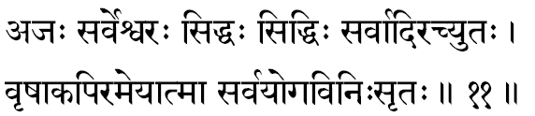
(95) Ajah -Unborn. Birth implies a modification; birth cannot be without the death of its previous condition. Since the Eternal and the Infinite, is ever Changeless there can be in It neither birth nor death. That which is born must necessarily die: -(Geeta Ch. 2, St. 27) and so, that which is unborn should be deathless (Amritah).
Rig Veda (1-81-5): “He was neither born nor is He going to be born.”
(96) Sarvesvarah -God of all gods or the Supreme Controller of all. In a sense it means the Almighty, the All-powerful. “He is the Lord of all,” says Brihad Upanishad (6-4-2).
(97) Siddhah -One who has achieved all that has to be achieved, as He Himself is the Final Goal for all. Or the term can also mean “the most famous”.
(98) Siddhih -He who is available for recognition (Siddha) everywhere at all points in His nature as Pure Consciousness. Again, Siddhi also means the ‘fruit of action’, and in the context here this would-mean, “He who gives the Infinite fruit of Kaivalya, Moksha.” All other karmas can acquire for us only relative joys of the heavens, but in realizing the Self the seeker gains an ‘Infinite State from which there is no return’, so describes Geeta.
(99) Sarvaadih -One who is the very beginning (Aadi) of all; one who was in existence earlier than everything else. Even before effects arise, the Cause. The Infinite which was before creation and from which the created beings had emerged out, as an effect, is naturally the Primary Cause (Moola-Kaarana).
(100) Achyutah -Chyutah= Fallen; Achy utah: One who has never fallen: the Ever-Pure Reality which is never fallen into the misconceptions of Samsar: the Pure Knowledge in which ignorance has never come to pollute Its purity. Lord Himself says in Bhagavata, “I have never ever before fallen from my Real Nature; therefore, I am Achyutah”.
(101) Vrishaakapih -There is a lot of controversy among pundits upon the exact meaning of this term. But all controversies become meaningless when we read Bhagavan’s own words, “Since Kapi has a meaning the ‘boar’, and since vrisha has the meaning of ‘Dharma’ the great Kasyapa Prajapati says I am Vrishaakapih”.
In Sanskrit the term Kapi has a meaning: ‘that which saves one from drowning’. Lord in the form of the Great Boar, (Varaaha) in that incarnation, had lifted the world from the waters at the end of the deluge; the term vrisha means ‘Dharma’. One who thus lifts the world drowned in Adharma to the sunny fields of Dharma is vrishaakapih
(102) Ameyaatmaa -One who has His manifestations (Aatmaa) in Infinite varieties, almost unaccountable (Ameya), The Viraat Purusha of the Form of All-Lord of the Cosmic Form is suggested here. As all forms have risen from Him, exist in Him, and dissolve into Him alone, all forms are His own different forms.
(103) Sarva-yoga-vinissritah -Yoga is from Yuj ‘to join’; ‘to attach’, One who is totally free (vinissritah) from all contacts or attachments. Attachment to a thing is possible only when the object-of-attachment is other than the subject, In the One Infinite Reality there cannot be any attachment with anything, mainly because there is nothing here that is not the Infinite Itself. The Infinite is a Mass of Love; there is no attachment in It; for, attachment is Love with possessiveness and desire for gratification, “This Purusha is, indeed, unattached”, roars Brihad Upanishad (6-3-15), Lastly, the term, Sarva- Yoga- Vinissritah can also mean that He is beyond the reach of the various systems of Yogas taught in the Sastras. These systems are to quieten the mind, to end the misapprehensions-of- Truth, to annihilate the Maayaa, What is there left over in the seeker’s bosom is the Self-the Great Vishnu,

Stanza 12
vasur-vasumanaah satyah samaatmaa sammitah samah
amoghah pundareekaaksho vrishakarmaa vrishaakritih.
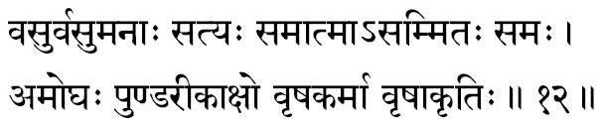
(104) Vasuh -The One who is the very support of all elements, and the One who Himself is the very Essence of the elements, This is something like the dream made up of our own mind; and the very same dream-world plays itself out, all the time sustained in the very same mind. Similarly, the Self indwells all and all dwell in the Self. In the Geeta we are told by the Lord, “I am among the Vasus the Paavakah”-(Geeta. Ch. 10, St. 23). Therefore, the Self exists like air-allowing everything to remain in it and sustaining everything by it.
(105) Vasumanaah -One who has a mind which is Supremely Pure; meaning a mind that has none of the sins of passions and pains; none of the storms of desires and jealousies; none of the quakes of likes and dislikes.
(106) Satyah -He is the Real. The term Satyam used in philosophy has a special connotation. That which remains the same in all the three periods of time is called Satyam. That which seemingly exists, but which never was nor shall ever be, is considered as a false delusion, A-satya. He who remains the same, before the creation, during the existence and even after the dissolution, is the Infinite Truth, Satyah. The Taittireeya Upanishad thunders that the Eternal Truth is “Truth, Knowledge, Bliss”: “Satyam, Jnaanam, Anantam Brahma” - Taittireeya Upanishad: 2-1.
We may here mention a couple of other meanings that are generally given to this term “The best among good people is Satyam. Again, the word Satyam is made up of three sounds -Sat-ti-yam -and, herein, according to the Upanishad itself, “Sat means praana, ti means food, Yam means sun;” therefore, Sat yam is the Law which orders the food to sustain the praana when both are blessed by the sources of all gross energies in the cosmos, the Sun.
(107) Samaatmaa -He wbo is equally in all. In Kathopanishad we read the declaration of Lord Death to Nachiketas how the same Truth has come to express itself differently from form to form. To visualize the Paramesvara who revels equally ill all, among the perishables and imperishables, is the Vision Divine. Kauseshika Upanishad (3-9) says, “One should understand that the Self is the same-in-all”. In the Geeta also is the declaration “I am the Seer in all the fields-of-experiences everywhere” -Geeta Ch. 13, St. 3).
(108) Sammitah -The term Sammatam means ‘acceptable’. The One. Truth, which has been proved and accepted by the Rishis In the Upanishads through subtle logic and philosophical reasoning, is called Sammatah. This is the most direct and very appealing meaning. But there are some who would interpret this portion of the Thousand Names of Lord Vishnu by combining Samaatmaa (107) and Sammitah (108) to form together a single ‘Name’, wherein the compound word would read Samaatma-asammitah. Here the term Asammitah then would come to mean “One who is incomparable, Inimitable (Atulya) who has none to equal Him”.
(109) Samah -Equal; the same. Truth remains the same. One Infinite Reality plays the game of plurality. As has been said in the Kathopanishad, “The One Principle of Fire having entered this world burns itself out differently according to the equipments upon which it is manifested”, so the One Truth manifests as the many Jeevas. Hence He is called the Samah. Also it can mean as One who is ever united, with (Sa) Lakshmi (Maa).
(110) Amoghah -Moghah means “useless fellow” (Nishphalah), “a disappointing power”. Amogha is the opposite of it: “Ever Useful”, “Ever the Fulfiller” of all the wishes and demands of His devotees. Chandogya Upanishad (8-1-5) declares: “Truthful is His wish, and Truth is His resolve”.
(111) Pundareekaakshah -One who can be contacted and fully experienced in the Heart Space (Pundareekam). In the Narayana Upanishad (10) we find the same term employed: “In the core of the body, in the Heart Space, dwells the Supreme.” In the ‘Heart’, the meditator can experience the Reality more readily and very clearly, and so the All- Pervading Reality is described as “dwelling in the Heart-cave”.
(112) Vrishakarmaa -Vrisha means Dharma. One whose every activity is righteous and who acts only to establish righteousness. “For the sake of establishing Dharma, I am born in every age”, says Lord -(Geeta Ch. 4, St. 8).
(113) Vrishaakritih -One who is of the form (Aakriti) of Dharma (Vrisha). It is not only that His actions are righteous but He is Himself Righteousness. It can also mean as One who takes different forms during His Divine Incarnations-all for maintaining the Rule of Dharma in the world.

Stanza 13
Rudro bahu-siraa babhrur visvayonis-suchi-sravaah-
amritah saasvatah-sthaanur- varaaroho mahaatapaah.
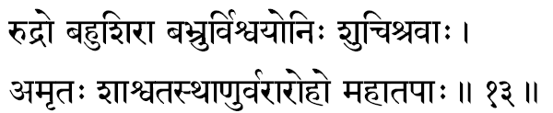
(114) Rudrah -One who makes all people weep, At the time of death or during the total dissolution, the One who makes all weep is Rudrah. From a devotee’s standpoint the same term is interpreted as the One who liquidated all sorrows is Rudrah. Bhagavan declares Himself to be “Among the Rudras, I am Sankara –(Geeta Ch. 10, St. 23). According to the Vedic terminology there are 11 Rudras; this eleventh “Rudra” is called as Sankara: Sam-karoti-iti = Sankarah - “One who blesses all with Auspiciousness (Sam).”
(115) Bahusiraah -One who has many heads. The Purushasooktam of the Rig Veda describes the Cosmic Form of the Lord with a narration, “The Purusha of thousand heads, thousand eyes and thousand feet…….” In Geeta a similar description of the Universal Form of the Lord is found in Chapter XI. Again in the Geeta Chapter XIII when the Lord was describing the Infinite Goal to be known (Jneyam), He describes It as “Everywhere legs, everywhere hands, every- where eyes, everywhere His face”.
Thus, He whose personal manifestations constitute the universe is known as “One who has many heads.”
(116) Babhruh -One who rules over the worlds. “Like a King” -Atmabodham gives this analogy .He in whose presence all the instruments of perception, feeling and knowing continue their coordinated activity is the Self, the Atman, who is Great Lord Vishnu.
(117) Visvayonih -One who is the Total Cause from which alone the entire world of experiences (visvam) has emerged out. The womb (yoni) from which thoughts and actions had risen is called Visvayonih.
(118) Suchisravaah -One who has beautiful and efficient ears (Sravas): “Everywhere are His ears”-(Geeta Ch. 13, St. 13) meaning thereby He is the Hearer in all ears. The term Sravas not only means ears, but it also means “names” -so Suchisravas can mean ‘One who has Divine and Sacred names’. Thus, the devotee can invoke Him with thousands of His names when He can readily listen in and rightly understand the exact purity and the real depth of devotion in the devotee. Also the term can be used to indicate the One whose “names” are worthy of being heard by seekers.
(119) Amritah -One who is Immortal and Immutable. Mritam = dead. The Infinite is Ajarah, Amarah and Avyayah. It can also mean as One who is of the nature of Nectar (Amritam) -a sure cure for those who are suffering from malady of ignorance. Amritah also means Moksha; and thus it is indicated, He is the ever-liberated-the Pure State of Being.
(120) Saasvata-sthaanuh -One who is both permanent (Saasvatah) and irremovable (Sthaanuh). He is the One who remains Changeless, because Immortal; who remains the same in all periods of time, because permanent (Saasvatah); and who remains changeless in His nature or Consciousness (Sthaanuh). This is a single term (Saasvata-sthaanuh) and, therefore, we must add the meanings together- Permanent and Changeless; Permanently Changeless Factor in lire is Vishnu.
(121) Vararohah - He who is the most Glorious (Vara) Destination (Aaroha). The Seat of the Self is the most Glorious because the imperfections of the world-of-matter (Prakriti) are not there in the Spirit (Purusha). Liberation from the thraldom of matter is the arrival of the Infinitude of the Self. “He never returns”, thunders the Chandogya Upanishad (8-15-1) three times in one and the same breath, assuring us that one who has reached the Seat of Vishnu, beyond the frontiers of the intellect, there is for him no more any return ever into the ego-centric life of tensions of sorrows.
(122) Mahaatapaah -One of great Tapas. The term tapas in Sanskrit has three meanings: ‘Knowledge’ (Jnaana), ‘Prosperity’ (Aisvarya) and also ‘Might’ (Prataapa). It is in the presence of Consciousness that we come to know all our experiences. ‘Conscious of’ a thing or an idea is the ‘Knowledge of’ the thing or the idea. That about which I am not conscious of, I have really no knowledge of it. All knowledges, of all bosoms, in all living creatures, everywhere, at all times, cannot be without the play of Consciousness upon the respective objects of knowledge, and hence this Consciousness is indicated in the Upanishads as Pure Knowledge, in the light of which alone all knowledges are possible. All achievements and prosperity (Aisvarya), all might and power of the living creatures can express themselves through them only when they are alive. This great truth is Maha Vishnu. “Whose Tapas is of the nature of Knowledge” (Mundaka- Upanishad. 1-1-9).

Stanza 14
sarvagah sarvavid-bhaanuh- vishvak-sena janaardanah
veda vedavid-avyango vedaanga vedavit kavih.
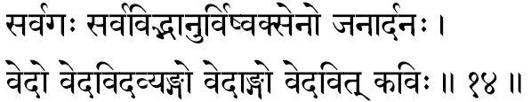
(123) Sarvagah –“He who has gone everywhere”, meaning “One who pervades everything”. The cause pervades its effect: gold in all ornaments; ocean in all waves; cotton in all cloth. The Infinite Consciousness Itself expresses as both world-of-matter (Kshetra) and the Knower-of-the-field (Kshetrajna). Vishnu, the Infinite is beyond these two (Uttamah Purushah) in whom there is no expression of matter and, there- fore, no ‘Knower’-hood. He is the All-Pervading Self, Maha Vishnu.
(124) Sarvavid-bhaanuh -One who is All- Knowing (Sarvavit) and Effulgent (Bhaanuh) .The Light of Consciousness is the “Light that illumines all lights” and it is again Consciousness that “illumines even darkness” -Geeta Ch.13, St.17. In the Mundaka Upanishad (4.10) also we read: “By its Light alone it illumines all other experiences.” Sarvavit-Bhaanuh is one term: meaning that all Knowing Effulgent Consciousness.
(125) Vishvaksenah -He, while facing whom, even the mighty army of the gods retreat and scatter away, is called as Vishvaksenah. He is the Almighty and All-Powerful, and no army can stand against Him.
(126) Janaardanah -The term Ardayati is a verb meaning both ‘giving sorrow’ or ‘giving joy’. Thus, One who gives sorrow and disaster to the vicious, and who blesses with joy and peace to the good people is called Janaardanah.
(127) Vedah –The term Veda comes from the root vid: ‘to know’. Since Veda gives knowledge, the Lord is termed as Vedah, in the sense, that He is the One who gives the Knowledge of the Reality, because He is the very Reality. In Mahabharata, Vyasa says: “Krishna alone is All-vedas, All-sciences, All-techniques and All-dedicated Actions”. In the Bhagavad Geeta (Ch. 10, St.2) Lord says: “Out of mere compassion for them, I, abiding in their Self, destroy the darkness born of ignorance, by the luminous lamp of wisdom”.
(128) Vedavit –‘One who knows the veda’. The Lord alone is the One Experience without which the Vedas cannot be fully realized. The surest and the most exhaustive commentary of the Vedas is to be found only in a stilled mind, which is in communion with Vishnu, the Supreme Reality. Geeta (Ch. 15, St. 15) says, “I am the author of the Vedanta, as well as the Knower of the Vedas.”
(129) Avyangah -He who has no imperfections (Vyanga) anywhere in him- The All-Perfect. The term Vyanga also means person, and so A vyanga means One who cannot be known by anyone in any ‘personal-form’. Geeta plainly says “This great Reality is Imperceptible, Unthinkable, without any modifications”. -Geeta. Ch. 2, St. 25
(130) Vedaangah –One whose very limbs are the vedas. In Kenopanishad in the closing stanzas, the teacher insists that all knowledges are Its limbs.
(131) Vedavit –‘One who contemplates upon the Veda is Vedavit’: (Vedam Vichaarayati=Vedavit). Mere word meaning cannot give us the true concept of the subtle theme discussed in the Vedas. Continuous reflection upon their declarations alone can reach us to the peaks of their imports. In the Geeta, Bhagavan Himself declares that He is not only the very Revealer of Vedas but He is at once the Knower of the Veda -Geeta Ch. 15, St. 15.
It is absolutely necessary that the student of the Vedas should try to understand the meaning of their declaration. To repeat the mantras parrot-like is not of any consequence: ‘He who has studied the Vedas but has not understood the meaning, but carries a load, as the ‘road-rest’ on the roadside.’ Thus He who constantly reflects upon the Veda, and naturally lives up to it, is the Great Lord.
(132) Kavih -The term Kavi in the Vedas means the ‘Seer’. One who experiences something more than the ordinary is called a Kavi. In the Isavasyopanishad (8) we read: -“The Seer, the Intelligent....” In the Brihadaranyaka Upanishad (5-7-23) we read: “There is no Seer except Him.”
In the Glory of the Lord, He confesses, in the Geeta, “among the Poets, I am Usanas, Sukra-Aachaarya”.

Stanza 15
lokaadhyakshah suraadhyaksho dharmaadhyakshah krita-akritah
chaturaatmaa chaturvyoohas-chatur-damshtras-chatur-bhujah.
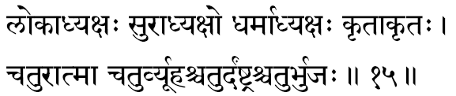
(133) Lokaadhyakshah –One who presides over all fields of experiences -all lokas. President is one who is responsible for the conduct of the assembly; he guides the discussion in a disciplined manner, and ultimately at the end of it all, he dissolves the meeting. All through the discussions he never interferes with the freedom of speech and action of the members, if they act within the agenda of the day. Similarly, the Lord presides over all the fields of activities, never interfering with the freedom of the individuals to act. “The Supreme Purusha in this body is also called the spectator, the permitter, the supporter, the enjoyer, the great Lord, and the Supreme Self.” From the Puranic standpoint the Lord in His Vaamana manifestation was installed as the king of the three worlds and, therefore, this name, say the Pauraanikas.
(134) Suraadhyakshah -The President of the Heavens to whom the Devas run for protection when they are threatened by their constant enemies -the Daityas and the Asuras. When in the Heaven of our bosom, the thought-angels are threatened by the negative tendencies and criminal purposes, He to whom the good in us surrender totally for sure protection and safety is Vishnu, the President within the bosom.
(135) Dharmaadhyakshah -Presiding over the activities of the living organisms, Consciousness revels, illumining both the good and the evil therein. The One Sacred factor that constantly thus illumines all the nature and functions (Dharma) of the body, mind and intellect is the Dharmaa- dhyakshah, Lord Vishnu.
(136) Kritaakritah -Kritam = that which is done = that which is manifested or created Akritam, therefore, is that which has not manifested or become. The former (Kritam) indicates all the “effects” manifested out of the Creator’s activities, and the latter (Akritam) is the “cause” from which no manifestation has yet emerged -it is still unmanifest. The Self, the Atman, is the ‘Post’ -in the ghost-in-the-post example -upon which the cause and the effect, the unmanifest and the manifest, like the “ghost” apparently come to play (Kritam = Vyaktam, A-Kritam = A-Vyaktam).
(137) Chaturaatmaa -The Self is described as four-fold when we consider the Atman as the Glory (Vibhooti) of the Self. Thus, the Essential factors, with which alone the endless play of creation, sustenance and destruction can continue, are the glories of the Self (Aatma-Vibhooti). In Vishnu Purana, four distinct vibhooties of the Lord -when He functions as the creator, sustainer and destroyer -are found enumerated. From the standpoint of a Vedantic student, since in the Non-dual Reality there cannot be anything other than It- self, all the plays of the gross, the subtle and causal bodies, in the microcosm and in the macrocosm, are the glories (vibhooties) of the One Self. In the Absolute, in the Eternal, all these are transcended; these- the water, dreamer, deep-sleeper, the Tureeya -are all Its Glories. The Possessor of these Glories is the One that transcends even “Tureeya”; He is called as the Tureeyaateetah.
(138) Chaturvyoohah -One who manifests into the four mighty powers (Vyooha). The Truth, that plays thus Himself in these four levels having apparently created the world of experiences, is Vishnu, the All-Pervading. According to the Vaishnava literature, for the purpose of creation, Maha Vishnu Himself became four mighty powers (Vyooha) and they were called Vaasudeva, Samkarshana, Pradyumna and Aniruddha. One who has Himself these four mighty powers, necessary for the conduct of plurality, is the Great Self, Maha Vishnu.
(139) Chatur-Damshtrah -The canine teeth fully developed in the upper and the lower rows, as in the case of carnivorous animals, are called in Sanskrit as Damshtraa. This is reminiscent of the Powerful Damshtraa of the Lord when He took the form of Nara-Simha to protect Prahlaada.
Also in the Puranas we find that the Great white Elephant of Indra, “ Airaavata,” has four tusks -He whose glory is the four-tusked Airaavata is Maha- Vishnu. To the student of the Upanishad, it is indeed very clear that these four ‘tusks’ or ‘teeth’ are nothing other than the four paadas which Mandukya thunders -”Chatushpaada”. The manifestation of the Might and Glory of the Supreme are the play of the waking, dream and deep-sleep conditions. With reference to these three, transcending them all, is the fourth plane-of-consciousness the Springboard for all these three. He, whose Glory are all these four grinding, crushing, fearful experiences of duality, is the One Non-dual Self, the Great Maha Vishnu.
(140) Chaturbhujah –“One who has four hands”. It is famous that Maha Vishnu has four hands and they carry the Conch, the Discus, the Mace, and the Lotus. According to the Puranas, these four are used by the Lord in maintaining Dharma among mankind. The ‘Conch’ calls man to the righteous path that directly leads to Peace and Perfection, the Divine Vishnupada. Very many of us in the enchantment of the immediate sense-joys refuse to listen to the small inner voice of conscience, the sound of the Paanchajanya-conch, and so He wields the ‘Mace’ and we come to suffer small calamities and tragic jerks in our smooth existence -communal, social or national. If still the individual is not listening to the call of the ‘Conch’, the wheel-of-time, Chakra annihilates the entire. The call and the punishment are all only to take man towards his Ultimate Goal, represented by the “Lotus” in His hand.
Subjectively Vishnu is the Self within, who manifests as the four-armed ‘subtle-body’ to serve as the Eesa of the gross physical structure, in all its actions and protect it with existence. The “Subtle-body” as the inner-equipment (Antah-Karana) functions as four mighty powers -mind, intellect, chit and ego. Chit is the ‘Lotus’, intellect is the ‘Conch’, ego is the ‘Mace’, and mind is the ‘Discus’. All these four are wielded by the One Infinite Blue-bodied Narayana, clothed in His ‘yellow garb’, manifesting to maintain and sustain the world of good and evil. Since the Self functions thus in a four-fold pattern, Vishnu has the appellation, “the four-armed Lord.”

Stanza 16
bhraajishnur-bhojanam bhoktaa sahishnur- jagadaadijah
anagho vijayo jetaa visvayonih punarvasuh.
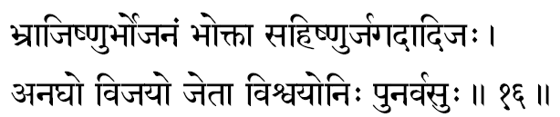
(141) Bhraajishnuh -Self-Effulgent Consciousness illumines everything; and it is not borrowing Its Light from any other source. “It is the Light of lights that illumines even darkness”-(Geeta Ch. 13, St.18). And the Upanishad is equally vehement and declares: “There the sun has no light nor the stars nor these lightnings; how little then can this fire! By its Light alone all these are illumined.
(142) Bhojanam -The immediate meaning of the term is food, viz. eatables. In philosophy it has a wider implication and the term “food” cannotes the entire field-of-objects experienced or enjoyed by the sense-organs. The world-of-objects projected by the sense-organs, the inner psychological play and this world-of-matter constituting the field-of-plurality, all together is comprehended by the term Maayaa. Thus cathodox commentators reduce this term ‘Bhojanam’ to the contents and functions of Maayaa. Taittireeya Upanishad (2-7) says: “He is indeed the Essence (Rasa)”.
(143) Bhoktaa -The “Experiencer” Not only the world-of-objects is essentially nothing but the Spirit, Lord Vishnu, but even the very instruments-of -experiences and their ultimate joys and sorrows, are all illumined for us by the Lord- of-Lakshmi. The Pure Self, expressing through the gross, the subtle and the causal bodies, becomes the waker, dreamer and deep-sleeper, experiencing all happenings, good and bad, as the individuality in that living person. Consciousness, Purusha, identifying with and functioning through matter (Prakriti), comes to experience the endless modifications that are born out of Prakriti. The Self in Its Infinite nature is actionless and yet in Maayaa seems to function and becomes the Enjoyer or Sufferer of the actions of matter.
(144) Sahishnuh -One who is capable of patiently suffering, in his perfect detachment, all that is happening around, is a sahishnuh. Whatever happens to the reflections of the Sun, the Sun in the cosmos is unaffected by them, and with reference to his reflections we can call him a Sahishnuh, the Sun is a mere “witness” of his own endless reflections.
The term has also got two more meanings in Sanskrit as ‘Forgiver’ or ‘Conqueror’. Vishnu is one who forgives us readily all our trespasses, and conquers for us all the inimical forces in our inner personality.
(145) Jagadaadijah -One who had born (Jah) in the very beginning (aadi) of the world (jagat) is called Jagadaadijah. At the time of dissolution (Pralaya) when the entire gross and subtle bodies go to lie absorbed in the Total Causal-body, the world, in Pralaya, lies merged in Eesvara. Before the gross world-of-plurality emerges out there should be a condition of subtle manifestation of it in the form of thoughts. Thoughts constitute the mind-intellect; when the Infinite functions through this Total Mind-intellect, It is called as Hiranyagarba the womb of all objects, it is from the Hiranya garba-state, the manifestation of the gross world emerges out, when the lord comes to play as a Virat Aatmaa. Maha Vishnu is the one who was born before the world of gross bodies, therefore it is indicated here that he is the “Womb-of all- objects” in the world, the Hiranyagarba-the very creator.
(146) Anaghah -Agham means sin (Paapa), impurities (mala); and therefore, Anaghah means One who has no imperfections and who is not affected by the good and bad Vaasanaas left over in the personality as a result of the wilful actions. He is the Uncontaminated (Aliptah) .The Light of Consciousness is the Illuminator of the mind, and so the peace of virtue or the agitations of the sin cannot affect the Illuminator -the Illuminator being always different from the illuminated. Chandogya Upanishad (8-1-5) says: “He is free from Sin”.
(147) Vijayah –“The Victorious”. One who realizes the Self can thereafter stand apart from the thraldom of matter, Victorious over the tyrannies of the flesh, feelings or facts. Thus, the Seat of Self is the Seat of Victory over matter. The Peace and harmony of the Self can never be assailed by the noisy hordes of the world of plurality. Vijaya is the name also of Arjuna and the Lord Himself says, “Among the Pandavas, I am Arjuna” - Geeta Ch. 10, St. 37.
(148) Jetaa –“Ever Successful”. In all undertakings He alone wins; One who never knows any defeat or failure. Upanishad says: “Truth alone wins, never falsehood”.
(149) Visvayonih -It can be interpreted in two ways as (a) He who is the Cause of the universe or (b) He who has the world as His Cause. The former is clear to those who have so far followed the commentary, and to them the latter may be a very confusing statement. From the standpoint of the Puranas, it is logical. The Self has manifested as the various Incarnations from time to time because of the condition of the world, and therefore, Visvam is the cause for His manifestations.
(150) Punarvasuh -One who comes to live again and again in various equipments of living organisms is Punarvasuh:

Stanza 17
upendro vaamanah praamsur-amoghah suchir-oorjitah
ateendrah samgrahah sargo dhritaatmaa niyamo yamah.
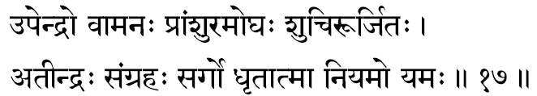
(151) Upendrah -The younger brother of Indra. In His Incarnation as Vaamana, He was born to Aditi, who was the mother of Indra, and hence, the Lord is known as the “Younger brother of Indra”. In Sanskrit the prefix upa denotes ‘Above’ in the sense of ‘superior to’; therefore, Upendra may also mean “One who is superior to Indra”, the king of gods. Such an explanation we find in the Harivamsa (76-47).
Indra, the king of the sense-organs, is the mind and the Consciousness, which is the Self, is the One factor that dynamises the mind. Since life is that which controls even the mind, certainly It is superior to the mind and this Self is the Maha Vishnu.
(152) Vaamanah -Of the ten great incarnations, the fifth one is Vaamana; and the very name indicates ‘One who has a small body’. It was in the form of a child (vatuh =A child student in a gurukula) that Vaamana approached the divinely righteous Emperor Mahaabali to beg of him a little land, of the length of his tiny three steps-and the Lord measured in His three steps all the three worlds and thus conquered Mahaabali. He checked (Vamayati) the rising pride of possession in Bali, hence He, in that incarnation as a Vatu, is called Vaamana.
The term Vaamana also means ‘worshipful’: “Him, the Dwarf, sitting in the middle of the heart, all gods adore”, so we read in the Kathopanishad (5-3). However, here the emphasis should be upon the meaning “short statured” because of the contrast it makes with the following name.
(153) Praamsuh -One whose body is vast is called Praamsuh. Vaamana, when He got the promise from the righteous King, and when He started measuring, the Lord took His Cosmic Form, and with each step measured the earth, the interspace, and the heaven. In Harivamsa (262-263) there is a beautiful description of the little Vaamana growing into His Total Form. The rate of His expansion is described with reference to two fixed factors the Sun and the Moon. When He took the form, the Sun and the Moon were His eyes; as He measured the earth, they came to His bosom; as He was measuring the space, the Sun was at His navel and as He lifted His feet to measure the Heaven, the Sun and the Moon were just below His knees.
(154) Amoghah -One whose activities are ever a fulfilment of some great purpose. Even insignificant actions, which, ordinarily, people would think are empty and purposeless, are never really so, when they spring from Him. Even when He punishes, it is only for inaugurating a greater evolutionary blessing.
(155) Suchih -One who is spotlessly ‘clean’, and therefore, Ever-Pure. Impurities in a substance are things other than itself; when dust is on the cloth, the cloth is impure, unclean. Since the Self, the Aatman, is the Non- Dual Reality, having nothing other than Itself in It, Ever-pure alone must It always be. And Suchih is One who gives this purity to those who contemplate upon Him constantly.
(156) Oorjitah -One who has infinite strength and vitality. Wherever, in the organism, we meet with any strength and vitality they are all the strength and vitality of the Self. The Infinite Vishnu is the One All-Pervading Self, and therefore, He is the very springhead for all strength.
(157) Ateendrah -One who is beyond Indra in knowledge, glory and strength. Since Indra represents the ‘mind-intellect’ equipment, Aatman, the Self is denoted here as that which transcends the mind.
(158) Samgrahah -One who holds the entire world of beings-and-things together in an indissoluble embrace unto Himself. Just as the hub of a wheel holds the rim unto itself by its endless spokes, so too the Aatman, the Self within, lends Its vitality to every cell in the body and to every thought in the inner-equipments.
In none can anything happen which is not a glory borrowed from Him. And, the Self, being the same everywhere, in all existence, in both the movables and immovables, gross and subtle -in the manifest as well as in the unmanifest - He certainly is the One who holds the world of phenomena unto Himself in a vast embrace of Love and Oneness.
(159) Sargah -One who has created out of Him- self the whole world. It therefore must also connote One, who has the whole created world as His own form, since the creation is His own manifestation as the Subtle and the Gross.
(160) Dhritaatmaa -One who supports Himself by Himself. In the previous epithet Samgrahah, He was shown as the Cohesion of Love in the world of matter and energy, and in Sargah, He, as the One material and efficient cause of creation, was shown as also the very supporter of the manifested world. But who supports Him? He is Dhritaatmaa - He is established in Himself.
(161) Niyamah -The Appointing Authority: It is He, who orders all the mighty forces of nature and prescribes for each the Laws of their conduct, the ways of their behaviour and the methods of their functions. The Sun, Moon, Air, Waters, Dik-Paalakas, Death etc. are all appointed and ordered by the Lord.
(162) Yamah -One who is the mighty Power that administers all the forces of Nature under His Law. Everything in nature strictly obeys ever all His Laws.

Stanza 18
vedyo vaidyah sadaa-yogee eerahaa maadhavo madhuh
ati-indriyo mahaamaayo mahotsaaho mahaabalah.
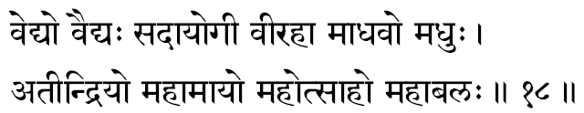
(163) Vedyah -That which is to be known; in the language of the Geeta, it is Jneyam. That final knowledge, knowing which every-thing becomes known. “Kasmin nu bhagavo vijnaate sarvamidam vijnaatam bhavati iti”-(Mundaka. 1-3).
All sciences are investigations into Truth After observing the nature and behaviour of things and beings when the investigator moves ahead seeking the ONE Harmonious Chord of Reality that holds all phenomena in its inescapable love-web, the scientist of Truth-comes to reject first the gross, and soon thereafter the subtle realms, and ultimately even the causal factors, and thus-comes to apprehend this harmony, which he is seeking as the very subjective core of his own Self. This final Goal to be realized, “having known which everything else becomes known,” the One Consummate Knowledge to be gained (Vedyah), is the Self, the Great Vishnu.
(164) Vaidyah -The One Supreme Doctor who alone can minister to the world suffering from ego and egocentric misconceptions. One who is a master of all knowledge (Vidyaa) is also termed as Vaidvah
(165) Sadaa Yogee -To the confused and the deluded to detach themselves from the false vestures-of-matter and to seek their identity with the ETERNAL Self is called Yoga. All attempts in attaining an at-one-ment with the Self is called Yoga. The Goal, the Self, therefore, in the language of the seeker must be Sadaayoga-ever-in yoga.
(166) Veerahaa –“He who destroys the mighty heroes”. The powerful men of strength and valour when they grow in their audacity to become tyrants, the Lord manifests to destroy such Raakshasas and thus protects the Dharma and the Good.
(167) Maadhavah -Earlier this term was used (72) where we interpreted the term as the “Lord of Lakshmi.” Maa means not only “Lakshmi,” but she is also “Vidyaa” (Knowledge). The Lord (Dhava) of all Knowledge (Maa) is Maadhava.
He who helps introspection and meditation in the seeker is Maadhava. “To become conscious of the existence of a thing” is called the knowledge of the thing, The Aatman, the Self is Existence (Sat) and Consciousness (Sphurana) and, therefore, Lord Vishnu, the Self is the source of all knowledge and as such the Master of all Vidyaas: (Maa-dhava), Harivamsa says” “O Hari, You are the Lord (Dhava) of Knowledge (Maa), and hence You are called as Maadhava, the Master of Maa.”
(168) Madhuh -The term Madhuh familiarly stands for “honey”. It is also a term to indicate “nectar.” One who generates Nectarine Bliss in the hearts of His devotees is called Madhuh. The springtime in India is called as Madhumaasa since spring is the season of flowers; full of honey for the bees, and joy for man. The month called Madhu (March- April) is the Chaitra month which is considered specially auspicious for prayers, and meditation. One who is of the nature of the Maadhava-maasa, the month of Maadhava (April-May) can also be the suggestion in this term. Vaisaakha (April-May) is considered as the most auspicious time of the year for the worship of Vishnu by all Vaishnavites.
(169) Ateendriyah -One who is beyond the sense-organs not only in the sense, that the sense-organs cannot perceive Him as their ‘object’ but also in the sense that He is other than the sense-organs and their functions. Lending to them, all their very vitality, is His mere presence! He is the very ‘subject’ in the perceiver, and, therefore, the instruments of perceptions, emotions, and thoughts cannot experience Him: this Source of All-life is Maha Vishnu. Kathopanishad (3-15) says: “He is soundless, untouched, formless, immutable, so without taste, eternal, smell-less.
(170) Mahaamaayah -One who is the Supreme Master of all Maayaa. He is the very Substratum upon which all the plurality spring up and play their infinite enchantments, constantly basking in the Light of the Supreme Consciousness. Aatman, the Self, is untouched by the play of Maayaa, and yet the Maayaa-play is sustained only by the exuberant warmth of His Divine presence. The Sun is the Master of all clouds, inasmuch as, in its presence, borrowing its heat, water by its own nature gets evaporated, and the water, vapour again, because of its own nature of a lesser density than the atmospheric air, rises to the higher altitudes and gathers there as clouds. It is, again, the nature of the atmosphere that at higher altitudes it is cooler and the water-vapour so cooled becomes water again, and due to the higher density of water it descends as rain. In this example the Sun can be called as the “Creator” of all clouds and the “Cause for the rams,” and consequently the sun is also the “ Master of the Seasons.” And yet, the Sun is uncontaminated by all these phenomena that are happening in its presence.
In the same fashion the Infinite Reality, Vishnu, is indicated here as the Great Magician, who has the magic of Maayaa at His command. Krishna Himself confesses in the Geeta: “Very difficult indeed it is to cross over My Maayaa” -(Geeta Ch. 7 St. 14).
(171) Mahotsaahah -The Great Enthusiast; the Ever-Dynamic Accomplisher. The Powers of creation, of sustenance and of annihilation-in their totality is the world of birth and death that we live in. This wonderful world cannot be sustained without the endless enthusiasm of this Mighty Power. Looking at the ocean, through the waves, we come to recognise the ocean as the “Sleepless Agitator”; similarly, looking at Vishnu, “through the ephimeral kaleidoscopic changes in the patterns of life available to us in our experience today, we call Him as the “Dynamic accomplisher” (Mahotsaahah). The term employed here, the Enthusiastic Accomplisher, is indeed one of the most appropriate names for Maha Vishnu.
(172) Mahaabalah -One who has Supreme Strength. He, being Omnipotent, is the Source of all Strength that we see in each individual organism in life. His Vitality reflected in each of us, is our individual strength; naturally He is the Infinitely Strong, Mahaabalah.

Stanza 19
mahaabuddhir-mahaa- veeryo mahaa-saktir mahaa-dyutih
anirdesya-vapuh sreemaan ameyaatmaa mahaadri-dhrik.
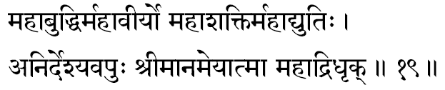
(173) Mahaabuddhih-In the previous term, we were told He is Omnipotent. Here He is indicated as Omniscient. The Supreme, functioning through the intellect, is the intelligence. The quality and quantity of the intelligence will depend upon the condition of the “intellect’ through which the Infinite comes to play. The intelligence in a mathematician, poet or an artist, scientist or politician-all are the different play-patterns of energies invoked from the one Supreme Intelligence, and therefore, Mahavishnu, the Self, is called here as Mahaabuddhih, the Reservoir of all Intelligence.
(174) Mahaaveeryah -One who is the Supreme Essence. “Veerya” is the Essence behind all the creative urges. Since the Divine is the very source, from which alone the dynamism for creation can manifest, the Supreme Divinity is termed here as the Mahaaveerya.
(175) Mahaasaktih -All-Powerful. Power here means efficiency. He-whose manifestations are the power-of-action, the power-of-desire and the power-of-knowledge saktees-must necessarily be the most powerful, in as much as a play of these three powers is the total play of the world.
(176) Mahaadyutih -Of Splendorous Light. Dyuti means ‘Glow’, Sobhaa. The Pure Consciousness is the illuminator of all, including all other material sources of light in the world-Sun, Moon, stars, fire etc.-but this is not all; He is also the One, who is Himself Self-Effulgent. This is Mahavishnu-the Supreme Self. In the Mundakopanishad (4-9) Lord is described as the “Light of lights”. Brihadaaranya- kopanishad (6-3-9) declares: “He is Self-effulgent”.
(177) Anirdesyavapuh -One whose form is indefinable, indescribable, inexplicable (Anirdesyam). Ordinary things can be defined, described or explained because they come within our experience. Our objective experiences can be satisfactorily expressed in words. Vishnu is that Truth which is the Subjective Essence in all of us; He is that ‘Knowledge’, in the light of which, all other knowledges are rendered possible. As such no “sources of knowledge” (Pramaanas such as Direct perception, Inference etc.) can be employed successfully in exploring the realm of the Self. Subjective experiences of ‘Be’, the Maha Vishnu, is possible; but It can never become an ‘idea’ to express, nor can It become an ‘emotion’ to feel, nor can It ever become an ‘object’ to be described.
(178) Sreemaan -Sree means Glory (Aisvarya). Vishnu is permanently wedded to Mother Glory; He, who is constantly courted by all glories, is Sreemaan, Lord Vishnu.
(179) Ameyaatmaa -He whose Essence (Aatmaa) is inestimable and immeasurable (Ameya). As Aatman (Kshetrajna) He, the One, expresses Himself everywhere in every equipment (Kshetra), as the ‘knower’ in each ‘field’. Since these equipments are infinite in number, as the individuality (jeeva) in each one of the created beings, His own Glory expresses in endless manifestations.
(180) Mahaadridhrik -One who supports the great Mountain. In the Puranas, we find two instances, wherein the Lord has been described as the uplifter of or as having lifted and supported the mountains. While churning the milky ocean with the Mandara mountain we are told that the “churning-stick” sunk into the bottom and the Lord had to manifest in the form of the Great Tortoise (Koorma) and support it, while the Gods and Demons continued the churning, until they gathered the nectar (Amritam).
Again, the Supreme, as Lord Krishna, in order to protect the cows had to lift the Govardhana Mountain. Because of these two stories in the Puranas, Lord, the Protector of the mind in Saadhanaa, is called as Mahaadridhrik.
Vishnu is the Divine, that supports the mind-intellect of the Saadhaka while he is churning, through study (sravana) and reflection (manana), his own Milk-like pure heart-of devotion in order to gain the experience of Immortality (Amritam).

Stanza 20
maheshvaaso maheebhartaa sreenivaasah sataam gatih
aniruddhah suraanando govindo govindaam-patih.
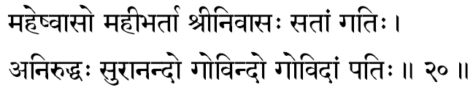
(181) Maheshvaasah -One who wears or wields the Great Bow called Saarnga.
(182) Maheebhartaa -The husband of Mother Earth. The Sanskrit term for husband is Bhartaa and the term denotes ‘Supporter’. In the Puranic language we have the description of how the Lord, as the Great Boar uplifted the earth from the “waters of Deluge.” Viewed from the platform of philosophy, just as gold is the supporter of all things made of gold, the Infinite Consciousness is the Essence from which everything has risen. Hence He is the Lord, the Supporter, the Husband (Bhartaa) of Mother Earth and everything that exists in her.
(183) Sreenivaasah -The permanent abode of Sree. Mother Sree connotes “all Glory and power, faculties and strength, to be good and to perform creative acts of righteousness”. She is found to remain never permanently in any bosom. Even saints and sages, in recorded history, have come to compromise the perfections in them. The only place, where imperfections never enter to molest the serene essence, is the seat of Eternal Perfection, which is the bosom of Narayana. Hence Maha Vishnu is indicated as Sreenivaasa –“the Permanent Abode of Lakshmi”.
(184) Sataam Gatih -For the truly virtuous and for all spiritual seekers (Sat-People) He who is the final Goal. In the language of the Geeta He is the “Paraa gatih”. The term gati is used to denote not only the goal, but the very movement, as well as the direction and the way. Narayana is the very Direction, Path, Progress and the Goal for his devotees.
(185) Aniruddhah -One who cannot be obstructed or resisted by anyone. Irresistibly, the will of the Lord functions in the world of created things-and-beings. Just as in the world of matter, the laws of nature are irresistible, the Rhythm and Harmony of Truth ever march in their Eternal Logic of objectless Love and immaculate perfection. Time and tide wait for none. When the sun rises, the living creatures absorb energy and nothing can obstruct this process. In the presence of the Self, the worlds of matter must get thrilled into their own independent activities, and in all these welter of efforts and exertions, achievements and failures, joys and sorrows, the Self is not involved by the Irresistible Enchantment of His presence, the Gopis seek their own fulfilment in their own dances. In the Puranas, we find Bhagavan Vishnu taking up in His various Incarnations different manifested forms and in all of them He was victorious; ever irresistible (Aniruddhah) is His Might.
(186) Suraanandah -The One who doles out happiness (Aananda) even for the Denizens-of-the Heavens (Suras). In the Upanishad we have the declaration, that the Infinite Perfection, the Lord is of the very nature of Absolute Bliss. In the Aanandavallee of Taittireeya Upanishad we find the arithmetics of Bliss. The Rishi concludes that all joys of the world and heavens-mental and supramental-are all but flickerings of the Infinite Bliss, which is the Lord Mahavishnu.
(187) Govindah -The word Go in Sanskrit has four meanings: ‘Earth’, ‘Cows’, ‘Speech’ and ‘Vedas’. As the earth is the supporter of everything that is existing, He, who is the supporter of everything within the individual, is called Govinda; He, who is the Protector of the Cow’s and played the part of Gopaala in Gokula, is the very controller of the animal instincts and passions in the bosom of man; “One, without whom, no speech can ever emerge out of any throat-He being the very Life in all Creatures” says Kenopanishad; and the Highest Speech is the declaration of Truth in the Vedas. The Lord Himself is the very Theme and the Author of the Vedas. This great Self is Mahavishnu.
(188) Govidaam Patih -One, who is the Lord of all ‘seers’ and “Men of Wisdom”. We have already indicated that Go means Vedas. Govit- Vedavit-those, who have realized the Theme indicated in the Vedic declaration as the Essential Reality in their Own subjective bosom. They are called the Seers or Sages. To such Men-of-Wisdom the Self-alone is the Lord and the Master.

Stanza 21
mareechir-damano hamsah suparno bhujagottamah
hiranyanaabhah sutapaah padmanaabhah prajaapatih.
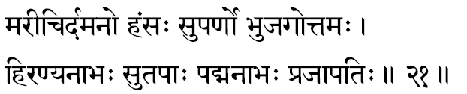
(189) Mareechih -The term Mareechih means ‘Effulgence’. Consciousness illumines objects and therefore in terms of worldly knowledge the Upanishads declare that the Supreme is the Light-Infinite. In the Geeta we read Bhagavan, Vaasudeva declaring: “I am the Light in all effulgents” -(Geeta Ch. 10, St. 36).
(190) Damanah -One who restrains and controls every Raakshasic impulse within the bosom. In the forms of the ten incarnations, He had controlled the irresistible tyrannies of the vicious against the good. In the form of pain and agitation, sorrow and death, it is He, who is the Controller, Damanah, of all negative tendencies in everyone’s Heart.
(191) Hamsah -One of the great declarations of the Vedas is: “I am Brahman” (Aham Brahmaasmi). Here the term I, the first person singular used, denotes the supreme. Self functioning through the conditionings.” This individual concept is called jeeva. Thus I, the Jeeva (Aham), once detached from the conditionings, IS essentially nothing other than He, the Lord (Sah). This experience that Aham is Sah is the very God-consciousness and therefore, Vishnu, the Supreme State of Realization is declared as Hamsah.
(192) Suparnah -Parna means wings; Suparna means that which has beautiful wings-bird. “A pair of white- winged birds extremely friendly sit on one and the same tree; one cats the fruits, the other eats not and gazes on”.
Thus traditionally in the Upanishads, the Suparnas suggest the Jeevaatmaa and the Paramaatmaa sitting on the same tree (body): one (Jeeva) eats the fruits (of actions) and the other (the Self) merely gazes on (Saakshee). Vishnu is this All-experiencing Principle of consciousness.
(193) Bhujagottamah -The sacred serpent named in the puranas as Ananta. “ Among the serpents I am Ananta,” says Krishna: -(Geeta Ch. 10, St. 29).
(194) Hiranyanaabhah -He, who supports at His navel, the creator, Hiranyagarba. The meaning for this term as given by some is “the One who has the navel region beautiful in its golden hue” must fail, in the context of the thoughts in the stanza, to appeal to all seekers.
(195) Sutapaah -One who has glorious Tapas. Consistent creative thinking is called tapas. For this, mental concentration is unavoidable. Mind cannot have consistent concentration unless it can have a perfect control over the sense-organs. Even when the mind is withdrawn from the sense-organs, it must have a consistent intellectual ideal to concentrate upon. In the Upanishad, we read: “He thought and through thought, He created all this”.
(196) Padmanaabhah -One who supports at His navel the very seat of all creative-power. We have described this term earlier (48). According to Sankara, here the term may mean one who has a navel region which in its rounded beauty, is as charming as the lotus flower .
(197) Prajaapatih -The Lord of the creatures. Since all creatures have emerged from Him, the living creatures are His children (Prajaa) and He is their Pati. The term Pati has a direct meaning: ‘father’. Thus Vishnu, as the only source from which all creatures have emerged out, is called as Prajaapatih.

Stanza 22
amrityus-sarva-drik simhah san-dhaataa sandhimaan sthirah
ajo durmarshanah saastaa visrutaatmaa suraarihaa.
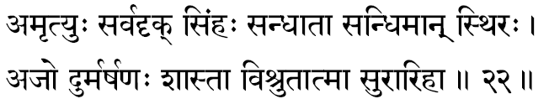
(198) Amrityuh –One who knows no decay Birth, growth, decay, disease and death, are the five great modifications through which every finite objects must necessarily pass. Everything born must perish. The one who has no birth has no death. The waves die but not the ocean. That which is Changeless in the changing whirls of matter is the Infinite Vishnu. In the Bhagavad Geeta, the Lord is emphatic: “He who sees the Changeless amidst the changing names and forms, He alone sees the meaning and purpose of life.”
(199) Sarvadrik -The seer and knower of everything. The Consciousness that illumines all motives and intentions -and the manifested activities that spring from them -in each individual, at all times, is necessarily the Witness of all, the Seer of everything, Maha Vishnu.
(200) Simhah -One who destroys. The Law be- hind all destruction and change in the Maayaa is the Mighty Lord. On transcending the Vehicles of the body, mind and intellect, at a time when all experiences of perceptions, emotions and thoughts are annihilated from us, the Experience left over is the Supreme. And in the Non-dual Supreme, there cannot be any object other than itself. Therefore, that “State” is called as the Total Destroyer. The State of Waking is the “destroyer” of the dream-world; the State of Sleep is the “destroyer” of the waking and the dream; the State of God Consciousness is the total “ Annihilator” of all the known three planes of Consciousness. He is Simhah -a word that has been formed by the mutual transposition of the letters in Himsaa.
Even taking its obvious superficial meaning Vishnu is a Lion in our bosom, in as much as, He is the king of the forest of Samsaar: at the roar of Narayana all the animal-passions flee from the jungles of the mind. In the Geeta while describing His own Glory, the Lord says, “Among the animals, I am the King of animals, Lion.” -Geeta Ch. 10, St. 30.
(201) Sandhaataa - The Co-relator, the Regulator, the One who co-relates the actions and their fruits. In fact, the fruit of an action is nothing other than the action itself; the action itself presents as its fruit in a different period of time, maturing under its own Law. This Great Law is the Lord, whom the devotee accepts as “The Giver of all fruits of action”.
202) Sandhimaan - The structural engineering of individuality is the mightiest of phenomenon available in nature. The Supreme is the Law and the Law-giver; and the Light of Consciousness functioning in the mind and intellect Itself is the individuality (Jeeva), that comes to suffer the good and bad results of the actions. Thus not only that it is He, who is the Giver of the results but It is He, again, Who is the enjoyer or the sufferer of the results. Hence He is called as the One who is apparently conditioned by the actions that emanate from Him, Sandhimaan, enjoyer (conditioned). In fact, He is the One presiding over and illumining all actions; the very Law of reaction Itself; the ensuing experience in all actions of all people, at all times. From the standpoint of our existence, with reference to our individual existence, the Divinity in us, for all appearances, seems to be conditioned; this Sandhimaan, the Jeeva in His own Pristine Purity is Maha Vishnu.
(203) Sthirah -Firm, consistent. One who is ever consistent in His nature and One who remains changeless, at all times.
(204) Ajah -Unborn. Ajah is also a term denoting the Creator, Brahmaaji; He who, in the form of Hiranyagarbha, apparently creates the delusory world of plurality is Vishnu.
(205) Durmarshanah -One who cannot be attacked and vanquished. In the long run, everyone in his own maturity will have to come and accept and walk the path of Vishnu -He is the final Goal. In the lesser levels of evolution, the animal-man may deny himself the peace and joy of living the spiritual values, and deluded by the senses and enchanted by the flesh, he may live a life of sense-joys and temporary fulfilments. But soon enough irresistibly he will be seeking the “feet” of Vishnu for real happiness and true achievement. His also is the final victory and one can stand apart from Him in a victory over him.
(206) Saastaa -One who rules over the universe, Not only that He is the Administrator of the laws of the Phenomenon but also He is the Saastaa. He is the One who, through Sastra, with firm hand, instructs and guides us through the righteous path, drives us along steadily to progress in cultural beauty and finally reaches us at the Great Goal of all evolutions: the Seat of Vishnu.
(207) Visrutaatmaa -The famous term Aatmaa, famous in all the Vedas, is Vishnu. This term clearly shows that all the thousand terms, used herein, though can be considered for the Saguna worship of Vishnu, represent nothing other than the Pure Self, which is the famous theme of the Hindu Scriptures. Through hundreds of suggestive definitions, this Great Self has been successfully pointed out through declarations of Its Transcendental Nature and through statements of negation indicating what He is not.
(208) Suraarihaa -Sura=“God of the Heaven”, Ari=“enemies”, Ha=“destroyer”. The Supreme is the Destroyer of the enemies of the gods. The sensuous claims of the flesh, the mild assertions of the ego, the nocturnal devils of i desires and passions, are the common enemies of the higher mind aspiring to evolve. When invoked with true devotion, He who drives away and destroys the inimical negative tendencies, and helps the devotee to master himself, is Suraarihaa, Sri Narayana.

Stanza 23
gurur-gurutamo dhaama satyas-satya-paraakramah
nimisho-a-nimishah sragvee vaachaspatir-udaara-dheeh.
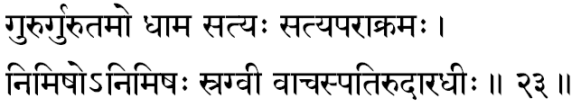
(209) Guruh -The teacher, who initiates seekers into the secrets of the sacred scriptures is called the Guru. Since the Lord, the infinite alone, is the very author and knower of the Vedas, He is the Teacher in all spiritual study. Aatman being the Light, that illumines the knowledge in the teacher, his very capacity to speak and the very ability in the student to hear, understand and apprehend this great Truth, He alone is the Teacher wherever there is any transference of knowledge.
(210) Gurutamah -The Greatest Teacher; One who had inspired with knowledge and initiated the very Creator Brahmaaji into the knowledge of the four Vedas. The creative mind of the very first Spiritual Master must have received this experience of the Transcendental, initiated by none other than the Supreme Itself. Later on, the Man of Realization might come to help other seekers, and to that extent the following generations of disciples, can, no doubt, psychologically believe that the teacher guided them to Truth. But, in fact for all times to come, the final experience of the theme of the Vedas is arrived at only through the final revelation, which has nothing to do with the teacher or the text. Svetaasvatara Upanishad (6-18) says, “He who first Created the Creator (Brahmaa) and imparted him the Vedas.”
The Guru and the scripture, devotion to God, meditation, moral conduct and the religious discipline are all necessary, in as much as, they prepare the bosom of the seeker for the dawn of realization. But the final unveiling is done by the Infinite alone, and hence, Vishnu, the Self, is the best among the Gurus. Heaviness is called by the same term (Gurutvam), and in this sense the Lord is Indicated here as “that which is heavier than the heaviest.
(211) Dhaama -The Goal; the Sacred destination of a pilgrimage. The Supreme is the Param-dhaama, the ‘Supreme Destination’, having reached which, there is nothing more to reach beyond. This Absolute State of Perfection is called the “Peak” (Dhaama). The Sanskrit term Dhaama also means “Effulgence” (Tejas); the Pure Consciousness as the illuminator of all experiences is considered and glorified as the Light of all Lights etc.
(212) Satyah -One who is Himself the Truth. The difference from the general connotation, we have for the term “That which remains without a change in the past, present and future” is called Sat yam. “Truth, Knowledge, Infinite is Brahman”, thunder the scriptures. Brihad Upanishad (4-1-20) says, “The Praanas are the truth, and He is the Truth of them.”
(213) Satyaparaakramah -Dynamic Truth. Passive truthfulness is the harbour of the fools, the dark den of the cowards; although it is any day better than suicidal un- truth and criminal dishonesty. The Lord, the Infinite is not only Himself the Truth but He is Dynamic in insisting that “Truth shall prevail, not untruth”. Not only gravity is a law of nature, itself ever truthful, but it insists that none shall escape its influence or disobey sway. So too, the Infinite Law of Harmony and Love is an Inevitable Truth persisting with insistence in life. The Lord is therefore indicated by the term “ Satyaparaakramah”.
(214) Nimishah -The condition of “the eyelids closed” is called Nimishah; the unwinking is called Animishah. When the eyes are open, the mind is extrovert; the condition of mental introvertedness is expressed in an unconscious closing of the eyes. When a man is deeply thinking, remembering, contemplating, we find him naturally closing his eyes.
In a state of intense contemplation, when the intellect is turned away from the objects-of-experiences, the bosom experiences the One Divine “Subject” both within and without. The Lord is described here as “with eyes closed”, only to indicate that He is ever rooted in Himself; from Him viewed, there exists nothing other than Himself to constitute the world- of-objects.
(215) Animishah -One who remains unwinking. Whenever we wink both the eyelids close together and what we are seeing is at least technically veiled from the seer in the eye. The Supreme is indicated here by the term “unwinking”, in the sense that, the consciousness is Ever-Knowing. In Sankara’s words, in Chandogya Bhaashya, “there is no cession of knowing in the knower”.
(216) Sragvee -A garland is called Srak and, therefore, the term means One who is constantly wearing a garland of undecaying flowers. The famous garland of Vishnu is called Vaijayantee.
(217) Vaachaspatir-Udaaradheeh -Vaachaspati is a term given to One who is eloquent in cham” pioning the Supreme law of life; and Dheeh means the power of intelligence; and Udaaradheeh one who has a “Large- hearted intelligence”, One who is not puritanical in his view points. God is not only the Declarer of the Law but He has a large-hearted tolerance to appreciate the weakness of the devotee’s heart, suffering under the delusion of Maayaa, and hence, has a great sympathy for the weakness in us This is expressed in God’s Infinite kindness towards sinners in general.
The laws of spiritual living can be disobeyed for a long time without any tyrannical onslaught, unlike the law of physical nature, which is blind and uncompromising. Fire knows no mercy. But Narayana, the Great Vishnu, is kind and considerate the while He expresses the Truth of Life eloquently at all times around us. In His Large-heartedness, He has enough paternal kindness to overlook our trespasses.

Stanza 24
agraneer-graamaneeh sreemaan nyaayo netaa sameeranah
sahasra-moordhaa visvaatmaa sahasraakshas-sahasrapaat.
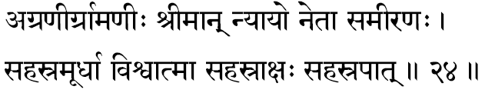
(218) Agraneeh -One wh0 guides us to the end -the peak. Also the One, wh0 leads (Agra) the entire pilgrim- age-the Guide. He moves ahead and following His footsteps, keeping Him in our gaze, faithfully following Him, we shall reach the Goal and thus He is called as the leader, Vishnu.
(219) Graamaneeh -One who controls, guides and leads the “Collection”, the “flock” (Graama). In Sanskrit Graama means “a collection of many number of things”.
(220) Sreemaan -Sree means Light, Effulgence or glory. Consciousness has all these three, and therefore, Sreemaan means the Self, the Lord.
(221) Nyaayah -The word in its direct meaning is “Justice”. In the spiritual world, it connotes logical arguments (Tarka) and lines of contemplation (Yukti), which help us in arriving at the absolute experience indicated in the Sruti, are together called Nyaaya.
(222) Netaa -the leader-one who protects, nurtures, nourishes and guides all living creatures in the world. One who is being the Superintendent of the machinery of life -(“Jagat-Yantra Nirvaahakah”)-Sankara.
(223) Sameeranah -One who efficiently administers all movements of all living creatures. In the physical body, all physiological activities are controlled by the five ‘Praanaas’ and thus in the form of ‘Praanaas’ He who governs all movements of all living creatures in the universe is Maha Vishnu.
(224) Sahasria-Moordhaa -One who has endless number of heads. All living creatures are His manifestations and He Himself is the One who has become the many. Therefore all heads are His, just as in a factory the proprietor considers all the employees as his own ‘hands’. Here the term Sahasra means innumerable.
(225) Visvaatmaa -The very Soul of the universe; the very inner Essence in all living creatures.
(226) Sahasraakshah -In describing the macro- cosmic form of the Lord we have an endorsement of this declaration in the Bhagavad Geeta.
227. Sahasrapaat -In the Purushasookta of the Rig-Veda, the same terms are used in describing the Infinite Form of the Mighty Truth: (“The Purusha is thousand-headed, thousand-eyed, and thousand-footed.”)
The “many heads” (224), “many eyes” (226), “many legs”
(227), together indicate that, through all these equipments of thinking (head), of action (leg) and of perception (eyes), the Thinker, the Doer and the Seer, the One Infinite Consciousness expresses everywhere, in all forms, at all times, and He is Lord Vishnu.

Stanza 25
aavartano nivrittaatmaa samvritah sam-pramardanah
ahassamvartako vahnir anilo dharaneedharah.
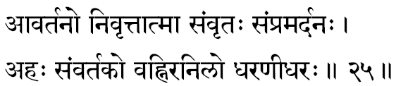
(228) Aavartanah -One who is the Unseen Dynamism behind the ever-whirling wheel-of time upon which play the endless drama of birth and death. The repetition (Aavartanam) of these changes is the experience of Samsaar, and the One mighty Lord, in whose presence alone the factors of matter start their thrilled dance of decay, is indicated here (Aavartanah) as “the Great Power behind the continuity of change in the world of phenomena”. In the Geeta, Bhagavan says, “O Arjuna, the Lord dwells in the heart of all, and spins, through His Maayaa, all layers of personal ties as though the universe is a complicated machinery.”
(229) Nivrittaatmaa -The pure Self, which has retreated totally (Nivritta) from all Its identifications with matter. In short, Maha Vishnu is the Pure Self, ever Immaculate and totally Free from all the sorrows of the constant modifications taking place apparently in the Prakriti.
(230) Samvritah -One who is completely veiled from the recognition of the “Perceiving-feeling-thinking entity”, the ego (Jeeva) .The Self is veiled away from direct experience of all Jeevas. This intellectual state of non-apprehension (Aavarana) creates the agitation (Vikshepa) which is the cause for the misapprehensions of Truth as the sad and sorrowful world of imperfections. Thus veiled, lies the Truth today to the seeker, and that Glorious spiritual Centre is Vishnu.
(231) Sampramardanah -One who persecutes relentlessly men, who are sensuous, evil-minded, and so, fully extrovert in their personality (Raakshasas). In the form of disease, decay, disaster or death That which manifests to annihilate the pride, vanity and conceits of all “animal-men”, as they live drowned in their flesh cravings, low emotions and materialistic values, is the Ultimate Reality-the Supreme Lord Vishnu.
(232) Ahassamvartakah -One who thrills the day (Ahas) and makes it function vigorously (pravartakah). The one who dynamises the day and lends the enchantment of joy to all living creatures is the Sun. The Mighty Truth, who, in the form of the Sun, gives life to all and lends this energy to them to act, is Vishnu. In the Geeta, Lord Krishna says, “Please understand that I am the Light of the Sun that illumines all earth; and the light and heat in the moon and fire are all mine only.”
(233) Vahnih -Fire. One, who is worshipped at the altar as the God of gods, was Fire in the Vedic period. Invoking the various deities, oblations were poured into the Fire in Vedic ritualism and Lord Fire is entrusted with the duty of conveying the oblations to the appropriate deities Invoked by the devotee.
In short, Vishnu is the Omniscient Lord, who conveys appropriate Karma-phala to the Kartaa (doer) and thus fulfils all actions of everybody, at all times.
234. Anilah –This term has four distinct meanings. All of them are appropriate here. (a) Air (Vaayu); living creatures; (b) “Beginning-less” (Aadi-rahitah); that Truth, from which the concept of time itself has born, must have been there even before time, manifested, and therefore, in terms of our intellectual concept of time, we can only say that He is “Beginningless”; (c) ‘Eater’ of food (Attaa); all experiences that satisfy the inner man is called the “food”, and since all experiences are lived only when illumined by the consciousness, the Supreme, in terms of our experience is called the “Eater” and (d) “The Homeless” since He is All-pervading He is the shelter of all and He is not sheltered by anything.
235. Dharaneedharah -One who supports (Dharah) the earth (Dharanee). The field of our experiences is the earth, and for all our earthly experiences, Consciousness is at once the very substratum and the very Illuminator. In the Light of Consciousness alone, the web of happenings around is held together to provide us with our experiences.

Stanza 26
suprasaadah prasannaatmaa visva-dhrik- visvablluk- vibhuh
satkartaa satkritah saadhur jahnur-naaraayano narah.
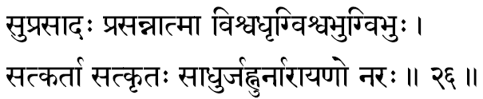
236. Suprasaadah -One who is full of the Supreme Grace and who, so little, so easily, becomes so entirely satisfied. Even to those who can remember Him, even if it be in a spirit of constant and faithful antagonism, His Grace is readily available. In Bhaagavata we read Pootanaa, who tried to poison Him, Kamsa, who planned to murder Him, or Sisupaala, who falsely accused Him-all of them were ultimately rewarded by the Lord. In the Geeta, He confesses, “with a little am I satisfied, if it is given with sincerity, and with faithful consistency”.
237. Prasannaatmaa -Ever-Pure and All- Blissful Self. The Supreme is ever-pure because, It is untouched by the sorrows lived by matter, when matter is ruled over by its gunas. In Geeta we read that the cause for all the sorrows of the individuality (Jeeva) is the attachment with matter and its various imperfect conditions (Gunas). Since He is untouched by them He is Ever-Pure; and since no identification of matter is in Him, He is all-Bliss.
238. Visvadhrik -As a Mighty Source of all existence in every thing and every being, He is the Supporter (Dhrik) of the total world of all perceptions, all emotions and all thoughts (Visva).
Herein the Supporter and the supported being essentially one, no calamity comes to the Lord by the increase in population. Ocean, the supporter of the waves, can never feel bothered by the stormy surface and the consequent increase in the number of waves.
239. Visvabhuk -The One who enjoys or swallows (Bhuk) all experiences (Visva). The Supreme Consciousness apparently conditioned by the mind and intellect is the experiencer of the joys and sorrows.
The term also means, “the One who absorbs unto Himself all names and forms” at the time of the dissolution (Pralaya) .In the plane of God-consciousness all other experiences, gathered in fields of waking, dream and deep- sleep, are transcended and, therefore, the State of Perfection can be figuratively indicated as “Visvabhuk” the One who swallows all other experiences of plurality”.
240. Vibhuh -One who manifests Himself in an endless variety of forms. Though essentially the Infinite is One, Non-Dual and All-Pervading, the Reality, when viewed through the equipments of mind-and-intellect (Maayaa) seems to have apparently become the pluralistic world. Mundakopanishad (1-6) says, “He is Eternal and Multiform.” Based upon this idea we have in the Puranas, the description of the Lord's incarnations and His play in the world of the many.
241. Satkartaa -One who revels and adores those who are good and wise. His palace is ever lit up with His hospitality and He Himself presides over the loving reception of the righteous.
242. Satkritah -One who is adored by all good people, not only is He adored and worshipped by great men of wisdom and devotion-as the Sanatkumaaras, Naarada and others-but He is invoked and worshipped consciously by all living creatures. The Upanishad describes every experience of all living creatures as a Yajna in which the stimuli received are the ‘Oblations’ poured at which the inner Consciousness flares up into brilliancy.
243. Saadhuh -One, who functions strictly according to the righteous code of living is a Saadhuh Atman, the Self, is the Mighty Presence, which apparently lends intelligence and capacity to inert matter. The Supreme Saadhu is Vishnu Himself.
244. Jahnuh -leader of men; the One who leads all creatures along the path of an inexorable law-the law of action and reaction, the rhythm of Karma. Irresistibly, the good is led, by his own subjective disharmony, dashes to reach a hell made by himself for himself.
245. Naaraayanah -This simple sacred word has an endless number of direct and indirect meanings, imports and suggestions, and Vyasa seems to have explored almost all its possibilities.
1. The Shelter (Ayanam) for man (Nara) is Naaraayana.
2. The term Nara implies the ego-centric individuality and a large collection of them is called Naara and the One who is the sole refuge for the entire living creatures is called Naaraayanah.
3. Nara also means Eesvara and the elements (Tattvas) born out of Him are called Naara; and One who is the controller, the regulator, the very source of all Existence. in these very Tattvas is called Naaraayanah.
4. Naaraah also mean “waters”. According to the picture painted in the Puranas of the Deluge, wherein the names, and forms devolve themselves into their elemental waters, the Lord is objectively described as lying alone upon the waters, the Eternal baby, floating upon a banyan leaf. “Holding in His Lotus-hand His own Lotus-feet, and sucking His own toe with His Lotus-lips, the Lotus child resting playfully upon a banyan leaf, floating up on the waters of the Deluge-I meditate.”
It is in this sense, we find Manu interpreting the word “Naaraayana”. In the great devotional classic, Bhaagavatam, we find very many suggestions digged out of this sacred name; such as the ‘Self of all bodies’, “the Dynamic Force behind matter”, “the Witness of all good and bad”. All these indicate that Sri Narayana is nothing other than the Glory (Ayanam) of the Self.
246. Narah -The Guide: One-who guides all creatures strictly according to their actions is none other than the Ancient (Sanaatana) Self.

Stanza 27
asankhyeyo-aprameyaatmaa visishtah sishta-krit-suchih
siddhaarthah siddhasankalpah siddhidah siddhisaadhanah.
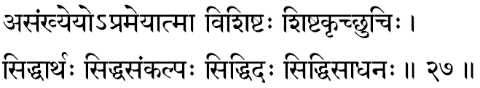
247. Asankhyeyah -Sankhyaa means number; Asankhya=numberless. Asankhyeyah is one who has numberless names and forms. The infinite variety of things and beings that constitute the manifested Universe are all His Own Form, and hence He is indeed numberless, whom He expresses Himself as the Universe. In the 11th Chapter of Geeta, we see through Arjuna’s eyes the Cosmic Form of the Lord. Of boundless forms on every side with numberless arms, stomachs, mouths and eyes-neither end nor middle, nor beginning do I see, O Lord of the Universe.
248. Aprameya-Atmaa -Prameya=Pramaana Vishaya-anything that can be known through any of the “Sources-of-knowledge”-direct or indirect. Atman, the Self, cannot be apprehended by the intellect through any of the known “Sources-of-Knowledge” (Pramaana) and so He is called as Aprameya. One who has this nature is the Self, Aprameya-Atmaa, Sri Narayana.
249. Visishtah -The One who transcends every- thing, in His Glory is the Supreme (Visishtah). Something that is other than the three bodies, something other than the five kosas, something definitely different from the finite world of perishable things is the Infinite Self-which cannot be defined in terms of either the waking or the dream or the sleep conditions. The Self is something other than all these:
This Supreme-most Troth is Maha Vishnu.
250. Sishtakrit -One who governs; One who is the Law Maker and the Law that governs the universe. The goal of His administration is the protection of the good (Sishtah). Maha Vishnu is the Governor of all, and the Protector of the good.
251. Suchih -One who is Pure. The immaculate Reality which is never contaminated by the Maayaa and its by- products is Maha Vishnu. When dirt (Mala) exists upon anything, it becomes unclean. In the Absolute Oneness there can be nothing other than itself and therefore the Fourth-plane-of- Consciousness (Tureeyam) is indicated in our Scriptures as the Transcendental Ever-Pure Self, Sri Hari.
252. Siddhaarthah -One who has gained all that has to be gained and achieved all that has to be achieved. That which has to be achieved in life during an individual’s existence have all been classified under four heads and they are called as the four “aims of life” (Purushaartha). Theyare Righteousness in conduct, (Dharma), Wealth and Possession (Artha), desires and ambitions (Kaama), liberation from imperfections (Moksha). One who has gained all these “four” have nothing more to gain as there cannot be any sense of imperfection in Him. One who has gained (Siddhah) all that has to be gained (Arthah) is Siddhaartha, Lord Vishnu.
253. Siddhasankalpah -Sankalpa means “intellectual willing and wishing”. One who gains all that He wishes for, or One who immediately gains what He wills is called Siddha-sankalpah. Ordinarily we fail to gain what we demand because of the disintegration within ourselves. The Lord, the Perfect, is One who instantaneously gains all that He wishes; hence the Upanishads define Him as the Satya Sankalpavaan. This great Paramesvara of the Upanishads is the Maha Vishnu, the theme of the “Thousand Chants’ (Sahasranaama).
254. Siddhiddah -One who is the Giver of the appropriate reward for all actions, for those who are doing spiritual practices. Lord Narayana is the great Universal Power that brings about the reward for all actions.
255. Siddhi-Saadhanah -One who is the very secret force which enables the seeker to diligently continue all efforts of his seeking. Siddhi ordinarily means “fulfilment”, here it means all efforts at a given fulfilment. It is also interpreted by some as the One Mighty Reality, to worship at whose altar is the very means (Saadhana) for all achievements (Siddhi), and this is Sri Narayana.

Stanza 28
vrishaahee vrishabho vishnur-vrishaparvaa vrishodarah
vardhano vardhamaanascha viviktah sruti-saagarah.
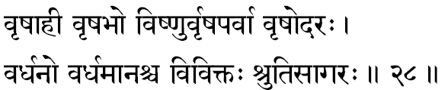
256. Vrishaahee -The term Vrishah is very familiar with the ritualistic portion of the Vedas and it connotes objectively the sacred “Left over” after the Yajna functions. Subjectively, Vrisha means the residual ‘results’ gathered in the personality after each devoted and dedicated act of offering, during all Self-less services (Yajnas). Therefore, Vrishaahee means “One who is a controller of all actions and the dispenser of all results”, in all individual, conscious, intelligent creatures.
257. Vrishabhah -The term Vrisha though not very familiar now is used in the Vedic literature to indicate Dharma-“the essential nature of a thing without which the thing cannot remain as the thing” is its Dharma. One who showers all Dharmas is called Vrishabhah. In short, one who showers glowing health, burning devotion and thrilling silence on all sincere seekers and faithful devotees is Vrishabhah; and He is Sri Narayana.
258. Vishnuh -All-Pervading: Long-Strident. We had already explained this term earlier (2). In Mahabharata we also read the Lord Himself explaining to Arjuna, “Because I stand striding across the Universe (Kramanaat), O Partha, I am known as Vishnu.” -(Mahabharata 12-350-43).
In the Upanishad also we read, “Vishnu has spread Himself and conquered all these three worlds.
259. Vrishaparvaa -We had already explained that Vrisha means Dharma. The term Parvam means “Ladder”, “a flight of steps” that takes us to the Higher floors (Hence Parvata means mountain). Thus, here, the term is explained as a flight of steps on the ladder of life to take one to the Ultimate Reality, the Eternal (Sanaatana) Dharma: “1 am the way”. Vishnu is the One to worship at whose altar will facilitate the devotee’s steady evolution towards the experience of the Higher consciousness.
260. Vrishodarah -Vrisha, that which rains; Udara = belly. The idea here is the seat of all-creative thinking is resting on a psychic, centre, roughly indicated by the navel, and hence we find the description that the total Creator of the universe is sustained and held aloft at the navel of Maha Vishnu. During Pralaya (sleep) the “creative power” merges back to its source, and thereafter, upon waking, the creation again starts; the creative power” manifests itself and continues its creative activities, from the same point of Its merger, (Udara). This culminating point of all creation, during the time of the dissolution-which is also the same from wherein, during creation, the manifestations of names and forms spring forth (shower down = Vrisha)- is Vishnu, the Supreme, and hence, He is called as Vrishodarah, “the Showering Belly.”
261. Vardhanah -One who is the nurturer and nourisher everywhere, at all levels of life, both material and spiritual. In short, from the standpoint of the student, who is studying with devotion these “Thousand names of the Lord”, the term indicates that Vishnu is the Mighty Power that supplies all spiritual growth, provides all well-being and ultimately blesses all His devotees with the final Realization.
262 Vardhamaanah -One who can grow Himself into any dimensions; ever-growing. Since the names and forms of the universe are ever dynamic and has the unseen movement of progressive evolution everywhere, the Lord is indicated here as this very “dimensional movement of progress” (Vardhana). (The Pauraanikas attribute that this name came to Him because He in His Vaamana incarnation grew
Himself to measure under His three steps the whole universe.
263. Viviktah -Alone=solitary. Every standing apart from everything. With reference to the dream and the dreamer, the waker is, we knew, indeed, separate. Similarly the world of names and forms and its joys and sorrows, passions and lusts, smiles and tears, though they all play in the Self, the Supreme is not affected by them.
The horrid “ghost” cannot affect the innocent “post”. One who thus remains alone and apart, in His Own Majesty and perfection, even when the world-of-Maayaa is heaving about is Viviktah. In the daily happenings of Samsar, in its births and deaths, He remains ever changeless and ever unaffected. This freedom is indicated in the Geeta and the Lord explains: “They are in me; I am not in them
264. Srutisaagarah -The ocean for all the rivers of all scriptural thoughts. All scriptures, irrespective of the age, language, tradition and beliefs, ultimately indicate a Theme which is ever the same. All scriptures are rivulets of thoughts, flowing through different terrains of national character and historical climates, gushing to reach forward the ocean of Perfection, which lies beyond the dark sorrows of mortality. That which is the goal of all Scriptures is the Immortal Bliss of God-consciousness, the Maha Vishnu.

Stanza 29
subhujo durdharo vaagmee mahendro vasudo vasuh
naika-roopo brihad-roopah sipivishtah prakaasanah.
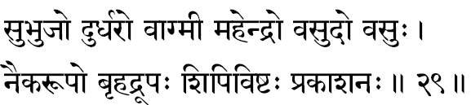
265. Subhujah -He who has graceful arms. This need not be taken as a description of the physical beauty of the anatomical structure of the arms but since those arms are ever working in the service of His devotees on sheltering them (Abhaya) and in blessing them (Varada) they are full of grace and hence graceful.
266. Durdharah -One who cannot be comprehended even by Great Yogis, who spend long periods of time in meditation. Transcending the mind and intellect is the “experience” of the Supreme and, therefore, the mind and intellect can never comprehend It.
267. Vaagmee -One who is eloquent of His Glory. The full sense or the term should embrace not only the eloquence in speech, but all physical capabilities in the world, all the Glories or the cosmos, all the beauties or the heart, the total might of the intellect-all are eloquent of His Glory. Through the scriptures of the world, it is again He, who speaks to us of our ultimate Harbour beyond the stormy seas; of Maayaa, in the simple words of brilliant suggestions declared by the Saints, Sages, Rishis, Prophets and other Divine Men.
268. Mahendrah -One who is Lord of even Indra, the Lord or gods. In philosophy the “Mind” is called lndra (lndriyaanaam Raajaa) and One who is the Lord of even the “mind” is the Self.
269. Vasudah -Vasu means wealth and, therefore Vasudah means One who enriches all, both in their outer prosperity and in their inner well-being. Once surrendered unto Him man learns to live ever in dynamic success, with all the glories of the loving heart, self-controlled mind, and contemplative intellect.
270. Vasuh –The term Vasu has got three meanings: Wealth (Dhana), Veil (Aacchaadana) and Sun (Aaditya); thus He is the One who manifests Himself in the form of the external wealth, for He, as the very sun, nurtures and nourishes the world. He is the One, who veils Himself from the comprehension and understanding of the unprepared men of evil temperaments and who possess no true devotion.
The term Vasu also can mean “One who lives in” (Vasati iti) all things and beings of the universe; or it can also mean as “One who allows all things and beings to exist in Himself” (Vaasayati iti). In Geeta and in the Upanishads we find the Infinite described as the very Indweller everywhere in His Eesvara status, and as the very substratum for the universe in the Pure Transcendental nature.
271. Naikaroopah -One who is of Infinite forms in his manifestations; the single waker’s mind becomes itself variegated to serve as the endless items of the dream-world. The One Supreme “Cause” of the whole Universe is Vishnu; and all “effects” are but different expressions of their “cause”. In a very familiar chant, traditionally repeated by all devotees, this Idea has been brought out beautifully.
Looking at Him through our distorting instruments of body-mind-intellect, we see the plurality, and only on transcending this equipment can we “experience” the Oneness of the Absolute Reality.
272. Brihadroopah -Vast of Infinite dimensions; pervading all. One whose very form (roopa) is the totality of the universe and therefore as vast as the universe, nay, in the description of the Supreme Person in the Rig Veda (Purusha- sookta) we read the Rishis declaring that Vishnu is not only of the total size and dimension of the Universe but He stands beyond it all by ten digits. – “Atyatishthat Dasaangulam”.
273. Sipivishtah -Sipi is the name given to the “Sacrificial cow”. The term denotes the One who sanctified all dedicated offerings poured into all fields of selfless sacrifices (Yajna). The root Si has also the meaning of waters; Sipi-‘that which drinks water’ –“The rays of the Sun”. Thus Sipivishtah would indicate the Supreme, who is the Presiding deity in the Sun, giving it both its energy of heat and light. In Geeta, the Lord confesses: “Understand that the light and energy that expresses themselves through the sun and moon is the Light and Glory essentially belonging to Me”.
274. Prakaasanah –The One who illuminates; expressing Itself as the All-pervading Consciousness in every equipment. He is the knower, knowing everything in each bosom (Sarvavit) and knowing all things that are happening in the universe at one and the same time in His omnisciency (Sarvajnah). He is the Illuminator of all experiences. Just as the One sun illumines everything in the world the Reality illumines both the fields of experiences and the knower-of- the-field.

Stanza 30
ojas-tejo-dyutidharah prakaasa-aatmaa prataapanah
riddhah spashtaaksharo mantras-chandraamsur-bhaaskara- dyutih.
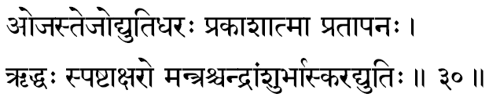
275. Ojas-tejo-dyutidharah -One who is the possessor (Dharah) of Perfect physical virility (Ojas), all brilliancy (Tejas) and every beauty (dyuti). These three terms indicate perfection at three different levels of personality known to us at present. Ojas is glowing health (physical) due to perfect balance in the constituents (Tattvas) of the healthy body. This virility in us when conserved, disciplined and trained can, through meditation, be converted into intellectual “brilliancy” and perfect personality “integration”.
The shine of an individual, who has thus sublimated Ojas, is termed in our Sastras as tejas. A Yogi, through intelligent living and through a devoted life of continued meditation, has thus gathered to himself ojas and Tejas sufficiently, he, in time, grows to become an experienced Saint of Divine Realization, a Buddha. The enchanting atmosphere of irresistible peace and compassion, love and perfection, knowledge and strength, such a man throws around him, is called the aura of Divinity (Dyuti). In the lOth Chapter of the Geeta, the Geetacharya autobiographically confesses, “I am the Might in all strength; I am the Brilliancy in all that is brilliant.”
Some commentators are found to take these three terms as separate names of the Lord. However, Sankara interprets it as one single term.
276. Prakaasaatmaa -The Effulgent Self. The One who is the Self in all hearts, who can be experienced as the Consciousness, which is the source of all illumination to shine upon all experiences in the three planes-of-consciousness, in all living creatures, at all times. This Universal and Absolute Self is Maha Vishnu.
277. Prataapanah -The One who manifests Himself as the Essential Thermal Energy, that lends Life Potential to the very atmosphere around each living creature. In the words of the Geetacharya, we find a confirmation to thus declaration when the Lord declares to Arjuna that He Himself is the Reality that manifests as the heat and light in the Sun and the Moon, and it is He again who warms up the crust of the earth and impregnates it with its fertility. (Geeta XV-12 & 13).
278. Riddhah -One who is ever full of all prosperity. As the very Lord of Lakshmi, Vishnu should be one who has all glories (Aisvarya). When the entire universe of wealth, strength and beauty is itself a manifestation from Him, He Himself must be the Absolute Glory.
279. Spashta-aksharah -Spashtam=clear. One who is clearly indicated by the Supreme Sound (Akshara), the famous Sound-Symbol of the Eternal Lord Om. In Geeta we read: “One who chants my name Om and leaves his body at the time of death thus remembering Me, he shall go to the Supreme State” In Sanskrit, Kshara means the “Perishable” and Akshara means the “imperishable.” The world of plurality, the “perishable” is no doubt nothing other than the All-Perfect, the Immutable Truth, but due to the imperfections of the instruments-of-perception-body, mind and intellect-the perceiving ego can experience only this world constituted of a plurality-sense objects, emotions and thoughts- The ego peeping through the vehicles can never experience the One co-ordinating Reality, the Divine. When the mind is hushed and the ego thus sublimated, the Immutable Akshara-factor is experienced, wherein we gain the clearest (Spashta) understanding of the Absolute. Since it is thus clear (Spashta) only in Its Immutable nature (Akshara=Kootastha), Vishnu, the Supreme Self, is indicated here as Spashtaaksharah).
280. Mantrah -One who is of the nature of the Mantras of the Vedas. The declarations of the Vedas the mantras are the vehicles that will take us straight into an experience of the Transcendental. The vehicles are often called by the nan1e of their destination. Mantra means that which can save us on being properly meditated upon. Only through the mantras of the Upanishads we ever come to experience the Supreme Nature of the Lord, and so He is named as Mantrah.
281. Chandraamsuh -Rays of the moon. That the moonlight has got an effect upon the herbs was known to India in the Vedic period. “As the rays of the moon (Soma) I fill the vegetable kingdom with nutrition”, confesses Bhagavan Vaasudeva. Thus the Lord is One who nurtures and nourishes all living creatures instilling into each its particular vitality. Though this is the deep philosophical significance, superficially the beauty, calm and peace that the moon suggests to our mind is but a reflection of the Infinite Peace of Vishnu.
282. Bhaaskaradyutih -The Effulgence of the Sun. Sun is the centre of the solar system, an eternal exchequer of energy, ever distributing Life and Strength to all living upon the earth; life would have been impossible but for the Sun. At the same time, the Sun stays where he is and he never interferes with life; from afar he blesses life. The Lord who thus from afar blesses by His mere presence is the true Sun of Life, the Atman, the Self- Sree Maha Vishnu.

Stanza 31
amritaamsoodbhavo bhaanuh sasabinduh suresvarah
aushadham jagatas-setuh satya-dharma-paraakramah.
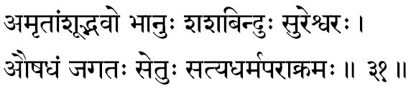
283. Amritaamsoodbhavah -The moon who has consoling rays that gives the essential food value (Rasa) to the plants and fruits is called in Sanskrit as Amritaamsuh. In the Puranas it is described that the moon was first born from the milky-ocean during its churning. Since Vishnu is described as ever reposing upon His Ananta-bed in Ksheerasaagara, the Lord is Himself termed here as the Begetter of the Moon. Subjectively Moon (Mati) is the Presiding Deity of the intellect, and the discriminating intellect itself arose when our bosom started churning the heart by the two forces, the positive -the good (Deva) -and the negative -Vicious (Asuras). If the Sun is the Presiding Deity of energy, moon represents the world of matter, and the very source from which the world-of-matter, Kshetra, has risen is Amritaam- soodbhavah.
284. Bhaanuh -Self-Effulgent; One who expresses Himself for the blessing of the world in the form of the Sun and presides over the entire solar system.
285. Sasabinduh -The patch in the moon looks like the silhouette of a rabbit for the naked eye; that which has a “beauty-spot” (Bindu) in the shape of a rabbit (Sasa) is called Sasabindu -the moon. Since the Lord is the Nourisher of all and He is Himself the entire world of matter, He Himself is the Moon “that nourishes with essence all plant kingdom”.
286. Suresvarah -Sura means Deva and so the term indicates “the God of all gods”. The word Sura also can be dissolved to mean Giver (Ra) of Plenty (Su); Sura therefore stands for a person of extreme charity .The Lord, Eesvara, who prompts and fulfils the loving kindness of all charitable men is Suresvarah, Lord Vishnu.
287. Aushadham -Medicine. Narayana is the Divine Medicine for the immediate cure for all the burning sorrows of Samsar. Even to consider it more directly as the specific cure for all bodily ailments is not necessarily wrong, for ailments of the body are caused by mental disintegration, and when the inner man has surrendered in devotion to Him, Lord Narayana indeed becomes a specific cure for even all the physical diseases of His devotees.
288. Jagatassetuh -A reclamation bund thrown across waters connecting distant islands to the main land is called Setu. Sri Ramachandraji built one and reached Lanka. The term Jagatassetuh, therefore, implies that the Lord is Himself the Bridge over which one can safely cross over the realm of egocentric imperfections and reach the joyous realms of the Infinite Perfection.
289. Satyadharmaparaakramah -One who champions heroically for Truth (Satya) and Righteousness (Dharma). It can also imply as One who has Truthfulness (Sat yam), Righteousness (Dharma) and Heroism (Paraakramah) .In short, Lord is One, who fights constantly against the false and the unrighteous to establish Truth and Purity.

Stanza 32
bhoota-bhavya-bhavan-naathah pavanah paavano-analah
kaamahaa kaamakrit-kaantah kaamah kaamapradah prabhuh.
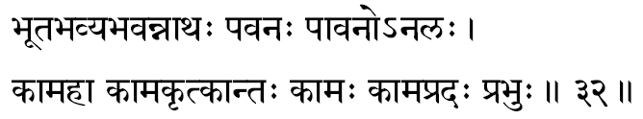
290. Bhoota-Bhavya-Bhavan-Naathah - The Lord of the three periods of time: the past, the present and the future. Lord of Time is the One, in whose presence alone, time concept is possible. “Time” is the interval between “thoughts” and the Awareness that illumines the rise and fall of thoughts is the very Lord of Time. Objectively He is the Lord of all those, that exist in the three periods of time; or He to whom all creatures conditioned by time, pray for comforts, solace and protection.
291. Pavanah -One who purifies everything. Or One who manifests as the life-giving atmosphere around the world and sustains the existence everywhere.
292. Paavanah -In the earlier term “Pavanah” the Lord is indicated as the One who has, in the form of the atmospheric air, filled the universe. He is the One who sustains life in all living creatures as the life-giving atmospheric air. Here, the present term “Paavanah” means the One who gives this life-sustaining power to the atmospheric air. It is very well-known that the moving air (Breeze) purifies more than any other known thing in the world. This purifying power is acquired by the atmosphere by His Grace. In short, He is the secret glory that lends the atmosphere, the very life-sustaining property for the air, and He is the dynamism that moves the air.
293. Analah -The term itself means Fire. So He who is in the form of fire, and sustains life. A certain amount of minimum thermal heat is necessary for life to continue, be it in the human body or be it in the Earth itself. This warmth of life in the world around and in the organism itself, without which life cannot continue. that mighty warmth of life is none other than the Lord, and hence, He is called Analah. Also the term ‘Ana’ has the meaning of Praana, and ‘La’ means to receive. Therefore, the term can also imply “One who is the very Self, the very Vital Factor, in the Praana”.
294. Kaamahaa -One who destroys all desires. Desires spring forth from the Vaasanaas. We can experience the Self only on transcending the vaasanaas. Just as the sun is the destroyer of night, similarly, the Pure consciousness, the Atman and the Vaasanaas cannot remain at the one and the same time. The Vaasanaas end when the Atman is experienced. From the devotees’ stand-point, He is the One who fulfils all his desires. Or He who is the father of Kaama, Pradyumna, which again is one of the names of Vishnu.
Desire is the source from which endless series of other sources of sorrows flow into the human life. When a desire arises in the mind, only two things are possible. Either we fulfil the desire or we do not. In case we get our desires fulfilled, it is natural for the human mind to crave for more and thus he becomes restless due to greed. If, on the other hand, the desire is not fulfilled, anger rises and when anger increases, it brings about delusion of the mind and makes the victim see things in others, in himself and the situation he is in, which are not in fact there around him. In such a deluded one, Wisdom slips away and, naturally, therefore, his discriminative power cannot function, since he cannot judge the present situation with reference to any standard ideal that he had in the past. When the rational discriminative power fades away that man falls completely off the dignity of mall and becomes worse than a brute. Geeta charters thus, a steady psychological fall in a spiritual being, and this entire chain of self-destruction springs forth from desire. A devotee, or a meditator, when he approaches this Great Reality, existing in the subjective Core of his own personality, he transcends all the realms of his desires and passions and, therefore, this Great Inner Self is indicated here as the “Destroyer of all Desires”. He is the One who fulfils all desires in His devotees, and thus bring about a calm fullness of joy within.
295. Kaama-krit -One who fulfils all desires. The implications have been indicated in the analysis of the previous term. It can also mean as the Very Creator of the Lord of Love-Kaama Deva. Even though desires spring forth from the realm of the Causal Body, constituted of the Vaasanaas without the thrilling touch of the Self, even Vaasanaas cannot express all by themselves. In that sense of the term, the very agitations of desire, erupt from His Grace. Hence, He is called the Kaama-krit.
296. Kaantah -One who is of enchanting form. Infinite Beauty is the very nature of the Self, and the Upanishads define the Self as Saantam-Sivam-Sundaram.
The aestheticism in man craves for harmony and where we experience the greatest of harmony, there we detect the presence of beauty. In front of beauty, the entire personality of an intelligent man becomes calm and peaceful, hushed in silence, transported to ecstasy. These are moments when the meditator has transcended his Sheaths and is in union with the Pure Self. Naturally therefore, the Pure personality of an intelligent man becomes calm and peaceful. Self is indicated here as Kaantah-Divine Auspicious form of Absolute Beauty.
297. Kaamah -One who is the beloved. Not only He is the beloved of the devotees, but every activity of all living creatures is an attempt at courting and winning bliss and happiness. The Blissful Self is the goal of all creatures in life. Even insignifical1t unicellular organisms revolt against pain, and they too seek happiness. Man is no exception. The Infinite Bliss which is experienced only on transcending the body, mind and intellect, is that which is constantly demanded by every organism that breathes in this universe. In the ignorance of this All Satisfying Goal, the world suffers. That Lord is the beloved of all devotees, and in fact, He is also the beloved of even those who deny Him and run after the sense- objects. The theist seeks Him through devotion or meditation. The atheist too seeks Him only in and through all his diligent pursuits of the sense-stimuli.
298. Kaamapradah –One who supplies the desired objects; One who fulfils all desires To the devotee, the Lord, is the giver of all desired objects, and to a man of meditation, the Lord is that state-of-mind where all desires are fulfilled- in the sense that no more can any desire linger in his heart after the Experience-Divine
299. Prabhuh -He is the Lord, the Master, the Owner, the proprietor. One who has all powers to do, not to do and to do otherwise is called the Great Lord.

Stanza 33
yugaadi-krit yugaavarto naikamaayo mahaasanah
adrisyo vyaktaroopascha sahasrajit anantajit.
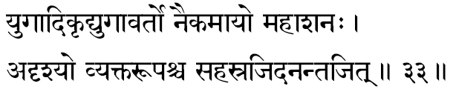
300. Yugaadi-krit -One who is the creator of the divisions of aeons, described in our Puranas, as Yugas. These Yugas are four in number. Kritam, Tretaa, Dvaapara and Kali. In short, He is the Lord of Time. By the term Aadi, it must be understood to indicate all other divisions of Time as Centuries, Years, Months, Weeks, Days, Hours, Minutes and Seconds. He is not only the Lord of the Yugas, but He is the Light of Consciousness that illumines the duration of each experience and the very interval between every pair of subjective experiences.
301. Yugaavartah -In the previous term the Lord is indicated as the Creator of the Yugas, and here we are told that He is also the Power behind the wheel of time that goes on changing and repeating itself, i.e. not only He is the Lord of Time, but He is the Mighty Administrator of the performances of Time, the very Law behind the constant flow of the flood of time.
302. Naikamaayah -One whose delusory forms are endless and variegated. According to Puranas, for the sake of sustaining the world and maintaining its order and rhythm, the Lord had taken different forms, each of His manifestations well-suited for the times of His arrival. Thus, we have ten in- carnations. Also, in that mighty manifestations of the Lord, as Krishna and Raffia, we find descriptions of how one and the same entity generated different attitudes and emotions in different types of people. In short, one who has realised the Self, can thereafter freely play through all his existing Vaasanaas and none of them can ever entangle him, because he has grown to be the master of his own Vaasanaas. Maayaa, otherwise called as Avidyaa, is constituted of the Vaasanaas in us, forming our Causal Body. One who has transcended this is the One who has realised the Infinite. Lord is therefore, one who is without Maayaa in Him. An individual entity, like us, is one who is under the tyrannies of Maayaa. The Lord is one who can wield Maayaa for His purpose without Himself becoming involved in it.
303. Mahaasanah -This word can be dissolved as He who eats up everything. One who swallows up all perceptions, emotions and thoughts, created by the Vaasanaas, at the various levels of personality, due to our own individual Vaasanaas. At the time of Samaadhi when the limited ego is ended and the Supreme is experienced all the expressions of Vaasanaas are, as it were, swallowed by that Infinite Experience, and therefore, this Great Vishnu is called as the “Consumer of Everything.”
304. Adrisyah -Through the sense-organs, the mind and intellect at this moment, we are aware of the outer objects and our subjective emotions and thoughts. The ultimate Reality is neither the objects perceived by us, nor the instruments of our perception. He is the Subjective Core, the Eternal Essence, wherein, the perceived and the instruments of perceptions are all totally absent. This Subjective Reality must necessarily be, by Its very nature, not an object-of- perception, and hence, It is called as the Imperceptible meaning, He is the very Perceiver in all perceptions.
305. Vyakta-roopah -He who has a form- clearly perceptible to the meditator in his meditation. The contradiction is so smotheringly apparent because of the very placing of the term. It is only just-now, in the above term, that we are told that the Lord is imperceptible (Adrisyah) and the very following term declares that He is perceptible. Here it means that though He is not perceptible with the physical instruments of perceptions, yet on transcending the equipments, the Yogi intimately comes to experience the entire Divine Glory of the Self. Though, ordinarily it is not easy to see Him, in the devotee's heart, the Lord comes to play vividly and drives the devotee mad in his ecstasy.
306. Sahasra-jit -One who vanquishes thou- sands. In all the Puranas everywhere, it is found that the Incarnations manifest to destroy the diabolically fallen (Raakshas) who approach the good in endless hoards to annihilate them. One who conquers over these diabolical forces is the Lord Vishnu.
Subjectively the hosts of passions and lusts, greeds and jealousies which invade the inner bosom, and loot away the seeker’s tranquillity and peace, are all ultimately vanquished by this Higher Consciousness and therefore, the Self is indicated as the one who is ever victorious over all the hoards of our lower impulses.
307. Ananta-jit -Ever-victorious. The victory of the Lord is endless; in every Incarnation, He alone wins in the end. The victory over negative forces becomes complete when once the Higher Consciousness is experienced, and hence, the Self is indicated here as Ananta-jit.

Stanza 34
ishto visishtah sishteshtah sikhandee nahusho vrishah
krodhahaa krodhakrit kartaa visvabaahur maheedharah.
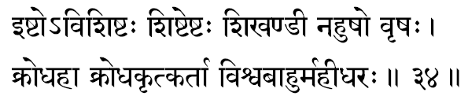
308. lshtah -This term can be interpreted in two ways. One who is invoked through the different types of Vedic rituals (Yajnas), is Ishtah. Or, it can also mean, One who is loved by all. The Lord being the very centre of all love in everyone. The Brihadaranyakopanishad very clearly indicates this idea in almost unvarnished words: “The man loves his wife not because of the wife, but because of himself. ...etc.”
All love spring from our personal love for the Infinite which is the Self in us.
309. Visishtah -One who is the noblest and the most sacred. Vishnu, the Lord, dwells in the heart of every- one. He is the sole essence presiding over every physical, mental and intellectual activities in every living creature and, therefore, He is indicated by this term.
310. Sishta-ishtah -To all spiritually minded good people and therefore sincere seekers, the Lord is the greatest beloved in-as-much as, He represents the Goal and the Destination of all devoted seekers. In short, He is the Supreme Beloved for all spiritually inclined divine hearts.
He can also mean that the Lord is one who Himself is sincere and ardent lover and courtier of all devotees, sincerely and diligently seeking Him. There are commentators who indicate that the term can also mean: One who is being constantly invoked and help in adoration by all true devotees with their physical, mental and intellectual activities.
311. Sikhandee -One who wears ‘Sikhanda’ meaning “the peacock feather”, Lord Krishna is described in Bhagavat as having adorned with the ‘eye’ of the peacock feather, especially in his early child and boy-hood.
312. Nahushah -The term “Nahanmn” means bondage, therefore, the term stands for “One who is familiar with bondages,” ln Vedanta, the word ‘Isvarah’ is the Supreme Consciousness conditioned by the total- Causal-Body (Maayaa); at the same time, Isvara is One who has the Maayaa under His control, It can also be understood as “One who bind, all creatures of the world with the cord of Maayaa.” Those who are students of the Puranas interpret this word as One whose glory was expressed in the spectacular magnificence in Nahushah, who gained the Office of Indra.
313. Vrishah -There is a famous statement in the Hindu tradition from which we can gather that the Lord is of the nature of Dharma. Dharma means the essential Law of Being, that because of which an individual is an individual, without which the individual cannot exist, is the Dharma of the individual. In this sense, the essential Dharma of one is the Self. Thus, Vrishah is but another name to suggest that the Lord Vishnu is none other than the Self in us. It can also mean “One who showers the fulfilment of all desires in all devotees.” Desires arise when the existing Vaasanaas get impatient and explode into manifestation. As the desire arises, the mind plans out and the body acts towards its fulfilment. All these activities are possible only when the vehicles are thrilled by the Self in us. Thus, ultimately, one who fulfils all desires is the Lord of our heart, the Atman.
314. Krodhahaa -One who destroys anger in all sincere seekers. We have already found earlier that anger manifests when fulfilment of a deep desire is obstructed. On realising the Lord, all desires end and, therefore, there cannot be any anger on any occasion. Also, anger can come only when we recognise the world of plurality around us. For one who is experiencing the Self, there is nothing but the One Self everywhere and, therefore, there is no occasion to entertain this emotion of anger.
315. Krodha-krit-kartaa –One who generates in a sincere and serious seeker anger against the lower tendencies when they manifest-”Krodha-krit”. Also He is the very creative impulse ‘Kartaa’ behind the lower tendencies; because all things come out from Him alone. Some commentators consider this term as two different words, but the majority consider them as an integrated one.
316. Visvabaahuh -One who has number of hands; whose hands are everywhere doing all activities in the universe. The life in the bosom as long as it exists, so long alone the hands and the legs function. The hands can lift and do its job only when it is in contact with life. Life expressing through the hand is its function. All hands that are doing variegater activities all over the world are all His hands in-as- much as, where He is not, that lifeless hand can perform no more any activity. Since He is thus the dynamic One Principle that functions through all hands at work, He is called a Visvabaahuh.
317. Maheedharah -One who is the Substratum and support for the Earth. The Lord is the very material cause for the universe and as such, He supports the world-just as cotton supports the cloth, mud supports the pot, gold supports the ornament. Since the term Mahee also means “the adorations sent up by the devotees,” it can also mean ‘One who receives all the worship of devoted hearts.’

Stanza 35
achyutuh prathitah praanah praanado vaasavaanujah
apaam nidhiradhishthaanam apramattah pratishthitah
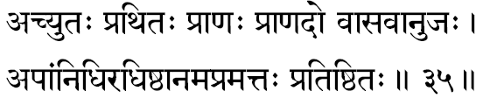
318. Achyutah -One who has not got any modifications (Chyutam) such as birth, growth, decay, disease, death etc. The Eternal and Immutable cannot have any change and the Self being the Eternal, it cannot have any of the changes that are natural to all mortal and finite things, Upanishads themselves thunder this Truth-“Eternal, Auspicious and Changeless”.
319. Prathitah -One who exists pervading all; spreading Himself everywhere. It can also mean “One whose glory, as described in the Upanishads, has spread round the world everywhere.”
320. Praanah -All manifested expressions of life are called as the Praana. He is the Praana in all-living creatures; meaning, it is His manifestations that we recognise as the endless activities in all living creatures in this dynamic world. Also it can mean that “He is the One who in the form of vital-air, sustains life in all creatures.”
321 Praanadah –One who gives strength (Praana) to everywhere The root ‘da’ has a meaning of destruction and, therefore, the term comprehends also the power of destruction everywhere According to the Puranas, therefore, He is the One who gives the strength and glory for Devas, and again, He is the One who supplies special strength to them to win over the brutal forces of the diabolically wicked, the Asuras Subjectively, it is the Self that supplies the mental strength for cultivating the higher values of life, and it is the same Source Divine that floods the seekers heart with the courage to annihilate the lower impulses that come to destroy his peace and tranquillity within
322. Vaasavaanujah -the brother of the Indra. This name has been acquired by lord Vishnu because of his incarnation as the Adorable Dwarf-(Vaamana). At that time, the Lord had to take birth in the womb of Aditi and manifest as the younger brother of Indra. In the subjective science of Vedanta, the king of the gods (Indra) is the Lord of the sense organs and so he is the Mind. The spiritual urge that dawns in us as a younger brother of the Mind, ultimately comes to measure away and win over the three worlds of waking, dream and deep-sleep, and thus comes to conquer over the entire kingdom of Indra in more sense than one.
323. Apaam-nidhih -Treasure of waters, meaning the ocean. The very glory and might of the oceans are all but a reflection of Sri Narayana’s own glory divine. In the Geeta, Bhagavan Himself says, “among the collections of waters, I am the Ocean.”
324. Adhishthaanam - the substratum for the entire universe. The delusory misconceptions can be projected only upon something that is real and this permanent ‘post’ is called the ‘substratum’ for the desulory ‘Gost’-Vision.
325. Apramattah -One who has no Pramaada, meaning, ‘One who never commits a mistake in judgement.” The Lord is the Law behind all happenings in the universe. The results of the actions are always strictly according to the quality of the actions. In administering this Law of Karma, One who never makes any mistake is Apramattah. We are full of Pramaada -we make the mistake of misunderstanding ourselves to be the matter equipment around us and due to this Pramaada, we project in ourselves the false concept of an Ego The Supreme is ever the Pure Consciousness and, therefore, He is without such wrong self-judgement.
326. Pratishthitah -Everything in the world depends upon something else to serve as its cause. Since all things that we perceive and experience in the world are all effects, they have their own causes, and the effects must necessarily depend upon the cause for their very existence. The Supreme Lord is the One uncaused Cause with reference to whom everything is only an effect. Since He is thus the ultimate Cause, He is not depending upon anything other than Himself. This self-established Reality is indicated by the term Pratishthitah.

Stanza 36
skandah skanda-dharo dhuryo varado vaaryuvaahanah
vasudevo brihat bhaanur aadidevah purandarah.
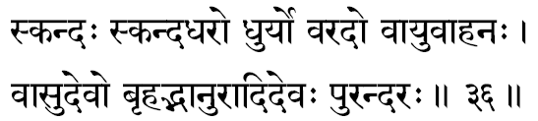
327. Skandah -This is one of the names of the youngest son of Lord Siva, Subrahmanya, who is described in the Purana as Commanander-in-Chief of the righteous army. Therefore, Skanda means “the Lord, whose glory is expressed, through Subrahmanya”, In order to realise the Self, it is a prerequisite condition that the different personality layers in the seeker should be completely integrated.
328. Skanda-dharah –“One who upholds the withering righteousness.” Or, “One who fathered Lord Subrahmanya”, meaning One who is in the form of Paramesvara.
329. Dhuryah -One who carries the Lord. The Lord is the One who carries the responsibilities of creation, sustenance and annihilation of the entire world of plurality. One who carries out these functions systematically without any hitch round millenniums is Sree Narayana and He is therefore Dhuryah.
330. Varadah -One who blesses all true devotees and fulfils their request for boons. It can also mean “One who gives the best (Varam) in life to those who seek Him with perfect detachment and sharpened discrimination.
331. Vaayuvaahanah –“The One who controls, regulates and moves the great winds”. In the Sanskrit literature, the movement of air in the atmosphere has been classified under seven types and they are called the ‘Sapta Marutah’.
In short, the inconceivable might and power of the winds and their life-sustaining abilities are all lent out to the air by His own munificence and, therefore, He is called as Vaayuvaahanah.
332. Vaasudevah –“One who is at once both Vaasu and Deva. Vaasu means “One who dwells in the physical equipments of all living creatures as its indweller (Jeeva); Deva means “One who revels or One who illumines”. Thus, Vaasudevah means “One who lives in the physical equipment as though conditioned by them, and yet, who is the Vital Consciousness in the light of which every experience is illumined. The Lord is the One who dwells in all things of the universe and He is at once the Supporter of the entire world.
Also, directly, it can be taken to mean, One who is born as the Son of Sri Vasudeva in the Jail of Kamsa, the Blue-Boy of Brindaavana. He is called Vaasu as He veils Himself with His own Maayaa; Deva means “He who sports, wishes to conquer, conducts, shines, creates and moves”. In the Udyoga Parva of Mahabharata, we read, “Like the Sun with his rays I am covering (Deva) in all beings and hence, I am called Vaasudeva”.
Vishnupurana says, ‘‘as He resides everywhere in and through all things, He is termed Vaasudevah. “ All beings remain in the Supreme, and He in all being and hence, the Omnipresent is called the Vaasudeva.
333. Brihat-bhaanuh -Possessed of endless rays, meaning “One who illumines the world with the rays of the Sun and the Moon.”
Mahabharata says, “He whose great rays are in the Sun, Moon and others and He who illumines the universe through them is called the Possessor of great rays.
334. Aadidevah –“One who is the Primary source for everything,” meaning the Lord. He is the First Cause, and hence the first Deity.
335. Purandarah –“The destroyer of the cities.” City is the well-equipped field for gathering endless experiences. The three cities through which we generally move about gathering our experiences in this world are the waking, dream and deep-sleep, On transcending the Gross, Subtle and Causal Bodies, one experiences the Self, and at such a moment these three cities are burned down or pillaged or blasted, The same ideal is explained in the Shiva-purana also; accordingly, we can say that He is One who as Mahesvara, performed the destruction of the three cities.

Stanza 37
asokastaaranastaarah soorah saurih-janesvarah
anukoolah sataavarttah padmee padmanibhekshanah.
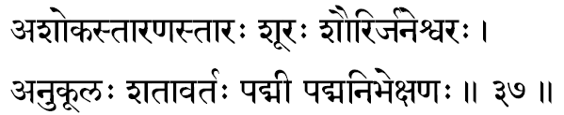
336. Asokah –“One who has no sorrows.” Sorrow is a condition experienced when the mind is agitated and extremely disturbed. The agitations of the mind come from desires, greed, etc. Therefore, the term Asokah indicates, “One who has none of these negative tendencies that create in their turn more and more mental disturbances”. This is a true appalation, because, the Lord, as the Self, transcends the realm of the thought-disturbances constituted by the mind-intellect- equipment.
337. Taaranah –“One who enables others to cross.” The ego suffering the constant agitations of the equipments is saved by the Self. The ego (jeeva), when it discovers its identity with the Self, automatically moves away from the sorrows of the vehicles. In short, as Vishnubhaagavata says, “who is there other than You that can save us from the wheel of birth and death.”
338. Taarah –“One who saves is called Taarah, One who saves from the fear of re-birth and also One who is a constant protector of the devotees and, therefore, the devotees themselves call Him as the Saviour (Taarah).
These three terms indicate how Vishnu is the Absolute Protector of His devotees. He saves us from the afflictions (Asoka) of the body and so Subjective-sorrows (Adhyaatma). He enables us to cross the ocean of Samsaara (Taaranah) and, therefore, He saves us from all Cosmic pains (Adhibhootah). He saves us from the elements (Taarah), and so, He is the Saviour from all sorrows of birth and death; this indicates all trans-Cosmic tragedies (Aadhidaivika), meaning that Narayana can save us from all sorrows contributed by the hand God.
339. Soorah –“The Valiant”. All sources of strength and courage spring from the Life in us and, therefore, the Lord of the universe is called here as the Valiant-capable of crushing all unrighteous forces, however well-trenched they may be in the world.
340. Saurih –Soorasena was the father of Vasudeva, and we have already found that Vasudeva’s son is Vaasudeva. Therefore, the Lord had taken His incarnation in the family of Soora and so He is termed as ‘Saurih’.
341. Janesvarah -The Lord of the people (jana). Those who are born are called Jana. Therefore the term indicates that He is the Lord of all creatures born the universe.
342. Anukoolah –“A hearty well-wisher, or friend of everyone”. Since the Lord is the Essential Life in everyone, He is the friend and ally of every individual in as much as, nobody spends his life except in concurrence with his own subjective intentions and purposes. Thus, the Lord is a friend fulfilling the intentions of a murderer, and He is again the friend of another helping Him to serve the mankind, if that be his intention. Thus, He is a friend and a devoted ally to everyone since He is the mighty power behind all Vaasanaas expressing through all creatures.
343. Sataavarttah -Sata means “hundred”, and here it is used as “innumerable”. Thus the term’ Sataavarttah’ means “One who takes infinite varieties of forms”. All forms in the universe are but His own, inasmuch as, His manifestation is the universe. Again, He takes innumerable incarnations in order to maintain the taw of the cosmos and also the law of evolution. It can also mean “One who, as Praana, moves in the innumerable Naadees in the body”.
344. Padmee –“One who has the lotus in his hand”. The lotus is the national flower in Bharat as it symbolises in our culture, the Goal of our Spiritual life. It is to offer this “Knowledge”, that the Lord blows His conch, and if people are not listening to this silent call of the Higher from within, He uses His gadaa (mace) to give merciful knocks in life. Still, if an individual or a generation is not listening to His kindly warnings, He has the Discus (Chakra) in His hand. He annihilates totally the existing forms and re-creates.
345. Padma-nibhekshanah –“One whose eyes are as beautiful as the Lotus.” In short, ‘lotus-eyed.’

Stanza 38
padmanaabho-arvindaakshah padmagarbhah sareerabhrit
maharddhi-riddhah uriddhaatmaa mahaakshah gantdadhvajah.
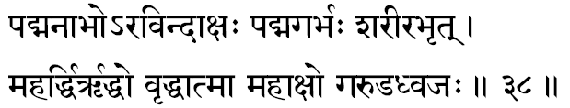
346. Padmanaabhah –“One who has the lotus in his navel”. This is not to be taken literally. Navel (Naabhi) is the psychic centre where all un-manifest thoughts first spring forth into our recognition (Pasyantee). The seedless state of all thoughts is called in the Yoga Sastra, as Paraa. It therefore means “one in whose bosom lies, in potential, all the possibilities of the universe of expression.” It can also mean “One who manifests Himself in the lotus of the heart of his devotee. Some translate as “He who is seated in the pericarp of the lotus.”
347. Aravindaakshah –“One who has eyes as beautiful as the lotus”. The lotus opens at sun-rise and closes in the night. The Lord opens His beauty and grace in the presence of the devotees and the flood of His grace, as it were, drys up in the presence of the dark sensuality of the ignorant.
348. Padmagarbhah –“One who is being meditated upon in the centre of the lotus-of-the-heart.”
349. Sareerabhrit –“One who sustains nourishes all bodies”. Or, it can mean “One who is form of food and praana, becomes the very cause for the sustenance of the body”. It is a fact very well known that even though a body can continue existing without visibly decaying for 50 years, once Life has ebbed away, the deadbody cannot maintain its form and it does not exist even for 48 hours intact. He who while presiding over the body nourishes and maintains it, and in whose absence the body decays and nourishes, He is the One who is the Sustainer of the body (Dehahhrit).
350. Maharddhih –“One who has great riddhi, meaning, prosperity and power”. These two-prosperity and power-together is called glory (Aisvarya). Thus the term means, “One who has by His very nature glory ever with Him.”
351. Riddhah -“One who has expanded Himself to be the universe.” In short, “One who has manifested Himself as the entire world of plurality, constituted of the finite things of the Cosmos.”
352. Vriddhaatmaa –“The ancient Self.” In the Self there is no concept of Time, It being beyond the intellect. But here, by the term Vriddhaatmaa, it only means that He was the Self before all creation. It is only after the creation of Time that we are capable of saying and indicating Him as the Self of the various living creatures. He is the first Self, meaning, He is the Self whose manifestations are the world of plurality.
353. Mahaakshah –“The Great-eyed”, meaning, the eyes that can see not only the world-of-objects, but also X-ray through them and see all that are happening deep within the bosom of all creatures. He is the “Great Eye” seeing all, at all times, as He is the Consciousness that illumines everything at all times, in all bosoms.
354. Garuda-dhvajah –“One who has the (Garuda) as his insignia on his flag. The eagle is consider as the vehicle of the Lord; most probably Because this bird ever soars high and from above sees even the minutest speck of dirt in the world. The eagle after spying the carrion, swoops down and takes it away, thus purifying the atmosphere. Similarly, the Lord never allows any negative thought to come into the heart of His devotees, and hence, the eagle is considered as His vehicle.

Stanza 39
atulah sarabhah bheemah samayajno havirharih
sarvalakshanalakshanyah lakshmeevaan samitinjayah.
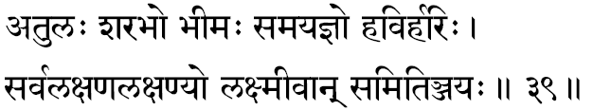
355. Atulah –“Incomparable.” For him whose name is the glory of the universe, there is no licence.” Again, Bhagavat Geeta says, “For Thy equal exists not, where is another superior to Thee in the three worlds ?” In short, there is nothing like Him, since He does not fall under the categories of the things perceived by the body or the emotions felt by the mind or the thoughts entertained by the intellect: nothing that we know of can be comparable with Him.
356. Sarabhah –“One who dwells and shines forth through the bodies.” Bodies are called Sara because they are perishable. The life that presides over the perishable body, whose glory is the individuality, is the Self, the Lord. It can also mean, “Lord, who is of the nature of Paramesvara,” for, Lord Siva had once taken the incarnation of Sarabha, a creature with eight legs, capable of killing even the lions.
357. Bheemah –“The All-inspiring, the Terrible,” meaning, One who is a mighty and terrible phenomena to those who are cruel and sensuous in the world. To the bad, the Lord is always a frightful power of vengeance, to follow them relentlessly as their doom.
Some commentators, due to the position of this word in the stanza, read it as a-bheemah, meaning thereby, “He who is the shelter” to those who are good.
358. Samayajnah –“Knower of all six systems of philosophy,” or it can mean “One who knows the exact time (samaya) for creation, preservation and destruction.” Or, it can also mean “One whose worship (Yajna) is nothing more than keeping an equal vision of the mind by the devotee” The great devotee Prahalada says, “to be equal in all conditions, is the worship of Achyuta.”
359. Havir-harih –“The receiver of all oblation.” He is the Lord of all Yajnas and as such, He is the One to whom the devotee offers his oblations, and He is the One who receives them in all dedicated activities. Bhagavat Geeta says, “I am indeed the enjoyer and also the Lord of all sacrifices.” The Lord is called Havis as He is worshipped through oblation.
Some commentators recognise in this term two different names of the Lord: ‘Havih’ and ‘Harih’. In this case, the former term, ‘Havih’ means “He who is invoked by everyone who performs the Yajnas.” The term Harih means “One who loots away all Vaasanaas (Paapa),” and consequently, “One who wipes away all expressions of Vaasanaas.”
360. Sarva-lakshana-lakshanyah –“Known through all methods of proofs,” meaning “He is the One Self that is ultimately proved by all scientific investigations and philosophical enquiries.” Whether it be through dualistic (dvaita) or through non-dualistic (advaita) philosophy, the Ultimate Truth experienced by the realised seeker, is this Great Vishnu.
361. Lakshmeevan –“The consort of Lakshmi.” He is the Spirit (Purusha) that thrills the entire world- of-matter (Prakriti). Matter thrilled with the spirit is the dynamic world that we see around. Thus, the manifested Lord is ever wedded to Lakshmi. Lakshmi also means Effulgent, and therefore, the Lord who is Ever-effulgent, meaning the Pure Consciousness, that illumines everything, is indeed Lakshmeevan.
362. Samitinjayah –“Ever-Victorious.” In the Puranas, we find the Lord ultimately wins in His battle with the unrighteous forces. He is the destroyer of all pains in the individuality of the devotees. Samiti as a word, has got the meaning-“Battle”.
Stanza 40
viksharo rohito maargo hetur daamodarah sahah
maheedharo mahaabhaago vegavaan-amitaasanah.
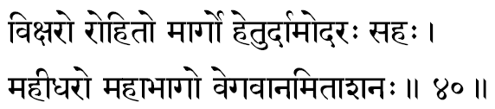
363. Viksharah -Ksharah means “decaying,” “that which is perishing”, and so Viksharah means “Imperishable”. Those who are meditating upon the Lord in His un-manifested State of Glory, this term is very often used. All material things are conditioned by time and all objects are, therefore, perishable. The Lord, the Self, is the Subject and is, therefore, ever Unchanging and always Imperishable.
364. Rohitah -The term ‘Rohita’ means fish, and this name has come to indicate Lord Vishnu because of His first incarnation as the Fish. When the entire world was submerged in the waters of the deluge, the only living creatures that were available at that time could only be fishes. Lord could incarnate at that time only in the form of the Fish. Therefore, here the term means “One who had manifested to serve the living creatures as the Fish among the fishes.”
365. Maargah –“The Path.” In order to realise the Highest which is the Nameless and Formless, human mind will have to first hold on to a divine form, and that is Lord Vishnu. He is the Way and the Goal. In short, “He is the One whom seekers of the Highest meditate upon in order to reach the Supreme.”
366. Hetuh –“The Cause”. One who is the cause for the whole universe. He is at once the material-cause (Upaadaana Kaarana), the instrumental-cause (Nimitta Kaarana) and He who alone is also the efficient-cause in the creation of this universe. Hence, He is called The Cause.
367. Daamodarah –This term has come to indicate the Lord because, He is One who is known through a mind which is purified (Udara) by means of self-control (dama) and such other qualities. According to Mahabharata, “We call Him as Daamodara as He is known by means of Dama.”
Brahmapurana re-capitulates the incident in the early childhood of the Lord when He was tied with a cord (daama) round His waste (udara). This term can also mean “One in whose bosom rests the whole universe.”
368. Sahah –“All enduring”. The Lord is One who has patience at everything, and is One who readily forgives all the defaults of His sincere devotees.
369. Maheedharah –“The Supporter or the Bearer of the Earth”. Since He is the very essence in the universe as its material-cause, He is the One who supports all forms in the universe. The Lord supports the world, just as gold ‘supports’ the ornaments, the cotton ‘supports’ the cloth, the ocean ‘supports’ the waves.
370. Mahaa-bhaagah -He who has extreme beauty in all His limbs, or He who is ever fortunate, or fie who gets the greatest share (Bhaaga) in every Yajna.
371. Vegavaan –“He who is swift”; One who is the fastest in reaching the devotee the moment his loving heart remembers Him. By import it means that He is All- pervading, therefore, He is the fastest, inasmuch as “nothing can ever overtake Him.”
In the Isavasyopanishad He is indicated as swifter than the mind- (Manasojaveeyah).
372. Amitaasanah –“Of endless appetite.” This should not be taken literally, but it only means that the entire world of plurality projected by the mind, merges back when the mind is transcended at the time of the experience of the Self. Just as we can say that the waker swallows the dreamer, the Higher Consciousness, with an infinite appetite, as it were, swallows the Infinite Cosmos; hence figuratively, He is considered as ‘the Great Consumer’ of the whole world of plurality during involution (Pralaya).

Stanza 41
udbhavah kshubhano devah sreegarbhah paramesvarah
karanam kaaranam kartaa vikartaa gahano guhah.
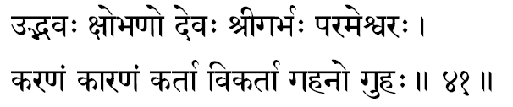
373 Udbhavah –“The Originator” The Lord is the material-cause from which the entire universe arises and, therefore, He is the origin for the Cosmos, or it can mean to indicate, “One who is again and again born as the endless jivas under the urge of their individual vaasanaas”.
374 Kshobhanah –“The Agitator” If the Self were not in the equipments, the equipments will not get agitated -will not pursue their functions The Atman, the Pure Consciousness is that which thrills and agitates both the matter (Prakriti) and energy (Purusha), and causes the manifestation of the living entities (jives), who, with their actions, constitute the dynamic aspect of the world. If the Self is not there, there can be no movement or expression of life; everything would have remained completely inert and insentient. He is the Lord who thrills the world and makes it so beautifully palpitating with life. Hence, He is called as the Agitator (Kshobhanah).
375 Devah –“One who revels is Deva. This term ‘Deevyati’ in Sanskrit also means ‘to conquer’, ‘to shine’ and ‘to praise’ Therefore, Lord Vishnu is rightly called as Derah because He sports through His play-the great Creation-Sustenance-Destruction-play, He functions in all Beings as He shines as the Universal Consciousness; and He is praised by all the devotees Svetasratara Upanishad indicates “there is only one Deva”.
376 Sree-garbhah -“Containing all glories within; One in whom are all glories (Aisvarya)” The glory of the Lord is the universe and this universe resides in Him, and therefore, all powers and glories that are manifested in the universe are also ever in Him.
377. Paramesvarah -The Supreme (Parama) Lord (Isvara). The fanatics generally interpret the word to mean as “the only Lord”, in the sense that all other concepts of God are wrong. The large-hearted, tolerant Rishis of old, could have never meant such a meaning. It could only mean “that He is the Supreme Consciousness whose expressions are all the deities”. The term Isvara indicates both might and glory. Therefore, Paramesvara means “One who is Omnipotent and All-glorious.”
378. Karanam –“The Instrument.” That which is most useful in fulfilling any piece of work is called the tool or the instrument. For the creation of the world He is the instrumental-cause (Nimitta Kaarana).
379. Kaaranam –“The Cause.” By the earlier term it was indicated that He is the instrumental-cause (Nimi- tta Kaarana) for the whole universe. Here now, by this term, it is indicated that He is the very material-cause (Upaadaana Kaarana) of the universe. Since the term directly means only “the cause”, it can mean not only the material cause, but also it can suggest the instrumental-cause. In the former case it would mean “He from whom the whole universe arises”, and in the latter sense, the term is interpreted by some commentators as “He who causes the universe to emerge out”.
380. Kartaa –“The Doer”. He is the One in whose presence alone all activities are possible, and hence by a transferred epithet, though the doings all belong to the equipments, the Self is called as the “Doer”. One who can freely perform all the functions of creation, sustenance and destruction, is the “Doer”.
381. Vi-kartaa –“One who creates the infinite varieties that constitute the universe.” It can also mean, “One who has created out of Himself, the endless self-manifestations of incarnations.”
382. Gahanah –“The Un-knowable”. One who cannot be comprehended by any of the known instruments of knowledge; One who is not an object of perception, but is the very subject and the perceiver in all sense-organs.
383. Guhah –“One who dwells in the cave of the heart” meaning “One who is the very core of every living creature.” He is concealed within the equipments and hence, He is described in our Scriptures as “One who dwells in the cave of the heart”. The Smriti describes Him as “This Lord, the Great Purusha, the Witness who dwells in the cave most secretively.” Mundakopanishad describes the Self as ‘Nihitam Guhaayaam’. Again, the Lord Himself says, “I am not readily perceivable by all as I am veiled by my own Maayaa “.

Stanza 42.
vyavasaayo vyavasthaanah samsthaanah sthaanado-dhruvah
pararddhih paramaspashtah-tushtah pushtah subhekshanah.
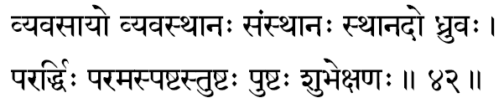
384. Vyavasaayah -“Resolute.” Being of the nature of Pure Wisdom, there is no vacillation in Him; all irresolution is at the level of the doubting mind and the unprepared intellect. The term ‘Vyavasaayah’ also means “Yoga.” In this sense, the term is used in the Geeta, “The intellect of one who is practising Yoga is single-pointed without vacillation.” Again, in the same chapter criticising those who are running after enjoyment and power, Krishna says, “those who are revelling in sensuality and consequently disturbing the poise of their intellect, cannot have a steady mind and consistent pursuit of Yoga.”
To work persistently until the Goal is reached is resolution. “To steadily apply ourselves in continuously withdrawing ourselves from our identifications with the not-Self, until we come to apprehend and experience the Self”, is Yoga. Hence, commentators interpret ‘Vyavasaaya’ as “Yoga.”
385. Vyavasthaanah –“The Basis or the Substratum.” The one who is the very Substratum for the entire pluralistic world; the One who orders the laws of the cosmos and administers those laws.
386. Samsthaanah –“The Ultimate Authority, State or Goal.” He who absorbs unto Himself all the multiplicities of names and forms during the time of deluge. The One Source into which all perceptions, emotions and thoughts retire and merge at the time of deep-sleep. In short, it means “the One who integrates the plurality and absorbs it all unto Himself when the projections are ended at that time of transcendence.
387. Sthaanadah –“One who confers the right abode.” Each living organism, “according to his actions and thoughts” gathers to himself vaasanaas and according to the vaasanaas, each individual takes his birth. Thus, the One who gives (dada) the appropriate abode (sthaana) to each individual (jeeva) is called Sthaanadah. In short, the Lord is the distributor of the fruits-of-actions.
388. Dhruvah –“The stable; the Firm.” That which remains “the Changeless in the midst of changes”, “that which is Imperishable in the midst of all perishing”. The body, the mind and the intellect and the worlds interpreted by them are all variables and changeable. The Consciousness, which illumines all of them and makes us aware of them is, indeed, the “Changeless.”
389. Pararddhih –“One who has Supreme Manifestations (Riddhi)”. The glory (vibhooti) of the Lord is expressed in His manifestations and there manifestations are indeed divine as the Geeta thunders, “the glories of the Self are indeed divine”.
390. Parama-spashtah –“The extremely vivid.” He who is extremely clear to those who have conquered the agitations and all disturbing thought-currents of the mind through a successful pursuit of the practice of meditation. He being the very Self, nothing in fact is so ‘clear’, meaning, so self-evident, as the Pure Consciousness is in us. No experience in the outer world or in our subjective bosom would have been possible had it not been for the Light of the Self. Even the sense of individuality in us is but an image of this Awareness, which is the very Self in every living creature. It being thus the Absolute Subjective essence. It is described as “the most Vivid.”
391. Tushtah –“The ever-Contented,” meaning “the One who is happy at the minimum offering of a devotee.” “I accept even if you offer some leaf or flower, or fruit or spoon of water, happily, if it is offered in love,” confesses Lord Krishna in the Geeta.
The Self being beyond body, mind and intellect, it cannot have any of the sense of imperfections or incompleteness and as such, the All-full Self must be at all times, complete in Himself. Naturally therefore He is All-Blissful. Consequently, His Nature must ever be Supreme contentment.
392. Pushtah –“One who is ever-full.” The Supreme Consciousness being All-pervading, He is Infinitely Full- nothing can we take out of It, nor can we add to It. It is Ever- full and, therefore, even when the manifestations emerge out from It, It is not less for it.
393. Subh-ekshanah –“All auspicious gaze.” One whose very gaze brings streams of auspiciousness to the devotee. The Self-being beyond vaasanaas, one who realises the Self, goes beyond all sins. A devotee walking the very path and moving towards the spiritual contents, purifies himself from all sins, since he will be living a life not identifying with his body, mind and intellect.

Stanza 43
raamo viraamo virajo maargo neyo nayo-anayah
veerah saktimataam-sreshthah dharmo dharmaviduttamah.
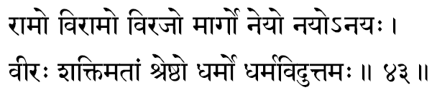
394. Raamah –“That which revels in every form or that in which all Yogins in their meditation revel. In Padmapurana, it is clearly defined, “in Him, who is Eternal Bliss, Pure Consciousness, and Endless, the Yogins revel.” Therefore, by the term ‘Raamah’, the Supreme Self is indicated. The term can also mean “One who has a compelling charm about Himself. He who is the most Handsome.”
395. Vi-raamah –“He in whom the creatures rest; The Abode of perfect rest”, having reached which, there is no return into the realms of experiences. That state is called Viraamah. Some commentators recognise in this term a meaning as, “He (Isvara) in whom the world of plurality merges during the deluge.”
396. Virajah –“Passionless.” “One who is not associated with the agitations (Rajas) of the mind.” The mind gets agitated when it identifies with the sense-objects of the world outside. The Atman, the Self, in its Pure Nature, has no such identifications, and, therefore, He is recognised as ‘passionless.’
397. Maargah –“The path.” There is no other way to know Him. For complete liberation, there is no way other than realising the Self, Sree Narayana.
398. Neyah –“The Guide”, the “Conductor.” He who guides and ultimately takes the seeker to the Reality is Lord Narayana, the Saguna Brahman. Through surrender to Narayana, the devotee develops the integration within and when fully integrated, he becomes the meditator and through meditation, the Highest is achieved. Therefore, Vishnu is indicated here as the “Conductor.”
The term can also mean “One who is fit to be conducted to the Highest.” The individual-ego .is that which tries to realise its own real nature, the self. The very individuality (Jiva) who is fit to be led towards the gateway to the Higher Consciousness is the One that has removed its false attachments and is held in animated joy, in meditation. In essence, such a jiva is nothing other than the Supreme, and, therefore, the Supreme is thus called as the Jiva.
399. Nayah –“One who leads.” When such a true devotee slowly and steadily gains his detachments from the outer world he moves himself more and more into the Higher and Subtler states of Consciousness. The one who leads such a seeker is again the grace of the same Self-Atmabala.
400. A-nayah -If the ego is led by the Lord (as Naya) to the Highest, then when once the Supreme State is reached, It has none to lead or guide It. The Lord guides all, but there is none to guide Him. This is because He is All- pervading and, therefore, He needs no guide to lead Him to Himself, as He is everywhere at all times.
401. Veerah –“The Valiant.” One who, by His prowess; creates the fear in the minds of the Rakshasas.
402. Saktimataam-sreshthah –“The best among those who have power.” All powers that are available, have been classified under three types: the power-of -Knowledge (Jnaana-Sakti), the power-of-Desire (Icchaa-Sakti) and the power-of-Action (Kriyaa-Sakti). All these powers are expression of the Self in the intellect, in the sub-conscious mind and in the physical body, respectively. Naturally the Self is the best among all other kinds of powers inasmuch as, all powers are expressions of this Great Self.
403. Dharmah -This term is used in Hinduism in thousands of different shades that, to the early student, the meaning of this term is lost in confusion. Dharma of a thing is that because of which the thing is, without which the thing is not.” This term, Dharma, has, therefore, been translated as “the Law of Being” -the Dharma of the Sun is light; the Dharma of the Fire is heat, the Dharma of Sugar is sweetness. What then is the Dharma of the individual? The essential Dharma of the individual can only be the self, because, without which is the individual cannot exist, and the individual’s expressions, physical mental and intellectual, are all expressions of the self through the equipment in Him. Thus “Dharma” means the only self in all individuals.
This is essential Dharma in anything is that which supports the things and, therefore, the self which is essence everywhere, is considered as the very one which supports everything.
404. Dharma-vid-uttamah –“One who is the highest among men of realisation.” All those who know the Reality are knower among all knowers of the self.

Stanza 44
vasikunthah purushah praanah praanadah pranavah prithuh
hiranyagarbhah satrughno vyaapto vaayuradhokshajah.
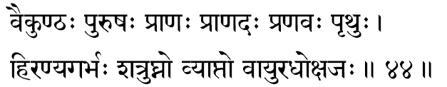
405. Vaikunthah –“One who prevents men from going astray into wrong paths (Vikunthah).” In Mahabharatha it is mentioned, “I united the Earth with Water, Space with Air with Fire, hence, the name ‘Vaikunthah’ has come to Me.
406. Purushah –“One who dwells in all bodies (Puris).” In Brihadaranyaka Upanishad (3-4-1) it is said, “because He as the first (Poorva) of all of them consumed (Aushad) by fire all sins, therefore, He is called Purushah.” In short, He is the One Self which thrills all living creatures everywhere at all times.
407. Paanah –“One who is the form of ‘Praana’ exits in the body, propels all sense organs to act in their appointed fields, it is the Lord Vishnu that activates the body as the 5 praanas, is found in the Vishnupurana. As Praana, He causes movements.
408. Praanadah –this can mean “One who gives ‘Praana’ or as one who takes away ‘Praana’, because, the root ‘da’ has both the meanings, ‘to give’ and to break.’ Therefore, Vishnu is the supreme who gives Praana to all creatures in the beginning of the creation, and He alone is again the one who destroys all the Praanaas (movements) at the time of the dissolution.
409. Pranavah –“That which is praised or adorned by even the gods.” There is a declaration of Sanatkumara, “because it is being worshipped and adorned by the gods, the self is called as Pranavah. This great reality is indicated in Vedas by the symbol Om and, therefore ‘Omkaara’ is called as Pranava. Thus the supreme self, ‘Omkaara’ is Vishnu.
410. Prithuh –“The expanded.” He whose expanse is expressed as the world of infinite forms. In short, “He who All-pervasive.” Looking at the world, through Puranas, it suggests, “the one who is born as the king Prithuh, the son of the king vena –for bringing prosperity to the country, is Lord Narayana.”
411. Hiranyagarbhah –it is the term used in the Vedanta for the “creator”. He is the expression of the creative urge of the lord Narayana. “The Golden-egg” means here that from which all the objective world had emerged out, indicating the creator.” The term thereby suggest that the entire creative power of the creator is but the expression of the Self, Narayana.
412. Satru-ghnah –“the destroyer off he enemies.” The lord is the one who annihilates all the enemies of the gods, meaning, He is the one who destroys all the negative tendencies in all serious seekers totally devoted to Him.
413. Vyaaptah –“The Pervader.” The effects can never remain without the Cause; the Cause is concurrent and inherent in it, effects. And thus, the world that has risen from the Infinite, should be pervaded by the Infinite. He who thus pervades everything is Narayana.
414. Vaayuh –“One who in the form of the atmospheric air, sustains all life everywhere.” He is not the air, but He is the life-giving rower in the air.
415. Adhokshajah -Mahabharata says, “at no time My vitality flows downwards, and hence, I am called, Adhokshajah'. The term can also mean, “One who is not available for the powers of the sense organs to perceive.” Or, it can also mean, “He who remains under both the atmosphere and the earth as the Supporter of the entire universe.”
Stanza 45
rituh sudarsanah kaalah parameshthee parigrahah
ugrah samvatsaro daksho visraamo visva-dakshinah.
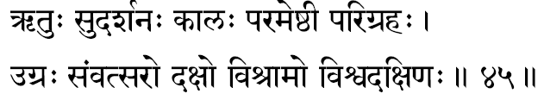
416. Rituh –“Seasons”-Here it means. the Lord of Time, who governs the seasons.
417. Sudarsanah -“One who is easy to be perceived if the seeker has sufficient devotion,” or “He whose meeting is auspicious inasmuch as it removes the seeker's worldly worries.”
418. Kaalah –“One who measures the merits and defects in each individual, and who doles out the appropriate results.” Bhagavat Geeta says, “I am the Time of counting.” Kaalah is also the name of Lord Death, and in this sense, it can mean “the Lord, who is Death or Annihilation- personified to all His enemies.”
419 Parameshthee –“One who is centred in His own infinite glory.” Or, it can also mean “One who is readily available for experience in the Supreme cave of the heart.”
420 Parigrahah –“The Receiver” He who receives from His devotees even insignificant things as a leaf or a flower, with all satisfaction” Some commentators stretch the suggestion of the word and find a meaning in this term as “One who has been accepted as the Sole Refuge by all devotees.”
421. Ugrah –“The Terrible.” The One who gives fear to those who are diabolically evil”, or, as the Upanishad declares, “For fear of Him the fire burns; for fear of Him shines the sun; For fear of Him Indra, Vaayu and Death proceed with their respective functions,”-therefore He is the Terrible
422. Samvatsarah –“The Year,” which is the abode of all living creatures. Time is spread in which creatures exist and gather their experiences.
423 Dakshah –“The Smart” One who undertakes the creation, sustenance and destruction of the Whole Cosmos with ease and efficiency, diligence and promptitude,
424. Visraamah –“The resting place;” “the Quiet.” That State wherein people who suffer in Samsar, can discover a perfect rest and quietude is the consciousness Supreme, Sree Narayana.
425. Visva-dakshinah –“The most skilful and efficient.” All efficiency and skill that we find in the universe among the dynamic living creatures are all His expressions alone, and, therefore, He is the source of all skill and efficiency. Again, He is the One who is the very Creator and Preserver of the whole universe and He must be the most efficient Manager and Administrator among the living creatures.

Stanza 46
vistaarah sthaavarah sthaanuh pramaanam beejamavyayam
artho anartho mahaakoso mahaabhogo mahaadhanah.
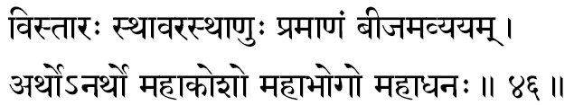
426. Vistaarah -The extension. The Lord is named thus because in the time of Pralaya, in Him the entire universe of names and forms comes to reside with ample accommodation for all of them. The term Vistaarah can also mean “manifestation;” since the Lord manifests in Himself all the universe.
427. Sthaavarah-sthaanuh –“The firm and the motionless.” The Firm (achanchala) indicates that He has no movements, because He is All-pervading. Sthaanuh (motionless) means that He is fixed like “the pillars that denote the frontiers of a country” (Sthaanuh) .The terms here used are as one- word because the Lord is both these at one and the same time. He is not only All-pervading, and, therefore, no movements in Him (Sthaavarah), but he is also without any locomotion (Sthaanuh). Both these terms indicate the All-pervasiveness of Lord Vishnu.
428. Pramaanam -The proof. He is the underlying principle of all intellectual arguments and for all scientific methodology, since He is the very Consciousness behind all discussions. Lord Narayana is the very authority behind all Dharmas and hence He becomes the essential Reality behind all (pramaana).
429. Beejamavyayam –“The Immutable Seed.” Since the whole world has sprung from Him, He is the indestructible and changeless cause of the world. It can also mean “that without which the world can never be.” Hence He is the undecaying root of all things.
430. Arthah -One who is worshipped by all; invoked by everyone. Lord Narayana is desired by all as He is the Paramaatman who is of the nature of bliss. Even the sensuous man running after the sense-objects is seeking the Lord in as much as he is searching for bliss which is the nature of the Self.
431. Anarthah -One to whom there is nothing that is yet to be fulfilled. This means one who has no desires, as He has fulfilled all His desires. So long as vaasanaas exist desires manifest. Where vaasanaas have ended there cannot be any desires and that state is the State of Self-realization.
432. Mahaakosah -One who has got around him great sheaths. The Self in us functions through the five- sheaths such as the food-sheath, etc. Sri Narayana is one who, as the Lord of the universe (Jagadeesvarah), is conditioned by the macrocosmic sheaths of the universe, and therefore, the great Isvara is here indicated as Mahaakosah.
433. Mahaabhogah -One who is of the nature of enjoyment (bhogah), He being of the nature of bliss. Also He is the one from whom the greatest bliss (bhogah) can be gained by the seekers. In short, the term indicates Him as one who gives the greatest happiness to all those who are devoted to Him.
434. Mahaadhanah -One who is supremely rich with the wealth of bliss which he can give to His devotees. Vishnu is one from whom His devotees gain great wealth.

Stanza 47
anirvinnah sthavishtho-abhoordharma-yoopo mahaa-makhah
nakshatranemir nakshatree kshamah kshaamahsameehanah.
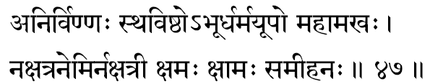
435. Anirvinnah -One who has no nirveda. This term nirveda means “the sense of disinterestedness that comes to the bosom of one who could not fulfil his passionate desires in life.” The Lord is one who is griefless as He has no desires to fulfil. In His fullness and perfection, He has no more any desires to fulfil, and therefore, Sri Hari has no occasion to suffer from the sense of nirveda.
436 Sthavishthah –One who is supremely gross. The entire cosmos being His form. He Himself is the universe, and as such in His total manifestation, He is supremely gross, Geeta says (Chapter XI-20) that the Lord spreads Himself covering the whole world and the atmosphere The Upanishad (Mundaka 1-4) also says how “the sky form' His head, the sun and the moon are His eyes.”
437. A-bhooh -One who has no birth, or the one, baying realised whom, the seeker will no more have births Some people dissolve the line Sthavishthah + Bhooh. In that case instead of A-bhooh they give the Lord the name, ‘Bhooh’, meaning ‘earth.’ Just as the earth is the stage upon which the entire drama of life is being played, Sri Narayana is the substratum upon which the entire world of experiences is playing about.
438. Dharma-yoopah -Yoopah is the name given to the post to which the sacrificial animal is tied in a yaaga The Lord is the very Post to which all Dharmas (righteousness) ace tied to This means He is the very essence behind all righteousness.
439. Mahaa-makhah -The Great Sacrificer. Because the sacrifices dedicated to Him confer total liberation -(Nirvaana). Also in the Geeta we were told, “offer is Brahman, what is offered is Brahman, the fire is Brahman, the offerer is Brahman and the goal reached is also Brahman.”
440. Nakshatranemih -The Nave of the stars. One who is the nave around which all the star and the planets including the sun, moon and other planets always move around. For this brilliant glowing wheel of Light, Sri Narayana is the very Axle
441. Nakshatree -One who is the Lord of the stars. Lord of the stars is the moon. Geeta says, “among the stars I am the moon.”
442. Kshamah -One who is supremely efficient in all undertakings. One who has extreme patience with all the stupidities of his devotees.
443. Kshaamah -One who ever remains without any scarcity- (kshaama). During the final deluge all things in the world dissolve and perish away but even then the Lord remains untouched by all distinction and hence He is called kshaamah.
444. Sameehanah -One whose desires are suspicious. The Lord is considered as “Well-desiring” in as much as he desires the well-being of all His creatures at all times. He knows how to control and regulate His power of desiring (Icchaa-sakti) and thus He is extremely efficient in His creative activity.

Stanza 48
yajnah ijyo mahejyashcha kratuh satram sataam gatih
sarvadarshee vimuktaatmaa sarvajno jnaanamuttamam.
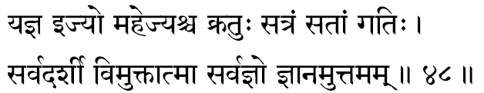
445. Yajnah -One who is of the nature of yajna. All sacrifices are His own forms. He exists as sacrifice in order to satisfy men and gods. Sruti says that all yajnas are of the nature of Vishnu (Yajno Vai Vishnuh).
446. Ijyah -One who is fit to be invoked through yajnas. Lord Narayana is the only one who is being invoked in all yajnas, even when the devotee particularly invokes any other deity. He, being the Infinite, all gods are expressions of His own glory and therefore, irrespective of the deity invoked, all yajnas are worship of Vishnu. In Harivamsa we read a declaration which openly reveals this truth: “They who worship through holy sacrifices, the devas or the pitris, they worship indeed the Vishnu, the Self, through the Self.”
447. Mahejyah -One who is to be most worshipped. One who most certainly is to be invoked in every ritual because all other devataas invoked during the yajnas can each fulfil the seeker’s desires; but to invoke Sri Narayana is to invoke the only Power that can supply complete liberation for the devotee. Therefore, He is the object of great sacrifice.
448. Kratuh -It is a kind of yaaga wherein there is a pillar to which the sacrificial animal is tied. Since all sacrifices are offered to Him-the Lord, even Kratuh, a sacrifice with violence inherent in it is also Vishnu.
449. Satram -The Lord who protects the good (Sat). In continuation with the previous Kratuh, when we read this it can also be considered as indicating a particular kind of yajna described as Satram in our Vedic literature.
450. Sataam gatih -One who is the refuge (for the good people). One who is worshipped and invoked by those who wish to liberate themselves from all limitations in life. Gatih in Sanskrit means both the path and the goal. Thus, through surrendering to the Narayana alone does one reach Sri Narayana.
451. Sarvadarshee –“As He is the pure Consciousness in all living creatures, all knowledge in all beings is illumined by Him. Just as the sun is “the eye of the universe,” so the Consciousness is the Illuminator of every- thing.
452. Vimuktaatmaa –“The ever-liberated Self.” The Supreme, though He expresses Himself through the equipments, He is never conditioned by the matter envelopments through which He apparently expresses Himself. Just as the waves rise, exist and dissolve in the ocean, the equipments of experiences rise, play and dissolve themselves in Him.
He is ever-liberated, never-shackled by gross matter. This great principle of Paraatmaa is Sri Narayana. -Sruti says (Kathopanishad 5-1).
453. Sarvajnah –“Omniscient.” He is the Principle of Consciousness and, therefore, He is the Illuminator of all thoughts, all intentions, motives, emotions and all sense perceptions in an individual. The meaning is the same as in Sarvadarsee.
454. Jnaanamuttamam –“The Supreme Knowledge of all other knowledges.” The Self is the Supreme Knowledge, for, without the Consciousness, no knowledge is possible. Taittireeyopanishad indicates the Self as. “Satyam Jnaanam, Anantam Brahma”

Stanza 49
suvratah sumukhah sookshmah sughoshah sukhadah suhrit
manoharo jita-krodho veerabaahurvidaaranah.
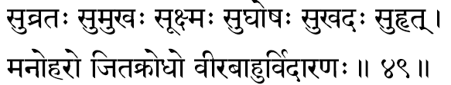
455. Suvratah –“The one who is ever performing the pure vow.” It is a sacred vow of the Lord that He has to give shelter and protection to all those who totally surrender themselves into him-says Sri Ramachandraji: “To give shelter to all living creatures-this is my vow.” This term can also refer to Him who had done tapas for a long number of years on the mount of Nara-Narayana in Badrinath.
456. Sumukhah -One who has an enchanting face. Truth is beauty and Beauty truth. In all conditions the Lord is ever cheerful and brings to His face the dignified beauty of calm repose. When the devotees come and surrender at His sacred feet Narayana is the one of Infinite mercy who beams with joy at the devotion of the surrender.
457. Sookshmah -One who is subtler than the subtlest. In Vedanta terminology subtlety indicates pervasiveness. Therefore, the term means All-Pervasive. The Upanishad says the Lord is All-Pervading, subtler than the subtlest (Sarvagatam susookshmam).
458. Sughoshah –“Of auspicious sound.” This is the name of the conch that Krishna blew in the opening of the Mahabharata war. The sound of Vishnu is the essence of all Vedas as all the four Vedas have come from Him, the Supreme. Hence the term “of auspicious sound.”
459. Sukhadah –“One who confers happiness.” It can also mean in Sanskrit one who is the destroyer of joy (Da-to destroy). Here, of course, it means that One who gives joy to His devotees and takes away joy from those who are undivine.
460. Suhrit –“The friend of all living creatures.” A true friend is one who gives all that he possesses without expecting any return.
461. Manoharah -One who is the looter of the mind; or charming. Not only is the Lord Beauty Incarnate, but He compels the attention of the devotee to come away from all other sense objects to dwell upon His enchanting form. Thus Vishnu is one who generates an irresistible joy in the mind of His devotees and compels them to spend their time in constant worship.
462. Jita-krodhah -One who has conquered anger. By the one term here, anger, we should consider all the six inner enemies Kaama, Krodha, Lobha, Moha, Mada and Maatsarya. These six constitute the types of thoughts in man; the six categories into which all his mental activities fall. One who has conquered all these means one who is beyond the mind-the Self.
463. Veerabaahuh -One having mighty, valiant arms. From time to time He has to incarnate in order to put down the wicked and thereby protect the good.
464. Vidaaranah -One who splits asunder; destroys. In the man-lion form, Narasimha, Lord Vishnu appears to tear open and kill Hiranyakasipu. Again, in order to destroy Hiranyaaksha and to lift the earth from the ocean, Sri Narayana had to take the form of the great boar (Varaaha). Accordingly in the Sanskrit vocabulary, bhoo-daarah is a synonym for boar (Varaaha). Dara means to split or to tear open. Thus the meaning of the divine Boar can be squeezed out from the term Vidaaranah used here.

Stanza 50
svaapanah svavaso vyaapee naikaatmaa naikakarmakrit
vatsaro vatsalo vatsee ratnagarbho dhanesvarah.
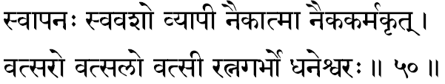
465. Svaapanah –One who puts people to sleep; stupefying. Lord Vishnu as Isvara has for Himself the total Vaasanaa (Maayaa) as an equipment for His self-expression as Eesvara (Narayana). He, through His Maayaa, veils each individual and renders them ignorant of their own divine nature. This “veiling-power” (Aavarana Sakti) creates many agitations (Vikshepa), due to which individuals rush out for sense-gratification. Since Isvara, thus, with His Maayaa-power deludes everybody, He gathers to Himself this epithet Svaapanah meaning “the mighty stupefying force.”
466. Svavasah - The One who has everything under His own personal control; the totally independent. Since He is the Supreme Consciousness, all living creatures and phenomenal powers are functioning by His grace, drawing their capacities to exist and act from Him only. If He withdraws His patronage everything in this Universe must stop functioning immediately. He is supremely independent inasmuch as, though the world-of-objects needs Him, He is entirely self-sufficient and needs no world for His Existence. Thus He is totally free. The waves need the ocean, but the ocean is totally independent of the waves’ existence.
467. Vyaapee -All-pervading. Pervasiveness in philosophy indicates subtlety. Thus All-pervading means that which is “subtler than the subtlest.” This concept is again sustained by the physical observations in the world. The cause always pervades all the effects; the gold pervades all ornaments. The entire universe is an effect and He being the Cause, He pervades all and everything at all times. Thus the All-pervading, in its suggestion, indicates that He is the Ultimate-cause and Himself in His pervasiveness is ever-present everywhere and in everything, presiding over all behaviours, actions and work, everywhere in the universe.
468. Naikaatmaa -Many-souled. Lord, the Infinite, though ever the one, expresses Himself as the many, while manifesting Himself, in the form of the universe. It is He, the One Great Consciousness, that expresses Himself as the creator, sustainer and destroyer-in order to maintain the play of the eternal dance, among the phenomenal things and deeds. He who becomes the Trinity is the great Vishnu Tattva.
469. Naika-karma-krit -The one does many actions, as He is the one Lord of all evolution, preservation, and involation of the universe. where he is not presiding over, no activity can ever take place.
470. Vatsarah -The Abode of the Lord. Not only Lord is living in each one of us our inner-Soul (Antaryaamee) but He is at once, the All-prevading Essence in which, the entire universe exists, and as such, He alone is the Abode of the creatures, He is the endless ‘time’ and the infinite ‘space’ at once. for, in the time-space field alone do things exist. the term “Vatsa,” in sanskrit also means “calf.” the world under discussion, therefore, can also mean “one who gives away claves.” this has reference to krishna who returned to Gopas all the calves, when they were taken away by the enemy.
471. Vatsalah -The supremely affectionate. One who loves his devotees extremely. Narayana is one who has got more affection towards his devotees that all the paternal and maternal love in the world put together. Supreme love is the meaning of the world ‘Vatsalah;’ Lord Narayana is Love Incarnate.
472. Vatsee -The Father. One who has infinite number of children; Lord considers the entire living kingdom as His own children; and nurses and nourishes them. It can also be interpreted as one who trains and protects the calves in the herd.
473. Ratnagarbhah -The Jewel-wombed. Like the ocean, One who has rich wealth concealed in Himself.
On the whole, the term Ratna-garbhah only means that the Lord is quick in His bestowing all the desired objects on His devotees.
474. Dhanesvarah -The Lord of wealth. Here the term “Wealth” means all the good things in the universe- all objects of happiness. He is described in the Puranas as the Lord of the Goddess Lakshmi (Lakshmipati) and as such He is ever the Master-of-all-wealth. The greatest of wealth is, of course, the liberation, and Lord Narayana is the Isvara of this great wealth, He blesses the true devotees with the experience of complete liberation from the entanglements and sorrows of the vestures of matter around us.

Stanza 51
dharmagub dharmakrit dharmee sadasatksharamaksharam
avijnaataa sahasraamsur vidhaataa kritalakshanah.
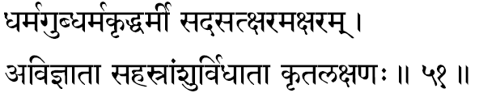
475. Dharmagup -One who protects the Dharma. In the Bhagavad Geeta the Lord says: “In every cycle I shall manifest for re-establishing Dharma.”
476. Dharma-krit -One who acts Dharma. Though He, as the Absolute Consciousness that illuminates everything, is beyond all Dharma and Adharma, Sri Narayana exemplifies what is the righteousness by His own conduct. He is, therefore, called as Dharma-Pravartaka. In the various incarnations, the Lord has exemplified how the generation should live under the ever-changing kaleidoscopic pattern of circumstances that play around us at all times.
477. Dharmee -The Supporter of Dharma; meaning the very Seat of all Dharma. Just as the waves exist in the ocean; just as the cotton supports the cloth; just as all the ornaments exist in gold-so Sri Narayana, the Infinite Truth is the very essence and support of the entire universe. Narayana is the Throne at which all righteousness take their refuge. Without direct reference to Him and His Glory, righteousness has no meaning; just as law books of a country are empty pages when the Government falls.
478. Sat -The Existence in all things and beings is the same ever, and it is All-pervading. The sun exists; the space between the sun and the earth exists; the ocean and the creatures therein exist; the physiological organs and their functions, mind and its activities, the intellect and its agitations -all exist. This Ever-present Principle of Existence is Sri Narayana. That which remains the same without any change in and through all changes, unaffected ever, same in the past, present and the future is called in Vedanta as ‘Satya.’ One who has all these natures is called Sat-Purusha. In the Upanishads, the Supreme Brahman is indicated as ‘Satya’ –“This, O Child, indeed was Sat.” In the Geeta while describing the Changeless Factor behind the eternally changing matter, Bhagavan says: “That which is the All-pervading in this world, that alone is indestructible and no one can destroy it.”
479. A-Sat -The Conditioned; Limited; the One who appears at this moment as the limited, conditioned, and therefore confined only to the world of plurality. That which actually is not, but apparently seems to be there, is called a delusion and this is indicated by the word “ A-Sat.” In the Vedantic terminology, higher-Self (Param) is ever Immutable and Eternal, while the lower-Self (A-param) constituted of all the universe of manifested things and beings, is mutable and ephemeral. Sri Narayana Himself is, in His Apara nature, expressing as the world of the many that we today recognise around us. Bhagavan Sri Krishna confesses to Arjuna in the Bhagavad Geeta: “Arjuna, I am at once immortality and mortality. I am both existence and non-existence.”
480. Ksharam -The Perishing. One who is the very Immutable Self in all things, that appears to suffer from constant mutation: The changeless-core in the midst of all the changes. All the changeable and variable things and beings of the Universe play in Him who is the only Substratum and, therefore, the Immutable Eternal Reality is called here as the Mutable; the changing and the dying waves are all ever nothing but the changeless ocean indeed.
481. A-ksharam -Imperishable. In order to recognize the change, there must be a changeless entity knowing it. If one ornament is to become another, there must be indeed the changeless consistent gold permanently supporting it all the time. In the same way, there must be a Changeless Factor which must be the essential core, that holds together the pattern of the constant changes, which together constitute the play of the universe. This Changeless Factor is called Narayana. Krishna says in Bhagavat Geeta: “all creatures together constitute the Kshara-purusha and the Changeless in an creatures is the A-kshara-purusha.”
482. Avijnaataa -The Non-knower. Here we must carefully understand the term ‘knower.’ The “knower” of the emotions and thoughts is the Self, imprisoned in the body, mind and the intellect, and, therefore, functioning as the perceiver, feeler, thinker-called in the Vedanta Sastra as the “Jeeva,” This individualised personality is the ‘doer’ and the ‘enjoyer’, in the calamitous world of activities. Sri Narayana is the Pure-Self, who has not been contaminated by the matter- vestures and their agitated-nature, and the consequent sorrows. Therefore, ‘Vishnu,’ the Pure-Self, is indicated here as Non- Knower (A-vijnaataa), meaning the “Jeeva.”
483. Sahasra-amsuh -The thousand-rayed. As the Pure Consciousness, He is effulgent, and in the Upanishads we read that even the sun, moon and stars gain their effulgence from Him alone. In fact the Upanishads conclude that all living creatures are resplendent after His effulgence alone. Or, we can say that it means Sri Narayana, in the form of the Sun, illumines and nourishes the world of living creatures; because the name of the Sun in Sanskrit is ‘Sahasraamsuh.’ In praising the Lord Sun it is usual to sing of him as ‘Sooryanaaraayana.’
484. Vidhaataa -All-supporter .As the final sub- stratum for everything, the Lord supports the entire universe of living creatures, and nobody supports Him, He alone is His own support. The Lord is at once the material, instrumental and the efficient causes for the universe of forms.
485. Krita-lakshanah -One who is famous because of six qualities, such as glory, righteousness, fame, wealth, knowledge and detachment. Again following the Puranic literature, Sri Narayana is the one who made on His own bosom the great mark of the feet of Maharshi Bhrigu. In fact from the standpoint of pure Vedanta, the term indicates the Ever-existing Pure Consciousness which is the very goal (Lakshana) to be ultimately achieved for liberation. Lakshana also means the scriptural textbooks and, therefore, the term also can mean He who is the author (Krita) of the Scriptures (Lakshana).

Stanza 52
gabhastinemih sattvasthah simho bhootamahesvarah
aadidevo mahaadevo deveso devabhrit guruh.
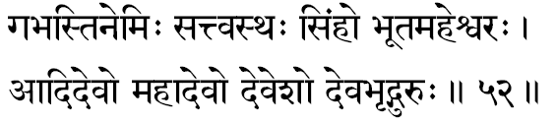
486. Gabhastinemih -The Centre of the Supreme planetary system. The Sanskrit term ‘Gabhasti’ means ‘rays’, and the term ‘nemih’ means the ‘spokes.’ Therefore, the term indicates “One who is the hub of the wheel-of-light in which the spokes are His own rays of brilliancy.” Astronomically, we can consider this as the sun, the centre of the planetary system. Subjectively, He is the Atman, the Self-the Effulgent Consciousness-beaming out Himself to the whirls of matter (the five koshas).
487. Sattvasthah -Abiding in Sattva. Maayaa is constituted of the three gunas: unactivity (sattva), activity (rajas) and inactivity (tamas). When the Maayaa is predominantly constituted of Sattva, it becomes the vehicle for the Supreme Brahman to express as God, Sri Narayana. The Lord is essentially constituted of the “Sattva Guna” and, therefore, He is pure truthfulness in nature (Suddha Satya Svaroopa). It can also mean that He who remains (Stha) in all beings (Sattva).
488. Simhah –The Lion Due to His great exploits in fighting the negative forces during His various incarnations, He is indicated as the Lion among beings in the universe Also in Sanskrit “any part of a name can indicate the full name” Thus Bheema means ‘Bheema Sena’ or ‘Bhaamaa’ means ‘Satya-Bhaamaa’ Similarly, ‘Simha’ here might mean a part of the Lord’s name as ‘Narasimha’; Narayana had taken the form of the Man-Lion in order to end the tyranny of Hiranyakasipu, and bless his God-devoted son Prahlaada
489. Bhoota-Mahevarah -The Great Lord of Beings One who is the Lord who orders, commands, regulates and presides over all activities of all living creatures, and hence is ever the Ruler of All creature.
490. Aadidevah -The first Deity. Or it can also mean as one who is First (Aadi) and one who is resplendent (Deva); further we can also take it to mean that He is the First Deva, meaning, He is the God of all gods. The term ‘Aadi’ also means “one who eats;” the term’ Deva’ can mean ‘one who evolves’: thus the term can mean “one who evolves in eating up,” by consuming the names and forms. This implies that to the extent one withdraws himself from his false occupations with the perceived names and forms, he moves deeper and deeper into the experiences of the divine Lord in himself; with this idea in mind, Lord is described by this term, “One who evolves in consuming the names and forms.”
491. Mahaadevah -The Great Deity, He is the Source of all Consciousness, and from Him have risen all further deities and beings, therefore, it is right to consider Him as the Supreme Lord.
492. Devesah -The Lord of all Devas. He is the very Consciousness in the gods themselves; therefore, in His unquestionable prominence, He is addressed here as “God of all gods.”
493. Deva-bhrid-guruh –“One who is the king of gods”-Indra -(Deva Bhrit) and one who is the teacher (Guruh). In short, He is the protector and advisor of the very Indra, who is the king of gods.

Stanza 53
uttaro gopatirgoptaa jnaanagamyah puraatanah
sareera bhootabhritbhoktaa kapeendro bhooridakshinah.
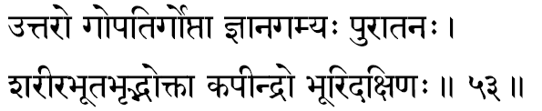
494. Uttarah -One who helps to lift us from (Uttarah) the ocean of Samsar. It also conveys the most excellent meaning of “One who is greater and nobler than all other deities.” Rigveda declares: “He is the most excellent of all.”
495. Gopatih -The shepherd-As one who played the part of a cowherd in His Krishna-incarnation. The term ‘Go’ in Sanskrit has got four meanings: the cattle, the earth, the speech and the vedas. In all these meanings He is the Lord (Pati): Lord of the cattle; Lord of Earth; Lord of speech; the Lord about whom all the Vedas speak of as the very Goal.
496. Goptaa -The protector He is the Protector of all living creatures in as much as, if He were not there, the creatures could not exist He is the very Existence in the living Kingdom.
497. Jnaanagamyah -The One who is to be attained only through the subtle perception of Jnaana He is not attained either by actions, or by progeny or by wealth Only through a (“JnaanaPrasaadena”) pure ‘knowledge’ alone He is experienced Here the word knowledge does not mean the ordinary knowledge-of-thing. The experience of Truth is gained only on transcending the intellect. Thus crossing the barriers of the non-apprehension (Avidyaa) the meditator comes to apprehend the Reality; this subjective first-hand apprehension is called True Knowledge (Jnaana); by this one process alone can one attain the Infinite; hence this term.
498. Puraatanah -He who was even before Time. That from which even the concept-of- Time itself rose up is the Infinite Truth and. therefore. Truth cannot be measured in terms of Time. Therefore, he is called the Ancient, for, he transcends Time.
499. Sareera-bhoota-bhrit -One who nurses and nourishes the very element from which the bodies are constituted. The Lord is the controller of the very five elements.
500. Bhoktaa -The Enjoyer or the Protector. The term “ Bhoktaa” can be dissolved in two ways. In (a) it would mean the ‘Protector’ and in (b) it would mean as the ‘Enjoyer’. According to Vedanta, Lord in His transcendental glory, as the Atman, is neither the ‘Doer’ nor the ‘Enjoyer’ and yet, here, the Lord is taken as the ‘Enjoyer’ only in the sense that the experiencer ‘ego,’ the Jeeva, is also nothing other than the Supreme in Its final Essence.
501. Kapeendrah -One who is the Lord of the Monkeys-Sri Ramachandraji. ‘ Kapih’ also can mean the Boar-incarnation (Varaaha).
502. Bhoori-dakshinah -He who gives away large gifts (Dakshinaa), as presents distributed at the end of the Sacrifices. When the body, mind and the intellect of man make sacrifices, man does Karmas. Lord Narayana is the One who gives the results for all actions: (Karma Phala Daataa); hence this term to indicate the Lord.

Stanza 54
somapo-amritapah somah purujit purusattamah
vinayo jayah satyasandho daasaarhah saatvataam patih.
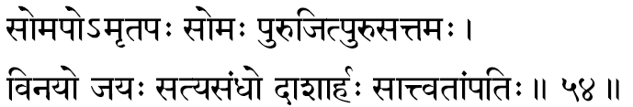
503. Somapah -One who drinks the Soma-juice in the Yajnas, in the form of the deity that has been invoked by the householder. In short, Narayana is the Lord that receives all the offerings, in all rituals, which we may offer, because He is the One invoked, who plays as the various hierarchy of deties.
504. Amritapah -One who drinks the nectar. As the Infinite Truth He at all times enjoys the blissful immortality (Amritatvam). Also, it may have the echo of the puranic story of the churning of the Ocean-of-milk (Ksheeraabdhi) until they got the Nectar, which was confiscated by the Asuras, and when they ran away, it was Sri Narayana, who, in the form of the irresistible Mohinee, a beautiful enchanting damsel, recovered the Nectar from them and distributed it to the gods. He had partaken the Nectar along with the gods.
505. Somah -One who in the form of the moon- light (Soma) nourishes all the plant-kingdom with their respective essential sap. It is very well known in the Hindu literature that the moonlight is that which enriches the food value in the fruits and grains. In the Geeta, Bhagavan says: “I in the form of the moon-light, enrich all the plant-kingdom,” The term can also mean Siva, in which case it would mean as “One who is ever consorted by Umaa.”
506. Purujit -One who has won over numerous enemies. The word Puru means ‘many’.
507. Puru-sattamah -One who is Greater among the great. Here the word Puru means ‘great’. In some readings we find instead of this term “Puru-sattamah” the term “Purushottamah” is used, in which case the meaning is the Omnipresent (Purusha) and the Best (Uttamah)-the Absolute Reality.
508. Vinayah -In direct meaning, of course, it means “He who shows the supreme humility.” But the term also means “One who humiliates those who are unrighteous.” The Lord is one who leads well (Vi-Naya) the seekers steadily through the path of truth and righteousness.
509. Jayah -The Victorious. One who has conquered all the matter. It connotes that in order to experience the ‘Self’ we have to conquer all the lower matter-realms and their by-products. Realizing the Self, the seeker himself becomes the Self. At that time he has conquered all.
510. Satya-sandhah -Of truthful resolution (Sankalpa). The Lord is One, who in His perfection, has so completely integrated, that His resolve, His thoughts, feelings, words and action are always truthful. There would he no com- promise in them, and as such, every resolve of His becomes fruitful “Heavens might fall down, the earth might tumble down, the Himalayas might be crushed, the ocean might become dry, but My word uttered shall never be in vain.” (Purana).
511. Daasaarhah –It is a name of Lord Krishna since He was born in the Dasaarha race (Yaadava-kula). It can also mean “One who is fully competent to receive all devoted offerings made in the ritualistic sacrifices.”
512 Saatvataam-patih -The Lord of the Saatvat-people Those who are followers of the Tantra named Saatvata-scriptures essentially Saattvic in nature- are called Saatvatas, and their Lord is Sri Narayana. The essential path of the Saatvatas is single-pointed meditation upon the form of Lord Vishnu with utter devotion

Stanza 55
jeeva vinayitaa-saakshee mukundo-amitavikramah
ambhanidhiranantaatmaa mahadadhisayo-antakah.
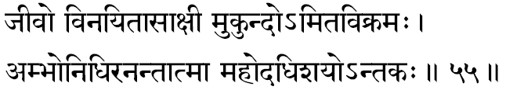
513. Jeevah -One who remains as the limited ego (jeevah), who in its sense of separateness comes to experience the endless joys and sorrows in the fields of life. One who functions as the Experiencer-of-the-Field (Kshetrajna), as described in the Bhagavat Geeta.
514. Vinayitaa-saakshee -The Witness of modesty. He is the one Consciousness that illumines the very sense of humility in His devotee’s heart. It can also mean that as Pure Consciousness, He is one without a second, and, therefore, from His state of Universal Oneness He sees nothing other than Himself everywhere. In this Absolute Nature He does not see the world of finitude constituted of the ego and its deluded devilry.
515. Mukundah -One who gives liberation. To those who are trying to free themselves from the imperfections of the matter-conditionings, and who are struggling hard to end their delusions, Sri Narayana, being the very Goal, ultimately gives complete liberation for all devotees who reach Him in the true spirit of total surrender.
516. Amita-vikramah -Of immeasurable Prowess or One whose step (Vikramah) is immeasurable (Amita). The Lord in his Vamana-incarnation measured the three worlds by His three steps, and, therefore, He gained the title of ‘Trivikramaha’. Since the Lord’s steps are so vast, they are, indeed, immeasurable-” Amita”- Vikramah.
517. Ambho-nidhih -The direct meaning of the word is “ocean” and the Lord Himself in the Bhagavat Geeta has declared, “Of the lakes I am the ocean”. According to the Taittireeya Braahmana: “These are the four Ambhas: viz. the Devas, Men, Manes and the Asuras.” Therefore, the term Ambhonidhih should mean “One who is the substratum for all the four types of creatures.
518. Ananta-atmaa -The Infinite Self. He is undefeated by time, space, or substance, and, therefore, in His own unconditioned nature He is the Infinite One Self. Or it can also mean One who manifests Himself as the endless varieties of entities constituting the universe. Ananta also means “end-less” and, therefore, the Endless Self, which means the Paramaatman, the Supreme Self.
519. Mahodadhisayah -One who rests on the great ocean. According to the description of Vishnupurana, Lord Narayana reclines upon the Aadisesha in the Milky-ocean of Vaikuntha. It can also mean, “One who remains on a fig-leaf, upon the waters of the deluge, when all names and forms have been dissolved into the unmanifest.
520. Antakah -The Death. As Time, He is the One who brings about constant changes in the world, without which no evolution or creative development is ever possible.

Stanza 56
ajo mahaarhah svaabhaavyo jitaamitrah pramodanah
aanando nandano nandah satyadharmaa trivikramah.
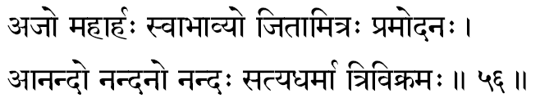
521. Ajah -Unborn. As the changeless and deathless Reality, He has neither birth nor any decay, ‘Unborn’ in philosophy means undying; therefore, Eternal, Changeless, “Born to Lord Vishnu” is yet another meaning, and according to this interpretation, the term can suggest “Pradyumna,” son of Vishnu, who is considered to be in our Purana as an Incarnation of the Lord of Love.
522, Mahaarhah –“One who deserves the highest worship.” Arhaa means ‘poojaa’: ‘worship’.
523. Svaabhaavyah -Ever-rooted in the nature of His own Self. One who is the Uncaused Cause, the God.
524. Jitaamitrah -One who has conquered all his enemies both within and without. Within, He has conquered all enemies such as desires, hope, etc., and externally, has conquered enemies like Ravana, Hiranyakasipu and others.
525. Pramodanah –‘Ever-blissful’. One who is constantly enjoying His own Eternal, Blissful nature. The term indicates ‘Vishnu’ because Sri Narayana is the One that causes bliss in the heart of those who meditate upon Him.
526. Aanandah -A mass of Pure Bliss. Bliss is His pure nature. The Brihadaranyaka Upanishad says: “Of this happiness, all other beings enjoy only a part.”
527. Nandanah –“One who makes others blissful.” Since the Lord is the very source of the happiness of the devotees who reach the divine plane of Pure Consciousness, it is in Him they get themselves intoxicated with the endless drunkenness of thus unceasing Bliss.
528. Nandah -One who is freed from all limited worldly pleasures. Worldly pleasures come through contact with the objects of the sense-organs. The term means One who has no contact with the world of senses, as He dwells in transcendence of all the equipments of pleasure-the body, mind and intellect. Chandogya Upanishad says, “That which is immensity is felicity; there is no felicity in littleness.”
529. Satyadharmaa -One who has in Him- self all the true Dharmas. Kindness, non-injury, charity etc. are considered as the noble Dharmas. Sri Narayana is One in whom we find all these Dharmas to the maximum. In short, He is the embodiment of Yoga (Yogesvara). It also means that One who is rich in the experience of the Supreme Self; for, the Upanishad says: “This alone is the Supreme Dharma which is to experience the Self through yoga”...
530. Trivikramah –“One who has taken the three steps”. One who has, in three steps, conquered the three worlds in his Vamana-incarnation. The spiritual seeker has only to take three steps to reach the Centre of the Self in him- self. Once he has stepped across the fields-of-experiences in the waking, dream and deep-sleep conditions, he has reached the Infinite Consciousness, the Atman. The very term ‘Tri’ in Sanskrit means ‘the three-worlds.’ “The greatest men of reflection have declared the three fields-of-experiences (Loka) by the simple term ‘Tri,”-(Harivamsa).

Stanza 57
maharshih kapilaachaaryah kritajno medineepatih
tripadastridasaadhyaksho mahaasringah kritaantakrit.
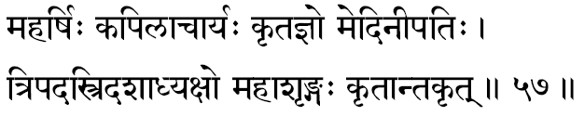
531. Maharshih Kapilaachaaryah - One who has manifested as the teacher Kapila, the great sage. “Rishi”, the sage, is one who has mastered a portion of the Veda, and one who has mastered the entire Vedas is called “Maharshi” in the Hindu tradition. The preceptor Kapila, who is a great master of the entire Vedic literature, is the propounder of the Saankhya philosophy. The glory of kapilaachaarya is endorsed by Lord. Krishna Himself in the Geeta when He declares, “Of the perfected-ones, I am sage Kapila.”
532. Kritajnah -The created and the knower of the creation. Kritam means “the universe that has been created.” Jna means “the knower of all the objects.” The Supreme Self is the material cause for the “knower” ego (Jna), and the effects constitute the world of things and beings (Kritam). He who is the very substratum for both cause and effect is the Absolute Self, the Lord. He is unconditioned by the outer matter vestures such as body etc. and thus Lord Sri Narayana is the Absolute Reality. Nowadays, this word (Kritajna) has come to mean “gratitude” or “thanks-giving”. It is a cheap application of this deep meaning. To express to my benefactor that “I have known (Jna) what he had done (Kritam) to help me” is thanksgiving, and hence, this usage is today very popular in our vernacular.
533. Medineepatih -The Lord of the Earth, Sri Narayana. The Preserver Vishnu as the husband of the inert matter, Earth, is a concept at once immensely beautiful and deep, philosophic and poetic.
534. Tripadah –“The One who has taken the three steps.” This indicates, the Vamana-incarnation, and how He measured, in just three steps, the entire universe. The jeeva, the limited ego, meaning the seeker, has also to take three steps forward, to reach across the delusion of the three worlds of sleep, dream and waking. The meditator can measure these three “worlds” in three steps and arrive at his own original Real Nature in his inner mystic experience.
535. Tridasaadhyakshah –“The Lord of the three steps”-the ‘three steps’ are waking, dream and deep-sleep. One who is the Witness of the ‘three steps’ is the Self. It can also mean that One who assumes, in His play, the three qualities of Sattva, Rajas and Tamas-and yet, Himself, is not affected by anyone of them.
536. Mahaasringah –“The Great-Horned.” The term indicates how the Lord in the Fish-incarnation tied the ship to his great horn and sported in the waters of the deluge.
537. Kritaantakrit -He is the destroyer of the “creation.” He is the Creator, in our subjective life, of the inactive (taamasa) and positive (saattvic and raajasa) vaasanaas- the sins and the merits. When the merits are more, the Lord provides a heaven for them to exist and when the sins are more, they move into the lower wombs, where sin-vaasanaas, too, get exhausted. An individual seeker when he exhausts all the above vaasanaas, rises to the realm of the Self and gets totally identified with the Self. Therefore, Sri Narayana is that State Divine, wherein all created vaasanaas (Krita) get destroyed (Anta). Thus, the end (Anta) of the vaasanaas (Krita) is called “total liberation” (Kritaantam). He who is the giver of the’ krita’, Him- self is the giver of “total liberation” (Kritaanta-krit)…. We find it also interpreted to mean that the Lord is one who has destroyed (Krindanam) Lord Death (Kritaanta) himself. One who is the destroyer’ Kritaanta’, in this sense we can take this term as meaning the Lord who has taken the form of Rudra, the Destroyer-Lord Siva.

Stanza 58
mahaavaraaho govindah sushenah kanakaangade
guhyo gabheero gahano guptaschakragadaadharah.
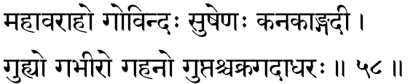
538. Mahaa-Varaahah -One who had manifested as the Great Boar. In order to heave up the world from the slush that formed naturally when the waters of the deluge receded. This is the third of the Lord’s incarnations.
539. Govindah -One who is to be known (Vid) through the declarations of the Vedanta (Go). In Vishnu Tilaka we read:
Here, “Gobhih” means the statements and declarations of the Upanishads.
540. Sushenah -He who has a charming army. The army of Vishnu is called as His Ganas. They are mainly constituted of the great sages and hence, their compelling enchantment.
541. Kanakaangadee -The bright-as-gold armlets. Armlets are ornaments worn on the upper arm covering the shoulder and the top portion of the arm.
542. Guhyah -The mysterious; the Profound. Due to the profound nature of the Truth even in the upanishads the essential theme is mysteriously secretive. Therefore, the entire Upanishadic literature is called as “the secret literature.” Vishnu is to be realised in the secret chambers of the heart, so He is called as the Supreme “Secret” (Guhya).
543. Gabheerah –“The Unfathomable.” Even the Upanishads declare that He is unknown. The limited human intellect cannot apprehend or visualise, or plumb the depth of, or unravel the mystery of His Wisdom, Power, Strength or Purity.
544. Gahanah -He is impenetrable; Imponderable. We cannot dash into the domain of His Nature Divine. Through surrender alone can we reach the realm of the Self.
545. Guptah -The Well-concealed. He is not easily revealed by words. Nor can the sense organs ever recognise Him. All the Upanishads repeatedly declare that the Self-being the very “subject,” the instruments of the body, mind and intellect can never apprehend Him. He can only be apprehended by a steady mind that has been purified by continuous meditation “Being the hidden nature of all beings he is not manifested.”
546. Chakra-gadaa-dharah -One who is the bearer of the Discus and the Mace. His Chakra is called Sudarsana; His Gadaa is called Kaumodakee. The ancient Acharyas have declared that the Discus represents the Mind and the Mace represents the Intellect.

Stanza 59
vedhaah svaangojitah krishno dridhah sankarshanochyutah
varuno vaaruno vrikshah pushkaraaksho mahaamanaah.
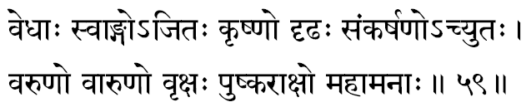
547. Vedhaah -One who is the Creator of the whole universe, the Supreme who is expressing Himself for the apparent function of creating the world of plurality. The Infinite Truth functioning through the Total-Mind is the Creator-Hiranyagarbha. According to Amarakosha, ‘Creator’ is called as Srashtaa, Prajaapatih or Vedhaah.
548. Svaangah -It is commented upon by some, as one who is beautiful, who has well proportioned limbs. This meaning emphasises the glory and beauty of the form of the enchanting Vishnu. The same term can also be interpreted as “Self-instrumental.” For the projection of the pluralistic phenomenal world, He has no instrument other than Himself. The Lord not only creates everything from Himself but He, Himself, is the instrumental cause for the world. We have already indicated earlier that in the making of anything, three causes must come into play, the “material-cause” (mud), the “instrumental-cause” (the pot-maker’s wheel) and the “efficient- cause” (the intelligent pot maker). In the case of the creation of the universe all these three causes are intrinsically the Lord alone. Thus, He is the material, from which He creates the world by Himself. This idea is expressed here when the compelling beauty of the Lord’s form is being indicated by the precious term “Self-instrumental.”
549. A -Jitah -One who is vanquished by none- unconquered-and therefore, the unconquerable in any of His incarnations. We never meet Him as vanquished in any of his confrontations with mighty evil.
550. Krishnah –One who incarnated in the Yaadava tribe as the son of Vasudeva and Devakee. It is commented upon as ‘one who served the Hindu Spiritual World in the form of Krishna Dvaipaayana’ which is the full name of Vyasa, the author of the Puranas. However, Krishna also means ‘The Dark’; the one great Infinite Consciousness that plays in us constantly, because of which we are aware of our experiences, and yet, never can we directly apprehend this Source of All- life within ourselves. The Krishna is the “unknown factor” that expresses through us-whose manifestations are all our physical, mental and intellectual capabilities. He is, therefore, called as the’ Unknown’, the ‘Dark’-Krishna.
551. Dridhah -“The Firm.” One who is firm in His convictions, judgements, love and mercy. It is in this sense that the Bhakti Marga describes the Lord often as ‘A-Dridhah’, especially when a sinner prostrates before Him; meaning that in full repentance were a criminal to surrender himself to the Lord’s Feet, the Infinite Justice even wavers and becomes anxious to help the sinner out of his mistaken notions and his consequent ugly actions. The Lord is ever vigilant to re-establish such a one in his own wisdom, which is his real nature.
552. Sankarshano-achyutah -During the great dissolution of the entire universe of names and forms, He, being the one who merges the entire plurality into His own essence-He is called ‘Sankarshanah.’ When an individual sleeps, his entire world of experiences get absorbed into himself and they all remain in seed condition in the ‘Causal-body’ as mere vaasanaas. One who never falls away from His own essential nature is called ‘Achyutah’ -one who knows no fall (Chyutih). The one expression used here for the Lord is the combination of both these terms. The Lord Narayana who absorbs the whole world into Himself at the time of the deluge, and He who never falls away from His own Real Nature.
553. Varunah -Since, in the evening, the sun reaches the western horizon (Varuna-Dik), the sun is called Varunah. Also after his day’s functioning in the world, in the dusk he gathers his scorching rays unto himself and disappears. Like the setting sun, the Lord withdraws all the pluralistic world unto Himself. The Eternal Reality, functioning through the sun as the sun’s energy and light, is described in the Upanishads as the ‘Golden One’, and hence the appropriateness of using this term Varunah for Narayana. The designation Soorya- Narayana is very familiar to the students of Purana.
554. Vaarunah -The son of Varunah is called Vaarunah. Both Vasishtha and Agastya are traditionally considered as sons of Varunah. Therefore, the term indicates the Lord, who manifested himself as Vasishtha or Agastya. Where-ever there is an explosive expression of any spectacular glory of stupendous achievement, “understand them all as coming out of my glory,” says Krishna in the Bhagavad Geeta.
The term can also be read in some manuscripts as A - Vaarunah-meaning, according to some commentators, “one whose nature is never subject to veiling.”
555. Vrikshah -In the Upanishads the world emerging out of the Supreme Brahman is described metaphorically as a ‘Tree’; in the Kathopanishad and in the Geeta, we read of the Samsaara- Vriksha-the Tree of Life-exhaustively described. In the Puranas, again we find, in more than 3 or 4 places, exhaustive descriptions of the world manifested from the Lord as a ‘Tree.’
556. Pushkaraakshah -One who has eyes (Aksha) as beautiful as the lotus flowers (Pushkara); the descriptive epithet: ‘Lotus-eyed.’ The Sanskrit term ‘Pushkara’ also means the Universal-Space, thus, it also has the interpretation, “one who is ever pervading all space.”
557. Mahaamanaah –“One who has a great mind.” Narayana as the Lord (Eesvara) is the Supreme Consciousness functioning through the Total-Mind, and He, with His Mind, creates, sustains and destroys, fulfilling the great game of Samsar, continuously.

Stanza 60
bhagavaan bhagahaanandee vanamaalee halaayudhah
aadityo jyotiraadityah sahishnurgatisattamah.
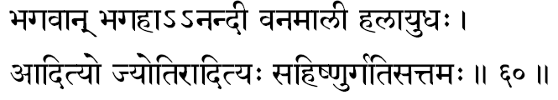
558. Bhagavaan -The word ‘Bhaga’, according to the Great Vishnu Purana means, “One who has all the Six Great Glories-Wealth, Power, Dharma, Fame, Character, Knowledge and Dispassion-is called ‘Bhagavaan’.” Again, Vishnu Purana says: “He is named Bhagavaan who knows (a) the beginning and the end, (b) the arrival and departure of beings, and also (c) Vidyaa and Avidyaa.” one who has all the six glorious in himself alone in Bhagavan and these great mighty power atomically come to Him, because his equipment is the Total-mind.
559. Bhagahaa -One who destroys, during the deluge, the six glories just mentioned. At this time, the lord absorbs everything unto himself, and in this sense the term, “destroyer of all great glories. When thus the total -mind rest from its self-willed projections, the world of plurality appears have to been absorbed by the lord unto himself.
560. Aanandee –“The one who gives delight.” the lord is himself Absolute Bliss, and those devotees who move towards him in pure surrender, come to share his divine nature of All-bliss. There is a version wherein we read this term as ‘Nandee’. Here, too, there is no difference in meaning. also this term indicates: “Son of Nandagopal”-lord krishna-who was natured and tended by Yasodaa and Nandagopal throughout his childhood.
561. Vanamaalee -One who wears always a garland of leavers and flowers named Vaijantee. Vaishnavas declare this to represent the subtle aspect of very fine elements themselves, (Bhoota-tanmaatraas).
562. Halayudhah –“One who has the plough as his weapon.” he is brother of lord Krishna, Balaabhadra, who is considered as the eight incarnation of lord Vishnu. Even today in our country the farmer repeat Bala-rama’s name while ploughing for a successful cultivation and profitable harvest.
563. Aadityah -One who was born as the son of Adhiti and Kasyapa as Vaamana, who begged of Emperor Bali three steps of ground and got all the three worlds.
564. Jyotir-aadityah –“The supreme who is the resplendence in the Sun.” the Atman expressing as the glorious light and energy in the sun is meditated upon as lord Vishnu. “One must meditate upon Vishnu who is adorned fully, holding in his hands the conch and Discus, sitting in padmasana, enveloped in golden hue, in the centre of the orb of the sun.” the Deity residing in the disc of the sun is Narayana Himself. “Aat” -’from Vishnu’; “ityah” -’to be obtained and so He is called as Aaditya. This interpretation gives us an insight into the meaning of the word Sun, in Sanskrit-‘Aaditya’: “One from whom all creatures have to receive”! The great-grand-giver is the Sun.
565. Sahishnuh -One who calmly endures the pairs of opposites. One who is above them, and thus is never influenced by these experiences of the physical and mental realms.
566. Gatisattamah -The ultimate refuge for all devotees; the best (Highest) destination and at once the noblest path. Lord Narayana. “Gati” means both the goal and the path. In short, One who is himself the very essence of the spiritual liberation.

Stanza 61
sudhanvaa khandaparasurdaaruno dravinnapradhah
divah-sprik sarvadrik vyaaso vaachaspatirayonijah.
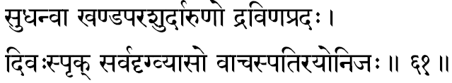
567. Sudhanvaa -One who has his glorious bow-called “Saarga.” Acoording to some, it represents the sense organs and their activities.
568. Khanda-parasuh -One who has the axe- weapon-called “Parasu.” The Lord used this weapon in His Incarnation as Parasuraama, the son of Jamadagni. It is endowed with terrible prowess in cutting down the unholy enemies of the nobler life and so it is called as the “Khanda-Parasu.” As such it means ‘one who wields the invincible Parasu.’
569. Daarunah –“The one who is merciless towards the unrighteous.” Up to a point the Lord is All-mercy- but when He finds that no other method can save the individual, like a surgeon at the operation theatre, He appears to be relentless-merciless.
570. Dravina-pradah -One who lavishly gives wealth asked for by His devotees. According to Vyasa, Lord Vishnu gives to his true devotees the wealth of the Sastra knowledge-the deeper and clearer understanding of the Science of Reality.
571. Divah-sprik –“The Sky-reaching.” The Lord who revealed His Universal Form to Arjuna in the Bhagavad Geeta.
572. Sarva-drik-vyaasah: -When considered as one word it means: “One who creates many omniscient men of wisdom.” One who encourages the spread of knowledge and thus turns out many men of wisdom and clearer understanding of life and the world. Or taken as two words its interpretation can mean: “One who is Omniscient and Vyasa.” This would mean, “The Lord who has expressed Him- self as Sri Veda Vyasa.” Vyasa is the poet-philosopher who codified, compiled and edited the Vedas and published them in four volumes-Rig Veda, with its 21 branches; Yajur Veda, with its 101 branches: Saama Veda, with its 1000 branches and the Atharvana Veda, with its 9 branches (or Saakhaas). He is the one who gave us the 18 Puranas and the Brahmasootras. Hence he is called: “The Omniscient Vyasa.”
573. Vaachaspatir-ayonijah -One who is a master of all knowledge (Vidyaas) and who is unborn through a mother’s womb.

Stanza 62
trisaamaa saamagah .Saama nirvaanam bheshajam bhishak
samnyaasakrit-sanaah saanto nishthaa saantih paraayanam.
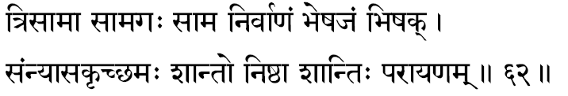
574. Trisaamaa –“One who has been glorified by the three Saamas.” ‘Saama’ means divine songs-hence, Veda. The one who has been praised by the singers of the Saama-Veda, those called as the Devas, the Vratas and the Saamans.
575. Saamagah –“The singer of the Saaman songs.” One who performs the actions prescribed in the Saama Veda and who invokes the Lord is called, in Vedic terminology, the’ Udgaataa’.
576. Saama -The Lord is the Saama Veda. This is to indicate the sacredness of the very Book. Lord Krishna has confessed in the Geeta: “Of Vedas lam the Saama Veda.”
577. Nirvaanam -The Lord is of the very nature of “Ever-liberated, Ever-free.” There is no trace of imperfection and sorrow in Him whose nature is, All-Bliss.
578. Bheshajam –‘Bheshajam’ means ‘medicine.’ Hence, He who is the very specific cure for the disease of Samsar (change, becoming).
579. Bhishak -One who is the ‘Physician,’ who is the ‘cure’ for the disease of Samsar. Or it can also mean that the Lord manifested during the “churning of the Milky Ocean “ as the Deity of Medicine, holding the pot of Amrita in His hand- The Lord Dhanvantari. In Indian systems of Medicines, He is considered as the presiding Deity of the Medical Sciences. Vishnu manifested as this Lord of Doctors, where upon this name for Him: “Doctor” (Bhishak).
580. Samnyaasa-krit -Lord is the institutor of the fourth stage of life (Aasrama) called ‘Samnyaasa’ which is meant for those who walk the path of total renunciation. The One who, in His Infinite Grace, gives the needed qualifications unavoidable for Samnyaasa.
581. Samah –“The Calm.” One who exists without the mind running out into the passions of the sense-organs. “ In Samnyaasa, He teaches the life of calmness and quietude and in the accumulated inner peace, the final experience is gained. The Smriti prescribes the duties of the four stages as: “The duty of the ‘Brahmachari’ is service; for the ‘House- holder’, charity; for the ‘Forest-dweller’ is the duty of restraint, and for the ‘Samnyaasin’ ‘Calmness’. Samnyaasa without Sama is inconceivable and this ‘Calmness’ is His nature.
582. Saantah -One who is quiet within, as in Him the sense-organs are perfectly controlled. The Upanishads glorify the Supreme State as actionless, partless, peaceful. This is a declaration from Svetaasvatara Upanishad.
583. Nishthaa -The Abode of all beings, not only while living, but during the Pralaya (deluge). During this Cosmic dissolution, the entire living creatures merge back into their Vaasanaas, (seed-form), and remain in Him. Therefore, He is called, “The Abode of the Universe.”
584. Saantih –“One whose very nature is Peace.” Agitations are caused by desires and the consequent temptations to strive for, acquire and indulge in them. In the All-Full, there is no desire, hence He need not seek His fulfilment among the perishable objects of the universe, and so He is Peace.
585. Paraayanam -The Supreme Goal is Narayana. After reaching Him there is no return In short, the term indicates that Narayana is the way to the Supreme Liberation (Moksha).

Stanza 63
subhaangah saantidah srashtaa kumudah kuvalesayah
gohito gopatir goptaa vrishabhaaksho vrishapriyah.
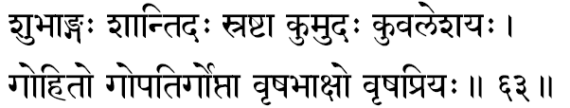
586. Subhaangah -One who has the most beautiful form. That one who is enchanting, most handsome.
587. Saantidah -Narayana dispenses that Peace which puts an end to likes and dislikes (Raaga-Dvesha). He is the One who cleanses the mind of His devotees and gives to each the inner Peace and Joy.
588. Srashtaa –“The Creator of all beings.” In the beginning, He has created all from Himself as the Great Five Elements: (Viranchi).
589. Kumudah -The reveller in the Earth. The term ‘Ku’ means Earth. Therefore, the term means “He who delights in the Earth.”
590. Kuvalesayah -He who reclines in the waters (Kuvala). Waters surround the earth, thus it is called as Kuvala. The term can also mean the ‘Crawler’-meaning ser- pent. In this sense it indicates-” Sarpa-Saaye”: “One who reclines upon the Great Sesha”-the Divine “Sesha-Saaye.”
591. Go-hitah -One who does the Cow-welfare-work, always. Sree Krishna, through many incidents, helps to develop and conserve the sacred animal, Cow, for, the very existence of Bharat’s dispensation depends upon the Cow; the agriculture being essentially Cow-centred. ‘Go’ also means Earth. Thus: “One who saved the world” from the materialists and their designs of excesses and imperfect vision. One who protects against the irresponsible havoc, for example, of Ravana and others; all inimical to the genius of the natural Bhaarateeya Samskriti.
592. Go-patih –“The husband of the Earth.” Or, One who is the Lord protecting all those who are weary of their samsaaric life of passions and desires. Such ones, exhausted by grazing in the pastures of dissipation’ and enervated from the world of happenings, are comparable to cows. Hence Narayana is called here as the “Lord of the Cows”, -‘Gopaala.’ ‘Go’ also may be interpreted as ‘sense-organs’. In this way the term suggests “Lord of the Sense-Organs,” Sri Narayana, the Self.
593. Goptaa -The root ‘Gup’ has two meanings: to protect; to veil. Thus ‘Goptaa’ can imply “One who protects the universe” or “One who, by His Maayaa, veils the glory of the Divine Self within.
594. Vrishabhaakshah -One whose eyes rain fulfilment of all desires of His devotees. He sees the un- expressed desires of His devotees and fulfils them easily. Or it can be taken that Sri Narayana is “One whose eyes are Dharma Itself”; meaning, One who sees righteousness clearly and continuously. If one wants to see clearly righteousness, he must cultivate and develop the Narayana vision.
595. Vrisha-priyah: -Vishnu delights in Dharma. ‘Vrisha’ means’ Dharma,’ so the term can be dissolved as “One who delights in Dharma”. Or it can signify, “One who is beloved of the virtuous, the Good.”

Stanza 64
anivartee nivrittaatmaa samksheptaa kshemakrit-sivah
sreevatsavakshaah sreevaasah sreepatih sreemataam varah.
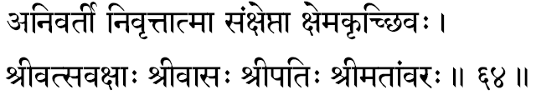
596. Anivartee –“One who never knows retreat.” During the clashes between the Good (Devas) and the Bad (Asuras), Narayana never retreats. He is One Who never turns back from Dharma; for He is its friend and protector.
597. Nivritta-atmaa -One who is fully restrained from all sense indulgences. So long as the equipments of our experiences-the Body, Mind and Intellect-are roaming about in their pleasures-among objects, emotions and thoughts-our attention is dissipated and is not available for the contemplation of the Higher, the Self. Narayana is the Atman in all, and to reach Him we have to retire from the fields of our indulgences. Hence, He is indicated as the “Restrained-Self.”
598. Samksheptaa -The One who absorbs unto Himself the entire universe of multiplicity during the dissolution-the “Involver.” Narayana presides over not only the evolution but also is the controller at the involution. In some readings, we find this term as “ Asamksheptaa”-meaning “One who never abandons His devotees.”
599. Kshema-krit –“The doer of Good”; One who protects and guides the devotees. “Kshema” signifies protecting what has been gained, and it includes “ Yoga” also, meaning “acquiring things not yet gained.” In Geeta, Lord Krishna promises that “I shall govern both your’ Yoga’ and ‘Kshema’ when you are a true devotee.”
600. Sivah -Lord Narayana is adored here as Sivah and, at the same time, all Vaishnavites repeat Vishnu- sahasranaama. Human prejudices have no logic or reason. Sri Narayana is Siva (auspiciousness) and there is no difference between the two. “I am the dweller of Vaikuntha, Vishnu. Between us there is no difference,” so says Lord Siva Himself. Vishnu is the “Purifier” (Siva), as His names, when chanted, and His form-divine, when meditated upon, become a means of quietening the mind and sharpening our perceptions of the subtler and the transcendental.
601. Sreevatsa-vakshaah -One who has the mark, Sreevatsa, upon His divine and sacred chest.
602. Sree-vaasah -The Abode of Sree; the dwelling place of Mother Lakshmi. This term is dissolved as “Sree”-all glory and riches-ever dwell in His bosom of love and beauty.
603. Sree-patih -The Lord of Goddess Lakshmi. During the great churning of the Ocean of Milk, holding a lotus in hand, there rose Lakshmi from it, and She chose, among all gods, Lord Vishnu as Her Beloved Husband. Hence Narayana is Sree-Patih, the Lord of Sree. The Svetasvatara upanishad says: “The Supreme Sakti of Him is declared to be various.” Sree represents the Energy (Paraa Sakti) in the universe. Lord Narayana is the One Vital Truth that functions through the Paraa Sakti and gives Her the dynamism to act and to accomplish.
604. Sreemataam-varah: -The best among those who have glory-in-life, (Sree), is Narayana. Taittireeya Braahmana says, “The Rig, Yajus and Saaman are the imperishable wealth of the wise”, so Sree has been interpreted here to mean the Vedas. Lord Narayana is the One who is the Best among those who know the ‘Books’; He being the very Infinite Reality that is the one theme of all the Vedas. Also Varah can mean “One Who blesses” and thus the term under discussion yields the meaning, “Vishnu, Who is the Lord That blesses all great students of the Vedas.”

Stanza 65
sreedah sreesah sreenivaasah sreenidhih sreevibhaavanah
sreedharah sreekarah sreyah sreemaan-lokatrayaasrayah.
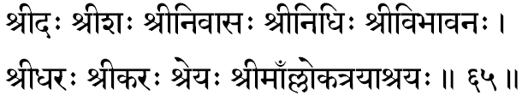
605. Sree-dah -One who gives Sree to all His sincere and dedicated devotees. Narayana provides wealth, for all His ardent devotees. He is the River of Knowledge and Joy for all devoted hearts which are surrendered to Him.
606. Sreesah -The Lord of the Goddess of Wealth, Sree-Mahalakshmi. Her wealth is ‘the ability to nourish.’ Thus She gives to the striving devotee, the mighty and noble virtues, his inner wealth.
607. Sree-nivaasah -One who dwells and manifests in the good people. Here the word Sree is to be understood as “those who have Sree in them.” The One Who abides in purified hearts-wherein the passions and lusts have been removed and peace, joy, devotion and understanding have arrived. In such people the Self comes to shine all by Itself.
608. Sree-nidhih -One Who is the treasure- house (Nidhih) of Sree. Vishnu, being the All-Full and Perfect, all glories draw themselves from Him alone. Even Sree-Maayaa --can play Her games only when She draws Her vitality from Narayana, the Self.
609. Sree-bibhaavanah –“One Who is a Distributor of Sree.” Vishnu provides each, according to his merit, the wealth, both inner and outer. Sree Narayana is the Law behind actions and so He is the Dispenser of the fruits- of-actions.
610. Sree-dharah -Lord always carries Sree in His bosom. In short, Atman, the Self, is never divorced from Its omnipotence and All-Fullness.
611. Sree-karah -One Who confers Sree upon His devotees who remember Him continuously, reflect upon His nature and meditate upon His Glories.
612. Sreyah -Narayana is Moksha-Liberation. He is the Way and the Goal. He gives to His devotees the total liberation from all their physical passions, emotional agitations and intellectual restlessnesses.
613. Sreemaan –One Who possesses all Glories, Riches, Capacities and Beauties. He who is the owner of all Sree; the abode of all Its Splendour.
614. Lokatraya-asrayah -The Shelter for the three worlds. The Substratum for the three worlds-of-experiences (waking, dream and deep-sleep). If the Self, the Consciousness, were not in us, no experience would ever be ours. Narayana is this “objectless awareness.”

Stanza 66
svakshah svangah sataanando nandirjyotirganesvarah
vijitaatmaa vidheyaatmaa salkeertischhinnasamsayah.
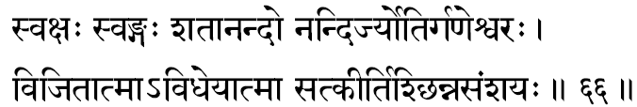
615. Svakshah -Brilliantly “Beautiful-Eyed”. is Vishnu.
616. Svangah –“Beautiful-Limbed.” Most hand- some form, captivating the hearts of all His loving devotees.
617. Sataanandah -One who divides Himself into the infinite Jeevas, manifesting through the different equipments and experiences in all of them. “Of infinite varieties of Joys”: gained through the individual equipments from each one’s appointed field of things and beings.
618. Nandih –“Infinite Bliss” is the nature or Vishnu as the Supreme Self. Thus by this term, Nandih, He is called.
619. Jyotir-ganesvarah -The Lord of the luminaries in the Cosmos is Narayana. He, as the Self, gives light to al! brilliant things in life. The Sun, itself, receives its light borrowed from the Infinite, Ever-Effulgent Self. Kathopanishad describing the Self as the Light or Consciousness declares, “When He shines all else shines after Him.”
620. Vijitaatmaa -One who has conquered the sense-organs. That devotee who is no more a slave to his sense-organs comes to experience the necessary mental quiet with which Narayana, the Self, can be apprehended.
621. Vidheyaatmaa -One who has come to live under the command of the Higher Self or One Who is ever available for devotees to command in love. Some read this as “A- Vidheya-Atmaa” -in which case it declare$ that Narayana is “One Who is of Unfathomable Nature-Divine.” One who obeys none, but all obey His Will is “ A- Vidheyaatmaa.”
622. Sat-keertih -Of Pure Fame is Narayana. He is the husband of Sree and therefore He is famous.
623. Chhinnasamsayah -One, whose doubts are ever at rest, or solved. Doubts regarding the Supreme can be only so long as we try to experience and comprehend Him with our Intellect. He is the very subjective vitality in the Intellect. So, on transcending the Intellect, the seeker can “become” the Self in a non-mediate experience, intimate and immediate. Once having become the Self, there cannot be any spiritual doubts. Therefore Narayana, the Self, is known as “The One in whom all doubts are resolved.” In Geeta, Arjuna admits that all his doubts were cleared.

Stanza 67
udeernah sarvataschakshuraneesah saasvatasthirah
bhoosayo bhooshano bhootirvisokah sokanaasanah.
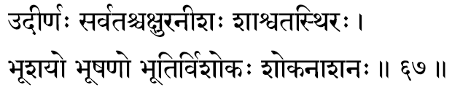
624. Udeernah –“The Great Transcendent.” He is the Infinite beyond all finitude, beyond all limitations and change, and therefore, beyond decay. Transcending all equipments of our experiences, as the Self in all, Sri Narayana revels as the Immutable Transcendental Reality, the sole substratum for the entire universe of forms and actions.
625. Sarvatah-chakshuh –“One Who has eyes everywhere.” Geeta declares Truth, the Pure Consciousness, as “Hands and legs everywhere, eyes-face-mouth everywhere.” Vishnu, as the Consciousness, is the One Self That sees through all eyes in the world, hence He, through all eyes, sees everywhere at all times. If He is not, the eyes are blind; when He is the indweller. The eyes then see-therefore, all eyes are only His.
626. Aneesah –“One Who has none to lord over Him.” The Supreme Lord is He. Mahanarayana upanishad says, “None rules over Him.”
627. Saasvata-sthirah –“One Who is ever Eternal and Stable”-never changing, thus permanent (Eternal) and ever-the-same (Stable). The body changes, the mind modifies, the intellect grows into new dimensions-but the Consciousness that illumines them all with Its Light of Knowledge is ever-the-same through childhood, through youth, in middle years and old-age. It is the Changeless throughout, hence Eternal and ever-the-same with- out any change.
628. Bhoosayah –“Resting on the Earth” is the word-meaning of this term, so it may signify One Who rested on the shores of the ocean, on His Way to Lanka- referring to Sri Ramachandraji. Or, one who slept (on) the Earth-meaning the Lord is Bhoo-Pati, the Husband of the Mother Earth. Or, its intention may also be: “One in whom the world rests” at the time of dissolution.
629. Bhooshanah –“One Who adorns the world”: physically with the infinite beauties of His Creation; emotionally He gives love and other finer instincts, and intellectually He is the One behind all great, noble and beautiful thoughts which have enriched human life, history and culture. Lord Narayana, in His various Incarnations, has also glorified the world.
630. Bhootih -One who is the Pure “BE”-ness or Existence. “ Bhooti” also means Glories (Aisvarya), so He is One Who is the treasure-house of all Glories.
631. Visokah -Narayana is sorrow-less; grief- less. He is the Self, transcending all matter vestures. At the body-mind-intellect level there are agitations and so there are sorrows. He is beyond them all, so He, as the Absolute Reality, is indicated as All-Blissful. Disturbances of sorrow or grief can never molest His nature of Infinite Bliss--ever contented, ever desire-less.
632. Soka-naasanah -The destroyer of all sorrows for His devotees. One who lifts the suffering ego- sense out of its meaningless identification with the changing, pain-breeding, equipments and gives it the true wisdom of Its Divine Nature. To those who truly worship “To them I shall be, err long, a Saviour from the Ocean of Samsar”, promises Lord Krishna in the Bhagavat Geeta.

Stanza 68
archishmaanarchitah kumbho visuddhaatmaa visodhanah
aniruddhoapratirathah pradyumnoamitavikramah.
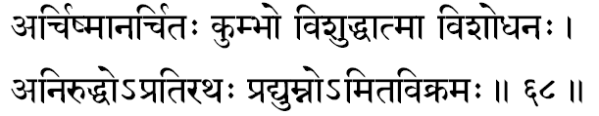
633. Archishmaan –“The Effulgent.” As Pure Consciousness, Narayana is the Source of all Light. The Kathopanishad confirms this when it declares, “There, neither the sun nor the moon, nor the stars nor the lightning, has any effulgence; how then can this Fire-light illumine It? By Its Light alone, all else in the world is illumined.”
634. Architah -One who is constantly worshipped by His devotees. Even Brahmaaji (The Creator) and Siva (The Destroyer) are worshipping Sri Narayana (The Preserver). Hence this term, “The Worshipped” for Lord Vishnu.
635. Kumbhah –“The pot.” The Lord, the Self, is called as “the pot” because just as things are contained within a pot, so the whole universe rests within Him, the “Container” and “Sustainer.” Everything and every happening is within Him alone.
636. Visuddha-atmaa –“One Who has the purest Soul.” When the Self is cleansed of all passions and thought agitations, in that uncontaminated purity It is realised. Therefore, the Lord, the Self, is called the Pure Atman, completely bereft of all equipments and their passions, all disturbances from desire. One who is beyond the “Three Gunas,” Trigunaateetah, meaning one who transcends all the Vaasanaas that generate the three moods constituting the entire phenomenon, Maayaa.
637. Visodhanah –“The Great Purifier.” The One, meditating upon whom all vaasanaas get exhausted and the personality purified from these desires, becomes free of all its accustomed, existent agitations. He who is the very Source of Purity; who lends purity even to the sacred-places. By remembering Him, the human heart becomes cleansed of its sins, immaculately swept of all consequent feelings of restlessness.
638. Aniruddhah -Of the four manitestations (Vyoohas) of Vishnu, the Aniruddha manifestation is indicated here. The four Vyoohas are: (I) Vaasudevah; (2) Samkarshanah; (3) Pradyumnah; and (4) Aniruddhah. The term can also mean “He Who is invincible by any of His enemies.”
639. Apratirathah -One who is never challenged by any enemies and who has no enemies to even threaten Him. Sri Narayana is without enemies; in His loving Presence they are vanquished.
640. Pradyumnah –“Very Rich.” Lord is Lakshmi-Pati and, in His benevolence, He gives riches and mighty glory to His devotees. Pradyumnah can also be the third of His four manifestations as Vyoohas.
641. Amita-vikramah -Of immeasurable Prowess is Sri Narayana. The Self, the Supreme, is Omnipotent and none can stand against Him. It can also mean, “One who has un-measurable steps” exhibited in His Divine performance in His Vamana Incarnation.

Stanza 69
kaalaneminihaa veerah saurih soorajanesvarah
trilokaatmaa trilokesah kesavah kesihaa harih.
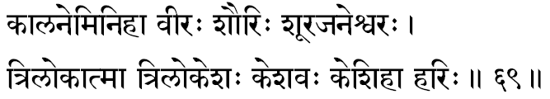
642. Kaalaneminihaa -The slayer of the Asura, Kaalanemi. “Kaala” means ‘Time.’ The Self is the ‘destroyer of time’ as It is beyond the intellect and ‘time’ is but a concept of the intellect only.
643. Veerah –“The Heroic Victor.” One who is ever victorious.
644. Saurih -Born in the Soorasena-clan, in Jagannaath-which, in the Puranas, is called the Utkala country. Also, Sauri can indicate the One who has invincible prowess always.
645. Soorajanesvarah –“The Lord of the valiant.” Sri Narayana, the fountain-head of irresistible might. He is invoked by the victorious, and is the Source of strength from which even lndra and others draw their vigour.
646. Triloka-atmaa –“The Reality, the Self of the three worlds.” The ‘three-worlds’ are the three ‘fields of experiences’: the waking, the dream and the deep-sleep. As the Pure Consciousness, in the Light of which the waker-dreamer- sleeper comes to experience all the ‘three-worlds,’ the Self, Sri Narayana is called “The Atman of the three-worlds.”
647. Triloka-eesah –“The Lord of the three-worlds.” Lord is One in whose presence all activities take place; in Whose absence all activities cease. He is called the Lord, the Great Proprietor. When life, the Self, manifests in a body, all experiences take place; when life is extinct, all activities cease. Hence Lord Narayana is the Self, the spark of Existence in all creatures.
648. Kesavah -Generally it is meant to describe Lord Krishna as “One Who has long hairs.” But Kesas are the rays of the Lord that illumine the Sun, Moon and such other effulgent things of the Cosmos. “The rays of mine that illumine (the Sun, etc.) are called Kesas. Therefore. the wise Brahmins call Me, Kesava.” Also’ Ka’ means Brahmaa, the Creator and ‘Eesa’ means Siva, the Destroyer. Both of them have sprung from Vishnu, the Preserver, hence He is called Kesavah.
649. Kesihaa -One Who destroyed the Asura called Kesi.
650. Harih -The Lord is called “The Destroyer.” He, it is, who destroys the false values and the inner conflicts created by man in his own life and in his consequent discordant contact with the world around him. These confusions and sorrows created by man, for man in life, due to his own ignorance of his own divine nature, is called Samsaara. Lord Narayana is the Destroyer of this Samsara-sorrows in His devotees.

Stanza 70
kaamadevah kaamapaalah kaamee kaantah kritaagamah
anirdesyavapurvishnurveeroananto dhananjayah.
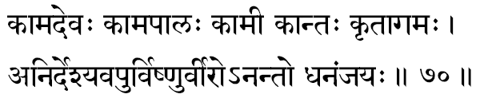
651. Kaamadevah –“The Beloved Lord.” One who is a seeker must necessarily get charmed by the Glory of Sree Narayana, and by the influence of this captivating love He is to be worshipped. Thus One Who is to be loved and worshipped by the seekers who strive for the four “aspirations-in-life”-Purushaarthas. There is also this meaning for the term: “The One Who is Pradyumnah”-since Pradyumna- form is an incarnation of Kaama (Love).
652. Kaamapaalah –“The Fulfiller of Desires of all His true devotees.” Those who in their sincere attitude and love for Him alone are surrendered unto Him, their hearts’ inner longings are satisfied by Him. The same idea finds similar but varied interpretation in that Koomapaalah can imply “One Who had taken the incarnation of Balarama,” for Balarama is called as the “Wielder-of-the-plough” (Hala-ayudhah) or as Kaamapaalah. Thus it can also mean “Protector (Paalah) of His devotees” (Kaama, meaning the ‘Desired Ones’).
653. Kaamee -One who has fulfilled all His desires. Desire is an expression of an inherent sense of in- completeness-and this insufficiency unto oneself is called ignorance of the Self. The non-apprehension of Reality gives rise to endless misapprehensions of the same. Sree Narayana is the Self, the Reality, and so all non-apprehensions must end in Him, then no desires can ever remain in Him demanding fulfilment. He is “One of fulfilled desires” ...Some commentators give just the opposite explanation, since the term Kaamee in Sanskrit can also mean “One who has desires.” Here it would mean that Lord Vishnu is the Supreme Reality who “desired to create” the world of plurality. The Upanishads roar: “He desired” (Sah akaamayata). The creative urge in the Supreme is that which expressed as the apparent illusion of a playful creation of multiplicity and the endless varieties in them.
654. Kaantah –“Of Enchanting-Form;” “Supremely-Handsome;” the “Beauty of Beauty itseIf.” In all His Incarnations we find Him described as extremely charming with His Grace and Beauty. In Sanskrit the term Kah means the Creator, Brahmaaji. In this sense, therefore, Kaantah can suggest “One Who destroys even the Creator during the dissolution.”
655. Kritaagamah -The author of the Scriptures (Aagamas). Sruti and Smriti form the Aagamas. Or in perfect harmony with the preceding term where Lord is termed as the destroyer of even the Creator at the time of deluge, some commentators have again interpreted this term as “The One Who is the inaugurator of the Krita-Yuga.” This means the Lord is One into Whom the world dissolves and from Whom the world rises up again.
656. Anirdesya-vapuh –“Of Indescribable Form;” “Of Indefinable Nature.” Since the Lord transcends the Elements and is the very cause for the three Gunas- as the pure Self, expressing Itself through the body, mind and intellect of man-it becomes impossible to describe or define His Form.
657. Vishuh –“All-Pervading.” One who pervades the entire Visvam. In His Visvaroopa-Form in Geeta XI we have from Arjuna a description of the dazzling wonderment of Him as “ All-pervading.”
658. Veerah –“The Valiant;” “The Courageous- the One of heroic exploits.” The root’ ‘Vi’ often means creation, radiance existence, involution or motion. One who has a1l these powers is called Veerah.
659. Anantah -“Infinite; Endless.” That which is unconditioned by Time-Space-Substance is ‘Infinite.’ None can discover the end or such a Truth. Conditioned things will all have an end-a change from one condition to another. The Infinite is totally unconditioned, so unlimited, and naturally, therefore, changeless. Hence Narayana is Infinite.
660. Dhananjayah -One who had gained through his conquest and his prowess vast wealth for the enrichment of his country. From his various campaigns, Arjuna had brought great wealth to the land. In Geeta, Lord Krishna says: “I am Dhananjaya, among the sons of Pandu.

Stanza 71
brahmanyo brahmakrit brahmaa brahma brahmavivardhanah
brahmavid braahmano brahmee brahmajno braahmanapriyah.
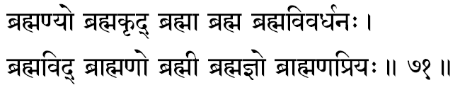
661. Brahmanyah -One who is a great friend of Brahman. The term Brahman includes in its connotation the Sastra, Tapas, Vedas, Truth, Knowledge, etc. Sree Narayana is a protector and friend of all these. Here Brahman means Jeeva-a friend of all individuals.
662. Brahma-krit -The One Who performs the Brahman-meaning the one who lives in Truth, who abides in Tapas, etc. He is the author of Brahman as enumerated in the explanation of the preceding term.
663. Brahmaa –“Creator.” As the total Creative- power, it is Narayana Who functions as Creator through Brahmnaji.
664. Brahma –“The Biggest, the Vastest, the An- Pervading.” Upanishads thunderingly declare the Brahman to be “Existence-Knowledge Infinite.” The Knowledge which lifts all false perceptions of differences, pure in all its aspects, ever beyond the grasp of the senses, and that which can be experienced only in one’s own Self, is called Brahman.”
665. Brahma-vivardhanah –“One who increases the Brahman.” Here, of course, the term Brahman means “Austerities, Vedas, Truth, Knowledge.” These are increased in one who has earned the Grace of Sree Narayana through total surrender and constant devotion.
666. Brahma-vit –“One Who knows Brahman.” The meaning here is one who has intuited the Vedas and their full commentaries. In Geeta (XV) we listen to the Lord declaring that: “I alone am the Author of the Vedas and the Knower of the Vedas.” Brahman alone can “know” Brahman just as the “dreamer” can never survive to know the “waker.” The knower-of-the-waker is the “Waker” alone. Similarly, the individualised ego conditioned by the equipments of Body, Mind and Intellect experiences the Brahman only when it has transcended the entanglements of matter-and then the ego is no more a Jeeva but “becomes Brahman.” Thus the Higher is experienced only by the Higher. Sree Narayana is the Brahman-and therefore, He alone is the Knower of Brahman.
667. Braahmanah -One who has realised that the pluralistic world is a mere superimposition upon the Brahman caused by an error of judgement, and who experiences the Supreme Consciousness of the One Reality is a Braahmanah. His duty is to convey this knowledge to others with a pure missionary zeal and a higher proselytising enthusiasm. By mere accident of birth one does not become a Braahmanah. Visvamitra and others through their Tapas and Divine Experience had reached the status of Brahmin-hood, so we read in the Puranas. Narayana manifests as such mighty men of realisation, serving their generations through their teachings.
668. Brahmee –“One Who is with Brahma.” The term Brahma meaning as before –“Austerities, Vedas, Truth and Knowledge-divine.”
669. Brahma-jnah -One who lives ever in Brahman, and so “knows” the nature of the Brahman. He, the Lord, being the very Brahman, no one knows His nature as He Himself can. The “waker” alone knows the waking- the “dreamer” and “sleeper” can never realise and experience the waking-state until they “become” the “waker.”
670. Braahmana-priyah -One who is the beloved or and One Who is the lover of true men of full realisation, the Braahmanas. Not the caste, but the men of supreme experience-divine. The Lord is dear to them, and they too are dear to Him.

Stanza 72
mahaakramo mahaakarmaa mahaatejaah mahoragah
mahaakraturmahaayajvaa mahaayajno mahaahavih.
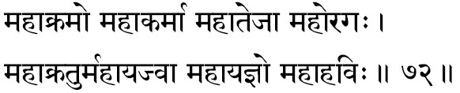
671, Mahaakramah –“Of Great-Step.” Directly we are reminded of the Vamana-Incarnation when the Lord measured the three worlds by His three steps. It also indicates the root meaning of the term, Vishnu-”The one who has the long stride-meaning, “ All-pervading.” Since He is All-pervading, He reaches everywhere earlier than all others.
672. Mahaakarmaa –“One Who performs great deeds.” The creation, the dissolution, the protection and the spread of the Knowledge-of- Truth, all these are indeed great undertakings. He alone performs them, through Maha- Purushas who have surrendered themselves unto Him-those who, in total surrender, have indeed become one with the Lord in love and being.
673. Mahaatejaah –“Of Great Resplendence.” The Upanishads glorify Him in that even the Sun, Moon, the stars and fire have no light of their own. By Him they shine, the Giver of Light to all. In the Geeta, the Lord insists that “The Supreme is the Light of all lights, beyond all darkness” and again He asserts, “Understand that Light in the Sun by which the whole world is illumined, and that Light in the Moon and in the fire to be My own Light.” Here the Light of Consciousness, the Self, is indicated.
674. Mahoragah –“The Great Serpent.” Uraga means serpent In Geeta, Bhagavan says (Among the nagas, the many-hooded serpents, I am Ananta.) Ananta is the five-headed Great Serpent also called Sesha, upon which the Lord Vishnu reclines. Again in Geeta the Lord says (Among the serpents I am Vasuki), Mythologically, this is the serpent adorning Lord Siva's ring finger, Though so small as to become a ring for the Lord, it was this Vaasuki who offered himself as the great rope in churning the milky ocean. This paradox reminds us of the Upanishadic declaration (Smaller than the smallest and greater than the greatest).
675. Mahaakratuh –“The Great Sacrifice.” The Supreme cannot be experienced without the greatest sacrifice, the total sacrifice of the Ego, the jeeva-Bhaava. The Great Sacrifice indicates traditionally the Asvamedha Yaaga. There- fore, some commentators explain this term “as one who is of the very form of Asvamedha Yaaga.”
676. Mahaayajvaa –“One Who had performed Great Yajnas.” In the Rama-Incarnation, He had performed Asvamedha- Yaaga. He is the One, by Whose Grace, all “Sacrifices” are fulfilled successfully. One who performs sacrifice properly and faithfully is called Yajvaa.
677. Mahaayajnah –“The Great Yajna,” In Bhagavat Geeta, the Lord in describing His Immanence in the world says to Arjuna: “I am among the Yajnas, the Japa- Yajna.” Lord Narayana Himself is the greatest Yajna- therefore, in devotion approach Him and gain His Grace. The Japa Yajna is glorified by the Lord as the greatest sacrifice because it is both the essential means of all other Yajnas and transcends them all as an end in itself, by maintaining a constant stream of the same divine thoughts in the mind.
678. Mahaa-havih –“The Great Offering.” The yajna is He; the very things offered to the sacred fire, the Havis, are also He. Geeta tells us, “We offer to Brahman that which is Brahman, in the fire which is Brahman, and the act of offering is also Brahman.”

Stanza 73
stavyah stavapriyah stotram stutih stotaa ranapriyah
poornah poorayitaa punyah punyakeertiranaamayah.
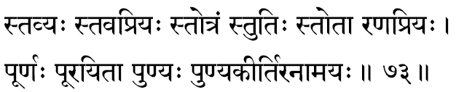
679. Stavyah –“One Who is the object of all praise”-meaning, One Who deserves all our praise but One who has none top praise, he is praised by all and he praises none. The jeeva invokes him; the self, the atman, never invokes the ignorant jeeva.
680. Stava-priyah –One who is invoked through the loving chants of the devoted hearts. When a devoted seeker melts away in singing the praise of the lord, his physical, mental and intellectual preoccupations with objects, emotions and thoughts silently roll away from him. In such quiet moments they rise above their present nature and explode into the realms of experiences of the higher state of divine consciousness – Sree Narayana.
681. Stotram –“The hymn.” A glorious hymn, that describes the lords divine nature, itself is he, as the words lift the singer into the experience of the supreme nature of the truth. It is infallible if the singer of the Hymn has full devotion and ardent aspiration to realise him. “Naama” and “Naamee” are one and the same in experience.
682. Stutih –“The act of praise.” The very noble, divine “act of invoking the lord” is by his grace alone.
683. stotaa –“One who adores or praises.” The true devotee, singing the divine hymns is also of the nature of supreme peace, love, beauty, goodness- the divine qualities attributed to the lord in whom he dissolves through his songful identification. Such a devotee in this at–one–ment with Him, the lord praises again and again as “He is the one dear to Me.”
684. Rana-priyah –“Lover of Battles.” Hence we see sree Narayana ever carrying his mace and discuss in order to destroy the vulgar and thus protect the decent. Here “battle” is the constant struggle for evolution.
685. Poornah –“The Full.” The infinite is ever the same. Though things are apparently emerging out of it, still the supreme remains irreducible and without a change. Lord Narayana is Ever-Full with is own glories and powers; One who is full with all the wealth, inner and outer, the supreme lakshmi-pati.
686. Poorayitaa –“The Fulfiller.” Lord Hari fulfils, surely, all the desires and demands of his true devotees.
687. Punyah –“The truly–Holy.” When the devotee’s heart is filled with remembrance of the glorious from divine and infinite nature and supreme of the lord Vishnu, he then, in that very moment, removes all sin from his devotee’s heart. The lord is Auspiciousness itself, so where he is invoked, all inauspiciousness must immediately retire.
688. Punya-keertih –“Of Holy frame.” He is gloriously renowned as the holy one. Whoever glorifies him becomes himself holy. All the unholy animal passions in the devotee are routed and beaten back when his heart is wholly in tune with the lord’s Glory and Form.
689. Anaamayah –One who has neither the mental or physical diseases. Of pure unstained divine essence is his nature. He is not involved in karmas, thus the resultant of the karmas which visit us in terms of mental restlessness or physical pangs, never touch Him.

Stanza 74
manojavasteerthakaro vasurtaah vasurpradah
vasuprado vaasudevo vasurvasumanaah havih.
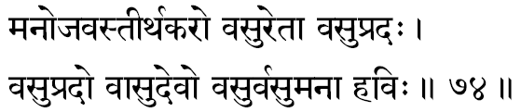
690. Manojavah –Fleet as the mind is the Lord’s movement. He is anxious to run and reach the devotee to remove his suffering and ignorance. All-pervading is the lord, thus he is faster than all those who run after him – and wherever they reach, the supreme, He, in the form of existence, is already there.
691 Teerthakarah –“The Teacher of the Teerthas” The term, Teertha” means vidyaas. Sree Narayana is the author of the Vidyaa, or auxiliary Sciences Therefore, “One Who is the most ancient Teacher of all Vidyaas and Tantras.”
692 Vasuretaah –“He Whose Essence is Golden.” In the beginning of Creation were the primeval waters Into this One Ocean the Lord dropped His Essence and it became a Golden Egg from which Brahmaa, the Creator, first arose Thus Lord, as the womb of all Creation is mentioned in the Puranas as “Hiranyagarbha,” the Golden Womb
693 Vasupradah –“The Free-Giver of Wealth” Inn this context, Vasu means “Worldly-Wealth”- money, property, grains, possessions, progeny Lord Vishnu who nourishes and maintains all beings with the wealth of His consort, Sree Laksmi, distributes and patronises His devotees very liberally
694. Vasupradah -Again, the same term as we read above, but here if means “The Giver of Salvation” Liberation (Moksa) is the greatest wealth-whom He chooses, Moksha is gained by him alone.
695. Vaasudevah –“The son of Vasudeva,” Lord Krishna. Or “One Who is Vaasu and Deva” “Vaasu” means “One who dwells in all creatures as their ego-centric individuality (Jeeva-raopa).” ‘Deva' means “One who revels” Therefore, this name for Lord Krishna has the appropriate meaning “One who revels in every living creature as the Jeeva-entity in each”.
696 Vasuh –“The Refuge for all.” The One Who dwells within, veiled behind Maayaa, the mind The mind projects this play of things, beings, emotions and thoughts. The world is the shadow-show round the Pure Consciousness Lord declares in Geeta: “I am the beginning, the middle and also the end of all beings.” Thus He alone is the Refuge, for there is no other existence. “All have emerged out from Me, exist in Me and must come back to Me.”
697. Vasumanaah -One who is attentive to, and, therefore, concerned with every object and being in this world: “Omnipresent.”
698. Havih –“The Oblation.” That which we offer unto Him is also permeated by Him-there is nothing other than He, Himself, the same everywhere, in all places, at all times. In Geeta, Lord insists that the “oblations” are nothing but Brahman.”
Stanza 75
sadgatih satkritih sattaa sadbhootih satparaayanah
sooraseno yadusreshthah sannivaasah suyaamunah.
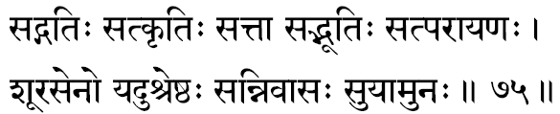
699. Sadgatih –“The goal of good and noble seekers.” Lord Narayana is the Spiritual Goal to be reached. “The Good” here means those who know the existence of Brahman, for the Upanishad says: “If a person knows ‘Brahmaji exists,’ then the wise call him ‘good.”
700. Sat-kritih –“One Who is full of Good Actions.” Lord Hari is the One Who maintains the rhythm of creation and the logic of its preservation. Even through His destructive activities, there is creation only for the sake of the individual and for the good of the world. All His actions are totally in harmony for the establishment of Peace.
701. Sattaa -The Lord is the “One without a second,” and, therefore, remains ever the same, without any differences of genus, species or in Itself.”
702. Sad-bhootih –“One Who has Rich Glories.” The term ‘Glories’ means wealth, power, happiness Or “One who has taken different kinds of Incarnations,” exhibiting in all of them the glories of the Supreme. So immeasurable are the Lord’s Glories that even all these splendours scarcely reveal His Divine Might. Him, whom even the Devas know not; only the Yogis in meditation come to perceive His Eternal Glory.
703 Sat-paraayanah –The Supreme Goal for the “Good” who pursue the path of Truth. Here the “Good” means those who are the Knowers of Brahman.
704 Soora-senah –“One who has heroic and valiant armies” The Incarnations as Rama and Krishna are indicated here in whose armies there were valiant people like Hanuman and Lakshmana, Arjuna, Bheema and others.
705. Yadusreshthah –“The Best among the Yadava clan.” The Glory of the Yadavas-Lord Krishna, Who was an Incarnation of Sree Hari.
706. Sannivaasah –“The Abode of the Good.” The great souls of realisation come to live in Him, the Self; drowned in God-Consciousness, they beam out from that Abode their divinity all around. Bhagavan in Geeta says: “My devotee thus knowing (realising the Truth, the jneyam, seated in the heart of all) enters into My Being.”
707. Suyaamunah -One who is attended by the righteous Yaamunas-meaning Gopas who live on the Yamuna banks. In a metaphysical sense, these Gopas are not the keepers of ‘cows,’ but the keepers of the sacred milk of Knowledge-Upanishads.

Stanza 76
bhootaavaaso vaasudevah sarvaasunilayo-analah
darpahaa darpado dripto durdharo-athaaparaajitah.
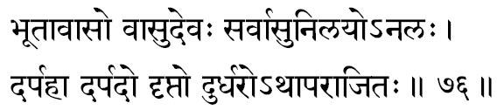
708. Bhootaavaasah –“The very dwelling place of the Great Elements.” “Since the Beings (Elements) dwell in You, You are called ‘Bhootaavaasa,’ “ so says Harivamsa. Bhagavaan Himself says in the Geeta: “I am the Source of all Creation.” Therefore He is also called the ‘Bhootayoni.’
709. Vaasu-devah -One who envelops the world with His Maayaa-powers of veiling and agitations. The Lord discloses: “I pervade the whole world with My Glory, as the Sun with its rays.”
710. Sarvaasu-nilayah –“The Abode of all Life-Energies.” One who is the very Substratum for the life and existence of all creatures. He is the Self, the Life in all of us-therefore, He is the very support for the Praana in each living creature.
711. Analah –“One who is unlimited wealth, power and Glory.” There is no boundary for his Glories – there is no limit for his greatness, and All-pervasive. ‘Of my Divine Glories there is no end’, Bhagavan Himself reveals to Arjuna.
712. Darpahaa –“The Destroyer of the pride in evil-minded people.” Easily He curbed the pride of Indra and others by lifting the mountain and protecting the cows of the Yamuna banks.
713. Darpadah –“One who gives pride to the righteous,”- meaning, one who creates in the Good an Anxious urge to be the best among the righteous and virtuous. This pride is their protection from compromising in even in a small way in any act. This is a positive ‘pride’ of the higher order. There is also a reading of A-darpadah when the meaning would be: “One who never allows his devotees to become proud.” In this way, devotees would totally surrender unto him all their virtues, acting on purely as His agents, are feed by him from bondage of spiritual pride. For such pride, resulting from a preponderance of Sattva guna and sense of doership, would make them vain-glorious of their goodness.
714. Driptah –One who is ever drunk with the infinite Bliss of his own essential nature as Sat-chit-Ananda.
715. Durdharah –the object of contemplation which is indeed very difficult to attain: -the one who is realized by yogis through radios process of intense, single pointed contemplation. Lord Krishna in Bhagavad Geeta admits: “Greater in their trouble whose minds are set on the unmanifest; for the goal, the unmanifested, is very hard for the embodied to reach.”
716. A-paraa-jitah –“The Unvanquished.” “Never-Conquered” is the Glory of the self, for, conquering is of ‘objects’; the ‘subject’ can be conquered. This, being the reality in all, the senses, mind, etc., including the faculties (Devas) can never reach or conquer him. Even when the mighty senses and the terrible Asuras fight against it, still this over whelming powers of desires and passions can never vanquish the self, the divine Narayana.
Stanza 77
visvamoortirmahaamoortirdeeptamoortiramoorimaan
anekamoortiravyaktah satamoortih sataananah.
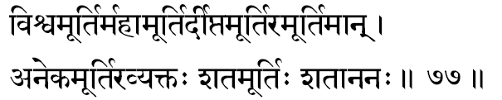
717. Visvamoortih –“Of the form of the entire universe.” Lord as the total – created, so his form is called Visvaroopa. The total gross form of the universe to be gather represents his gross-form-divine.
718. Mahaa-moortih –the great form divine of the lord as he reclines upon the sesha couch as the very support for the creator to bring into existence the universe of the forms and plurality. The entire universe and the creator of the universe are but an aspect of Sree Narayana, the Supreme Self.
719. Deepta-moortih –“Of the Resplendent Form.” As Consciousness, He is never bright and fully effulgent illuming all experiences at all times. Sanjaya reports: “If the splendour of a thousand Suns were to blaze out at once in the sky, that would be like the splendour of that Mighty Being.”
720. A-Moortimaan –“Having no Form.” Though He is described above as Deepta-moorti: “of the resplendent Form”; Mahaa-moorti: “of great form”; Visva-moorti: “of the universal-Form” – He has, in reality, “No-Form”; A-moortimaan. He pervades all, but nothing limits Him. The limited alone has a form-the unlimited, like ‘Space’, has no form. The Infinite Brahman being so subtle. “Subtler than the subtlest.” Sree Narayana as the Self-in-all, allows everything to remain in Him, but He is not conditioned by anyone of them. ever.
721. Aneka-moortih –“Multi-Formed”: One Who Himself has become the world of varieties of Forms -Who has Himself taken the various Incarnations in order to help the world of beings to evolve quicker and fuller.
722. Avyaktah –“Unmanifest.” Things are called manifest when they can be perceived by the sense- organs. As the Self. The Consciousness in us. Sree Hari is the very faculty of seeing. Hearing, smelling, tasting and touching in the five sense-organs. He being, thus, the very subject. He cannot at the same time be the object of the sense-organs. Hence. He cannot be defined or described.
723. Sata-moortih –“Of Myriad-Forms”: even though Consciousness, like Light, has no form of its own, all thought and the thought-projected world of infinite forms are all illumined by the Supreme. Therefore, the Self, functioning through the fluctuations of the restless mind “creates” the illusion of forms-all those forms as His, just as all dream- forms are created by the waker’s mind only.
724, Sataananah –“Many-Faced”: because He is of the Universal-Form, all faces are His only. “Hands and feet everywhere, with heads and mouths everywhere, His ears everywhere, stands (The Lord). enveloping all”

Stanza 78
eko naikah savah kah kim yattatpadamanuttamam
lokabandhurlokanaatho maadhavo bhaktavatsalah.
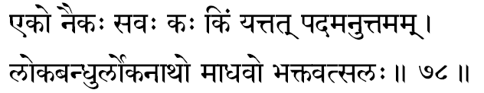
725. Ekah –“The One. The One-without-a second.” As the Infinite is without any of the three distinctions, He, Sree Narayana, the Brahman, can only be the One without any otherness.
726. Naikah -“The Many.” One who, though the One, yet plays in the bosom of all the living creatures. Just as we are one entity, but our thoughts are many, the Supreme Consciousness, Sree Narayana, though One, His reflections as ‘Jeevas’ play in all mind-intellect-equipments. Because He is thus seen to be manifested in the world of plurality, He is “Not One.” Again, “The One” is a definition, a quality. The Lord is Indefinable, quality-less (unqualified). Hence after making the student grasp that He is “The One,” where the pluralities are all merged, the teacher is immediately pointing out that He is “Not even One” For, to conceive “The One” is to conceive the Truth with our intellect-He is to be experienced on transcending the intellect. “The One” has a meaning only with reference to the many. “The One” is a relative statement. To show that the Infinite is to be “experienced” by the “becoming” and not by “knowing,” the teacher has negated “Not even One.” Sruti says “The Lord sports with many forms by His Maayaa.”

727. Savah -“He Who is of the nature of the Sava-Sacrifice.” The sacrifice in which the Soma juice is squeezed out is called Sava.
728. Kah –“Happiness.” One who is of the Nature of Bliss. Since He transcends the body-mind-intellect-equipments, which are the seats of sorrow, in Him there can be only Bliss. Or Kah means a question: He Who is ever a “question without an answer” to the human intellect-He who can be experienced only on transcending the intellect and not apprehended through intellection.
729 Kim –“What.” Since the Lord is the final Goal to be reached, Ho is the On, Who is to be enquired into or diligently sought through constant questioning upon What is His Nature Also because the Truth is realised through this process of enquiry and discrimination-the final Goal of all “What” enquiring-the Lord, is termed here a, “What,” (Kim).
730 Yat –“Which.” The pronoun “Yat” means “that which is self-existent” Hence in the Upanishad, we find the usage of this term frequently. It may also be noted that the pronoun “Which” (Yat) denotes an already existing object Thus the Self-existence of the Supreme Reality, independent of the existence and non-existence of things in the world is indicated when Lord Sree Hari is termed as “Which.”
731 Tat –“That.” The Supreme is indicated by this term in all the Upanishadic literature, and one of the Mahaavaakya is “That Thou Art” Here “That” means the Truth that is not comprehended now, but is to be apprehended through listening to the Teacher (Sravana), reflections upon what you have heard (Manana) and meditation (Nididhyaasanaa). In Geeta, Bhagavan says “Om Tat Sat” are the three designations of Brahman” Or again, the term Tat can mean, “That which expands all the world of plurality:”
732 Padam Anuttamam -“The Un-equalled Stare of perfection The Supreme State of Truth.” Lord Vishnu is the Way and the Goal and the very pilgrimage. “He than whom there is no Higher.”
733. Loka-bandhuh –“Friend of the World.” Everyone is inextricably bound to Him in His Love Infinite, and He is the Father to all. Since there is no well-wisher or friend dearer than one’s own Father, He is the One unfailing sure Friend of the world of beings and things. The Lord serves for the uplift of the world whenever the creatures come to suffer sorrows created by their own immoral negative ways.
734. Loka-naathah –“One Who is the “Lord” of the World,” or “One Who is ‘solicited’ by the world of beings for the fulfilment of all their desires and needs. Or it also means, “One Who ‘adds glory’ to the world. There are also interpretations for the term ‘Naath’ which express “ shines, praised by or loved by”: in all these different meanings, Sree Hari is described as the Lord of the World Lokanaatha.
735. Maadhavah –“One Who was born in the family of Madhu.” The Vaisaakha-month is called Maadhava- month because the Lord is the Spirit of Beauty behind the Spring and its regal lush.
736. Bhakta-vatsalah –“One Whose Love for the devotees knows no bounds.” He is ever merciful and endlessly kind towards His devotees.

Stanza 79
suvarnavarno hemaango varaangaschandanaangadee
veerahaa vishamah soonyo ghritaaseerachalaschalah.
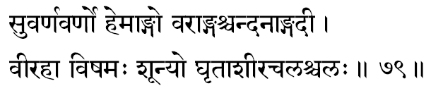
737. Suvarna-varnah –“Golden Coloured” is Sree Narayana for He is, in the devotee, the pure Self; and in all, He is the very All-Illumining Pure Awareness. Mundaka Upanishad declares: “When the Seer sees Him of Golden- hue.” Upon witnessing the Self-Effulgent (Golden) Being, the seer’s realization is completely transforming, and “then that wise one, shaking off all deeds of merits and demerits, becomes stainless, and attains the supreme State of Equipoise.”
738. Hemaangah –“One who has limbs of Gold.” The description of the Lord functioning through the orb of the Sun is well-known: Hiranmaya-”of pure-golden- form.” Sruti mentions it: “This Golden Person seen in the disc of the Sun”… This same Upanishad insists further that “Mind is Brahman” and the “Sun is Brahman.” Lord Hari, as the Infinite Brahman, plays in the Sun (Soorya-Narayana)- thus the term is most appropriate.
739. Varaangah –“With beautiful limbs.” Also, Vara can take the meaning “lovable,” therefore, Sree Narayana is described here as “One whose form (limbs) is supremely “lovable” to the yogi-of-devotion.”
740. Chandanaangadee -This is made up of two terms, “Joy-giving” (Chandana) and “armlets” (Angada). Thus the phrase means “One who has attractive armlets.” It can also be used as describing “One Who is smeared with the sandal.”
741. Veerahaa –“The destroyer of the valiant heroes”-in order to uphold righteousness, Lord Hari takes His Incarnations and destroys the intrepid and daring Asuras in battle. Again, it may be interpreted as One Who destroys the powerful and mighty forces of likes and dislikes-Dvandva -pairs of opposites, the hosts of our own negativities in our hearts.
742. Vishamah –“Unequalled.” Arjuna, in Bhagavad Geeta, estimates his experience of the Lord’s Cosmic Form and says: “None there exists who is equal to You; how can there be then another superior to You in the three worlds, O Being of unequalled power?”
743. Soonyah –“The Void.” Here Void means the total absence of (a) the equipments-of-experiences-the body-mind-intellect; (b) the fields-of-experiences-the objects- emotions-thoughts; (c) the experiencer-attitudes-the perceiver-feeler-thinker personality. In Brahman, the Pure Consciousness, all these three (a, b and c) are totally absent as the devotee of Hari transcends them all. So the Lord, in His Infinite Nature, is ‘without attributes;’ seemingly then, He is the “Void.” This is not “non-existence” of the Buddhists. This is Pure Existence without the object-emotion-thought world-the Self, Sree Narayana.
744. Ghritaaseeh –“One Who has no need for any good wishes from anyone.” The Infinite Lord, perfect and transcendental, has no need for any of the objects of the world to make Him complete since the state of incompleteness is indeed the springboard for all desires to gush forth. It can also mean one who has eaten away the ghee stolen from the cow-herds’ store-rooms in Brindavan.
745. Achalah –“The non-moving.” Either it can signify One Who never falls and therefore does not move away from His own Infinite nature, or it may mean that since the Lord is All-Pervading, He cannot move as there is no place where, at any time, He is not. He is Ever-Present everywhere.
746. Chalah –“Moving.” By the juxtaposition of these two opposite qualities, we are reminded that the apparent world of plurality that constitutes the realm of change is also nothing other than the immovable Atman interpreted through our personal equipments of experiences. Unconditioned by the body, mind and intellect, the Lord in His Infinitude is motionless, but as conditioned by the vehicles He apparently seems to move. We have already explained this relationship earlier. It is something like a traveller, though himself sleeping, is able to travel all the night since he is conditioned by the vehicle which carries him.

Stanza 80
amaanee maanado maanyo lokasvaamee trilokadhrik
sumedhaa medhajo dhanyah satyamedhah dharaadharah.
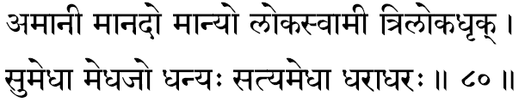
747. Amaanee –“One who has no false vanity.” Since He knows His own real divine nature, He has no false identifications with the equipments of not-Self such as the flesh, the emotions or the thoughts.
748. Maanadah -”One who gives, or causes, by His Maayaa the false identification with the body.” The Sanskrit term ‘maana’ can also mean ‘honour,’ and therefore, ‘maanadah’ can mean One who honours all His true devotees. The root ‘da’ in Sanskrit means ‘blasting’, and therefore, the same term can also mean one who blasts all false notions from the bosom of his devotees.
749. Maanyah –“One Who is to be honoured.” He is the most worshipful as He is the very material Cause for the world of plurality. Bhagavan Sankara says: “If he, who has realised the Supreme, is so blessed and to be honoured in this world,” how much more worshipful is the Lord who is the very substratum and support of the whole universe and by whom all are blessed and inspired to gain their experiences in the world of things and beings!
750. Lokasvaamee –“Lord of the Universe.” Here the word ‘loka’ in Sanskrit means ‘field-of-experience.’ The One Who is the Controller, Director, Who is the Lord and Governor of all fields-of-experiences of all living creatures, at all times, everywhere, is the Consciousness that illumines matter. Therefore, the term Loka-svaamee is extremely appropriate.
751. Thriloka-dhrik –“One Who is the support of all the three worlds.” Apart from the usual concept of the three worlds: heaven, earth and hell, there is a deeper import of the term ‘loka’. It should mean the three fields of experience constituted of waking, dream and deep sleep. Atman, the Self, as Consciousness, is the One that supports all these three states inasmuch as, without this kindling support of life in the bosom, it would be impossible for us to have any experience.
752. Sumedhaah –“One who has Pure Intelligence.” In fact, the term may denote a special power in the human intellect which is the capacity to remember and repeat what has been once experienced before. As such, the term indicates that the very nature of the Self is not a knowledge newly gained, but it is only a remembrance of the seeker’s own real nature, which the seeker in his earlier confusion had forgotten. So long as we have not invoked this great power of memory of our real nature, we shall continue to grope in our sorrows created by our misconception. On realising the Self, it is not that we gain anything new, but we re-discover our own essential Self. Naturally, therefore, with reference to our present forgetfulness, the ultimate goal is indicated by the pregnant term ‘Divine Memory Power.
753. Medha-jah –“Born out of sacrifices.” ‘Medha’ means sacrifices like Asvamedha Yajna. In such a sincere and great ritual, He is invoked and in His Pure Presence there in the sacrifice, we can say He is born. The Geeta meaning of ‘sacrifices’ (Yajna) is “a co-operative endeavor wherein: -we offer our capacity into a field of chosen work invoking in It the unmanifested Lord Who pours forth His blessings in terms of profit.” In this sense, when all the personality layers are offered in an act of total surrender, the spiritual experience of the Self is born. To the student of Vedanta, the term is rich in its suggestiveness.
754. Dhanyah –“Fortunate.” As He has no objects yet to be fulfilled, or any of His wishes not already fulfilled, He is indeed one who is utterly fulfilled. The state of the Self is an eternal state of total contentment.
755. Satyamedhah –“One whose intelligence never fails.” He is the supreme Power of Discrimination, never deluded by the finite world of appearances, but is, in all circumstances, ever rooted in the Truth that He alone is the world of multiplicity.
756. Dharaadharah –“The sole support of the earth.” The earth here stands for matter; and the very essence from which matter has come to express itself, both in its gross and subtle forms, is the Self, Narayana, and therefore, He is considered as the very substratum for the play of matter (earth). Geographically, the earth is supported by water. Water is supported by the atmospheric air and the atmospheric air by the space. The daring enquirer may still continue the question and investigate into the source of space. We know that the space is a concept which we experience in our intellect. All experiences of the intellect are established in Conscious- ness and, therefore, the ultimate support for the entire ‘world’ is the Supreme Narayana.

Stanza 81
tejovrisho dyutidharah sarvasastrabhritaam varah
pragraho nigraho vyagro naikasringo gadaagrajah.
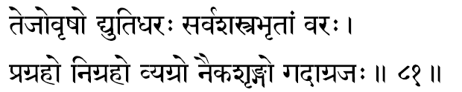
757. Tejo-vrishah –“One Who showers Radiance.” In the outer cosmos the Sun gives out heat and light, and because of this, rain and cultivation are possible-not directly because of the Sun, but due to the sum-total-result of an endless chain of cause-effect links. In the same way, He Who by His mere presence illumines the experiences of all living creatures with His Light, is Sree Narayana, the Self.
758. Dyutidharah -The term ‘Dyuti’ indicates the glow of beauty and strength in a form; thus the term means “One Who bears an Effulgent Form.” The expression also discloses that the seat of Pure Consciousness is described as “the Bearer of Radiance” for it is in the light of the Atman that creatures become aware of all their perceptions, emotions and thoughts.
759. Sarva-sastra-bhritaam-varah -“The best among those who wield weapons.” Since Sree Narayana is described in the Puranas as wielding the Discus (Sudarsana), it, being the greatest of all weapons, justifies this term. Also, the Lord never uses His weapon of annihilation indiscriminately-for He is ever supremely just. It is also significant that all destructions in nature are always ‘constructive destructions’, therefore the Lord’s Discus is itself called “the auspicious vision” (Sudarsana). In the maturity of one’s evolution when one becomes fit for one’s own inner unfoldment, slowly, but irresistibly the seeker can ever detect a secret hand that diligently cuts off all his connections with the outer world, and compels him to lean more and more on the higher. Our Puranic literature is replete with instances, and, without exception, in all of them Sree Narayana is described as using His weapon to destroy the devilish-and to give him Moksha! –“the Auspicious Vision”: Su-darsana. Others, when they employ their weapons of destruction, the result invariably end in a sad ‘destructive destruction’, and, therefore, to invoke Him as “the best among those who wield weapons” is most significant for a seeker.
760. Pragrahah -One who is the sole receiver of all the worship of every devotee, irrespective of his creed or race, or his location in the world, at all times. The devotee may invoke the spiritual presence in various institutions, using different symbols, believing in his own creed and scripture, but, whoever he be, when he comes to transcend his vehicles of perception, feeling and thinking, the experience of the Self (God) should be universally one and the same-as God is All-Pervading and Changeless. This great factor-transcendental IS the Self, Sree Narayana, and therefore, He is the ultimate, sole Receiver of all prayers that rise consciously or unconsciously in every heart, be it from a plant, an animal or a man.
The term ‘Pragrahah’ is used in Sanskrit to mean the reins with which horses are controlled and their movements regulated. In this sense when we reflect, the metaphor of the chariot In the Upanishad suddenly comes in front of us. In this famous scriptural metaphor, mind is the rein by which the steeds of the sense-organs are controlled and regulated. Here Lord Sree Narayana Himself is invoked as ‘Pragrahah’ because when the mind has turned in devotion to His feet, the devotee need not strive to control his sense-organs, but the Lord’s own glory shall imperceptibly do the job for His beloved seeker. There- fore, a truly devoted heart in its utter surrender, calls the Lord ‘‘as the very controller of his sense-organs.”
761. Nigrahah –“The killer.” An uninitiated student may get shocked when he finds that the Lord is invoked as a murderer! But it is true. The only difference is that He is only the destroyer of the ego-just as a doctor is a ‘murderer’ of diseases; just as the sun is the destroyer of the night; as summer is the annihilator of winter. Similarly, the Lord is the destroyer of ego and ego-centric limitations in the devotee. In Sanskrit this word also indicates “One who absorbs the devotee unto Himself.” Once an individual withdraws himself even a wee bit from his total pre-occupation with the world and turns his attention to the spiritual centre in himself, the Lord fascinates and enchants the seeker’s attention more and more to His own Infinite Glory, and ultimately “absorbs (Ni-grahah) the individual totally into the state of Pure-Consciousness.
762. Vyagrah –“One Who is ever engaged in fulfilling the devotee’s desires.” Desire arises in the human mind due to a sense of imperfection in oneself. In the absolute sense of bliss and peace, which is the true nature of Sree Narayana, there cannot arise any desire and, therefore, He is described as “the fulfiller of all desires.”
763. Naika-sringah –“One Who has many (na-eka=Naika) horns.” To a modern student it would look fantastic and even foolish should one worship his Lord, the God, as One with many horns. This mental shock can even stun him when he understands also that his Lord has three legs: “Chatvaarah Sringaah Trayo Asya Paadaah,” says the Maha Upanishad. If the literal translation shocks the student, the very jolt prods him to a more vigorous enquiry. The four horns mean the four States of Consciousness-the waking, dream, deep-sleep and the fourth plane of consciousness, the Pure Awareness. The three feet (paada) indicate the three states of consciousness in which we now revel in our gross, subtle and causal bodies respectively.
764. Gadaagrajah -“The elder brother of Gada.” Lord Krishna had a younger brother whose name was Gada. The term Gada has also the meaning in Sanskrit of ‘mantra.’ Mantra are chanted and therefore Gada can indicate ‘mantra, -”Gadyate iti gadah.” A commentator insists that Ni-gada means mantra, but the prefix Ni gets dropped, so Gada means mantra. Naturally, “Gadaagraja” would mean One who manifests or is invoked through mantras.

Stanza 82
chaturmoortischaturbaahuschaturvyoohaschaturgatih
chaturaatmaa chaturbhaavaschaturvedavidekapaat.
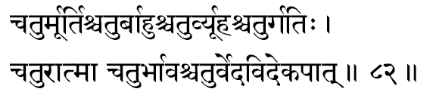
765. Chatur-moortih –“Four-Formed.” The Lord, the Infinite is considered as having four forms-meaning that He, in His manifestations in the world, takes these four forms.
The Puranas have declared that the incarnations of the Lord in the various Yuga, were of different colours: white in Krita Yuga, red in Tretaa Yuga, yellow in Dvaapara Yuga and dark (black) in the Kali Yuga. But according to Vedanta, the Lord, the Self, has four distinct expressions in the subjective life of each individual: the Waker, the Dreamer, the Deep- sleeper and the Pure Self. In the microcosm these are called as Virata, Taijasa, Prajna and Tureeya, and in the macrocosm, the Lord’s complete expression, in the total gross, subtle and causal bodies, is called as Viraat, Hiranyagarbha, Eesvara- and, beyond all bodies as the Eternal Paramaatman.
766. Chatur-baahuh -Lord Narayana is represented as having four hands. These represent the four factors that together constitute the inner equipments in man- mind (Manas); intellect (Buddhi); thought flow towards objects (Chitta) and ego (Ahamkaara). These are the four agents by which all the physical activities are controlled, regulated and constantly commanded from within the body.
767. Chatur-vyoohah –“One Who expresses himself as the dynamic centre in the four Vyoohas. A “Vyooha” is a whirlpool of activities made by a large number of imperfected forms, commanded by a pivotal person who remains in the centre of the whirlpool-just as a battalion functions under the orders of its commander. It is shown in this analogy that the Lord, the central Source of all activities, is manifest as the universal Force which blesses every engagement and contact of a living man with his outer world. In the Aitareya Upanishad, the four Vyoohas (or persons) are mentioned: the person in the body, the person in the Chhandas (Vedic mantra), the person in the Vedas and the Great Person.
768. Chatur-gatih –“The ultimate goal of all the four.” Though their means and purposes appear divergent, Sree Narayana alone is the inevitable goal of all activities of the four types (Varnas) of men: Thinkers (Braahmanas), Rulers and Leaders (Kashatriyas), Men of Commerce (Vaisyas) and Workers (Soodras). The Lord, also, is the consummate goal to be achieved by the four stages (Aasramas) of life: the Age of Study (Brahmacharya), the Householder (Grihastha), the Retirement (Vaanaprastha) and the Stage of Renunciation (Samnyaasa).
769. Chatur-aatmaa -There is also a reading as Chatvaraatmaa. In the former reading, the definition suggests “the clear-minded”-meaning the Lord is one who is completely free from desires, passions, vanities, in short, free from all maladies of ego in His essential Nature. In the latter term, the meaning signifies that Sree Narayana is the one Infinite Effulgence which expresses Itself as the four aspects of our inner equipment (Antahkarana Chatushtaya).
770. Chatur-bhaavah –“The Source of the four.” One who is the Source for the four types (varna), for the four stages-of-life (Aasrama) and the four human aspirations (purushaartha). The human aspirations as codified by the Sanaatana Dharma are again four in number. Righteousness (Dharma), Wealth (Artha), Pleasure (Kaama) and Spiritual Liberation (Moksha). Lord Krishna reveals in the Bhagavad Geeta: “ All the four types in creation have come from Me.”
771. Chatur-veda-vit –“Knower of all the four Vedas.” The Lord is the very theme discussed and expounded in the four vedas. The student of the vedas when he realises the Lord, then only he fulfils his study of them. In this sense of the term, Bhagavan proclaims in the Fifteenth Chapter of Geeta: “I am verily that which has to be known in all the Vedas: I am indeed the author of the Vedas and the “knower” of the Vedas am I.”
772. Eka-paat –“The one-footed.” The term ‘paada’ in Sanskrit has two meanings: a ‘part’ and a ‘foot.” The Lord, in Bhagavad Geeta, uses the first meaning to describe His mighty Glory: “The whole universe’ is supported by one part of Myself.” There is a reference in the Taittireeya Aaranyaka which clarifies the latter meaning: “All beings are His foot.” The significance here is the ~me as in Geeta-wherein even the totality of all universes cannot be compared to Him, the Infinite Absolute Existence.

Stanza 83
samaavarto-anivrittaatmaa durjayo duratikramah
durlabho durgamo durgo duraavaaso duraarihaa.
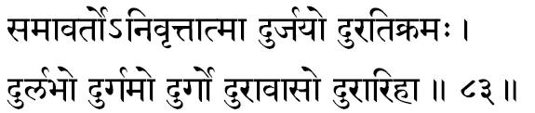
773. Samaavartah –“The efficient turner’ -of the wheel-of-life. ‘ Aavarta’ is to turn. The wheel-of-life- and-death, the samsar, is constantly being churned by the Law, which is none other than the Lord. The Law and the Law-Giver are one and the same in this universe-Sree Narayana.
774 Nivrittaatmaa –“One whose mind is turned away from all sense indulgences.” The famous ‘two birds’ of the Mundaka Upanishad strike a simile here. “Two birds bound one to the other in close friendship, perch on the selfsame tree. One of them eats the fruits of the tree with relish, while the other looks on without eating,” The latter is the Nivrittaatmaa, Some commentators have taken the word as’ A-nivrittaatmaa’ in which case the meaning would be: “One who never turns away from anything, but enters into every- thing.” as the very Self is every thing and every being-that Supreme One, Lord Narayana.
775. Dur-jayah –“The Invincible”-One who cannot be conquered by anyone else. Even though, in the majority of us, there is a preponderance of the lower urges, in the patient grinding of time, the evolutionary goal ultimately wins and irresistibly pushes each one of us towards the altar of the Self. Battles may be lost but the war in the end is won by the Lord of our heart.
776 Durati-kramah –“One who is difficult to be disobeyed:’ This term declares a truth which is proven upon observation of this scientifically precise world where no object or being dares to disobey the Lord, the Cosmos The Rishi in Kathopanishad says “through fear of Him the Fire burns, through fear of Him shines the Sun, through fear of Him functions Indra, Vaayu, Lord of the Wind, and Death itself is the fifth”-as though He is behind each one with uplifted thunderbolt. The term ‘Atikromah’ means ‘going beyond’, therefore the term, as it stands, indicates “a state beyond which no one can go”-meaning Sree Narayana is the final and the absolute destination of all evolution He is the transcendental Reality and other than He there is no more a beyond to he achieved
777. Dur-Labhah –“One who is obtained with consummate effort.” The final destination of all evolution is He, the spiritual perfection. Therefore, He is only gained after millenniums of slow evolutions, from the insignificant unicellular existence to the status of man, and the fulfilment of man’s evolved, rational life is the state of Godhood. The reward for all the slow and steady efforts of evolution is bestowed when an organism reaches the height of the rational human being; and, thereafter, through selfless, dedicated service, deep and individual devotion, and sincere and serious study of the scriptures, man learns to remove his mind from all his worldly pre-occupations and brings himself to finally realise his divine Godhood. Indeed, the state of Narayana- Consciousness is an experience that is to be obtained with consummate effort.
778. Dur-Gamah –“One Who is realised with great difficulty.” In Bhagavata there is a statement that the Lord is easily obtained (A-dur-gamah). For those who have not already developed extreme meditative abilities in their devoted hearts, the processes of self development, when studied from a book or heard from a teacher, the immediate reaction in the bosom of such students will be that it is very difficult. But as he marches forward in his saadhanaa he gains the further guidance and inspiration to ‘go-forward.’ More bounteous aspects on him beam and the ‘kindly light’ leads him safely to the goal through all obstacles. A candle or torch can at best light up only ten or fifteen yards in front of a traveller. It can never illumine the whole path of one or two miles at a stretch. He has to start and proceed as far as he can see and as he marches ahead the forward stretches will be illumined.
779. Dur-Gah –“Not easy to storm into.” The term is used in Sanskrit to indicate a fortress; therefore the suggestion is that the essence of the Lord, Sree Narayana, is fortressed around by the matter vestures and their objects of fascination. Attracted by them, our attention is always distracted towards the joy contents in them. This seducing power of the matter vestures is itself the mighty Maayaa, which only very rare, courageous and blessed ones are able to cross over.
Bhagavan Himself says: “Mama My Duratyayaa….” The Upanishads say that the truth, Narayana, cannot be perceived by the senses, imagined by the mind or thought of by the intellect. These being the only source of our knowing, it almost impossible to realize the Truth. It is only an all-out suicidal attack that enables some rare ones to storm the fort and reach the Goal. Hence to an extrovert man, the seat of Consciousness apparently seems to be impenetrably fortified. The direct meaning here indicates the great Lord seated in our heart who is “not easily realized.”
687. Punyah –“The truly–Holy.” When the devotee’s heart is filled with remembrance of the glorious from divine and infinite nature and supreme of the lord Vishnu, he then, in that very moment, removes all sin from his devotee’s heart. The lord is Auspiciousness itself, so where he is invoked, all inauspiciousness must immediately retire.
688. Punya-keertih –“Of Holy frame.” He is gloriously renowned as the holy one. Whoever glorifies him becomes himself holy. All the unholy animal passions in the devotee are routed and beaten back when his heart is wholly in tune with the lord’s Glory and Form.
689. Anaamayah –One who has neither the mental or physical diseases. Of pure unstained divine essence is his nature. He is not involved in karmas, thus the resultant of the karmas which visit us in terms of mental restlessness or physical pangs, never touch Him.

Stanza 84
manojavasteerthakaro vasurtaah vasurpradah
vasuprado vaasudevo vasurvasumanaah havih.

690. Manojavah –Fleet as the mind is the Lord’s movement. He is anxious to run and reach the devotee to remove his suffering and ignorance. All-pervading is the lord, thus he is faster than all those who run after him – and wherever they reach, the supreme, He, in the form of existence, is already there.
691 Teerthakarah –“The Teacher of the Teerthas” The term, Teertha” means vidyaas. Sree Narayana is the author of the Vidyaa, or auxiliary Sciences Therefore, “One Who is the most ancient Teacher of all Vidyaas and Tantras.”
692 Vasuretaah –“He Whose Essence is Golden.” In the beginning of Creation were the primeval waters Into this One Ocean the Lord dropped His Essence and it became a Golden Egg from which Brahmaa, the Creator, first arose Thus Lord, as the womb of all Creation is mentioned in the Puranas as “Hiranyagarbha,” the Golden Womb
693 Vasupradah –“The Free-Giver of Wealth” Inn this context, Vasu means “Worldly-Wealth”- money, property, grains, possessions, progeny Lord Vishnu who nourishes and maintains all beings with the wealth of His consort, Sree Laksmi, distributes and patronises His devotees very liberally
694. Vasupradah -Again, the same term as we read above, but here if means “The Giver of Salvation” Liberation (Moksa) is the greatest wealth-whom He chooses, Moksha is gained by him alone.
695. Vaasudevah –“The son of Vasudeva,” Lord Krishna. Or “One Who is Vaasu and Deva” “Vaasu” means “One who dwells in all creatures as their ego-centric individuality (Jeeva-raopa).” ‘Deva' means “One who revels” Therefore, this name for Lord Krishna has the appropriate meaning “One who revels in every living creature as the Jeeva-entity in each”.
696 Vasuh –“The Refuge for all.” The One Who dwells within, veiled behind Maayaa, the mind The mind projects this play of things, beings, emotions and thoughts. The world is the shadow-show round the Pure Consciousness Lord declares in Geeta: “I am the beginning, the middle and also the end of all beings.” Thus He alone is the Refuge, for there is no other existence. “All have emerged out from Me, exist in Me and must come back to Me.”
697. Vasumanaah -One who is attentive to, and, therefore, concerned with every object and being in this world: “Omnipresent.”
698. Havih –“The Oblation.” That which we offer unto Him is also permeated by Him-there is nothing other than He, Himself, the same everywhere, in all places, at all times. In Geeta, Lord insists that the “oblations” are nothing but Brahman.”

Stanza 85
sadgatih satkritih sattaa sadbhootih satparaayanah
sooraseno yadusreshthah sannivaasah suyaamunah.

699. Sadgatih –“The goal of good and noble seekers.” Lord Narayana is the Spiritual Goal to be reached. “The Good” here means those who know the existence of Brahman, for the Upanishad says: “If a person knows ‘Brahmaji exists,’ then the wise call him ‘good.”
700. Sat-kritih –“One Who is full of Good Actions.” Lord Hari is the One Who maintains the rhythm of creation and the logic of its preservation. Even through His destructive activities, there is creation only for the sake of the individual and for the good of the world. All His actions are totally in harmony for the establishment of Peace.
701. Sattaa -The Lord is the “One without a second,” and, therefore, remains ever the same, without any differences of genus, species or in Itself.”
702. Sad-bhootih –“One Who has Rich Glories.” The term ‘Glories’ means wealth, power, happiness Or “One who has taken different kinds of Incarnations,” exhibiting in all of them the glories of the Supreme. So immeasurable are the Lord’s Glories that even all these splendours scarcely reveal His Divine Might. Him, whom even the Devas know not; only the Yogis in meditation come to perceive His Eternal Glory.
703 Sat-paraayanah –The Supreme Goal for the “Good” who pursue the path of Truth. Here the “Good” means those who are the Knowers of Brahman.
704 Soora-senah –“One who has heroic and valiant armies” The Incarnations as Rama and Krishna are indicated here in whose armies there were valiant people like Hanuman and Lakshmana, Arjuna, Bheema and others.
705. Yadusreshthah –“The Best among the Yadava clan.” The Glory of the Yadavas-Lord Krishna, Who was an Incarnation of Sree Hari.
706. Sannivaasah –“The Abode of the Good.” The great souls of realisation come to live in Him, the Self; drowned in God-Consciousness, they beam out from that Abode their divinity all around. Bhagavan in Geeta says: “My devotee thus knowing (realising the Truth, the jneyam, seated in the heart of all) enters into My Being.”
707. Suyaamunah -One who is attended by the righteous Yaamunas-meaning Gopas who live on the Yamuna banks. In a metaphysical sense, these Gopas are not the keepers of ‘cows,’ but the keepers of the sacred milk of Knowledge-Upanishads.

Stanza 86
bhootaavaaso vaasudevah sarvaasunilayo-analah
darpahaa darpado dripto durdharo-athaaparaajitah.

708. Bhootaavaasah –“The very dwelling place of the Great Elements.” “Since the Beings (Elements) dwell in You, You are called ‘Bhootaavaasa,’ “ so says Harivamsa. Bhagavaan Himself says in the Geeta: “I am the Source of all Creation.” Therefore He is also called the ‘Bhootayoni.’
709. Vaasu-devah -One who envelops the world with His Maayaa-powers of veiling and agitations. The Lord discloses: “I pervade the whole world with My Glory, as the Sun with its rays.”
710. Sarvaasu-nilayah –“The Abode of all Life-Energies.” One who is the very Substratum for the life and existence of all creatures. He is the Self, the Life in all of us-therefore, He is the very support for the Praana in each living creature.
780. Dur-aavaasah –“Not easy to lodge” –within the heart steadily for even great seekers who are diligent in their consistent pursuit. To withdraw the mind from the objects of pleasure and to steadily contemplate upon the great seat of Life is not an easy accomplishment. Therefore, even yogins, in their persevering meditation, find it not easy to contemplate steadily upon Sree Narayana, hence this name. “This Yoga of equanimity, taught by Thee, O slayer of Madhu, I see not its enduring continuity, because of the restlessness (of the mind),” cries Arjuna in the Geeta. Bhagavan also adds in the same Chapter that the meditation should be “As a lamp placed in a windless place does not flicker.”
781. Duraarihaa – “One Who is the slayer of the devilish Asuras.” Even in those among us who are not steadily good, the Lord, when invoked, out of His compassion destroys the devilishness and redeems our personality from its sad consequences. The asuric tendencies are in the bosom of every seeker and devoted invocation of the Lord in our bosom can cleanse the heart of all its negative tendencies. Therefore, it is indeed appropriate that He is significantly indicated as `Duraarihaa.’’

Stanza 84
subhaango lokasaarangah sutantustantuvardhanah
indrakarmaa mahaakarmaa kritakarmaa kritaagamah.
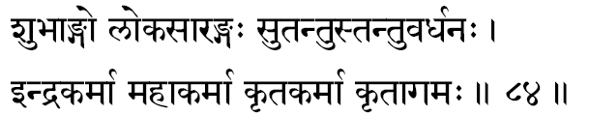
782. Subhaangah –“One with enchanting limbs of perfect beauty.” The Beauty of all beauty is the Lord, and His captivating form and the rhythm of His shape are the theme of meditation for the devotees. In the Upanishads the Infinite Lord, the Self, is described as Peace-Auspiciousness-Beauty (Saantam-Sivam-Sundaram). Thus the devotees of the Lord, remembering the auspicious beauty of His sacred limbs, prostrate at His altar in their deep reverence and mounting joy of devotion.
783. Lokasaarangah –“One who has enquired into or understood the Essence behind the universe of names and forms” Or, Lokasaarangah can mean the essence, or the source, of the world which is the great Pranava, `OM.’ So the term means the State of Supreme Consciousness that is gained or reached through the contemplation upon the significance of OM.
784. Sutantuh –“Beautifully expanded.” Just as the thread is drawn out in different counts from cotton which is later employed as the warp and woof in the creation of infinite varieties of cloth, so too, from the Narayana-Consciousness, the endless variety of beings and things gets projected to constitute the enchanting tapestry of His mighty universe. As the thread is the substratum for all the various fabrics, the Narayana is the beautiful thread, the-substratum, for all this wonderful universe. The Lord Himself says: "There is nothing whatsoever higher than I, O Dhananjaya. All this is strung on Me, as clusters of gems on a string.
785. Tantu-vardhanah –“One who sustains the continuity of the drive for the family.” The family is maintained by the virility of the members and this potency in the individual is an expression of vitality which Life imparts to the living organism. Thus, the grace of the Self is that which is manifested in the fertility of the seed (Ojas). Generally in India, among the Hindus, it is customary to attribute the continuity of the family to the Grace of Narayana.
786. Indrakarmaa –“One who always performs gloriously auspicious actions” The root ‘Id’ is used in the sense of Supreme Auspiciousness, Parama-aisvarya.
787. Mahaa-karmaa –“One Who accomplishes Great Activities.” To create a cosmos so scientifically precise and perfect out of the five great elements, and to sustain them all with an iron hand of efficiency, all the time constantly presiding over the acts of destruction without which the world of change cannot be maintained, is, in itself, a colossal achievement of an Absolute Intelligence.
788. Krita-karmaa –“One Who has fulfilled all His activities.” There is nothing more for Him to achieve. He is the Goal. He is the Destination. In His Eternal Perfection there is nothing more for Him yet to achieve. This sense of complete fulfilment is described in all the scriptures as the State of Blissful Perfection-the Self.
789. Kritaagamah –“One who is the author of the Vedas.” The vedic mantras are called Aagamah. The mantras were revealed to the great Rishis during moments when they were not identified with the Body-Mind- Intellect and, therefore, they were not, at those inspired moments, limited individual egos. Where the ego is thus ended, the Self-alone comes to manifest. In this sense of the term, all scriptures have burst forth from prophets and seers when they transcended their limited existence to experience their oneness with the Eternal, Sree Narayana, In Bhagavad Geeta also, Lord Krishna confesses, “I am the author of all the Vedas; I alone am the knower of the Veda.”

Stanza 85
udbhavah sundarah sundo ratnanaabhah sulochanah
arko vaajasanah sringee jayantah sarvavij-jayee.
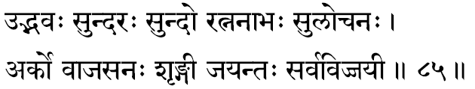
790. Udbhavah –“The ultimate source”- the very spring of Creation. In the Puranic view of the term, it may mean One Who has by His own free-will manifested Himself by Himself for the service of mankind, or, it may designate subjectively, the Self, Sree Narayana, as the one dynamic Witness in Whose Presence alone the vital activities of life gush forth into expression.
791. Sundarah –“Of unrivalled beauty.” In almost all religions the Infinite Lord is described as one having the most enchanting beauty. When we experience beauty in the world, we are moved to consider its beauty either by the pro- portion or the symmetry, or th~ tender charm in the object of observation. Within the mind of the observer, there reflects for a moment the rhythmic grace in the proportion, the smooth peace in the symmetry, or the joy of ecstasy which ripples out from the object into the contemplative eye. In all these conditions, the observer’s mind, sensitive to the aestheticism in him, quietens, and, it is at such moments of supreme inner satisfaction, the flashes of “beauty-experiences” floods the bosom. Remember, beauty is not in the object nor is it in the mind. The enchanting occasion silences the mind that is now available for the aesthetic reaction which resultingly fills the observer- and this is nothing but the manifestation of That which is behind the mind, Sree Narayana. Hence, the Infinite Reality is glorified in the Upanishads as “Peace-Auspiciousness-Beauty’. ( Saantam-Sivam-Sundaram} .
792. Sundah –“Of Great Mercy.” Whatever be the amount of vaasanaas hoarded in our personality, due to our ego-centric, extroverted activities, once a devotee turns unto Him in total surrender, all the vaasanaas are purified and he comes to move more and more towards Him-as though, in infinite mercy, He forgives all sins that a man might commit in his innocent ignorance (Avidyaa).
793. Ratnanaabhah –“Of beautiful navel.” Text books of Bhakti-cult advise devotees that they should meditate upon the Lord’s navel-point, as a flashy, brilliant jewel (Ratna). This point of concentration is not without significance. The mystics of India long ago explored the percentage of human action that is grossly manifest at the physical level. Today also, psychologists confess that they have no other knowledge beyond the obvious fact that thoughts express themselves as actions. But deeply meditative mystic enquirers delved deeper to detect and chart the story of actions. In their adventurous explorations, they discovered that in seed form all thoughts are with the Infinite (Para) before manifestation. From this womb they become manifest and an individual becomes dimly aware of thoughts in their embryo form-vague and still incompletely un-formed (Pasyantee). Thereafter, the thoughts get translated into expressions (Madhyamaa) and in their last full stage of manifestation they come to express themselves as actions in the outer world (Vaikharee).
In this chain of processes when thoughts become manifest for the thinker, it is said the seat of Pasyantee-stage is the navel region. This brilliant seat of nascent manifestation of all thoughts is indicated here as “the jewel of his navel.” Generally, the intelligent student would readily jump to the conclusion that this truth is merely a poetic exaggeration, but there is a deep significance in it indeed.
794. Sulochunuh –“One Who has the most enchanting eyes.” The term indicates the beauty of the Lord’s eyes for those devotees who turn to the Lord’s form. To the deeper students of contemplation, the eyes are great not be- cause of their form, colour or expression, but because of their ability to see constantly the infinite purpose and goal of the entire creation. Therefore, the term means. “One who has the wisdom of the Self.”
795. Arkah -“One Who is in the form of the Sun.” The Sun is worshipped as a Vedic deity, even by the Creator Himself-hence, the term suggests ‘most worshipful.’ The Sun-centre of the solar system-is the one source of light and energy illumining and nourishing everything. The Infinite Consciousness, Sree Narayana, is the Sun by Whose Splendour the experiences of all people are illumined, at all places and at all times. He, as the One Life, thrills all living creatures and presides over, in and through their nurture and nourishment. Once He has left from therein, that body cannot be maintained -though we witness today the experiments of medical science to do so.
796. vaajasanah –“The giver of food.” The one Vital Force that ultimately sustains, supports and nourishes all living creatures in the Universe is the Supreme. and Its Nature is not really different from the Lord, Sree Narayana. In the Bhagavad Geeta the Lord describes Himself as manifesting through the sun as the sunlight which penetrates the earth to fertilise it. The fertility of the soil, in turn, becomes the plant on the surface into which the Lord transfuses the food value of the vegetable world by the essence of moon- light from the moon. Further, in the Upanishads, we find indicative declarations that offerings, given in the worship of Fire themselves come down as a reward in the form of rain and plenty for the society.
Again, it is a law of life that each individual is supplied with the exact type of ‘equipments for experiences’ and each one also finds himself in the precise environmental circumstances for their expression according to the texture and type of vaasanaas in him. Thus, in the larger sense, the entire world of ‘emotions-feelings-and-thoughts’ constitute the total food (Annam) for the experiences of the body, mind and intellect.
797. Sringee -“The horned one.” This is generally commented upon as reminiscent of the Lord’s Incarnation as a Fish. It would have been happier had it been reminiscent of the Boar-Incarnation which Sree Narayana took to lift up the world from its slushy condition to the plane of dry-surfaced earth.
798. Jayantah –“The conqueror of all enemies.” No force could ever vanquish Him who is ‘the Source of all energy and strength’-the Almighty. Sree Narayana is acclaimed as the conqueror, because it is by His Grace and direct help that the gods always win against the ‘diabolically bad’ (the Asuras). In our bosom it is the grace of the mind and intellect, in attunement with the Self, that helps us to conquer our lower impulses, our endless desires for the sensuous-and our craving for the cruel pleasures of indulgence.
799. Sarvavij-jayee –“One Who is at once Omniscient (Sarvavit) and victorious (Jayee).” The term, however, is not two words and, therefore, as a single expression, we can also understand it to mean, ‘One who is victorious over all men of wisdom.’ Prattlers of wisdom, however eloquent in their discussions, must become utterly silent in their moments of Samaadhi, in the presence of the Self, Sree Narayana.

Stanza 86
suvarnabindurakshobh yah sarvavaageesvaresvarah
mahaahrado mahaagarto mahaabhooto mahaanidhih.
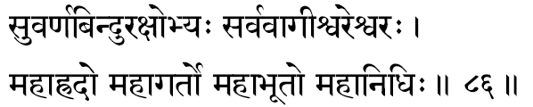
800. Suvarna-binduh –“With limbs radiant like gold.” Chhandogya Upanishad declares: “He, having a golden body, even to the tip of his nails.” The great name of the Lord in the Vedic literature is ‘OM’ which consists of the sounds ‘A’, ‘U’, and the bindu ‘M.’
801. Akshobhyah –“One Who is ever unruffled.” Ordinarily an individual gets disturbed, subjectively, by the presence of desires, anger, passions, etc., and objectively an average man is constantly stormed by the enchanting dance of beautiful sense-objects all around him. Lord, the Self, is a state of existence wherein neither the subjective disturbances of the mind, nor the objective persecutions of the sense-organs can ever reach to ruffle the quietude and peaceful grace of His perfection. In describing the state of the Sthitaprajna, Bhagavan says in the Geeta that such a one will be Akshobhya like the ocean: “He attains Peace into whom all desires enter as waters enter the ocean, which filled from all sides, remains unmoved; but not the ‘desirer-of-desires.”
802. Sarva-vaageesvaresvarah –“The very Lord of the Lord of Speech.” In the Kenopanishad it has been made amply clear that it is not the instruments of actions and perceptions that act by themselves as they are all made up of inert matter. The immediate animation to the equipment is given by the ‘inner instruments.’ Therefore, for all the sense-organs, the mind-intellect-equipment is their immediate Lord. But these subtle instruments themselves get their dynamism to act only in the presence of Sree Narayana, the Consciousness. Therefore, it is most appropriate to invoke Him as the Lord of Lords in all living creatures.
The term Vaageesvara (Lord of Speech) is often used in the language to indicate poets, writers and orators. Therefore, the term can also be interpreted as ‘the Lord from whose altar all ordinary speakers draw their powers. Theologically, some commentators have spun a meaning out of this term indicating that Sree Narayana, as the Absolute Reality, is the ‘Lord’ of even the Creator .
803. Mahaa-hradah –“One Who is like a great refreshing swimming pool.” In the hot summer season, plunging into the cool crystal waters of a. pool holds the swimmer in a refreshing cool embrace on all sides. Similarly, the plane of Narayana-Consciousness revives, refreshes and en- thralls all meditators when they plunge into its reviving quietude. The Yogins often plunge into It from the springboard of their devotion, and after a time emerge out of It-cool, clean and refreshed. Sree Narayana is metaphorically addressed as the great (Mahaa) pond (Hradah).
804. Mahaa-gartah –“The great chasm.” Here the ‘chasm’ means the Lord’s maayaa which He Himself describes, in the Bhagavad Geeta as “My Maayaa (non-apprehension and the consequent misapprehension) is very difficult to cross over.” The industrious lexicographers enter here and additionally press out of this word garta the meaning, ‘chariot,’ and, therefore, the term can also mean that He is a ‘mahaaratha’ (Great Chariot).
805. Mahaabhootah –“The Great Being.” He is the Source from which even the Great Elements spring forth into existence and, therefore, in His Infinitude and Pervasiveness, Lord Narayana is called ‘Mahaabhootah.’ The entire play of birth and death, of integration (sanghaata) and disintegration (vighaata) are taking place in Him Who is the mighty substratum and, therefore, it is very appropriate that the Lord, the God, is considered by the devotees as the “Great Being.’
806. Mahaa-nidhih –“The Great Abode.” “The Eternal Source from which everything springs forth and the Infinite substratum upon which the entire play of the finite is held in animated suspension.” The term ‘nidhi’ means ‘treasure’ and, therefore, its indication here is that Sree Narayana is the richest treasure of all His devotees-to loot at will!

Stanza 87
kumudah kundarah kundah parjanyah paavano-anilah
amritaaso-amritavapuh sarvajnah sarvatomukhah.
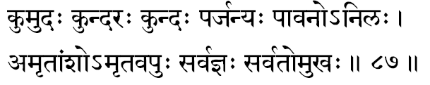
807. Kumudah –“One Who gladdens the earth,” or “one who gets gladdened by the earth.” Earth here should be understood as the entire cosmos ever so dynamic and scientifically precise. The world of plurality is Narayana’s joyous expression of His infinite potentialities. It is the fulfilment of the Omnipotent.
808. Kundarah –“The one who tore the earth in His Incarnation as the Boar in order to destroy the mighty tyrant, Hiranyaaksha. It can also mean: Darah(one who wears); Kum (the earth). The term is further commented upon as “One who bestows rewards as beautiful as the Kunda flowers.”
809. Kundah -Here we read it as ‘Kunda flower.’ In this context the term means “One who is as comely and attractive as the kunda flowers.” In Harivamsa it is said that the Lord, as Parasuraama, in order to atone for the battles he had fought, gave (do) gifts of this earth (kum) to Rishi Kasyapa. ‘ Ku’ also has the meaning of the “rulers of the earth,” and ‘do’ means “slaying.” In this way the term indicates the “one who had taken the Incarnation of Parasuraama to destroy the unreasonably vicious tyrants of the land.”
810. Parjanyah –“He who is similar to the rain-bearing clouds.” Lord Krishna has been described as being so gloriously hued. Again, agriculturists and all living creatures are extremely happy when they see these clouds-the harbingers of comfort and prosperity. To the devotees, the Lord is a total fulfilment, as the clouds are for the parched earth.
811. Paavanah –“One Who ever purifies.” The impurities of a personality are gathered when the mind and intellect, in a natural impulse of animal voluptuousness, rush towards the sense-objects with ego-centric passion. To I retrieve the mind from the sense-objects and to peacefully let it settle in contemplation of the divine nature and the eternal J glory of Sree Narayana, the Self, is to exhaust all the existing vaasanaas, which are the personality-impurities within.
812. Anilah -Like the atmospheric air the Lord is the life-giver everywhere, and also He is All-pervading. Nilah also means ‘to slip’-into a condition of non-apprehension: thus, one who is ignorant (avidya). When the symbol of negation, ‘a’, is added to it, ‘A-nilah’ comes to indicate “One who slips not, but is ever of the nature of Consciousness.” Hence it means “Omniscient.”
813. Amritaasah -Since ‘amrita’ has both the meanings of ‘nectar’ and ‘immortality,’ the term is interpreted to mean “One whose desires are never fruitless,” as well as “One whose greatest desire is for the State of Immortality.”
814. Amrita-vapuh –“He Whose Form is Immortal.” He, the Eternal Reality, is unconditioned by time. This principle of Consciousness, functioning as the flame of life in every bosom, by its mere presence has in Itself neither the physical, subtle nor causal bodies-which alone are the perishable. Transcending them all-unconditioned by time, and, therefore, never undergoing any of the natural modifications of mortality, Sree Narayana revels in His Absolute Glory.
815. Sarvajnah –“Omniscient.” It is only when the light of Awareness illumines the happenings that living creatures can become conscious of their experiences. To know the outer and the inner world of happenings, they must be lighted up by the principle of Consciousness. This seat of Sree Narayana is, therefore, called the Pure Knowledge- the Principle, because of which all other knowledge is possible in every being.
816. Sarvato-mukhah –“One Who has His face turned everywhere”-just as the light in the sun, or the light of a lamp. In the Bhagavad Geeta He is described as having eyes, heads and faces on all sides.

Stanza 88
sulabhah suvratah siddhah satrujit satrutaapanah
nyagrodhodumbaro-asvatthaschaanooraandhra-nishoo-danah.
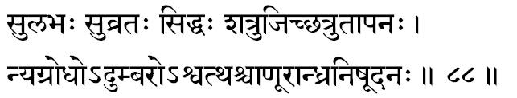
817. Sulabhah –“One who is readily available” and, therefore, easily attainable for those who have true devotion and the heroism to put forth the right effort in unveiling Him from the miserable pits of matter. To the mind in contemplation, the Reality is self-evident; all saadhanaas are only to render the mind contemplative.
818. Suvratah –“He Who has taken the most auspicious Forms”-to destroy the evil and to protect the good is the motive behind all His manifestations. The seeker himself is one of the Lord’s own manifestations; thus, every spiritual/ student will ultimately realise that to destroy the ego in himself and finally gain back the very state from which he apparently manifested is re-discovery of the Self.
819. Siddhah –“One Who is Perfection”-not one who has attained perfection. Sree Narayana, the Absolute State of Perfection, can never, even when He is playing as the Incarnation, forget His real nature of Eternal, Unbroken, Unchanging Perfection.
820. Satrujit –“One Who is ever victorious over His hosts of enemies.” In the bosom of man, his enemies are none other than consciousness of his body and the con- sequent passions of the flesh-both objective and subjective. The seeker feels that these urges in him constitute a very powerful team of belligerent forces, and against their concerted onslaught he feels helpless. But when such an alert seeker turns himself towards the Truth, the Lord Who is in his own heart, all obstacles whither away. It is natural then that Sree Narayana is invoked here as the “Supreme Conqueror of all Enemies.”
821. Satrutaapanah –“The Scorcher of enemies.” When the devotee offers himself at the altar of His Feet, He burns down all the negative tendencies polluting the devotee’s heart.
822. Nyagrodhah –“The One who, while controlling all beings, veils Himself behind this Maayaa.” The Consciousness constantly functions within us, but due to the Vaasanaas, our attention is constantly distracted to the perception of objects outside and not to the Effulgent Being which is the core in us. At the same time Sree Narayana, the Self, is the very Life which has made possible the entire manifestation of the world. Still, by His own playful inscrutability we recognize Him not. Interpreted in another sense, the term can also mean, “He who is above all.’ The nobler, the mightier power which controls and regulates any organised set of activities, when it is conceived by human intellect, it is always expressed as something higher or above. Therefore, the significance of this term must be clear to the students.
823. Udumbarah –“He Who is the Nourisher of all living creatures”-supplying each with its appropriate food. The term also suggests: “one who transcends even Aakaasa, the subtlest of the manifested elements.” Sree Narayana, the Source out of which all creatures have emerged, He alone must also be the Great Cause from which even the subtlest element, Aakaasa, (space) has sprung forth. The cause is subtler than the effect, therefore, the essential principle, Narayana, transcends even the concept of space.
824. Asvatthah -In the Upanishad, (Kathopanishad) and in the Bhagavad Geeta (Chapter XV), Lord Narayana is indicated as the great “Tree of Life,” the Asvattha. Ficus Religiosa is a perennial tree, seemingly relatively immortal, as compared with the quickly-perishing mankind that comes in waves, generation after generation, to play under its shade, to make love at its base; to grow old in its breeze. Even when they are dead, their bodies are carried in moonlit procession to the burial ground, where under the tree’s dancing leaves, a play of light and shade splashes a wizardly pattern upon each lifeless face. The children of each departed one, in their turn, repeat the unending cycle of life under the shade of the same old tree whose nodding grimace mocks the procession of fleeting joys and sorrows. This tree has been chosen to represent the finite play of the Infinite and the Tree itself has been named: A-svattham meaning: “That which will not remain the same tomorrow.”..
825. Chaanooraandhranishoodanah - “The slayer of Chaanoora, the great wrestler. Andhra means wrestler.”

Stanza 89
sahasraarchih saptajihvah saptaidhaah saptavaahanah
amoortiranagho-achintyo bhayakrit bhayanaasanah.
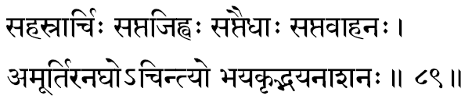
826. Sahasra-archih –“He Who in His Effulgence has thousands of rays.” The Self, Sree Narayana, the Pure Consciousness which illumines all experiences, is considered in our scriptures as the ‘Light of all Lights,’ and, in the Geeta’s famous description of this mighty Effulgence of Reality we read: “If the Splendour of a thousand suns were to rise up together and at one and the same time blaze forth. In the sky, that would be like the Splendour of the Mighty Being.”
827. Sapta-jihvah –“He Who expresses Himself as the ‘seven tongues’ (flame).” ‘Jihvaa’ means tongue; here it is used as the ‘tongues-of-flame.’ These seven flames of different properties are enumerated in the Mundakopanishad. It sets forth the idea that the Light of Consciousness beams out through seven points in the face of a living entity-two eyes, two ears, two nostrils and the mouth. As intelligent beings, powers of perception metaphorically flame out through each one of them, illumining the world for us. The one in our heart, Sree Narayana, Who totally manifests as the seven distinct tongues-of-flame is classified here by the scientific-poets, the Rishis, in the language of lyrical service as Sapta-jihvaah.
828. Sapta-edhaah –“The Seven Effulgent flames.” The earlier term invoked Him as the “Seven tongues- of-flame.” Here the emphasis seems to be for the Effulgence in those flames.
829. Sapta-vaahanah –“One Who has the vehicle of seven horses.” Lord Sun is described by the poet-seers of the Vedas as riding in a chariot drawn by seven horses, representing the seven days of the week.
830. A-moortih –“One Who is formless.” ‘Form’ implies a thing that is limited by other factors. The All-Pervading cannot have a form-just as space has no particular form. All things having a form are perishable. Narayana who is Infinite and Eternal is thus ever Formless.
831. Anaghah -The Sanskrit term Aghah means sin or sorrow. Therefore the term means one who is sinless or sorrowless. Lord Paramesvara, the Self, is Immaculate-untouched and uncontaminated by the Vaasanaas. He is Eternal Bliss-beyond all traces of sorrow.
832. Achintyah –“One Who cannot be comprehended by man’s mind and intellect.” Not only the Lord is Formless, and consequently Imperceptible, but He is also unavailable as an object for our emotional experience, or for our intellectual appreciation. He is the Pure Conscious- ness in Whose Light all our perceptions, feelings and thoughts are illuminated. In Geeta, this “Nourisher of All” is compared with the changeless white screen upon which all the perishing scenes of life are focused.
833. Bhaya-krit -Lord is the “Giver of fear.” He is a terror to the evil-minded. In all His Incarnations, He gives fear to the evil-hearted, that they may ultimately be swayed to the path of Dharma.
834. Bhayanaasanah –“Destroyer of all fear,” is the Supreme Lord. The Upanishads repeatedly -declare the State of Self-Knowledge to be the only state of absolute fearlessness. From a sense of otherness or plurality alone can fear spring forth. In the One Reality, where there is no other, how can there be fear? Sree Narayana alone is the only harbour from all fears.

Stanza 90
anurbrihat krisah sthoolo gunabhrinnirguno mahaan
adhritah svadhritah svaasyah praagvamso vamsavardhanah.
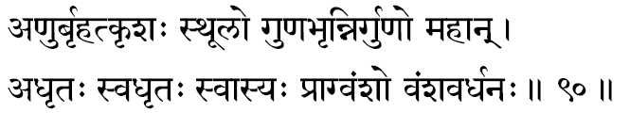
835. Anuh –“The Subtlest; the All-pervading.” Sree Narayana is the subtle flame-of-life in our bosom, the Essence from which all life’s activities spring forth. He is called as Anuh because He is in the centre of even the Subtlest. Bhagavan Himself says: “I am seated in the heart of all-as the core or Essence in all.”
836. Brihat -At the same time He is Greater than the Greatest in dimension, He being the All-pervading. These two may seem paradoxical but the apparent contradiction dissolves into an illumining experience for the contemplative mind. The Upanishad daringly combines these two terms to give the students a vague comprehension of the All-pervading Infinitude of the Self.
837. Krisah –“One Who is lean; subtle; delicate.” Again, this description will be opposed by the next following one, for herein is a deliberate use of contradictions. The Rishis made an art of effectively employing terms of contradiction in order to bring the incomprehensible within the cognition of the students of contemplation.
838. Sthoolah –“One Who is the fattest; the grossest; roughest.” These two terms are indicating opposites. Here it is to be understood that the Lord, in His state as Pure Consciousness, is the subtlest, and He is the grossest in the form of the Universe (Viraat).
839. Gunabhrit –“One Who supports”- maintains and expresses through the three Gunas. Through rajas He creates; through Sattva He preserves and through tamas He annihilates. He, as Consciousness, expresses Him- self through these three textures of vaasanaas.
840. Nirgunah-“Without-any-properties.” That which has property is matter-perishable, changeable, finite. The Imperishable, the Changeless, the Infinite is property-less; it is the Consciousness that illumines all properties (Gunas). With the matter equipments, in His Incarnations He manifests as having ‘form’ (Guna-bhrit), and in His Absolute Nature He is ‘form-less’-the Non-dual Self.
841. Mahaan –“The Great; the Glorious; the Mighty.” “One who is not conditioned by the five Elements- nor by Time and Space. Quite on the other hand, it is He Who is the very Existence in everything.
842. Adhritah -None supports Him, but He supports all. Just as the cotton in cloth, gold in ornaments, mud in pots, He is the supporter of the entire universe. To the devotee who feels the Lord is far away from him, to contemplate upon Sree Narayana as his very own support will open his heart to the certainty and plenitude of faith.
843. Svadhritah –“Self-supported.” When from the previous term we hear that the Self is he ultimate support of the Universe, the question automatically rises in a rational intellect: ‘what supports the Self?’ The Lord is “supported” by nothing else other than His own Glory. In the Upanishad, in answer to a question where the Mighty One abides, the teacher declares, “He abides in His own Glory.”
844. Svaasyah –“One Who has an Effulgent Face.” Because He gives to the Vedas their beauty and charm, He is conceived as brilliantly beautiful, enchantingly fascinating, hauntingly charming.
845. Praag-vamsah –“One Who has the most ancient ancestry.” The Infinite, the Cause for the universe and Time itself, is indicated as the ‘Most Ancient’. The term can also mean the accommodation reserved during a Yaaga meeting where the invitees and guests may rest. Generally built on the eastern courtyard of the house~ this accommodation is called ‘Praagvamsah.’ Since everything connected with a Yajna or Yaaga is considered as sacred, the ‘Praag-vamsah’ has been used here as a name to indicate Sree Narayana.
846. Vamsa-vardhanah –“He who multiplies His family of descendents.” The Lord’s family is the whole Universe of things and beings. Or it can also imply just the opposite as the root Vardh means ‘the annihilator.’ Narayana is the sacred factor in us, to Whose Feet we turn in all love and undivided attention, in Whom the world of perceptions, emotions and thoughts merge as a dream merges into the mind of the waker.

Stanza 91
bhaarabhritkathito yogee yogeesah sarvakaamadah
aasramah sramanah kshaamah suparno vaayuvaahanah.
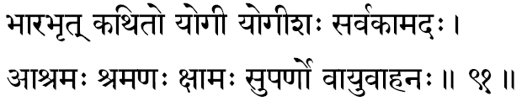
847. Bhaara-bhrit –“One Who carries the load of the Universe.” This carrying is not as a man would carry a load-something other than himself. The Self Itself has become the world so here it means only that Narayana is the very material Cause of the Universe.
848. Kathitah –“One Who is glorified in the Vedas and other spiritual text books.” Narayana-essence is the theme of all scriptures in the world.
849. Yogee –“One Who can be realised through Yoga:” “One Who is the greatest Yogee.” The term Yoga is defined in the Sastra as ‘stopping all thought flow.’ One who has no thought agitations-who has totally conquered the mind( Maayaa) and lives in His own Effulgent Self-nature is the greatest Yogee.
850. Yogeesah –“The King of Yogees.” “One who realises the Self, becomes the Self,” is an Upanishadic declaration. Therefore, Self alone is the perfect Yogee and Sree Narayana, the Self, is the King of all Yogees. The sense of agency-in-action and the sense of enjoyership-in- experience is the ego (Jeeva-bhaavanaa). To end this ego-personality is to rise to the awareness of the Universal Consciousness, the Self. Sree Narayana, the Absolute Reality, alone can be free-entirely and fully-from any involvement while being ever in the midst of Samsar and its seething activities. Hence He is glorified as the best among Yogees.
851. Sarvakaamadah –“One Who fulfils all desires of all true devotees.” Such devotees have no other desire but to reach, meet and merge in Him. In this way the term would also indicate that He destroys the chances of fulfilment of all unholy, sensuous and lusty desires in the faithless.
852. Aasramah -Sree Narayana is the harbour, the sequestered haven for all who are tossed about in the storms of life without and within. For each one, the source of all strains is attributable entirely to his functioning as a body-mind-intellect equipment. To remain as the Self-the essential real nature of man-is to experience the end of all stresses and strains. This state of Peace and Joy, of Quiet and Bliss is Sree Narayana, the Lord of the heart.
853. Sramanah –“One Who persecutes the worldly people”-who, driven by their hungers and passions, seek sense-gratifications. By the very nature of the ephemeral sense-objects and the ever-changing instruments of experience in us, the life of gratifications can only yield exhausting fatigue and weary disappointments. This is the ‘Law’ and Sree Narayana is the ‘Law-Giver.’ The Law and the Law-Giver are but one in theology.
854. Kshaamah –“One Who destroys everything during the final deluge”-He who prunes our agitations and shrinks our desire-prompted world-projections.
855. Suparnah –“The Golden Leaf.” In Bhagavad Geeta the world is pictured as the Asvattha tree and its leaves are declared to be the Vedas. The theme of the Vedas is none other than the Self, making the term extremely en- chanting with its springs of suggestions.
856. Vaayu-vaahanah –“The mover of the winds.” From fear of Him Fire burns, Sun and Moon function, earth rotates, the Wind moves....declares the Upanishad.

Stanza 92
dhanurdharo dhanurvedo dando damayitaa damah
aparaajitah sarvasaho niyantaa niyamo yamah.
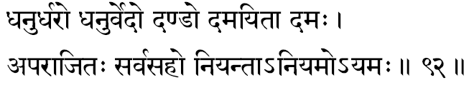
857. Dhanurdharah -“The wielder of the Bow.” In His Incarnation as Sree Rama, He drew the great Bow as no one else ever could. Also in the Upanishad there is the famous metaphor of the Bow with which the arrow of the individuality is to be shot to strike and sink into the goal. The Rishi of the Mundakopanishad explains that the ‘Bow’ is the OM (Pranava mantra). (The significance is clear.)
858. Dhanurvedah –“One Who declared the Science of Archery.” The One Who propounded the unfailing technique of OM -meditation for realisation of the Self.
859. Dandah –“One who punishes the wicked.” In Geeta, Bhagavan declares Himself to be the policeman of the Universe. The term can also mean the ‘Sceptre’-the insignia of king-ship. Sree Narayana, the King of kings in the entire, limitless universe, holds the Sceptre of total royalty.
860. Damayitaa –“The Controller.” One who punishes the wicked, destroys the sinners and thus regulates and cultivates life in the universe, making it a garden for the blossoms of spiritual beauties.
861. Damah -That which is ultimately gained by the worldly punishments-the final experience of Beatitude in the Self.
862. Aparaajitah –“The Invincible; One who cannot be defeated.” The Self ultimately asserts within every bosom from wherein the spiritual values finally emerge victorious. The Self alone remains when all else has been destroyed.
863. Sarvasahah –“One Who carries the entire Universe.” The One Who meets heroically all the enemical impulses of unspiritual lusts. He carries the entire Universe as its very material Cause: as mud in pots.
864. Aniyantaa –“One Who has none above Him to control Him.” He is the One Who has appointed all other controllers of the phenomenal forces as the Sun, the Moon, Air and Waters.
865. Aniyamah –“One Who is not under the laws of anyone else.” He is the Law and the only Law- Giver. It is His hand that governs the inscrutable and un- relenting laws of nature.
866. Ayamah –“One Who knows no death.” He is the Eternal: how can He know death? - the principle of death cannot act in Him. Within Time alone there is change or death. The Pure Consciousness is That which illumines the sense of time and so is beyond Time-beyond death.

Stanza 93
sattvavaan saattvikah satyah satyadharmaparaayanah
abhipraayah priyaarho-arhah priyakrit-preetivardhanah.
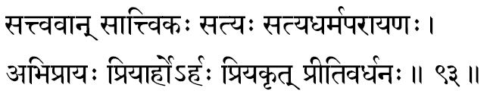
867. Sattvavaan –“One Who is full of exploits and courage.” Supremely adventurous, daring and heroic is Narayana-as witnessed in all His actions during all His Incarnations.
868. Saattvikah –“One Who is full of Saattvic qualities.” Quietude, tranquillity, peace-these are some of the saattvic qualities. Sattva is the creative-pause of the mind before it launches out into a burst of creative thoughts and action. Full of inspiration and meditative-poise is the Total-Mind, Sree Narayana.
869. Satyah –“Truth.” That which remains the same in the past, present and future is Truth. Self knows no change. It is ever in Its own Nature in all the three periods Time.
870. Satya-dharma-paraayanah - Who is the very abode of Truth and Righteousness.” Satyam (Truth) is ‘truthfulness in thought, speech and action. Dharma (Righteousness) is the injunctions regarding what is and what is not the duty to be fulfilled.
871. Abhipraayah –“One Who is faced by all seekers marching to the Infinite.” Or it can mean, “One who merges the entire world of plurality into Himself.”
872. Priyaarhah –“One Who deserves all our love.” Priya also expands its meaning into: “things we are supremely fond of,” therefore, the term, as it stands, may be read: “One Who deserves to be worshipped by His devotees with all that they are supremely fond of.” As an expression of our devotion we do offer to the Lord that which we love the most in life.
873. Arhah -Narayana is the One Who de to be worshipped by all devotees. He, being our very own self is the treasure-source of all our devotion. Thus He does from us all our surrender, love and reverence.
874. Priya-krit –“One who is ever-obliging in fulfilling our wishes” -One Who is anxiously eager for the well-being of all devotees. But the term can also yield just opposite meaning –“One who- destroys the wishes or disturbs the well-being of the wicked and the faithless.”
875. Preeti-vardhanah -The sense of drunken joy that arises in one’s bosom when one loves deeply and truly is called Preeti. “One who increases Preeti in the devotee’s heart” is Sree Narayana. The more He is contemplated upon, the more His glories are appreciated, thereby the more

Stanza 94
vihaayasagatirjyotih suruchirhutabhug vibhuh
ravirvirochanah sooryah savitaa ravilochanah.
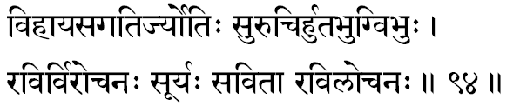
876. Vihaayasa-gatih -The term Vihaayasa means pertaining to, depending on, the space-aerial. Gatih means one who moves. Therefore, in its totality, this name describes: “One who travels in space-having the nature of the Sun, Soorya-Narayana.”
877. Jyotih –“Effulgent with His own inherent Light.” The Lord as Consciousness is the ‘Light of all lights.’ “By Its Light all are brilliant: by Its Light all are illumined.” Sree Narayana is the Self-effulgent Atman, the Self.
878. Su-ruchih -The suffix ‘Su’ indicates Auspiciousness (sobhana): the term ‘Ruchi’ is Glory or Desire. The Glory of Lord Narayana is this world: it is His ‘desire’ (sankalpa) that manifests as the universe.
The Supreme Brahman, the Infinite Reality, functioning through the ‘Total- Vaasanaas,’ meaning the ‘Total-Causal- Body’ (Maayaa), is Lord, the Eesvara. So we are given the irrefutable scientific truth in the Sruti-declaration that the universe is the ‘will’ or ‘desire’ of Lord Narayana.
879. Huta-bhuk –“One Who receives and enjoys all that is offered into the sacred fire during the Vedic Rituals- Yajnas and Yaagas.” The faithful may offer oblations invoking his own special Deity, but it is the One Lord, Narayana Who receives them all, manifesting as the particular Deity invoked.
880. Vibhuh –“All-pervading.” Lord Narayana, the Self, is unconditioned by time or space for He is the Eternal, the Omnipresent. In His Absolute Nature, He is All-pervading as He is unlimited by any conditionings.
881. Ravih –“One Who absorbs the vapour (Rasa) from everything.” As the Soorya-Narayana, Sree dries up everything in the universe.
882. Virochanah –“One Who shines in different forms.” Whatever form the devotee chooses for contemplation upon Him, the Lord manifests in that very Form for the sake and joy of the devotee. Additionally it may be interpreted as “One Who Himself manifests as the Sun and the Moon and all other resplendent spheres in the Consmos.”
883. Sooryah -The term etymologically means the One Source from which all things have been born or out of which they have been delivered. The Lord as the First Cause is the Womb of the Universe. On the surface of the world it is the Sun that nurtures and nourishes all living creatures. It must be noted that many of the Lord’s names indicate or are associated with the sun –as he is like the sun in the solar System: the Centre around which the entire system revolves and by Whose benign rays, as the ‘Orb-of-all Energies’, He thrilling to life the infinitude of creatures.
884. Savitaa –the one who brings forth, from Himself, the me Self functioning through the sun is called savitaa.
885. Ravi-lochanah –“One Whose Eyes are the Sun.” In the Upanishad and the Geeta, the Viraat Form of the Lord (the Cosmic-Form) is described as having for His eyes the Sun and the Moon.

Stanza 95
ananto hutbhugbhoktaa sukhado naikajoagrajah
anirvinnah sadaamarshee lokaadhishthaanamadbhutah.
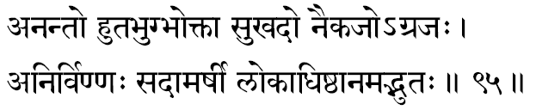
886. Anantah –“Endless.” One who is not conditioned by time and place is Self. In His All-pervading nature He is immortal, and thus Immutable.
887. Huta-bhuk –“One who accepts the things devotedly poured as oblation into the sacred Fire.” These oblations which may be in the name or any devataa, are all received by Narayana in the form of that devataa because He is the One Infinite Self Who plays in and through all forms, worldly and heavenly.
888. Bhoktaa –The One Who enjoys the world of objects-emotions-thoughts, through the equipments of body- mind-intellect is none other than the Self expressing through these ‘instruments-of-experiences’ as the individuality-constituted of the perceiver-feeler-thinker-ego.
The term Bhoktaa also means “One Who Protects” (the Universe)-as He is the very material Cause for the entire world of names and forms.
889. Sukha-dah -“One Who gives the experience of Eternal Bliss to the devotees at their final spiritual destination-Moksha. As the term stands in the verse, some would read it-’ A-sukha-da’ in which case the nominative would mean: “One Who removes all the discomforts and pains of the devotees.”
890. Naikajah -Na-’not’; Eka-’once’; Ja ,-born.’ One who is born not only once, but many times, in many Forms, to serve the devotees in His different Incarnations. In fact, all births are all His manifestations alone as he is the Spark-of-Existence in the Universe of inert matter. Through all equipments He alone is the One Consciousness that dances Its Infinite Glories.
891. Agra-jah –“The One Who was First-Born.” Naturally, everything came from Him alone; this Primordial First Cause is the concept of God. That from which everything comes, in which everything exists and into which all things can again finally merge-'That' is conceived as God.
892. Anirvinnah –“One Who feels no disappointments”-Who has no chance to feel disappointment as He is ever the totally fulfilled. The agonising disgust with things that comes to a bosom when a burning desire is unfulfilled is called Nirveda. One who has no Nirveda is called Anirvinnah. He, being “Ever-full” and “Perfect,” has no desires yet unfulfilled or something yet to be fulfilled in the future. Bhagavan declares this in Geeta: “There is neither anything that I have not gained nor anything I have yet to gain.”
893. Sadaa-marshee –“One who ever forgives the trespasses of all His devotees” -One who is infinitely merciful and kind.
894. Loka-adhishthaanam -The one sole substratum for the entire Universe of things and beings.”
895. Adbhutah –“Wonder is He.” The Geeta roars of this 'wonder,' and the Upanishads assert that He and the teacher who teaches of Him, and even the student who grasps Him are all ‘wonders.’ “ Wonder” is an experience that comes to one whose mind and intellect are stunned by the overwhelming experience of any given moment. The experience has made the mind stagger, the intellect to halt-so that no feelings or thoughts emanate from them. That moment of realisation is a moment of total transcendence of the “inner- equipments,’ so this term “Wonder” is often used in our scriptures to point out the condition within at the time of our Experience Infinite.

Stanza 96
sanaat sanaatanatamah kapilah kapirapyayah
svastidah svastikrit svasti svastibhuk svastidakshinah.
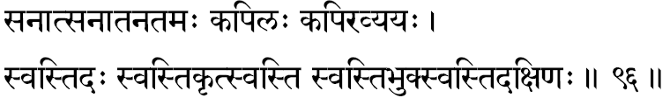
896. Sanaat –“The Beginningless and the Endless factor is He.” Time cannot condition Him. He, the Consciousness, illumines the very concept of Time and Space. He was, is and shall ever be-He being Changeless, Immutable.
897. Sanaatanatamah –“The most Ancient.” It is from Him that the very intellect springs forth and thereafter one of the concepts of the intellect is Time. Therefore, He is the most’ Ancient,’ inasmuch as He was already there to be aware of even the first experience of the beginning of Time.
898. Kapilah -The Lord Himself, manifested as the great Rishi Kapila, propounded the Saamkhya philosophy. In the Geeta, Bhagavan Sree Krishna declaring His own Glory, describes Himself: “I am Kapila among the great ones.”
899. Kapih –“One Who drinks water” -by one’s rays. The Sun it is that dries up everything, evaporating the water-content contained on the surface of the earth.
900. Apyayah –“The One in whom the entire Universe merges”-during the great deluge when the Total- mind-the Creator-rests. The Supreme Atman functioning through the Total-mind is the Creator, Brahmaaji-each mind being ruled by its own vaasanaas. The Total-vaasanaas in the Universe (Causal-Body) is Maayaa and the Supreme Self expressing through Maayaa (the Total-Causal-Body) is Eesvara. Therefore, Sree Narayana, as Eesvara, is the One into Whom the total world of experiences merges when the Total-mind rests during the ‘pause’ between two busy cycles of Creation and involvement in the projected world of thoughts-feelings-objects.
In the north this term is read as Avyayah where the meaning is clear: “Immutable”: and needs no explanation.
901. Svasti-dah –“One Who gives Svasti to all His sincere devotees.” A true devotee is one who has discovered his fulfilment in seeking and gaining the Infinite Bliss that is Sree Hari. Naturally, he comes to turn away from the realms of inauspiciousness. To the extent he is able to move into the Hari-Consciousness, he is to that degree in the Bliss- Experience. Therefore, the Lord is termed as the ‘Giver-of- Auspiciousness.
902. Svasti-krit -As in many earlier terms which were preceded by the suffix ‘ Krit,’ here also, it expands into two meanings: “One Who brings Auspiciousness” -or “One who robs all Auspiciousness.” To the seeker who is moving towards the Narayana-Consciousness, his experience is of added joy and peace in life, but the one who seeks only sense-gratification and so moves away from the Reality, to him the experience is more and more sorrow, agitations, tears and tragedies-total inauspiciousness. The indeclinable (Avyaya) Sanskrit word ‘Svasti’ means Auspiciousness.
903. Svasti –“One Who is the Source of all Auspiciousness” -as He is Himself the Auspicious. In essence His Nature is Sat-Chit-Aananda so there can be no cause for inauspiciousness therein. The individual functions within the powers of His avidyaa and so is under the infatuation of Maayaa, while the Lord rules over Maayaa and plays out through Maayaa.
904. Svasti-bhuk -“One who constantly lives in His Experience a perpetual sense of holy Auspiciousness”-as it is His very nature-divine. It can also be interpreted as “One Who showers Grace and makes His devotees constantly experience Auspiciousness in their loving Narayana- centred hearts.”
905. Svasti-dakshinah -Lord is ever engaged in smartly distributing Auspiciousness. The word ‘Dakshinaa’ has, apart from the meaning of ‘gift,’ also a meaning: “One who is efficient and quick.” Therefore, the term indicates that Sree Narayana quickly and efficiently will reach His sincere seekers to give them the experience of Auspiciousness which is the Lord’s very nature.

Stanza 97
araudrah kundalee chakree vikramyoorjitasaasanah
sabdaatigah sabdasahah sisirah sarvareekarah.
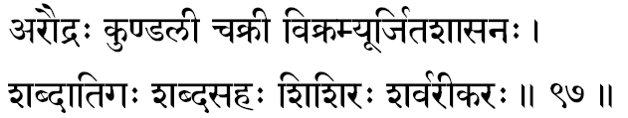
906. Araudrah –“One who has none of the negative terrible urges and emotions.” The State of Perfection is a condition where the frailties of the mortal heart can never remain. The Lord is One in Whom the cruelties which rule the man of the world-likes, dislikes, hatredness, jealousy and his other imperfections-can never abide or even be contained.
907. Kundalee –“One Who wears the famous ear-ring called the Makara-Kundala.” The term Kundalee also signifies the ‘Serpent’-hence the Kundalinee-Sakti-the ‘Serpent-Power’-the coiled mystic-glory lying now inert, uninvoked at the base of the back-bone in the deep pelvic region. Here the ‘Serpent’ may be taken as the thousand- tongued Ananta on whom Sree Narayana is described as ever reclining in His Yoga-rest.
In all religions, ‘Serpent,’ it seems, symbolises the ‘mind.’ In Hinduism it is true. Whether it is in Krishna’s dance on the Kaaliyan-Serpent, or Siva wearing as ornaments the Serpents (Bhooshana), or Sree Hari resting upon Ananta-the idea is always the conquest of the mind, the poisonous serpent.
908. Chakree –“He Who wears ever His Discus called Su-Darsana (Auspicious Vision).” The Lord destroys with the Discus only the foul and the low in us and the individual naturally gains the Experience Divine, the Self.
909. Vikramee –“He Who is more daring than all others.” The term is also interpreted: “One who travels by air,” as ‘Vi’ means Bird. Famous is the allegory that Lord Vishnu travels on the back of the white-necked Eagle.
910. Oorjita-saasanah –“One who commands and administers with His Hand.” His commands in the scriptures advise us firmly what is right to do and what are the destructive forces in each one of us. In case man decides to disobey His Laws, He severely punishes him on all such occasions. Disobedience of Laws is immediately followed by His loving curative punishment. It permits no exceptions; accepts no excuses; admits no circumstantial conditions.
911. Sabdaatigah –“He who transcends all words”-One who is Indescribable. The Vedas themselves are but indications ‘pointing to Truth’ and are not explaining, describing or even defining Truth. The Infinite and the Eternal Truth is beyond even the Vedas, beyond all that can be gained through even the highest faculties of the finite equipments (mind and intellect).
912. Sabda-sahah –“One who allows Him- self to be invoked by the Vedic declarations.” If, however, the Upanishadic declarations are properly reflected and sincerely meditated upon, even though the Vedas have failed to define Truth, their contemplative implications can transport us into the realms of the Infinite Experience-Divine.
913. Sisirah -The term means winter, the cold season. In India it is the cool season. Therefore, by suggestion, this name indicates that the Lord is the ‘cool arbour’ for those who are tortured by the heat of Samsar.
914. Sarvaree-karah -The word Sarvaree means ‘night’ or ‘darkness’; therefore, the term defines the Lord as “One Who creates darkness.” To the men of realisation, our world of sorrows and pains, of strains and stresses, of worries and anxieties are unknown -while to those who live in their ego-sense, to them the Real is unknown. ! The unknown means ‘veiled in darkness.’ The subtle meaning is clear now.

Stanza 98
akroorah pesalo daksho dakshinah kshaminaam varah
vidvattamo veetabhayah punyasravanakeertanah.
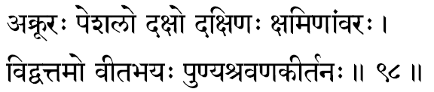
915. Akroorah –“Never-cruel.” Cruelty comes from anger, and anger rises from ‘desire’--craving or lust. Sree Narayana, the Fulfilled and the All-Full, cannot have ‘desire’ from which could come anger-thus, naturally, never any cruelty. Generally this term is interpreted as “One who is of the form of the Yaadava, Sree Akroora.” Akroora was a great devotee of the Lord upon whom were bestowed many divine powers. “Wherever, there is any special glory in anyone, know that to be a manifestation of a part of my Splendour,” sings Lord in Bhagavad Geeta. Thus the term is interpreted as the Lord Whose one ray of glory was the Kamsa-employee, the Yaadava-Akroora.
916. Pesalah –“One who is supremely soft.” In His Infinite Kindness and Mercy, His Heart-divine is ever flowing out in love and tenderness towards His devotees when they call out for help ardently and lift themselves from their body-consciousness and ego-centric life of sense-pursuits.
917. Dakshah -This term stands for the quality of ‘promptitude.’ In army training, the Sanskrit command Daksha is equal to “attention alertness, vigilance and utter preparedness to act immediately with supreme urgency.” All these are implied in that pose of “ Attention.” The Lord is ‘Daksha’ in serving the world and in rushing to His sincere devotees. Omnipotent and divinely Efficient in His Infinite Smartness to reach and help all, at all times, everywhere, under every circumstance is echoed in the charming suggestions of this chosen term in the Sahasranaama of Sree Narayana, the Self in All.
918. Dakshinah –“One who is most liberal.” The term’ Dakshina’ is popularly used for the ‘gift’ presented to the priests after a ritual as their fee. This giving must be done in a spirit of large-hearted, liberal charity-so that very large-heartedness of mind (Daakshinya) itself is the Lord, as it is the opposite of selfishness and attachment to the wealth which one possesses. “One who has Infinite Kindness and Charity towards all good people and One Who is thus ever- ready to liberally give away His endless Benevolence” is Sree Narayana, the Dakshina.
919. Kshaminaam-varah –“One Who has the greatest amount of patience with the sinners and forgiveness for their sins.” Sree Narayana is more patient than even the Earth which is generally pointed to as an example of highest patience (Kshamaa). He exhibits supreme patience with the evil-minded, with the tyrant, the foul and the fiendish. Hiranyaksha, Hiranyakasipu, Ravana and others of this type were given many fair opportunities to realise for themselves the folly of their baser attitudes to existing things and their immoral ways of life. It is only when no other method of treatment could cure them that the Lord destroyed them in His infinite kindness.
920. Vidvat-tamah –“One who has the greatest Wisdom.” There are wise men in the world-each one also may be a master in his own subject. The Lord, the very Consciousness illumining all bosoms simultaneously everywhere, is the One Knowledge Absolute, the Knower of all knowledge of all wise men. Omniscient-Infinite Truth is Sree Narayana as He is Pure Knowledge by the Light of which all ‘Knowledge’ is known.
921. Veeta-bhayah –“One who has lost all fears.” Fear can come only from the sense of ‘other.’ In Advaita Reality, there cannot be any fear as He is the “One- without-a-second.” The state of Narayana-Consciousness is declared in all scriptures to be’ Abhaya’-the Fearless State.
922. Punya-sravana-keertianah –“One whose Glory when ‘heard’ (sravana) and ‘sung’ (keertana) causes merits (punya) to grow in the bosom of that devotee. This statement of fact is never investigated deeply by students so they generally understand its superficial and obvious meaning only.
By ‘hearing’-with attention-to the stories of the Lord- we must get ourselves involved in the ‘listening’ and thereafter we must reflect upon the glories of the Lord (Bhagavat Guna) and thus expose ourselves to those recreative thoughts. Not only is it sufficient thus that we imbibe the qualities spiritual, but we must learn to get ourselves committed to the life of God- centred activities. This is called true keertana-singing His Glories. It is not to be a mere noisy chanting of hymns, a mere muttering of mantras; we must teach ourselves to allow Him to express through us. Our physical activities, mental feelings and intellectual thoughts must all shine forth the awareness of His Divine Presence that is in us at every moment, every- where. The life of such a deyotee will itself become, in its dynamic beauty, love and devoted tenderness, a constant worship (poojaa), a continuous (akhanda) hymn chanted (keertana) in praise of the Lord-of-the-heart.

Stanza 99
uttaarano dushkritihaa punyo duhsvapnanaasanah
veerahaa rakshanah santo jeevanah paryavasthitah.
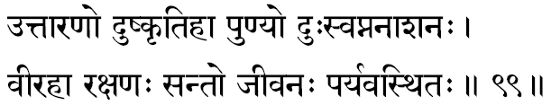
923. Uttaaranah –“One who lifts us out of the ocean-of-change.” We, by identifying through our body- mind-intellect, with the changing whirls of matter around us, assume to ourselves the changes and these provide us, in their totality, the horrible sorrow of the mortal finitude. On lifting our attention from the giddy changes in these whirls of finite matter, when we fix it upon Him, the one Consciousness that illumines all changes in all living creatures, we get uplifted into a state of Immortality-Changeless, Blissful, Supremely Satisfying. Hence, Sree Narayana is called as the ‘Up-lifter,’ the ‘Saviour.’
The ‘Taara-mantra’ lifts us from the cesspool of sense living into the serener climes of the lit-up peaks of peace and perfection.
924. Dushkritihaa –‘Kriti’ means actions; ‘Dush-kriti’ means bad actions. When actions are undertaken, prompted by sensuous desires, they leave impressions (vaasanaas) and these always have a tendency to make us repeat similar actions. When one turns the mind towards Narayana,-the Self, he is emptied of his existing vaasanaas, so Lord is indicated as the ‘destroyer (Haa) of the sins.’
925. Punyah –“Supremely Pure.” One who purifies the heart of His devotee-removing all his sensehunting vaasanaas of indulgence. Sree Narayana guides the pure-hearted to the portals of the final goal, the Higher Consciousness.
926. Duh-svapna-naasanah –“One who destroys all ‘bad dreams’.” The worst dream is the samsar. Perception of plurality is the horrible dream of terrible pangs, consuming fears and drowning sorrows. Dreams are explosions of the suppressions stored away in the subconscious. A real devotee exists in utter surrender unto the Lord. When his life is ever-centred in Narayana-smarana, in such total and humble dedication he has no chance of earning these suppressions. Since his sub-conscious mind is not loaded with half-digested thoughts and unexpressed intentions, repressed desires and suppressed motives, immoral passions and covetous inclinations, he has no fearful dreams in his daily sleep. Ultimately each seeker will rise above his little ego and its hungers and enters into the plane of Narayana-Consciousness.
927. Veerahaa –“One Who ends the passage from womb-to-womb-the wheel of birth and death.” ‘Veera’ means diversified ways, or one who functions in innumerable fields in countless ways.
928. Rakshanah -“One who is the Protector of the Universe.” Among the Trinity, Vishnu is the Protector, the Sustainer of all the created. “For the protection of the good, the destruction of the wicked and the establishment of righteousness, He takes different Incarnations.”
929. Santah -This term, used in the plural number, indicates “the good people.” They are considered as “good” who have moral virtues, ethical values, spiritual purity and scriptural knowledge. By using the plural form here, the import is that the holy beauty of Sree Narayana is found expressed in the glory of such a company of good and saintly men.
930. Jeevanah –“The Life-Spark in all living creatures.” The Flame-of-Existence that warns an organism to life is the presiding Consciousness Supreme, the Self. This Self is Narayana. “Permeating the earth I support all beings by (My) energy; and having become the juicy Moon I nourish all herbs”-is the declaration of Bhagavan.
931. Paryavasthitah -In all places, in all creatures, He dwells. He is the final Factor-Divine beyond which there is nothing, and upon which all else depends.

Stanza 100
anantaroopo-anantasreer jitamanyur bhayaapahah
chaturasro gabheeraatmaa vidiso vyaadiso disah.
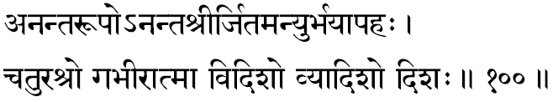
932. Ananta-roopa –“One of the infinite forms.” The endless variety of forms constituting the world of objects are all projections in him. They are in their essence nothing but himself. Just as the entire spread –of –objects in a dream is nothing but the creation of the single mind of the waker, and it is seen as many only in the dream –plane –of –consciousness, so, too, the world of objects –emotions-and –thoughts are all discovered as the Narayana –Consciousness.
933. Anantasreeh –“One who is full of infinite Glories,” “One who is full of Incomparable Powers,” the main tree ‘powers’ which the lord expresses in the world are the ‘Desire Power’ (Icchaa-sakti). These are expressions of his Glory at our physical, mental and intellectual levels. These are three manifestations of his ‘powers’ and their continuous interplay, together weave the fabric of the total dynamic expressions of life in the world. The self, Sree Narayana, the one spring –board for all these vibrant aspects of the life –He, the Omniscient, is called “One of Infinite Forms.”
934. Jitamanyuh –“One who has conquered anger” (manyuh). It cannot be repeated too often, thus this significance is again given in this term, that anger is one of the most overpowering enemies within us –”One who has conquered anger” is One who established in his own Purity. Earlier, the technique of anger was explained that when a desire is unfulfilled, anger rises in a man’s heart towards a desire is unfulfilled, anger rises in a man’s heart towards the obstacle between him and his desire. The self is All-full (Paripoorna); it cannot feel any need, want or desire. The Self, then Sree Narayana, is ever without the low and ruinous passion called ‘anger.’
935. Bhayapahah –“One who destroys or removes all fear in the samsaric life.” Naturally, lord Narayana is the one sure harbour wherein the boats of life, tossed mercilessly on the high seas of passions, can find their calm of peace and total security.
936. Chaturasrah –“One who deals squarely with all.” The term Chaturasrah means a geometrical square of equal sides. Sree Narayana distributes the results of actions equally to all: each one can get only the exact reward of his own previous actions. Thus, Narayana bestows justly and squarely upon all.
937. Gabheeraatmaa –“One who, in his real Nature, is too deep to be fathomed by the frail instrument of our mind.” Depth here indicates the profoundness –the supreme essence pervading the Universe is unfathomably profound in its significance and glory.
938. Vidisah –“One who is unique in his giving.” He is divinely liberal, magnificently benevolent in fulfilling the earnest desires of all his true devotees.
939. Vyaadisah –“One who is unique in his Commanding –Power.” One who orders even the phenomenal powers, the deities and gods.
940. Disah –“One who advises and gives knowledge.” It is the self who is author of the Vedas, nay, the very theme and essence of the Vedas. Lord Narayana, in the form of the sruti-texts, gives to man the knowledge of the self.

Stanza 101
anaadirbhoorbhuvo lakahmeeh suveero ruchiraangadah
Janano janajanmaadir bheemo bheemaparaakramah.
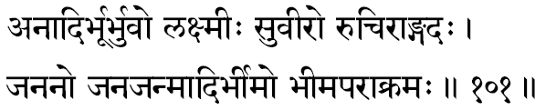
941. Anaadih –“One who is the first cause” –and who is himself the uncaused. The eternal, the Beginingless is Sree Narayana.
942. Bhoorbhuvah –“the very substratum or support for the earth.” Since the earth revolves in the space in which the universe exists and revolves is the supreme, Narayana.
943. Lakshmeeh –“One who is wealthy, the richness or glory of the universe.” If self were not, then all would have been inert, unborn, deed. As the one life every-where, as pure existence, all the glories of this dynamic Universe are in him and from him alone.
There is a reading wherein the terms 942 and 943 are coupled, in which case their combined meaning would be: “One who is the glory in the universe and in the interspace everywhere.”
944. Suveerah –“One who moves through various ways which are all divinely glorious.” Or, One who exhibits in all his Incarnations the inimitable splendour of valour in his actions and achievements.
945. Ruchiraangadah –“One who wears resplendent shoulder-caps” –a kind of ornament used by ancient Indian kings to protect their upper arms and shoulders from their enemies slashing swords.
946. Jananah –“He who delivers all living creatures.” Lord Sree Narayana is the great Father of all living beings as all the universe comes from him alone. He alone was before all creation; from him alone everything has risen; in him everything exists, is nurtured and nourished by his Glory. Thus, as the very progenitor of the universe, Sree Narayana, the Self, is the only jagat-Eesvara (Lord of the universe).
947. Janajanmaadih –“One who is the sole Cause of birth for all living creatures in the universe.” The immediate cause is, of course, the vaasanaas of each being, but the real and ultimate cause in the self, Sree Narayana.
948. Bheemah –“One whose form is terrible and frightening to the sinners.” “Oh, Glorious Sir, seeing yours wonderful but awesome from, the whole world is shuddering with fear,” cried Arjuna upon beholding the cosmic Form of the lord. He adds: “Having seen Thy Immeasurable Form … the worlds are terrified and so am I.” Again, “On seeing thee touching the sky…my heart is stricken with dread and I find no courage nor peace, O Vishnu.”
949. Bheemaparaakramah –“One whose prowess is irresistible and fearful to his enemies.”

Stanza 102
aadhaaranilayo-adhaata pushpahaasah prajaagarah
oordhvagah satpathaachaarah praanadah prranavah panah.
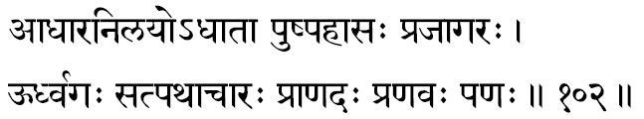
950. Aadhaaranilayah –“One who is the fundamental sustainer” –the support for all that exists. All things and all beings are supported by the earth which itself rests upon the lord, the self, that each mind projects the entire world of names and forms.
951. Adhaataa –“Above whom there is no other to control or to command” –One who is the supreme controller of all. He is the Law; the eternal truth is that the Law and the Law-Giver are one and the same.
952. Pushpahaasah –“He who shines like an opening flower.” The bud opens and manifests into the lord at the time of deluge existed as the total Unmanifest, and there after, at the maturity of the vaasanaas, opens up as the manifest world of things and beings, He came to be indicated by this term.
953. Prajaagarah –“Ever-Awaked” –He who knows no sleep. Sleep means ‘non-apprehension.’ This ‘non-apprehension’ of reality is called ‘Avidyaa’ (nescience) which produces our ‘mis-apprehension’ of I and mine, and the world of pains and shocks. Since Narayana is the self, He is ‘Ever-available” and is never asleep to his Eternal-Divine-Nature.
954. Oordhvagah –“One who walks the path of truth” –a path which other implicitly follow to reach the Truth Inifinite. “Whatever an adored one does, other people will implicitly follow,” warns Krishna in Bhagava Geeta. Lord is the standard of perfection” and all devotees place him as the ideal –trying to imitate, in their own lives, His Absolute Goodness, Absolute Love and Absolute Peace.
956. Praanadah –“One who gives ‘Praana’ to all.” The term ‘Praana’ in our Sastras means the physiological functions, the manifestations of life in man. Therefore, Narayana, the self, is the Vital Source from which all sense organs, mind and intellect barrow their power of perception, capacities of feeling and their faculties of thinking and understanding.
957. Pranavah –“Om-kaara is Pranava.” The Infinite reality is indicated by ‘OM’ in the Vedas. ‘OM’ is the manifesting sound of the supreme self. Therefore, Sree Narayana is called ‘Pranavah’: meaning he is of the ‘nature of Omkaara.”
958. Panah –“The supreme Manager of the universe.” The root ‘Pana’ means “to transact.” By giving the exact rewards for all actions, Lord both orders and justly manages all activities of each individuals and things constituting this scientifically precise universe.

Stanza 103
pramaanam prananilayah praanabhrit praanajeevanah
tattvam tattvavidekaatmaa janmamrityujaraatigah.
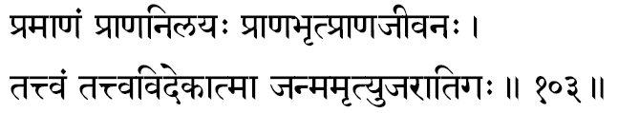
959. Pramaanam –“He whose very form is the Vedas” –which are the only ‘proof’ for the Eternal Reality. Or, we may read it: He who is pure Infinite Consciousness (Prajnaanam) as we have it in the great Commandment, “Consciousness is the Infinite Reality.”
960. Praananilayah –“He in whom all ‘praanas’ stand established.” He who is very substratum –vital foundation –for all ‘activities’ manifested in a living organism.
961. Praana-brit –“He who rules over all ‘Praanas’ –Sree Hari is the one who causes everyone to eat, digest, feel energized, act, achieve the fruits thereof, grow old and die. In all ‘activities,’ the great One-commanding, Factor-Divine, Sree Narayana, the self, presides in silent detachment, and by His Presence He initiates and maintains all these activities in all living creatures upon the earth’s surface.
962. Praana-jeevanah –“He who maintains the life-birth in all living creatures.” This interpretation is not a happy one as this meaning has just come in the preceding, endearing term. In love, of course, there is no rule that the lover should not repeat the same loving words to address his beloved. But, we can find yet a new depth of suggestion if we understand this term to mean “One who is the very life-giving divine-touch in every breath.”
963. Tattvam–“the Reality” –that which is eternal, the essence. “That which one gains in subjective realization is the self,” Sree Narayana.
964. Tattvavit –“One who has realized fully the reality” –meaning the original essential nature of the self. On realizing the self, the individual become the self and, therefore, Sree Narayana, that very self, is One who has realized fully the Reality which is His Own Nature Divine.
965. Ekaatmaa –“The Advaita Reality” –Narayana is the One self, the Oversoul, Who expresses himself as the individualities of the infinite entities in the universe.
966. Janma-mrityu-jaraa-atigah –“One who knows no change or modifications in Himself.” Ever finite object in the world undergoes constant ‘change’ and each of them is extremely painful. They are birth, growth, decay, and the Eternal, the changeless Self, Sree Narayana, Ever- the-same Supreme. Geeta thunders the nature of the self to be “ever-birthless and never dying,” and once It has existed, Self never becomes non-existent.

Stanza 104
bhoorbhuvah svastarustaarah savitaaa prapitaamahah
yajno yajnapatiryajvaa yajnaango yajnavaahmah.
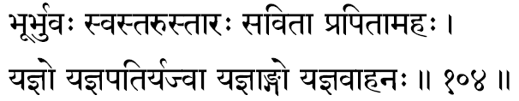
967. Bhoor-bhuvas-svas-taruh –“One who is snap in the tree-of-life existing in all the universe of the higher world, our-world and the lower world.” The famous Vedic terms bhooh Bhuvah and Svah connote the three worlds (lokas). The world ‘Loka’ in Sanskrit means “a field of experience.” Therefore, in fact, these three terms, called Vyaahritees, subjectively represents all our experiences in the walking, dream and deep-sleep states of consciousness. His constant Yajna to nurture and nourish the Universe. So, this epithet has been given to Sree Narayana, the infinite Self, the glorious Essence (Sap) that pervades the entire Tree-of-Life-flowering out to even embrace all experiences in all planes of Consciousness. Everywhere, in the everything at all times.
968. Tarrah –“One who helps all to cross –over” –the Eternal Boat-man, to whom, if the devotees can surrender in unswerving faith and true devotion, he will surely row them across the “Ocean of samsara:” that one is Taarah. Through exclusive, devoted meditation, alert with understanding, the individuality in each of us wakes up to the higher plane – and there is Be-attitude to experience the Self, the eternal Brahman – Sree Hari.
969. Savitaa –“He who is the father of All” –Who is the eternal father of the entire Universe.
970. Pra-pitaamahah –“He who is the father of even the ‘Father of all Beings,’ the creator, Brahmaaji, of the trinity.” The creator Himself rose from the Absolute self. Creator is known in our scriptural language as Pitaamaha –the Father.
971. Yajnah –“One whose very nature is yajna.” The term yajna means “work undertaken with a pure spirit of total dedication in complete co-operative endeavor with total selflessness, there is Sree Narayana in action through His creatures.
972. Yajna-patih –“The lord of all yajnas.” I am the ‘Enjoyer’ in all self –dedicated, co-operative endeavors (Yajna). These are the joyous words of the lord who Himself declares; “The ‘Enjoyer’ and the ‘lord’ in all yajnas am I.”
973. Yajvaa –“The one who performs Yajna according to the strict prescriptions laid down in Vedas” –the one who maintains in ll his divine actions the true Yajna spirit.
974. Yajnaangah –“One whose limbs are the ‘things’ employed in Yajna.” In Harivamsa we told that ‘things’ are the very aspects of Lord Sree Narayana.
975. Yajna-vaahanah –“One who fulfils Yajnas in complete and exact accord with the Vedic instructions.”

Stanza 105
yajnabhridyajnakridyajnee yajnabhugyajnasaadhah
yajnaantakridyajnaguhyamannamannaada eva cha.
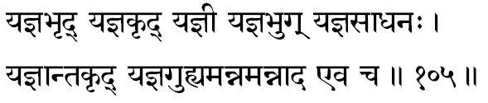
976. Yajna-bhrit –“the ruler of the Yajnas” –the One who helps us to conclude successfully all our ‘good, dedicated. Selfless acts of service to others’ –Yajnas.
977. Yajna-Krit –“One who performs Yajna.” The same term also mean One who destroys the yajnas. The term Yajna connotes all noble and divine actions of service and love undertaken in a pure sense of God dedication, selflessness and joy. Lord issued forth the creation as an act of yajna, and in the end He must also undertake the total dissolution of this very yajna. Sometimes this is interpreted as “One who ‘performs’ the yajnas of the good people and one who ‘destroys’ the Yajnas of the evil minded folk.”
978. Yajnee –“One who is constant ‘Enjoyer’ of the perpetual Yajnas.” In all Yajnas, because every act is Narayana –centered-god-dedicated-to him alone is the attribute of being the only single ‘Enjoyer.’
979. Yajnee –“All that is offered into the scared Fire during a Yajna, though with an invocation to any of the deities, in tender devotion and joy. Goes to Him alone, the “One receiver of all that is offered,” for all deities are but Narayana in different forms.
980. Yajna-saadhanah –“One who fulfills all Yajnas.” It is by his grace alone all noble endeavours, undertaken in an honest and true sincerity, gain spectacular success.
981. Yajnaantakrit –“One who performs the last, concluding act in all Yajnas.” The final item in a yajna is the “total –offerings” (Poorna-Aahuti) when Sree Narayana is reverently and earnestly invoked. Without this prayer-ritual. Yajna is never complete. Sree Hari, therefore, is of the form of Poorna-Aahuti -in the sense that when ‘total’ surrender of all vehicles and their actions is accomplished, the transcendental experience of the Self, Narayana alone, comes to manifest in all His divine Splendour.
Some commentators have, however, taken the meaning of the Yajna-anta-not as “the last item in yajna” but as ‘anta,’ the ‘fruit’ of the yajna by which they bestow the meaning that Narayana is the “One who gives away the ‘fruits’ for all Hari-dedicated, selfless acts of love and service.”
982. yagna-guhyam –“Sree Narayana is the most profound truth to be realised in all yajnas.” The self is the most noble truth to be sought through ‘offerings’ all the ‘Dravya’ (objects) into the “consciousness” (Fire) in the “body” (kunda). This kind of subjective-Yajna is called in the Geeta as “Knowledge-Yajna.” This is also called in the Vedas as Brahma-Yajna.
983. Annam –“One who has himself become the ‘food’ ” –sense –objects which are the ‘food’ consumed by the sense –organs. As a verb it can be used as One who “Eats” the whole universe at the time of the great dissolution. At that time, he is the one in whom the world remains absorbed in the pralaya, just as our individual world each day gets dissolved in our sleep. The one in whom alone the world of names and forms can remain in their ‘seed-form,’ is Sree Narayana, the self.
984. Annaadah –“One who eats the ‘food.’ ” not only the objective world is the projection on Narayana, but the subjective-enjoyer –the individuality, the ego, that experiences-is also Narayana. The self, functioning through the “equipment” is the jeevaatman, the individuality in each of us who “experiences.” Thus the self is the both ‘food’ (Annam) and ‘eater-of-food’ (Annaadah) just as our own waking-mind becomes the “experiencer” and the “experienced” in our dream-world.

Stanza 106
aatnayonih svayamjaato vaikhaanah saamagaayanah
devakeenandanah srashtaa kshiteesah paapanaasanah.
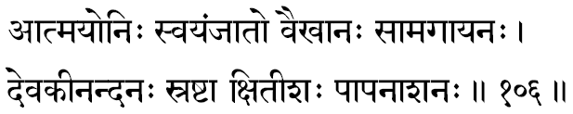
985. Aatma-yohin –“One who is himself the ‘material cause’ (Upaadaana Kaarana) for himself;” the self born, the uncaused cause.
986. Svayam-jaatah –“One who, as the lord of the universe, has no other ‘Instrumental cause’ (Nimitta-Kaarana) in projecting Himself.”
Three cause are necessary in all ‘creation’ in the pluralistic world: the Material cause’ (mud), the “Instrumental cause’ (wheel), and the ‘Efficient cause’ (the pot maker). In sree Narayana’s self-projection, as in the dream, that all these three causes are He, Himself, is shown in these term.
987. Vai-Khaanah –“The one who dug through the earth” –cutting through the denseness of the gross to reach, apprehend and kill the subtle Hirnyaksha, the terrible and the monstrous who had tried to destroy the spiritual values in the world. The self has to reach us to destroy the ego in us and give us the ‘liberation’ from our evil adherence to the body-mind-intellect.
988. saama-gaayanah –“One who signs the Saama-songs.”
989. Devakeenandhanah –“He who appeared as born to Devakee in his Incarnation as Krishna.” And since Devakee could only, from afar, see, watch and enjoy the pranks and play of her blessed child in Gokula, Krishna is called as the “Joy of Devakee” (Devakee-nandhana).
990. Srashtaa –“One who creates.” Even the Creator can perform his job only by drawing his abilities and capacities from the infinite self, Sree Narayana.
991. Kshiteesah –“One who is the lord of the earth.” Sree Narayana is the husband of mother Earth. He is her protector. Her nurtuer and nourisher. Her, earth may stand for all that is gross –the entire maayaa-and Narayana is the Lakshmee-Pati.
992. Paapa-naasanah –meditating upon whom, all vaasanaas (sins) are liquidated. When the individuals, surrendering in love to Him, acts and fulfils his duties, all his existing vaasanaas are destroyed and no new ones are created –this is the very root in the theory of karma Yoga in the Vedas. Through meditation upon the self, all sins are dissolved and totally removed.

Stanza 107
Samkhabhirnnandakee chakree saarngadhanvaa gadaadharah
Rathaangapaanirakshobhyah sarvapraharanaayudhah.
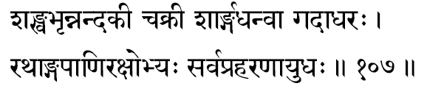
993. Samkha-bhrit –“One who has the divine conch named “Paanchajanya.” The word meaning is this term pancha-janya is “that which is born of the five” (sense organs), so it stands for the mind. Mind being the seat of ego, the sastras declare that the conch in the divine hand of Sree Narayana is the ego-factor (Ahamkaara-Tattva) in our personality.
994. Nandakee –The lord’s sword is called Nandaka. Therefore,this term indicates one who holds and wields the Nandaka sword. The word Nanda-kam mean “that which brings bliss.” The Sastras sing that the divine sword in the sacred hands of the lord hari represents the knowledge-Spiritual (Vidyaa-Tattva) with which the seeker can destroy all his “ignorance” of the self in him.
995. Chakree –“one who carries the discus called Sudarsana.” The term Su-Darsana means “that gives the auspicious vision.” The sastras attribute to this discus-Divine the representation of the human mind.
996. Saarnga-dhanvaa –“One who aims his unerring bow called Saarnga.” This bow of Narayana is glorified in our texts as representing the Ego, as the ‘apex’ of all the sense organs, Ahankaara-Tattva. In this concluding Stanza, the instruments of Blessing in sree Narayana’s hands are remembered with reverence and devotion.
997. Gadda-dharah –“One who holds his divine club (Mace) celebrated as Kaumodakee –which generates and spreads beauty and joy.” This Mace is described as representing the intellect in man (Buddhi-Tattva).
998. Rathanga-paanih –“The traditional meaning is, of course, “One who has the ‘wheel of the chariot’ as his weapon.” This means the discuss which already has been mentioned in this very Stanza as Chakree. But, there are others who would like to interpret this term in other ways. In a glorification-Hymn or devotional-Chant, repetition is no sin; in fact, it should be quite natural.
999. Akshobhyah –“One who cannot be exasperated by anyone, by any act or acts, however blasphemous they may be.” One whose peace and calm cannot be stormed out by any happening in his outer world; Ever-peaceful. The term suggests Infinite patience, love and kindness towards man and his frailties.
1000. Sarva-praharanaayudhah –“He who has all implements for all kinds of assault and fight.” No enemy can surprise Him. The ‘conqueror of all.’ One who has weapons to meet any missile. However powerful.

Sree Sarva-praharanaayudhah Om Namah iti
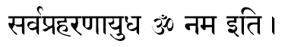
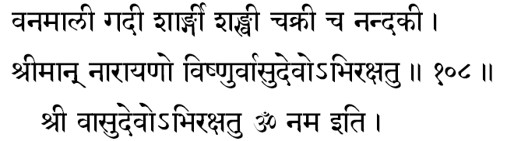

[The 1000 names end here...]

Concluding Verses:

1. Itidam Kirtaniyasya Keshavasya Mahatmanahah
Naamnaam Sahasram Divyaanaam Asheshena Prakeerthitham

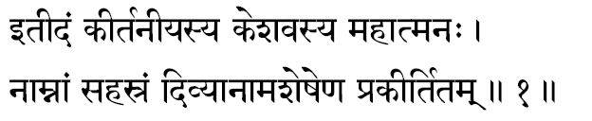
1. In the above verses have been given a complete enumeration of the thousand divine names of the the Great Being Keshava, who is the fit object for all praise and prayer.

2. Ya Idam Srunuyaan Nityam Yaschaapi Parikeertayet
Naashubham Praapnuyaat Kinchit Somutreha Cha Maanavah

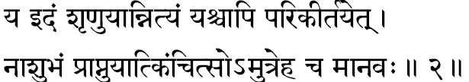

2. Nothing evil or inauspicious will befall a man here or hereafter who daily hears or repeats these names

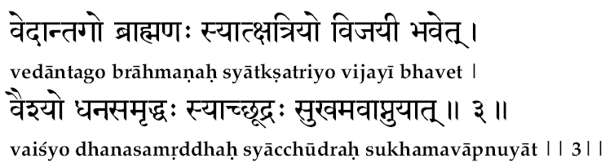

------------------------------------------------------------------------------------------------------------------------------------------------
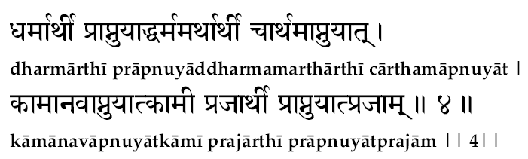
------------------------------------------------------------------------------------------------------------------------------------------------
5. Bhaktimaan Yah Sadotthyaaya Suchis-tadgata Maanasahah
Sahasram Vaasudevasya Naamnaam Etat Prakeertayet
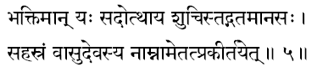
Whichever devoted man, getting up early in the morning and purifying himself, repeats this hymn devoted to Vaasudeva, with a mind that is concentrated on Him...

6. Yashah Prapnoti Vipulam Jnaati Praadhaanyam Eva Cha
Achalaam Sriyam Aapnoti Sreyah Praapnotyanuttamam
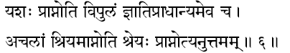
That man attains to great fame, leadership among his peers, wealth that is secure and the supreme good unsupassed by anything....
7. Na Bhayam Kvachid Aapnoti Veeryam Tejasya Vindati
Bhavatyarogo Dyutimaan Bala-roopa-gunaanvitahah
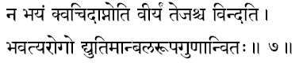

He will be free from all fears and be endowed with great courage and energy and he will be free from diseases. Beauty of form, strength of body and mind, and virtuous character will be natural to him.

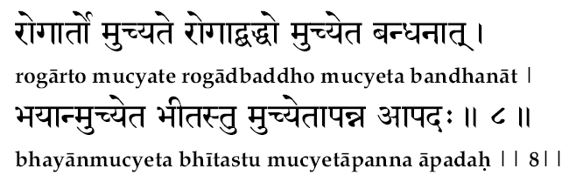

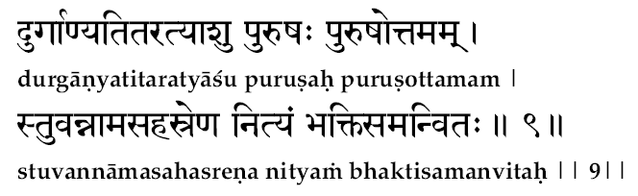

10. Vaasudeva-ashrayo Martyo Vaasudeva Paraayanahah
Sarva Paapa Vishudhaatmaa Yaati Brahma Sanaatanam
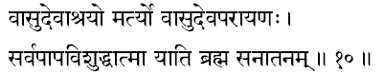

Free from all sins, a man devoted to Vaasudeva and completely dependent on Him attains to the eternal status of Brahman.

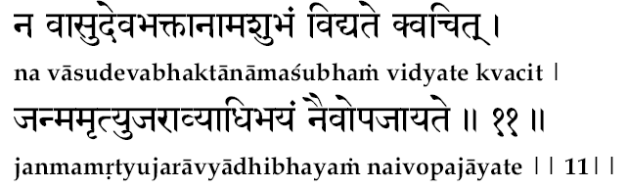

No inauspicious things can happen to a devotee of Vasudeva. The person will conquer the cycle of birth, death, fear and disease.
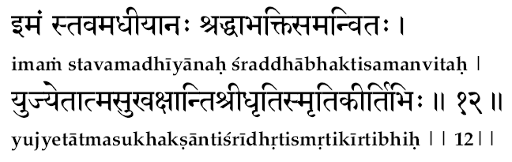

One who reads this hymn every day with devotion and attention attains peace of mind, patience, prosperity, mental stability, memory and reputation.

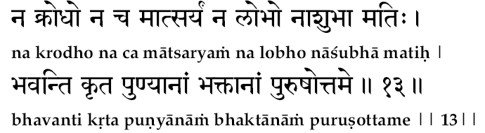
Such a person is not caught by anger, binding, jealousy, or any inauspicious event. Such a bhakta becomes a "punyatma" and merges with the Purshottama (i.e. supreme being)

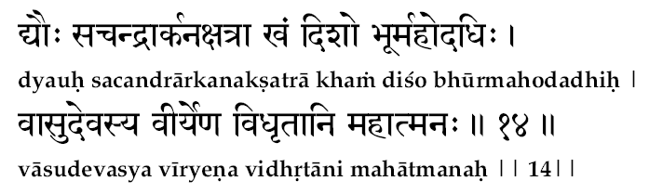

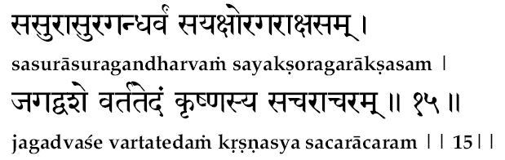

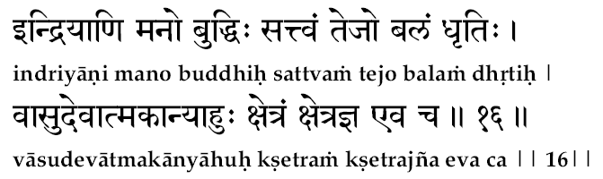

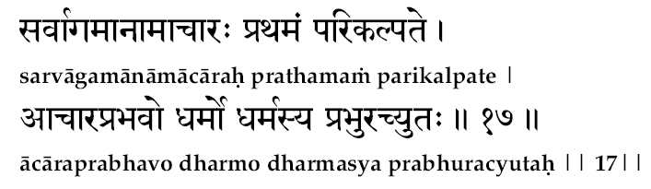
All scriptures consider right conduct as the foremost requisite. Dharma is based upon right conduct, and Dharma, Achyuta is the master.

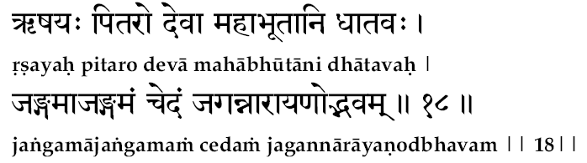

The rishis, pitrus, the devas, the great elements and in fact all things moving and unmoving constituting this universe have originated from Naaraayana.

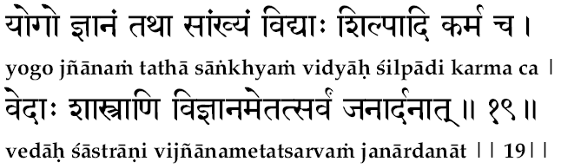
The Yoga, Jnaana, Saamkya, sciences, arts, works, Vedas, scriptures, spiritual illumination -- all these have originated from Janaardhana.

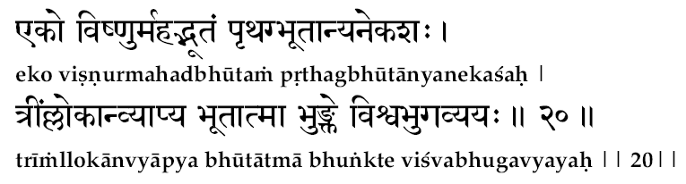

Mahaavishnu is the one all-comprehending being who appears as many. He is the essence of all brings, the consumer of the world, the indestructible one, and the master of all. Pervading all the three worlds, He enjoys all entities constituting them.

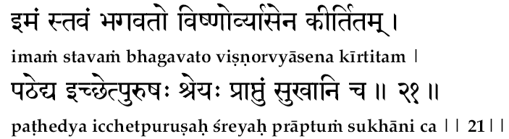

Whoever desires advancement and happiness should repeat this devotional hymn on Vishnu composed by Vyaasa.

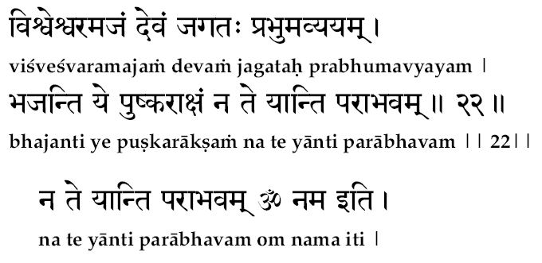
Never will defeat attend on a man who adores the Lotus-eyed One, who is the Master of all the worlds. Who is birthless, and out of whom the worlds have originated, and into whom they dissolve.

---------------------------------------------------------------------------------------------------------



